# CPSC 254 Lab 5 Group 2-3 Test Results

## R28 <Primary>

## R27 <Factor>

## R26.1 <Term'>

## R26 <Term>

## R25 <Expression>

## R25.1 <Expression'>

## R24 <Relop>

## R23 <Condition>

## R22 <While>

## R21 <Scan>

## R20 <Print>

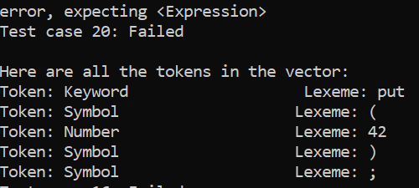

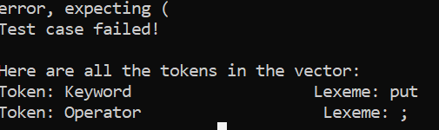

* Ended up fixing it a little bit but still gives me error, expecting (
* I tried to add ( and then I go back to the same error in the first image

## R19 <Return>

* 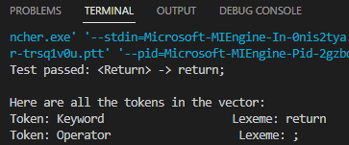
* checking and testing if the simple return function checks the tokens properly.

## R18 <If>

* Results: reading in from a text file, the vector of tokens contains a complete “if” statement but failed the test.
* Multiple combinations of “if” and “if else” statements were tested but the procedure_If() function would return false.
* 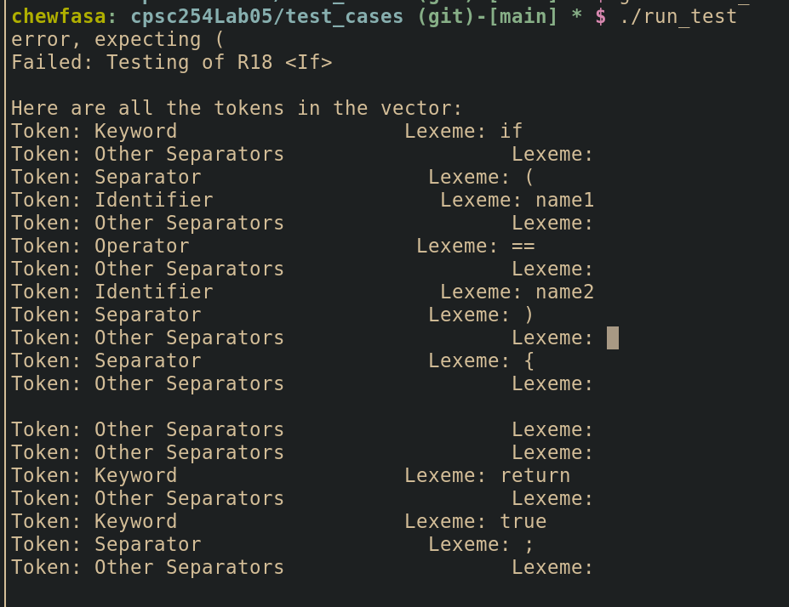

## R17 <Assign>

## R16 <Compound>

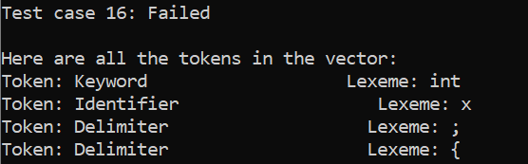

* Could not get the statement list test case working. I tried putting in many variables and changing all the token names and couldn’t get it to work. I did get the statement list error fixed however

## R15 <Statement>

## R14 <Statement List>

## R13 <IDs>

* 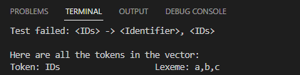
* Checks whether the token IDs are properly read

## R12 <Declaration>

* Results: reading in from the text file these qualifiers and IDs returned false and did not pass the test: const int max_size = 5; bool validInput = false;
* I’ve tried other qualifiers with and without initialization but the procedure_Declaration() function would still return false.
* 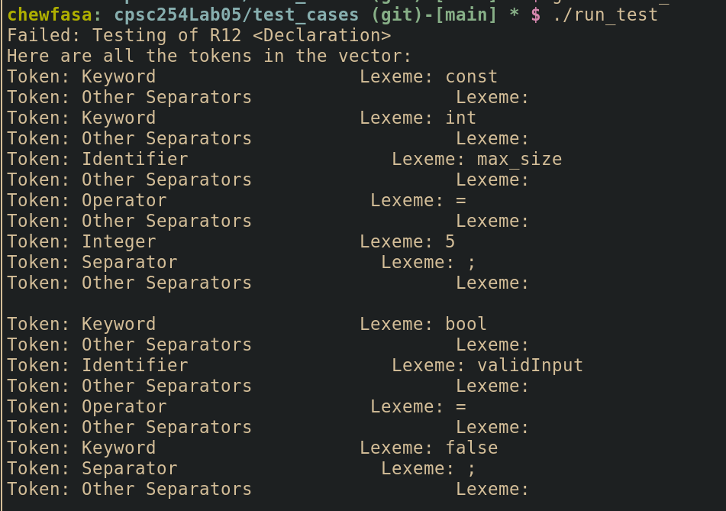

## R11 <Declaration List>

## R10 <Opt Declaration List>

## R9 <Body>

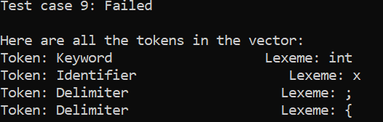

* Could not get the statement list test case working. I tried putting in many variables and changing all the token names and couldn’t get it to work. I did get the statement list error fixed however

## R8 <Qualifier>

## R7 <Parameter>

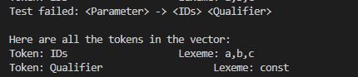

Checks whether The IDs AND the Qualifier tokens are read properly.

## R6 <Parameter List>

## R5 <Opt Parameter List>

* Results: in the temp.txt file, there were 2 parameters: int num1, float account_balance
* The procedure_Opt_Parameter_List() function returned true so the tokens in the vector were valid
* 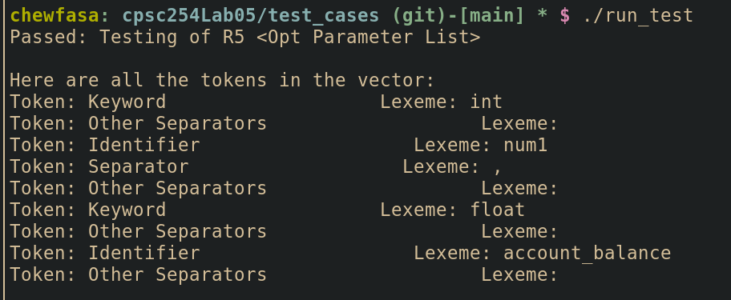

## R4 <Function>

## R3 <Function Definitions>

## R2 <Opt Function Definitions>

## R1 <Rat20F>