Winona State University
CS 465 Deep Learning
Brain Tumor MRI Classification Using Convolutional Neural Networks
Zeke Berryman, Israa Mohamed, and Michael Renteria
May 7, 2026

Abstract
Our project focuses on the use of Convolutional Neural Networks (CNNs) for the classification of brain tumors from MRI scans. A dataset of approximately 7,000 preprocessed MRI images were sourced from Kaggle. We then trained three different models using four classes: glioma, meningioma, pituitary tumor, and no tumor. We used a Multilayer Perceptron as our baseline model, and we also created two more CNN architectures with more depth and complexity. The baseline MLP achieved an accuracy of 77.69%, whereas CNN Model 1 achieved an accuracy of 87.38%. CNN Model 2 was the deepest architecture as it had four convolutional layers and six layers that are fully connected, and it had the highest accuracy with 89.62%. With these results we can conclude that using spatial feature extraction within the convolutional layers outperforms pixel-level classification, and having a deeper architecture with the appropriate filters will better identify the shape and structure of tumors. All of the models were implemented with Python using PyTorch and trained for 10 epochs using the Adam optimizer with cross-entropy loss.
Related Work
Several studies have explored the use of convolutional neural networks for brain tumor classification from MRI scans. The study by Gupta and his colleagues implemented a CNN-based approach for classifying brain tumor images, by comparing a custom CNN to a pretrained VGG-16 model that was using transfer learning. The results showed that even a rather simple CNN architecture could achieve competitive accuracy on a small dataset. Also, the study done by Li and colleagues implemented a more advanced method by combining parallel CNNs with a firefly optimization algorithm and was able to reach an accuracy of 98.6%. Both of these studies allowed us to make an informed decision on how to build and compare multiple CNN architectures of increasing depth and complexity when trying to classify brain tumors.
Dataset
The dataset used in this project was sourced from Kaggle, published by Masoud Nickparvar. It consists of 7,000 preprocessed MRI images in JPEG across four classes: glioma, meningioma, pituitary tumor, and no tumor. The dataset is separated into a training set and a testing set. The testing set contains 400 images per class. Each image was then resized to 150x150 pixels with grayscale and then normalized in preprocessing. The dataset was chosen because it presents a classification problem consisting of four different tumor categories. This required the model to learn the shape and location of the tumor growth rather than focusing on texture differences and patterns which is important when evaluating CNN performance in a medical imaging scenario.

Figure 1: Sample MRI Images from Dataset
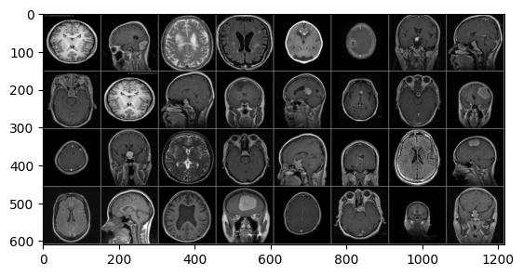

Methodology
All of the models were implemented in Python using PyTorch and were trained for 10 epochs with a batch size of 32. The Adam optimizer was used alongside cross-entropy loss for all three models.
The baseline model was a Multilayer Perceptron (MLP). The MLP flattens the image into a single vector of pixels and passes it through two fully connected layers. This model serves as the baseline because it cannot recognize patterns based on position or structure.
CNN Model 1 consisted of two convolutional layers followed by two max pooling layers, and two fully connected layers at the end. The first convolutional layer consisted of 8 feature maps and the second layer consisted of 16. This allowed the model to detect complex spatial features.
CNN Model 2 had a deeper architecture that consisted of four convolutional layers, three max pooling layers, and six layers that were fully connected. The convolutional layers produce 16, 32, 64, and 128 feature maps which allow the model to learn more complex spatial patterns within the MRI images.
Results
Figure 2: Baseline MLP Evaluation Summary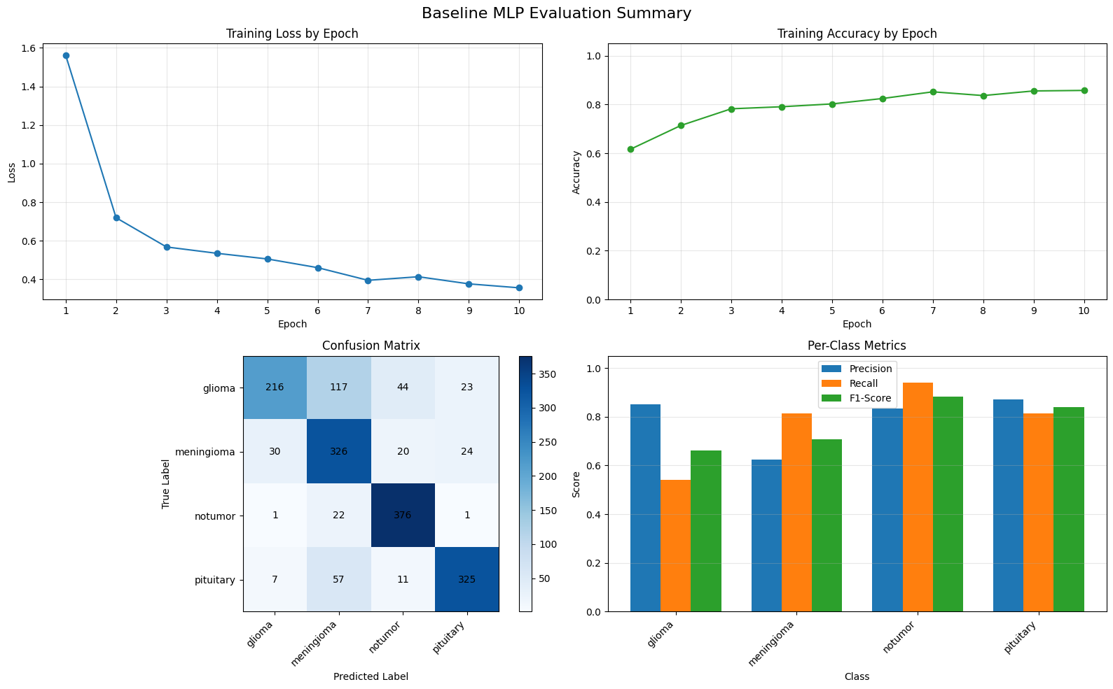
The baseline MLP achieved an accuracy of 77.69%. By looking at the confusion matrix, the model struggled with glioma the most as it only correctly classified 216/400 images. The no tumor class performed the best with an F1-score of 0.8837, while glioma had the weakest F1 score of 0.6606.
Figure 3: CNN Model 1 Evaluation Summary
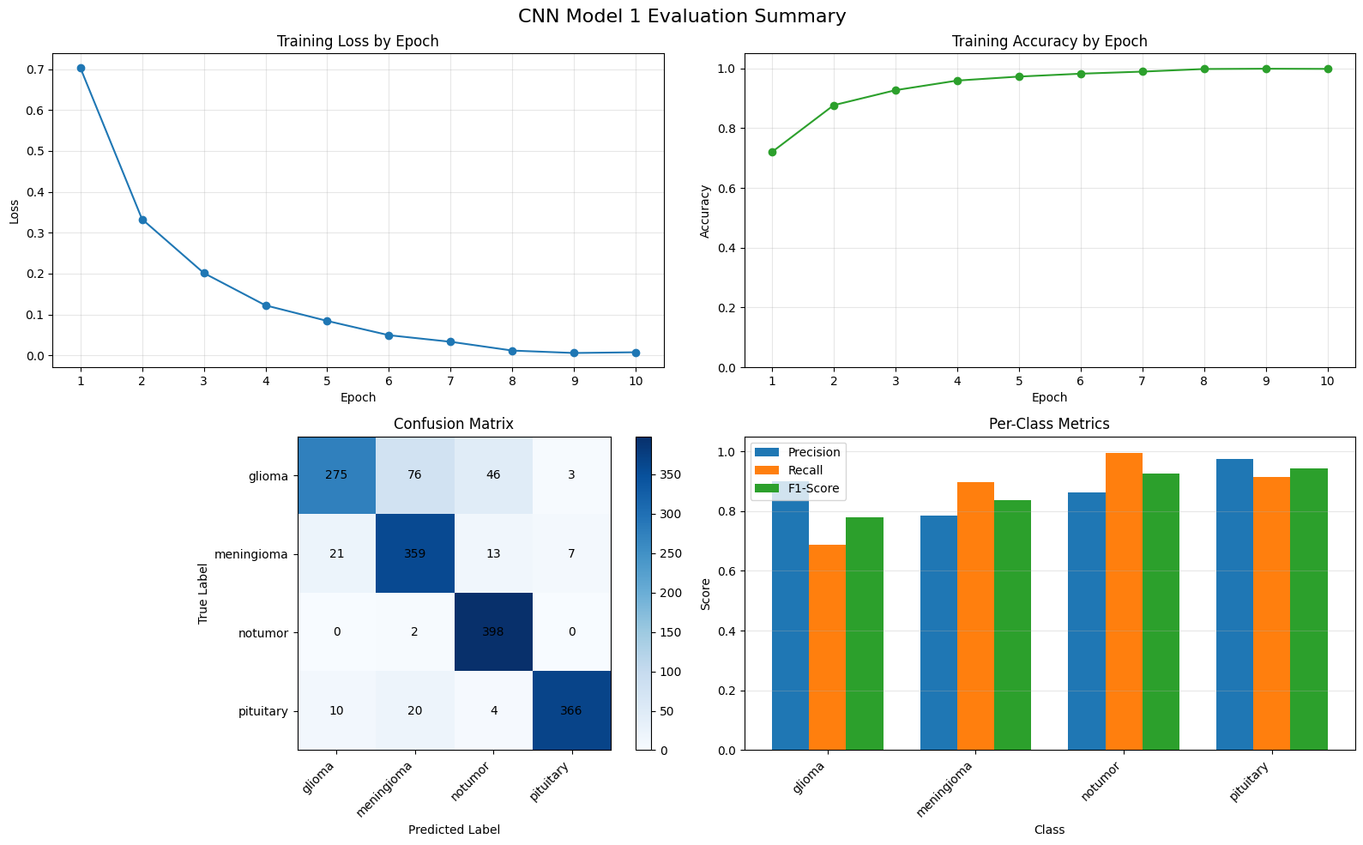
CNN Model 1 showed a significant improvement when compared to the baseline by achieving an accuracy of 87.38%. Training loss decreased significantly over 10 epochs which suggests that the model learned effectively. The no tumor and pituitary classes performed best, with F1-scores of 0.9245 and 0.9433. Glioma was still the hardest class to classify.

Figure 4: CNN Model 2 Evaluation Summary
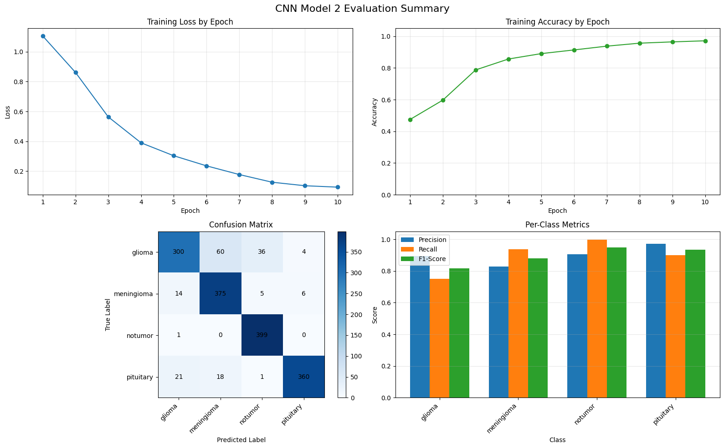
CNN Model 2 achieved the highest accuracy of 89.62% when compared to the other models. The deeper architecture allowed the model to better differentiate between tumor types. The no tumor class achieved an F1-score of 0.9489. Glioma still continued to be the most challenging class, even though performance improved compared to both previous models.

Figure 5: Model Comparison
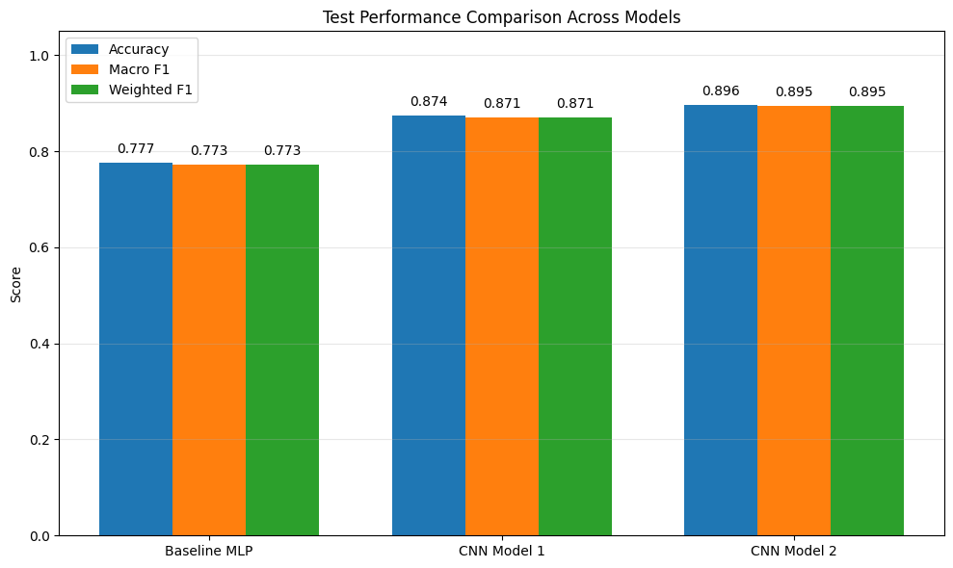
The comparison chart shows improvement throughout accuracy, macro F1, and weighted F1 as model complexity increased. The MLP baseline scored 0.777, CNN Model 1 improved to 0.874, and CNN Model 2 achieved 0.896. This indicates that deeper CNN architectures are the best option for medical image classification tasks.
Conclusion
This project showcased the effectiveness of Convolutional Neural Networks when it came to classifying brain tumors from MRI scans. By comparing a baseline MLP against two custom CNN architectures, we were able to see that CNNs with spatial feature extraction were better than pixel-level classification. CNN Model 2 had the deepest architecture tested and was able to achieve the highest accuracy of 89.62%, confirming that increased model depth and complexity yielded better results when it came to classifying medical images. Glioma was consistently the most challenging class throughout all of the three models. This is likely due to its visual similarity to other tumor types. Future work could include the use of saliency maps to visualize which regions of the MRI scan the model is focusing on.

Works Cited
Gupta, Manali, et al. "Classification of Brain Tumor Images Using CNN." Computational Intelligence and Neuroscience, vol. 2023, 12 Oct. 2023, doi:10.1155/2023/2002855.
Li, Chen, et al. "Classification of Brain Tumor Types through MRIs Using Parallel CNNs and Firefly Optimization." Scientific Reports, vol. 14, 1 July 2024, doi:10.1038/s41598-024-65714-w.
Nickparvar, Masoud. "Brain Tumor MRI Dataset." Kaggle, 2021, www.kaggle.com/datasets/masoudnickparvar/brain-tumor-mri-dataset.

