**Michael Rallo – msr5zb - 12358133**

**Project Final - Escape**

**5/09/2017**

***General Information***

***Team Member List***: Michael Rallo

***Contact Person***: Michael Rallo (msr5zb@mail.missouri.edu)

***Title***: Escape

***Overview***: Escape is a first person dungeon puzzle such that the user must navigate their way out of a dungeon in order to find a way to escape. There are obstacles and small puzzles that the player must overcome. Collision, object interaction, lighting, and more is demonstrated in this project.

***System***

***Platform:*** This Game was developed using Unity developed for PC. The game is played though a FirstPersonController with a Camera attached.

***Controls***: A FirstPersonController is used to navigate through to game. A camera is attached to FirstPersonController game object.

***Environment Interaction***: The FirstPersonController can detect collision of gameObjects it collides with. Methods have been written to detect and act upon specific kinds of gameObject collisions so that the player may interact with the world.

***The Player/UI:*** The player has a set amount of HP that Is displayed in the top left corner of the player’s screen. If the player hits any traps or falls in pitfalls, the player may take damage. If the player’s HP falls to or below 0, the player will have to restart the game. A red flash indicates when a player gets damaged and there is a brief amount of time after a hit where the player is invisible. Traps the harm the player will also be destroyed to alleviate level difficulty.

***Resources***: A majority of the resources used in this project came from the Unity Store. You may find these assets from the Unity Asset store here: <https://www.assetstore.unity3d.com/en/>.

***Rooms/Obstacles***: *There are 4 main rooms/obstacles the player must overcome.*

***-Trap Hallway:*** This is the first obstacle room the player encounters after leaving the starting area. It is a simple hallway that the player must make their way through. Here, players may learn that they can take damage – but there aren’t enough traps in this room to fully kill the player just yet.

***-Parkour Puzzle Room:*** Consists of various structures, moving platforms, and traps that the player must navigate through in order to activate a switch enables the player to move onto the next room.The exit of this room is blocked by two angel guardians, the switch to move these guardians is located at the highest point, indicated by gold particles.

***-Moving Pillar Puzzle Room:*** In this room, the player will find 4 buttons and 4 pillars. Each button will raise of lower specific pillars. Button 1 swaps the heights of pillars 1 and 4. Button 2 swaps 1 and 3. Button 3 swaps 2 and 4. Button 4 swaps 2 and 3. The player must find the right combination in order to create a stairway up to the switch that will activate ½ of the keys needed to release the exit door.

***-Maze Trap Dungeon:*** This is where the other ½ of the key to the exit resides. This is a maze filled with traps. Fire, Blades, Spikes, and more. Somewhere deep within the maze the player will find the switch. Once activated, the player must navigate back.

***Methods***

***Most notable Methods can be found below.***

-***Object Collision Detection:*** Object Interaction was done within the OnControllerColliderHit method. It looked at gameObjects being collided with and picked out specific gameObject names or tags to deal with them accordingly.A timer was used to ensure the player could not spam collisions.

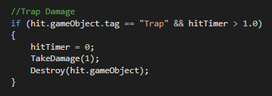

***-Take Damage:*** This script handled what happens when the player took damage. It shows the red flash, as well as managing the Player HP data/ui.

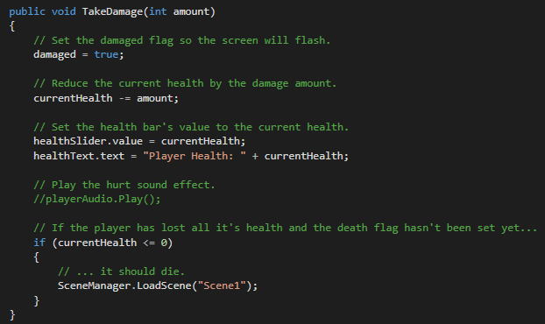

***-Angel Switch Handler:*** This script handles the Button the moves the Angel Guardians at this room’s exit. It’s a simple script that translates the button down a bit and plays an audio clip.

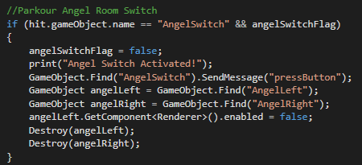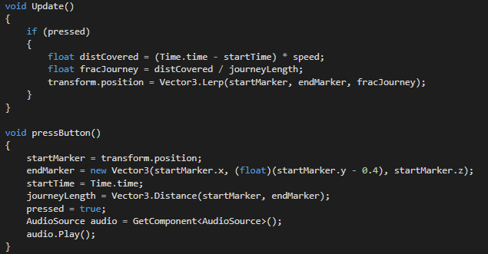

-***Pillar Puzzle and Maze Switch Handler:*** On Collision, the button is translated down and plays an audio clip. Each Button also reveals a Key/Flame that appears near the exit gate. Once both are collected, the Final Exit Gate is opened.

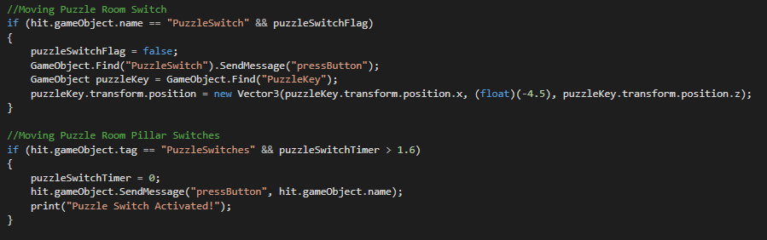

***- Pillar Logic and Scalars:*** The Pillar Logic was a bit tricky. As explained before, Buttons 1-4 control pillar heights. This script handles the logic behind this.

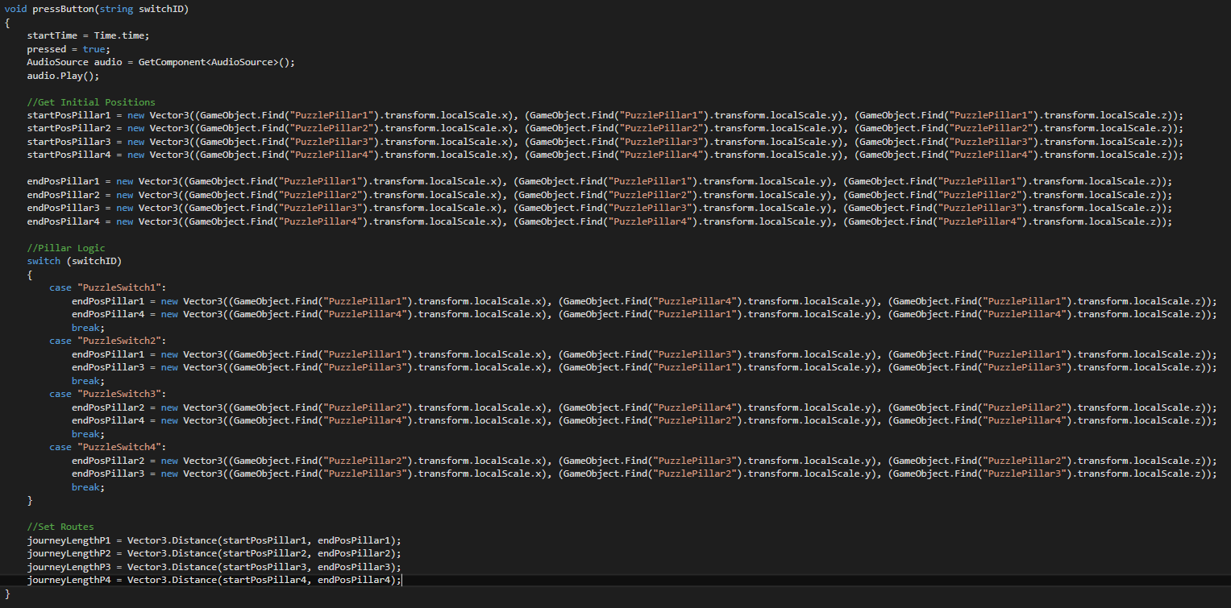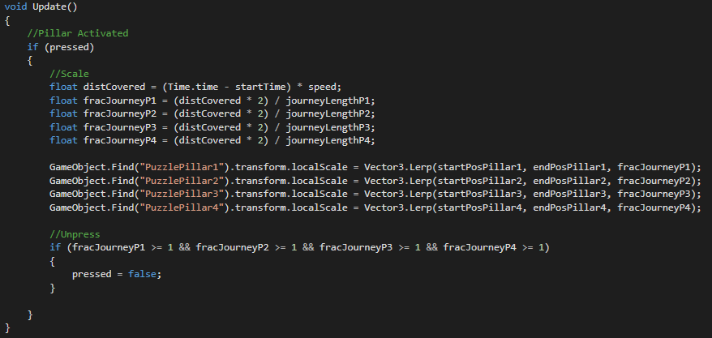

***Issues/Problems***: Due to time constraints, I had to remove the monster chase towards the end of the game. Instead, the player finds himself almost seeking freedom – but ends up right back where he started (There is no Escape).

***Everything was done by***: Michael Rallo

***Youtube Link***: <https://www.youtube.com/watch?v=5maeDKM86HI>