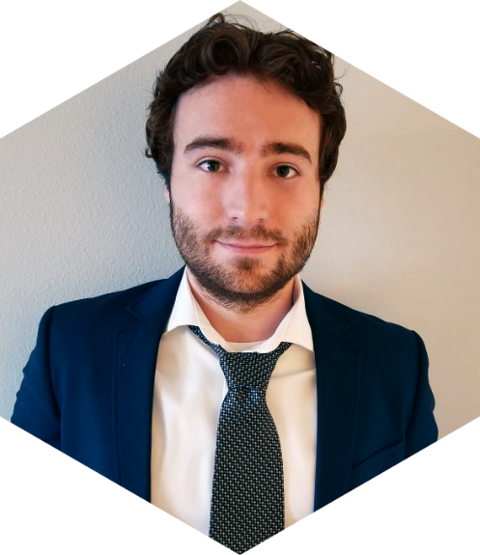

CONTACT

**Michael Rallo**

Full Stack Software Engineer

(314)-322-0042

[michael.s.rallo@gmail.com](mailto:michael.s.rallo@gmail.com)

<http://linkedin.com/in/michael-rallo>

2019 130TH PL SW, Unit B

Everett, WA 98204

Specialized Skills

**Software Development:**

OOPLs – C++ & Java

GUI Tools QT (C++) & JavaFX (Java)

Low Level / OS – C & Cmake

Unit Testing (GTest)

Unreal Engine 4.0

Python

**Web:**

Web Services / REST APIs

Spring / Angular / React / Laravel

Javascript / PHP

SQL

**Dev Environment/Tools:**

Git

Agile / SAFe

Pivotal Cloud Foundry / Jenkins

Virtual Machines

AWS / Azure

**Team:**

Communication

Cooperation

Design

Innovation & Motivation

**EXPERIENCE**

Boeing July2018 - Present

**Software Engineer – Automation Integration**

* Responsible for delivering valuable Software Applications to support automated manufacturing in the Fuselage Assembly Center.
* Maintain/Update Data, Metrics, and Applications used to display the statistics of the Automation performance.

Boeing June2017 - June 2018

**Software Engineer – Flight Simulation**

* Responsible for defining the requirements; designing, developing, and testing software features; and supporting products through delivery and in the field.
* Maintain/Update Pilot Training Simulators and Instructor Operator Systems.
* Develop in a Scaled Agile Framework alongside many other brilliant engineers.

MBS July2016 - May 2017

**Web Developer**

* Responsible for independently Developing/Designing University Bookstore Websites from the ground up within an Internal Content Management System.
* Maintain Multiple Live Websites and provide excellent and proficient Client Services.
* Lead the company forward to pursue Responsive and Modern Web Designs.

University of Missouri - Columbia

**Bachelor’s Degree** August 2014 - May 2017

* ***Bachelor of Computer Science***
* ***Majors***: Computer Science
* ***Minors***: Mathematics
* ***Latin Honors***: Cum Laude

Saint Charles Community College

**Associate’s Degree** August 2012 - May 2013

* ***Associates of Arts***
* ***Majors***: Computer Science
* ***Latin Honors***: Summa Cum Laude

**EDUCATON**

I am a Full Stack Software Developer seeking employment where I can utilize my expertise of development, design, and vision to help meet and exceed the company’s goals.

**CAREER OBJECTIVE**