**Help-file ROLE qa­­­­­­­­­­­­**

**The goal of the first phase is to create 2 ArrayLists of Row objects that logically and physically represent the information located in the SmartSheet, and HTML Help-File Directory.**

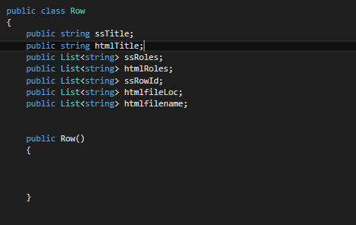

# Code Breakdown - Smartsheet

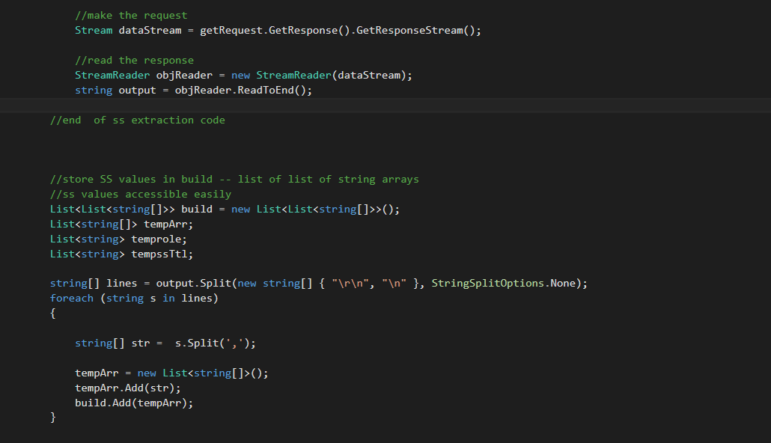

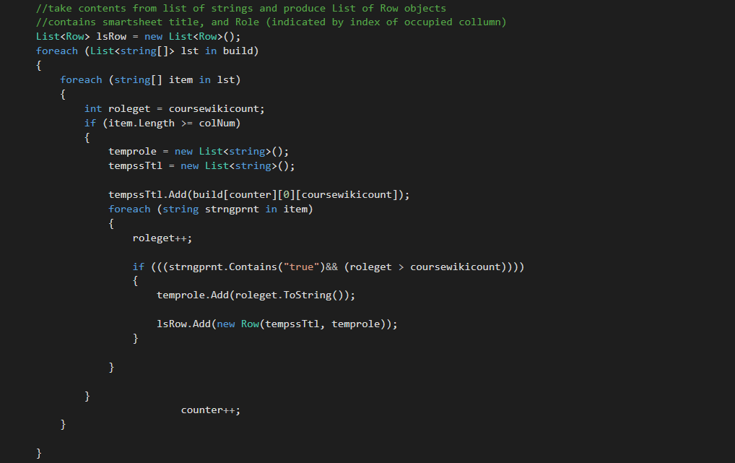

Traverse through contents of build, and produce a list of Row objects.

Stream is in CSV format, and is stored into a List of List of string arrays -- build. This was done so that values can be accessed simply.

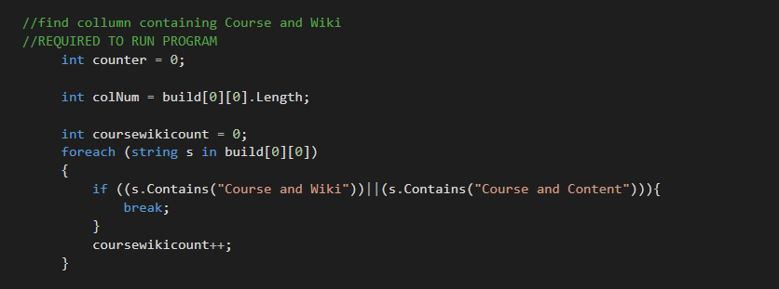

This code finds the column with the help-file titles. If a column in the SmartSheet does not contain “Course and Wiki” or “Course and Content” then the application will not run successfully.

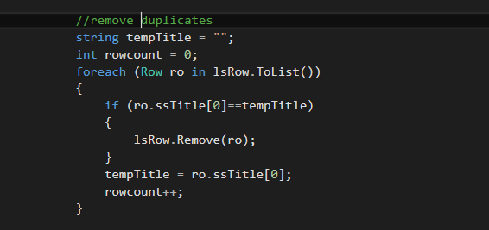

Remove duplicates.

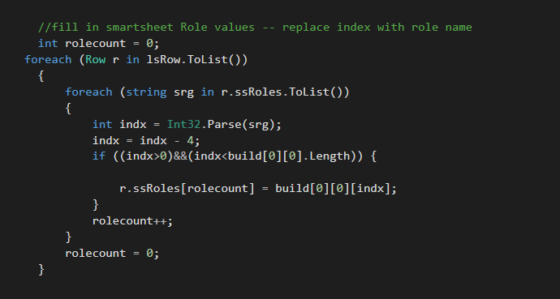

Before this point, the value inside of role variables are the index of the column. Since what we want is the name of the role, by accessing the role names from the first row of the Smartsheet, you can then link the names of the role by subtracting 4 from the index, then linking.