Git fundamentals

Command or concept | Description
git init
change set | Git doesn't work with files. It works with change sets
git init | Initializes a repo from where ever the command is executed
git status | Shows the contents of the staging area as well as lists the contents of untracked files.
git add | Adds files to the staging index. The staging index can be thought of as a “pre-commit” area. Files are committed from the staging area to the repo.  git add . adds all the changes in the working directory to the index.
git rm | Removes items from the staging index. To remove a directory from the index:  git rm --cached -r directory-name  https://stackoverflow.com/questions/1143796/
git rm –-cached <file> | Removes a file from the index without deleting from the local file on the system.
got commit | Commits what is currently in the staging index to the project repo. The -m option is used to add the commit message which should be less than 80 chars. You can edit the most recent commit message using:  git commit --amend  https://help.github.com/articles/changing-a-commit-message/
git log
git remote add <remote_name *>  * “origin” is used by convention | Adds a remote to the local git system. The example below adds a remote repo used for my Getting and Cleaning Data Coursera project:  git remote add origin https://github.com/MichaelSzczepaniak/HumanActivityRecognition.git  The newly added remote is stored in the .git/config file of the project.
git remote | Lists the remotes the local git project knows about. Using -v option lists urls to push and fetch (which are usually the same).
git remote rm origin | Removes the origin remote
git push | Pushes local changes to a remote. The example below is what is typically used for pushing changes from the local master branch up to a remote named origin:  git push -u origin master  If you need to revert a commit already pushed to the remote, use:  git push origin +abc123^:master  where abc123 is the SHA of the commit you want to remove. This forces the master branch of the origin remote repo to the parent of abc123. Reference:  http://christoph.ruegg.name/blog/git-howto-revert-a-commit-already-pushed-to-a-remote-reposit.html
git remote add origin https://github.com/MichaelSzczepaniak/<repo name>  git push -u origin master | push an existing local repo to github:  1) create an empty project on github (described in Kevin Skoglund's lesson 13. Remotes video 02. Remotes-Setting up a GitHub account.mov  2) follow the commands shown on the left to create a reference to the remote and then push up that branch
git clone <url> | Pulls in a remote repo and uses the project name as the folder. Execute this from the parent dir under which you want to pull the project in under.  You can rename the directory that clone creates by passing the name you want after the url. See the following video for more details:  ...\Dropbox\sw_dev\training\Lynda\Lynda - GIT Essentials\13. Remotes\  05. Remotes-Cloning a remote repository.mov
git fetch | Pulls updates from a remote into the tracking branch (typically called origin/master). A fetch syncs the remote with the tracking branch, but before these changes can be used by the local master branch, a merge must be done (typically a fast-forward merge)
git branch | List the branches in the current project
git checkout -b <branch name> | Creates a new branch from the current branch and puts you into that branch.
Git branch -D <branch name> | Forces the remove of a local branch
git push origin --delete <branch_name> | Removes a remote branch. Reference:  https://stackoverflow.com/questions/2003505
git merge | --no-ff this option forces git to do full merge: it will NOT do a fast-forward merge.  --ff-only tells git to do a merge ONLY if it can do a fast-forward merge
git merge –abort | Aborts a merge and puts you back into the state prior to attempting the merge
git checkout --track -b <local branch> <remote>/<tracked branch> | Pull down a remote branch so you can work with the code locally. I used this on 4/12/2018 to pull down Nathan Turnbows code to validate a PR request. Reference: http://gitready.com/intermediate/2009/01/09/checkout-remote-tracked-branch.html
git checkout <branch name>  git reset --hard master  git push -f # force push the branch | If you want to make a certain branch the same as master and you don't care about preserving any commits from that branch, you can do a hard reset. References:  https://stackoverflow.com/questions/29796127/
git reset –-soft <hash>  vs.  git reset –-mixed <hash>  vs.  git reset –-hard <hash> | The reset command moves the HEAD pointer to a specific commit. The soft, mixed, or hard options determine how git handles the changes between the previous HEAD and the reset HEAD. The soft option, put your changes in the index, the mixed leaves them in your working directory but with not changes to the index. The hard wipes out your index and working directory and makes them both like the head of master. Nice description here:  https://gist.github.com/tnguyen14/0827ae6eefdff39e452b
.gitignore | Add this file to your project to specify which files should be ignored by the git version control system. Windows Explorer doesn't allow you to create files that start with . (dot) so use the following work around:  1) Hold SHIFT, right click the folder you're in, then select Open command window here  2) Then rename the file in the command line, with  ren [original name] .gitignore  git recognizes simple regex expression as described in these videos:  ...\Dropbox\sw_dev\training\Lynda\Lynda - GIT Essentials\08. Ignoring Files

Git learnings and common tasks

Date: mm/dd/20yy

Date: 10/20/2017

To enter a multi-line commit message in git, use the following format:

git commit -m $'first line\nsecond line'

NOTE: THE $ IS THE KEY TO MAKING THIS WORK! Words of the form $'string' are treated specially. The word expands to string, with backslash-escaped characters replaced as specified by the ANSI C standard.

Reference:
https://stackoverflow.com/questions/5064563/add-line-break-to-git-commit-m-from-command-line#5065387

Date: 10/20/2017

After cloning a repository that had 3 branches (master, enh_configfile, and enh_qualplots), I only had master showing up when I did a git branch I wanted to track all three branches. How to do this was described here:

https://stackoverflow.com/questions/379081/track-all-remote-git-branches-as-local-branches
I upvoted answer given by slm on 12/1/2014. I copied the following text into git bash and it worked just fine:

for i in $(git branch -r | grep -vE "HEAD|master"); do
git branch --track ${i#*/} $i; done

Date: 10/15/2017

Rename a local and remote branch in git

1. Rename your local branch. If you are on the branch you want to rename:

git branch -m new-name

If you are on a different branch:

git branch -m old-name new-name

2. Delete the old-name remote branch and push the new-name local branch.

git push origin :old-name new-name

3. Reset the upstream branch for the new-name local branch.
Switch to the branch and then:

git push origin -u new-name

Reference: https://multiplestates.wordpress.com/2015/02/05/rename-a-local-and-remote-branch-in-git/

Date: 12/2/2015

Remove a file from a Git repository without deleting it from the local file system:

For a file: git rm --cached mylogfile.log

For a directory: git rm --cached -r mydirectory

Reference: http://stackoverflow.com/questions/1143796

Date: 12/2/2015

How to list all the files in the last commit. Use: git ls-tree –-name-only -r <commit-ish>
WARNING!!! DO NOT COPY AND PASTE THE ABOVE COMMAND DIRECTLY INTO A GIT BASH CLI!!! IF YOU DO, YOU MAY SEE STRANGE BEHAVIOR BECAUSE OF HOW THIS CONSOLE HANDLES VARIOUS FONTS. TO BE SAFE, COPY AND PASTE INTO SOMETHING LIKE NP++ AND THEN COPY & PASTE FROM NP++.

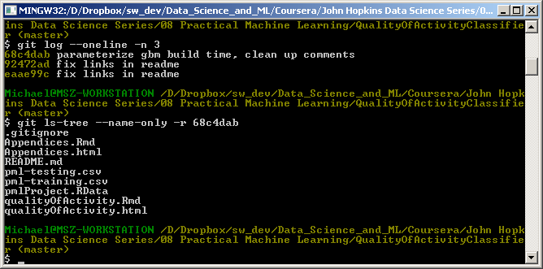

reference: http://stackoverflow.com/questions/424071/how-to-list-all-the-files-in-a-commit

Date: 5/11/2014

Fix for how to exit after doing a git diff in windows 7. It was hanging as shown below:
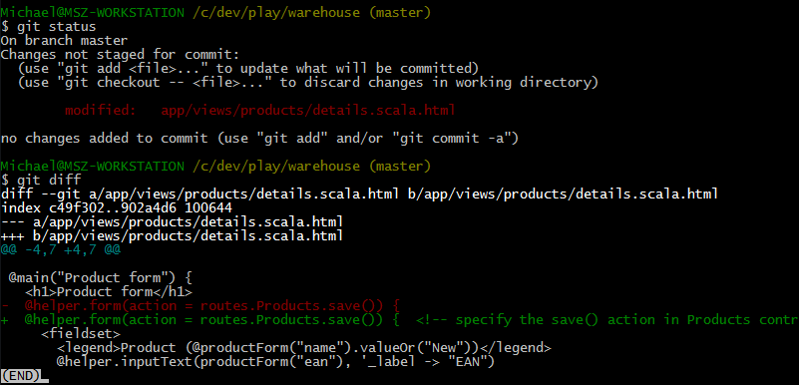

Simply type Q to exit.

Reference:

http://stackoverflow.com/questions/9929457/how-do-i-exit-the-results-of-git-diff-in-git-bash-on-windows

Date: 5/11/2015

How to set up NP++ as the git core editor:

git config --global core.editor "'C:/Program Files (x86)/Notepad++/notepad++.exe' -multiInst -notabbar -nosession -noPlugin"

reference: http://stackoverflow.com/questions/1634161/how-do-i-use-notepad-or-other-with-msysgit

Date: 5/11/2014

Fix for the
fatal: pathspec '...' did not match any files error that I was seeing as shown below:

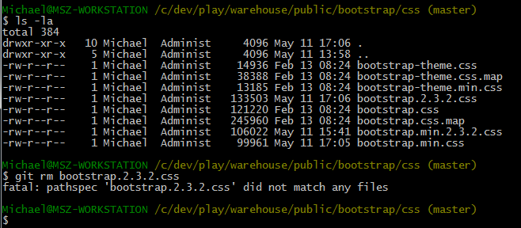
The file I was trying to remove was not being tracked (had an entry in the .gitignore file).

References:
http://stackoverflow.com/questions/15931238/unable-to-remove-file-that-really-exists-fatal-pathspec-did-not-match-any

Date: 5/11/2014

How to configure git to use bcompare as the difftool and NP++ as the default editor. Below is a copy of the User level .gitconfig (located in C:\Users\Michael\.gitconfig)

[user]
name = Michael Szczepaniak
email = golf4enlightenment@yahoo.com
[core]
editor = \"C:/Program Files (x86)/Notepad++/notepad++.exe\" -multiInst -notabbar -nosession -noPlugin
[mergetool "bcompare"]
path = \"C:/Program Files (x86)/Beyond Compare 3/BComp.exe\"
[merg]
tool = bcompare
[diff]
tool = bc3
[difftool "bc3"]
cmd = \"C:/Program Files (x86)/Beyond Compare 3/BCompare.exe\" -expandall -solo \"$LOCAL\" \"$REMOTE\"
[color]
ui = true
References:
http://stackoverflow.com/questions/15873874
http://www.scootersoftware.com/vbulletin/showthread.php?t=9449

Date: 10/13/2013

Fix for the
Can't connect to any repository:... not authorized error
I was seeing in using the Egit eclipse plugin

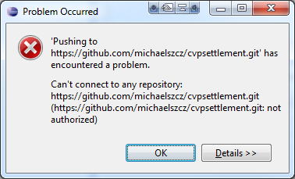
Description: When I tried to push a change to my remote git repository, I got this message:

The problem was that I had set the default repository password setting incorrectly in the Egit plugin and needed to change it to the correct one so the eclipse could make the connection.

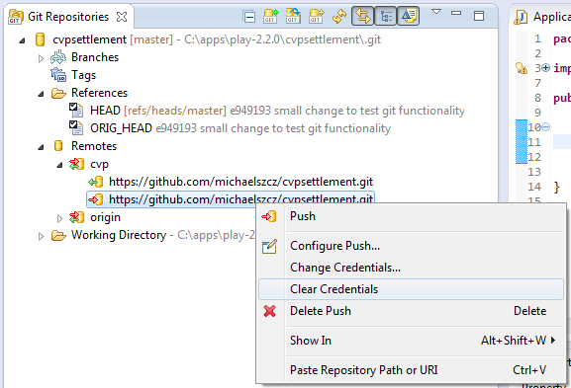
I found that I could right click the push under the Remotes list in the Git perspective, clear the credentials, and then then try the push and it worked IF I HAD COMMITTED THE CHANGES FIRST as shown to the right:

After doing this, when I tried to do the commit and push, I was prompted for my git repository credentials as shown below:

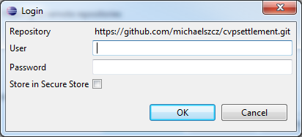
I made sure the uncheck the Store in Secure Store option after providing my credentials and the push succeeded. Happy day!

Date: 7/25/2015

How do you do a diff between the different areas of git?

- git diff: Show differences between your working directory and the index.
- git diff --cached: Show differences between the index and the most recent commit.
- git diff HEAD: Show the differences between your working directory and the most recent commit.
- git diff <branch1> <branch2> <file_name>: Shows difference between two branches
Replace diff with difftool to tell git to launch your configured diff too to do the diff (e.g. bcompare)

reference: http://www.gitguys.com/topics/git-diff/

Date: 7/25/2015

What's the best way to rename a file in git?

Date: 7/26/2015 How do you revert a single file:

git checkout -- <filename>

reference: http://www.norbauer.com/rails-consulting/notes/git-revert-reset-a-single-file.html

Date: 8/5/2015 Editing/amending the last commit message

git commit --amend

Will open your editor, allowing you to change the commit message of the most recent commit. Additionally, you can set the commit message directly in the command line with:

git commit --amend -m "New commit message"

If you've already pushed your commit up to your remote branch, then you'll need to force push the commit with
git push <remote> <branch> --force
# Or
git push <remote> <branch> -f
Warning: force-pushing will overwrite the remote branch with the state of your local one. If there are commits on the remote branch that you don't have in your local branch, you will lose those commits.
Warning: be cautious about amending commits that you have already shared with other people. Amending commits essentially rewrites them to have different SHA IDs, which poses a problem if other people have copies of the old commit that you've rewritten.

reference: http://stackoverflow.com/questions/179123/edit-an-incorrect-commit-message-in-git

Date: 11/10/2015 Workflow of creating remote repo then pushing and fetching from two local repos (laptop and workstation). My thinking around this example is that knowing how to quickly do this will allow me to work from anywhere and from any machine.
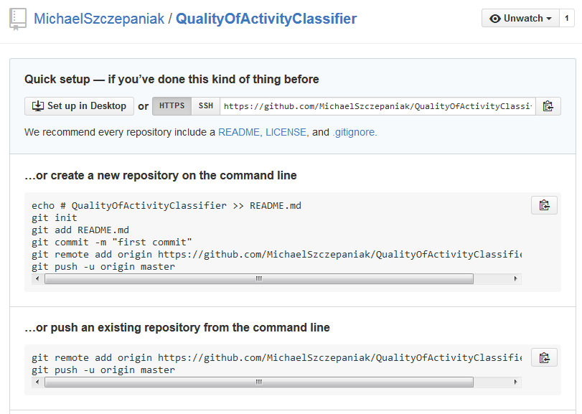
1. Create a remote repository on github as shown on the right.

2. Create a local project directory and do a

git init

to initialize a repo in this location as shown below left.

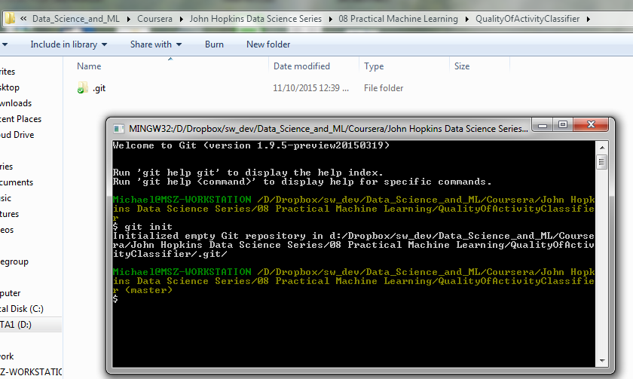

3. Create a README.md file and commit it to the local repo. We may use this file to make changes, push to the repository, and fetch back changes made from (the) other machine(s).

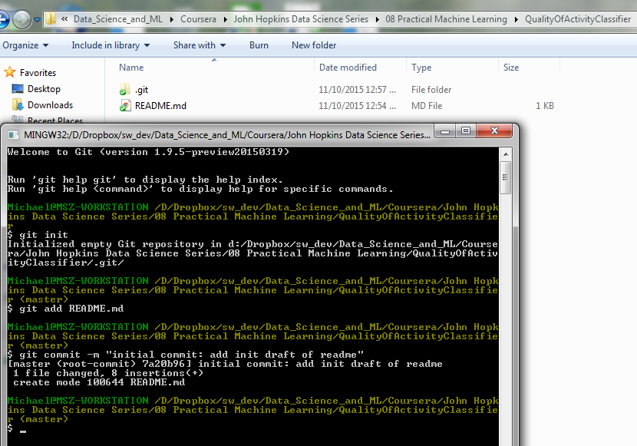
4. Configure the remote repository locally so that it knows where to push to and fetch from. Doing a

git remote

at this point will not show anything because no remotes are set up yet:

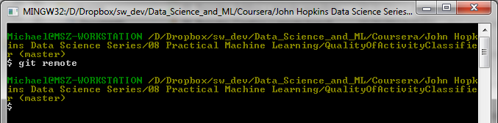
From within the project directory, execute the following command from the git command line:

git remote add origin <alias> <url of remote> For our example that would be:

git remote add origin https://github.com/MichaelSzczepaniak/QualityOfActivityClassifier.git

Note: The alias “origin” is used by convention, but this could be anything.
Adding the remote adds an entry into the .git/config file in the project directory and provides git a reference to push to and fetch from. This new entry can be seen below:

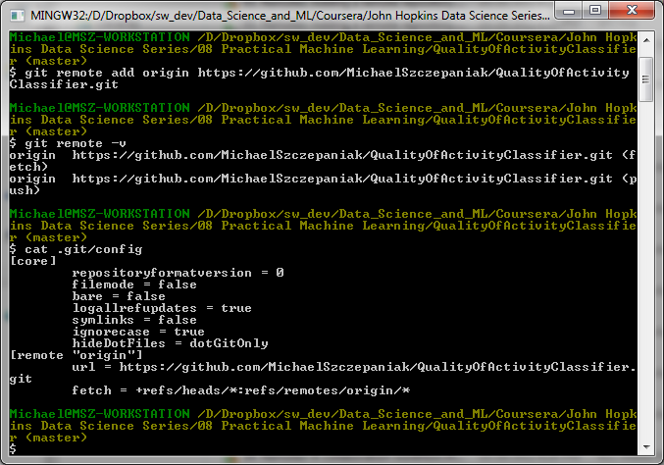
5. With the remote configured, we can now push our changes to the remote by doing the following from the git bash CLI from within our project repository.

git push -u origin master

The -u option is short for –-set-upstream and says to push our code up and also make a note of that fact because we're going to be coming back and working with this branch frequently. When we do a git clone it tracks the remote branch, and we can see that tracking in the .git/config file of the project.

6. (Update 11/28/2015) At this point, we have a remote configured, a local project configured, and we have pushed changes to that project from the workstation (machine which originally created the project). If we just worked on this project using the workstation, we would just make changes locally and then push those changes to the remote periodically.

If I want to use the laptop to work on a project originated from the workstation, I first need to clone the project, make my changes, and then push those changes back to the remote. The problem with this situation arises when additional work is done from the different laptop and workstation systems. For the rest of this example, I'll use the AbaloneRegression project.
The project has been cloned on the laptop as shown below:

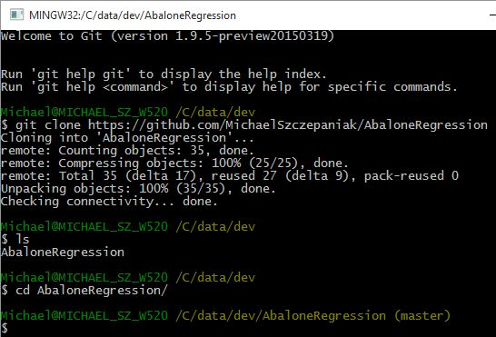
The next thing to do is make some changes from the laptop system and then...

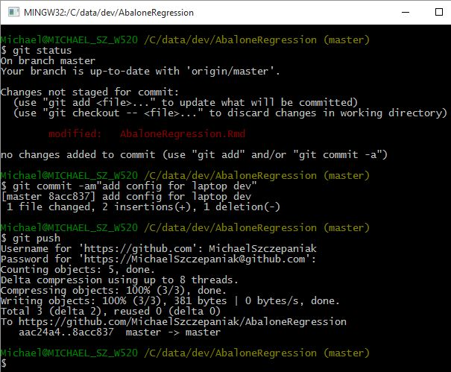

...push those changes to the repository as shown on the right:

Now, when I make a change on the workstation, commit that change and then try to push that change back to the remote, I see the following error:

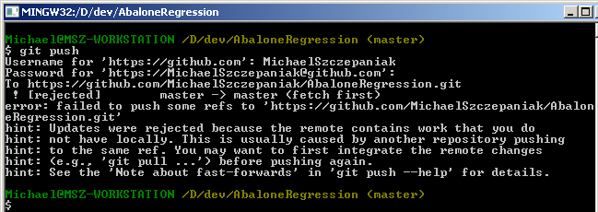
To fix this, I need to pull the changes down from the remote (fetch), merge those changes locally on the workstation, and then push those changes back up to the remote. The next steps show how to do this.

7. Next step is to pull down the remote changes.

Date: 11/10/2015 Delete a repository on github

1. Navigate to the main page of your repo on github.

2. Click on the Settings button on the right of the page:
3. Scroll down to the Danger Zone section at the bottom of the page.
4. Click Delete this repository.

Date: 11/10/2015 Make github HTML pages viewable in your browser:

https://www.dropbox.com/s/yy5iv12puu6cyd5/Project%20-%20Why%20and%20How%20to%20use%20gh-pages.pdf?dl=0

Date: 11/28/2015 Create an alias for showtool:

http://stackoverflow.com/questions/17558221/how-can-i-view-the-output-of-git-show-in-a-diff-viewer-like-meld-kdiff3-etc/33975521#33975521

https://git-scm.com/book/en/v2/Git-Basics-Git-Aliases

Date: 11/28/2015 Get rid of the push.default message

git config --global push.default simple
reference: http://stackoverflow.com/questions/13148066/warning-push-default-is-unset-its-implicit-value-is-changing-in-git-2-0

Date: 05/02/2016

Issue: When I did a git log on a newly initialized repo, I was seeing the following:

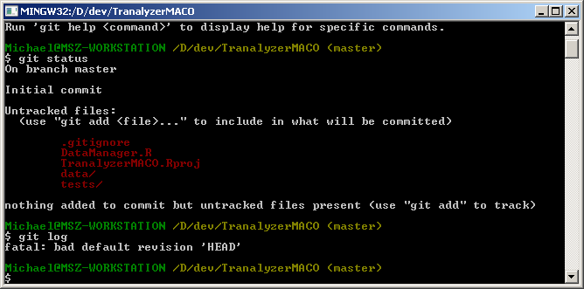
Solution: Just need to do a commit and this goes away. Reference:
http://stackoverflow.com/questions/15628720/fatal-bad-default-revision-head#answer-27118243

Date: 05/17/2017 How to diff the same file in two different branches

reference: http://stackoverflow.com/questions/4099742/how-to-compare-files-from-two-different-branches

git difftool <branch1> <branch2> <file_name>

For example: git difftool master disconnectbug ui.R

