Vehicle Design Basics
For 2008 Mustang

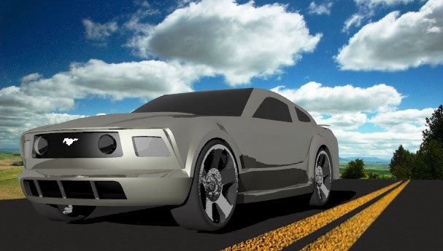

Mitchell Montgomery
Cedarcrest High School
Tuesday, May 03, 2011
- Introduction
  - The Purpose of this Tutorial is the help with the modeling of a car, specifically a 2008 mustang. While this tutorial will help specifically with the modeling of a 2008 mustang, the general idea can be applied to almost any car type. As you read through this model, take into consideration that there are a lot of steps, where self experience and experimenting will be required in order to make the model to your liking.
- Prerequisites
  - This Tutorial uses Rhino 4.0 and requires some general knowledge of the program. You will want to know how to use:
  - Control point curves
  - Control Points
  - Edge Curves
  - Network Surfaces
  - Sweep2 rails
  - Activate Control Points
  - Join
  - Boolean Union
  - Boolean Difference
  - Mirror (only use on surfaces that are strictly on one half of the car)
  - For surfaces that are mirrored across the center line, make sure to adjust the control points of the curve so that the next point over from the end point is linear to the end point. This will make the surface smooth when you mirror it.

Correct Way:

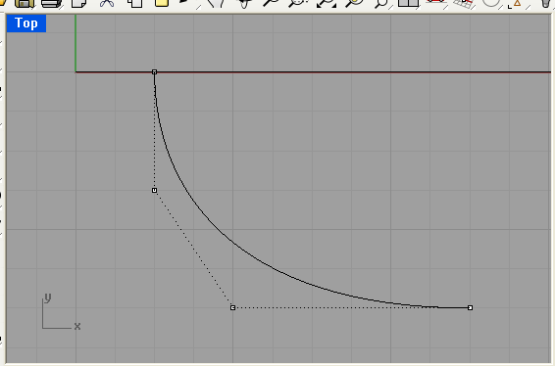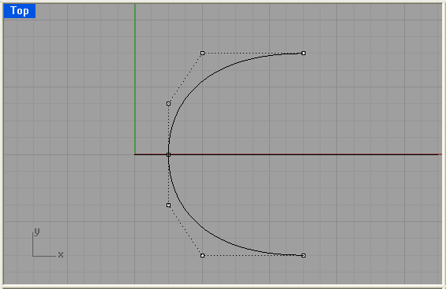

Wrong Way:

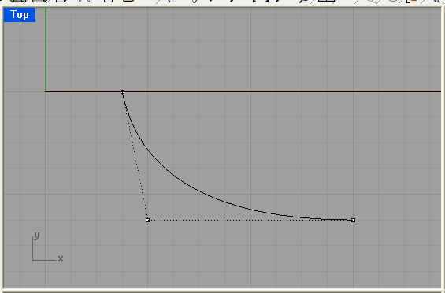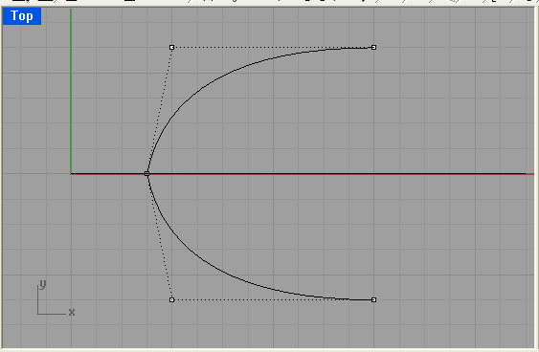
There are some other skills that may need to be used, especially if errors occur, but those will be explained in further detail as we approach them. Make sure that throughout the process of creating and joining surfaces, you make sure that the edge curves of each surface are flush with each other to prevent from getting any naked edges. Only mirror Surfaces that are strictly on one half of the car such as the doors (create one and mirror it), but not the hood (which is already in both halves)

- Skills to Be Learned
  - Generally, coming into Rhino 4.0, users are unfamiliar with creating shapes other than the standard circle, ellipse, sphere, and extruded curves. This Tutorial will explain how to take surfaces and join them together to create a 3-D shape (preferably in the shape of a car). Once you learn how to join surfaces to create a solid shape, you can take that skill further to create almost any other type of model.

  - Skill 1: Creating a simple surface using Control Points.

Start out by creating a flat hood shape using 4 Control point Curves
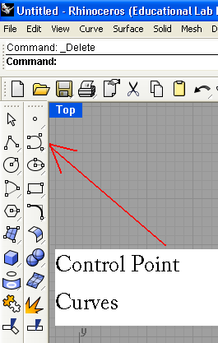
To make the hood curve, activate the control points. Drag them in the side view until they are either flush with the outline of your bitmap, or to your liking. Then go into the top view, and front view to further adjust the control points to keep the overall shape looking like the hood you desire: (It helps to trace one half and mirror it to make both halves look the same. Remember to make the first two control points linear to each other) Use Network Surfaces to create the following Surfaces.
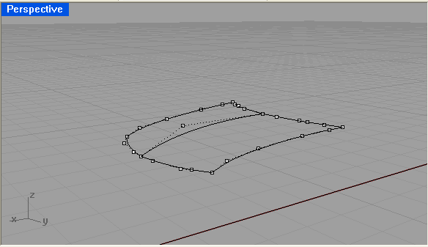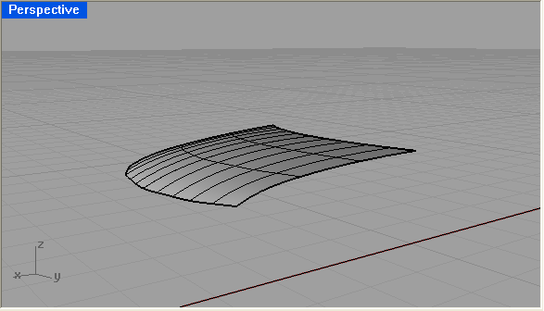

Next is the creation of the windshield. The same steps are to be applied for the windshield.

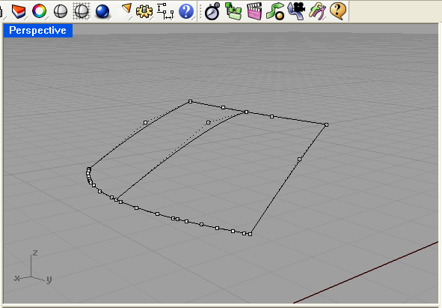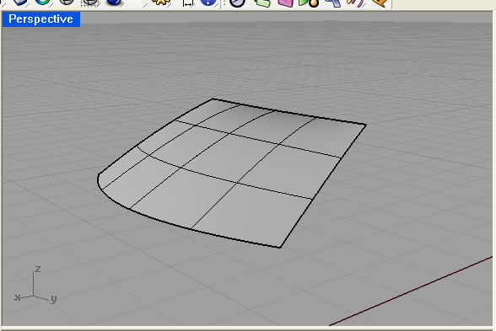

Continue with this process for the roof and the rear window.
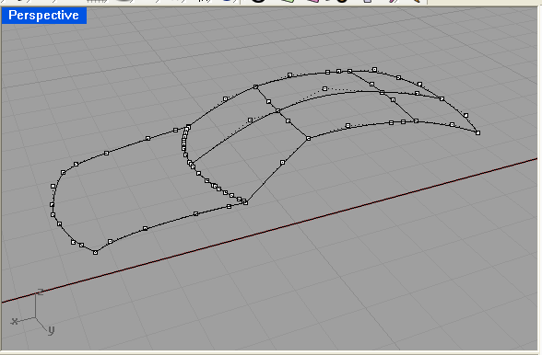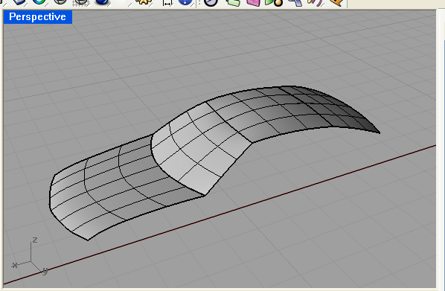

3.3: Creating the Doors
The doors are a bit trickier because they will not be able to be created from just one surface, as the hood, windshield etc… To create the doors, start out by tracing the bitmap in the side view, and making sure that it lines up in the front view.
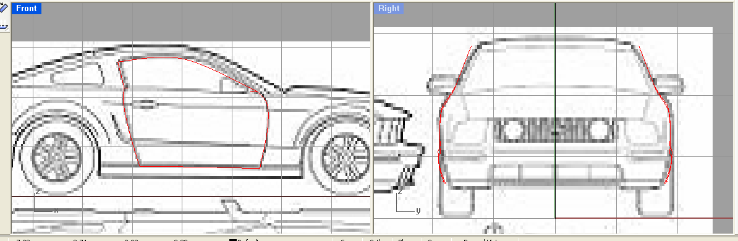

3.3b: Now, break the door up in to multiple sections. This will allow you to create the hard lines on the side of the mustang, as well as a surface that runs flush with all of the edge curves. Once this is done, use Network Surface to create all of the rectangular shaped sections, and Sweep2 to create surfaces on the triangular sections. Mirror each door over the center line so that each half is exactly the same.

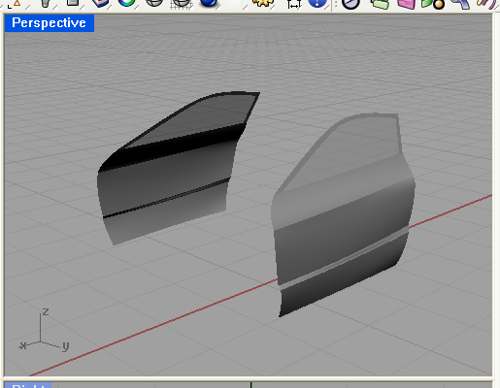

The Windows can also be created by creating a solid in the shape of the window, and Boolean differenced with the door:

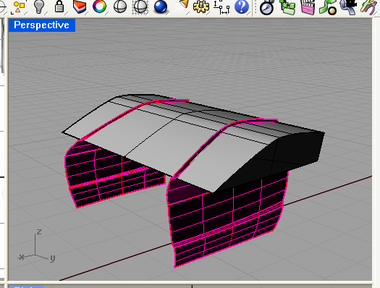

  - The Sides and Fenders:

3.4a. Sides: The sides will be created like the door. First trace the bitmap and make sure all views line up as closely as you can. Next, break it up in to different sections, based on the contour of the side of the car. Make sure that any defined lines match up with those on the door. Mirror the surfaces created over the center line.
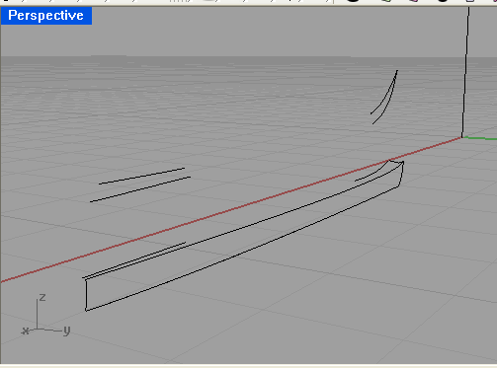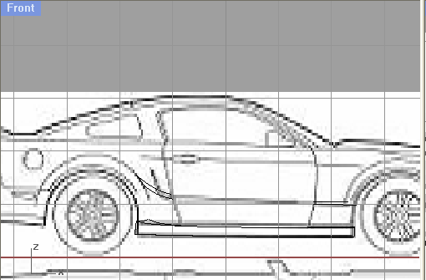

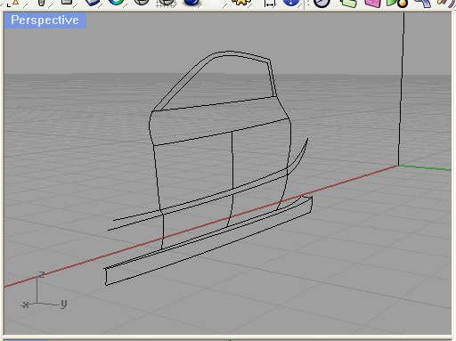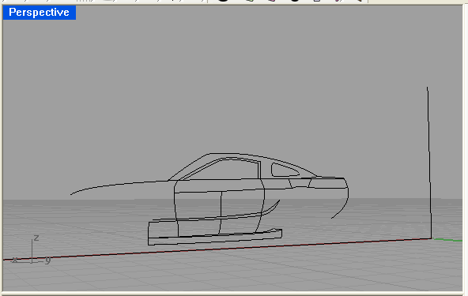

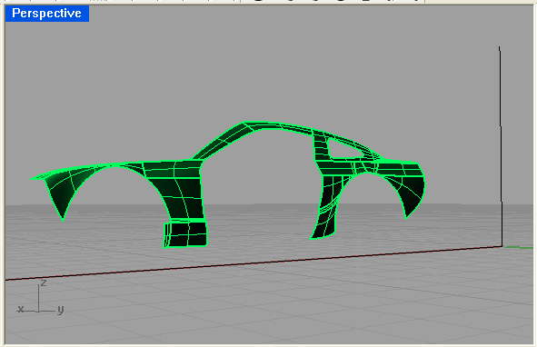
3.4b The Fenders: The front fenders will be created using 3 circular curves that will be offset to create the bulge. The process of creating the surfaces will be through “Sweep2”.

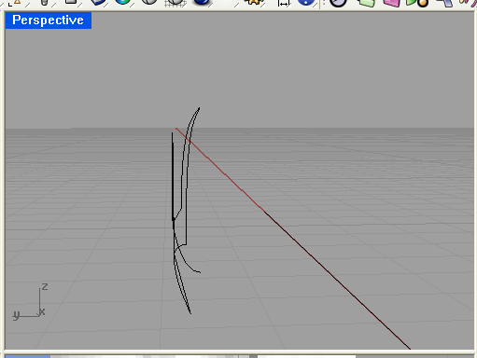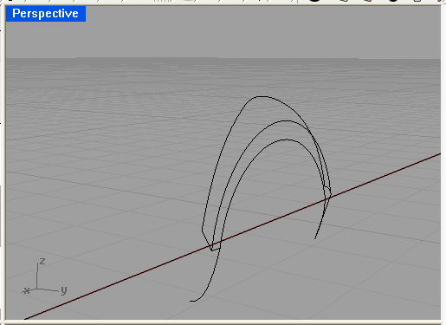
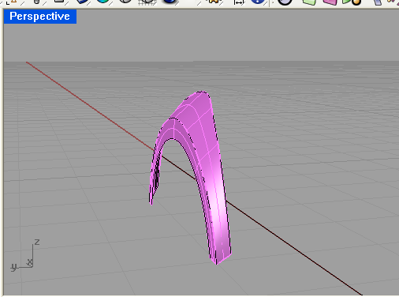
The Rear fenders will be created using the Sweep2 process. The rear fenders are supposed to be more curved than the front, which has a flat and hard edge. To create the rear fenders, trace the most inner portion and the most outer portion of the bitmap. Move the inner portion farther out than the outer, to allow for the fender shape. Adjust the control points to make the curves flow with the contour of the vehicle. Then create a curved Control Point Curve from the outer fender curve to the inner. This will allow for a curved surface when you Sweep2. Mirror the fender over the center line.

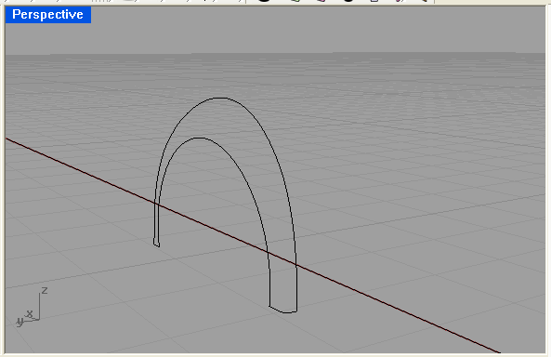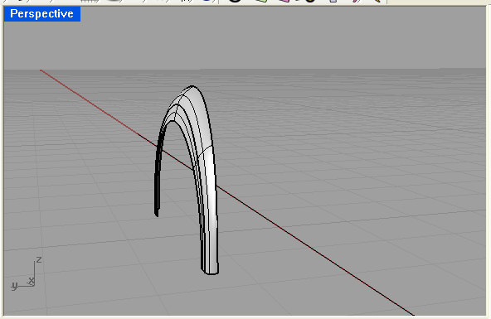

Once these surfaces are created, you can see what it all looks like so far…

.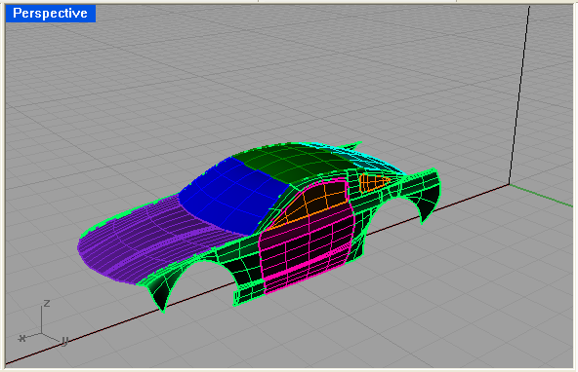

  - The Trunk: To create the trunk, trace it in the top view and adjust the control points to give it some curve so that its not completely flat on the top.

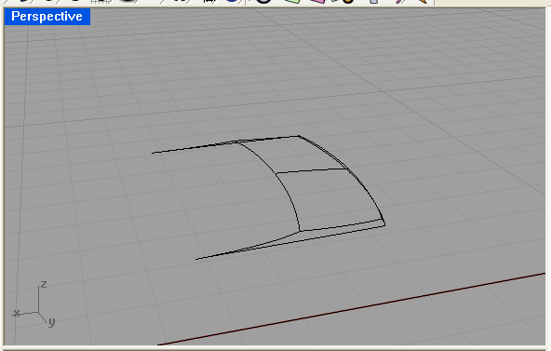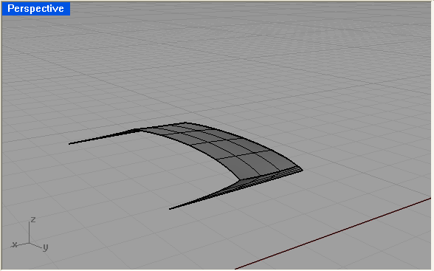

  - Rear ¼ Panel: The rear ¼ panel is tricky because there aren’t many flat surfaces. You want to create a smooth curved surface that joins the side to with the back. To make this, trace the bitmap in the side view, and adjust the control points in the front view to show how much it curves. Adjust the curves to your liking. Mirror each half over the center.
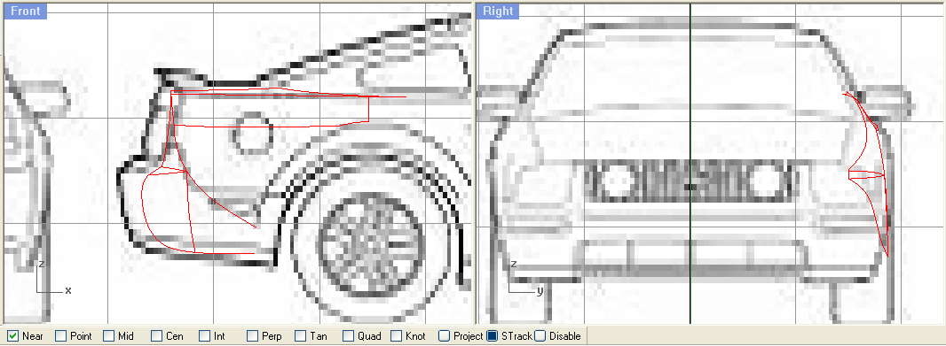
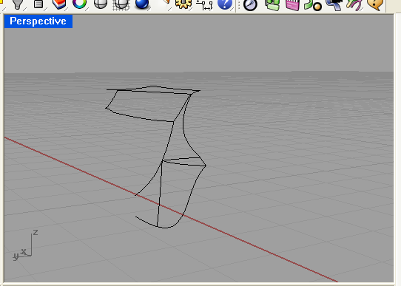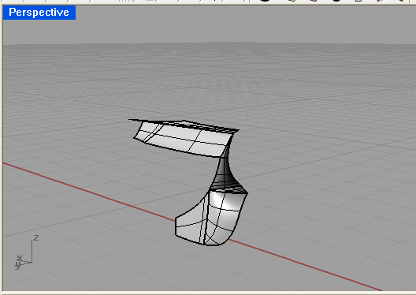

  - The Back Surfaces and Bumper: The Bumper is created by a series of Control Point Curves that join up each of the ¼ panels and the trunk surface. This will not need to be mirrored.
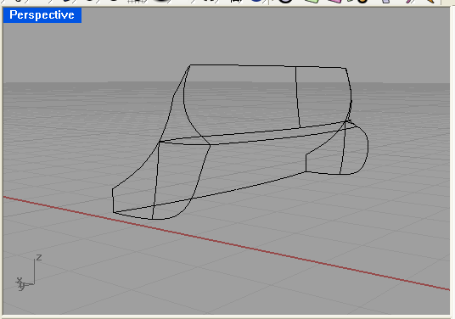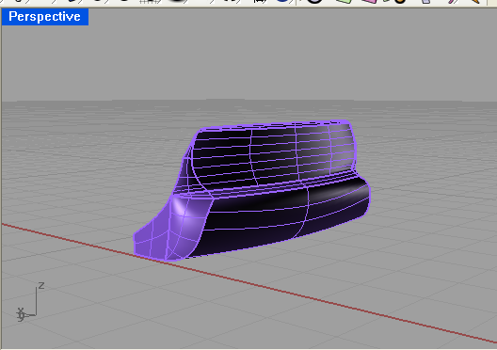

At this point, your model should look like:

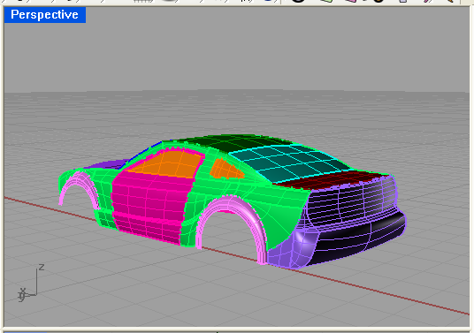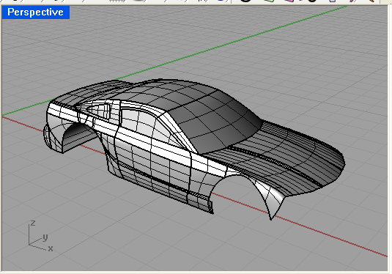

  - The Front: The front is going to consist of a few fairly rectangular surfaces. These surfaces will be mirrored. Trace, in the front view, the front of the car from the bitmap. Adjust the control points as you would for all of the other parts. Use Network surfaces for the rectangular surfaces. Remember, when making the Control Point Curves for pieces that you will be mirroring, make the first control point next to the end point, linear to the end point to ensure a smooth surface.

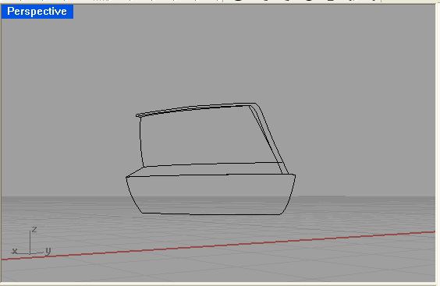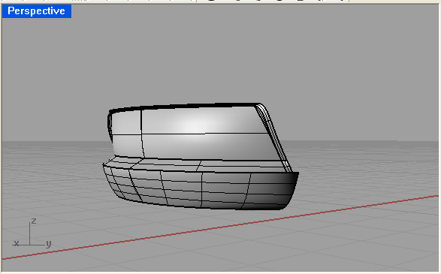

To connect to hood to the front section, I created a series of curves that would act as the front lip of the hood. The highlighted pieces in the following picture show what I’m talking about…
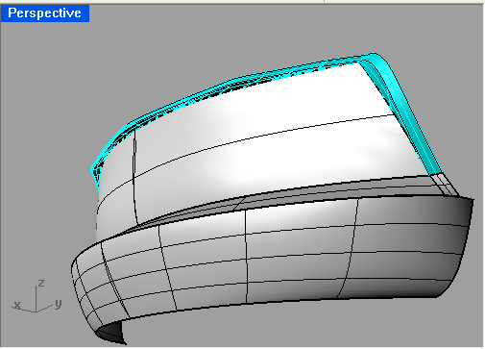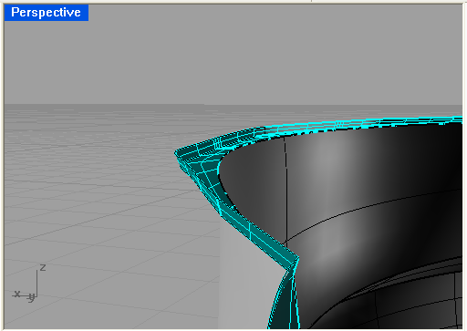

  - Creating the Inner Shell: To make your model a shell (Preferred by Miyoshi), flip the model upside down in the perspective view. Now create a series of regtangular surfaces within the model.
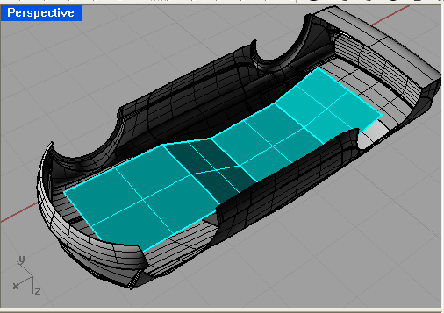

Next, create a series of side walls, just off the interior of the shell. Make sure the shell is thick enough so that it doesn’t break in the printer. You will have to use Network Surfaces for flat rectangular surfaces and Sweep2 for sweeping, irregular surfaces.

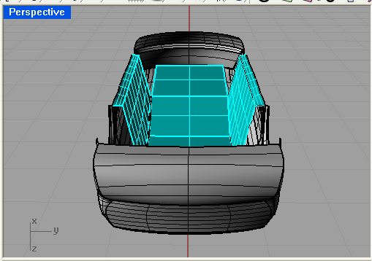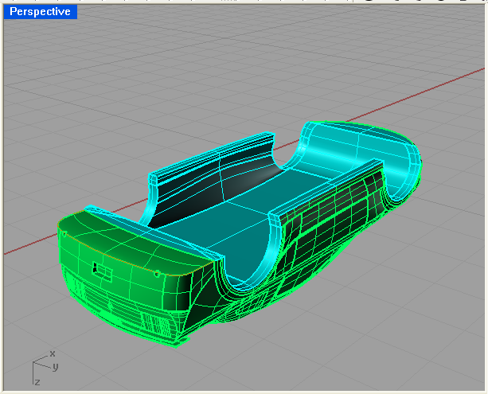

- Adding Detail: Now that the model is a solid, you can move on to adding detail to it. To create details such as the license plate cubby and the lights that bulge and indent, Use the Boolean Union and Boolean Difference controls. To make the light and license plate intents, create a separate solid in the shape of the indent. Ex: for the cubby, you can make a pyramid like shape (without the point at the top). Then drag it to the back area and submerge it into the model. Use the Boolean Difference control to create the license plate cubby. The same can be done for the lights, but use different shapes. To make the indents on the front, such as the lower indent, you need to ceate a solid that flows at the same curve as the model.
    - To do this, you must explode you model and make a copy of the surface that you want the indent on. In the front view, trace the indented area. Create a solid out of the trace by using the extrusion control. Line up the extruded curve so that it sits in the copied surface that you made earlier. Split the copied surface with the solid so you are left with a curved surface. Create a solid out of this. Join the model back together and Boolean Difference it with the model. The Next images are of the rear indent. The same process applies for the front…

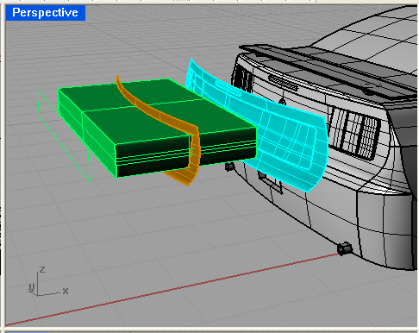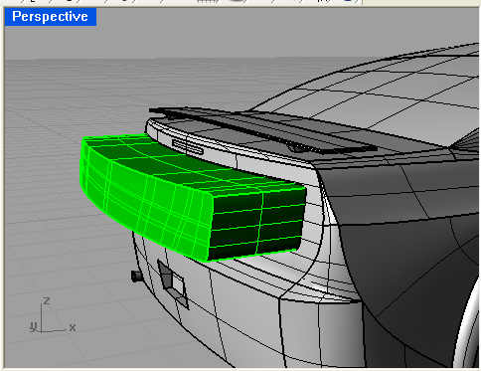

License plate Cubby: Front Light Indents
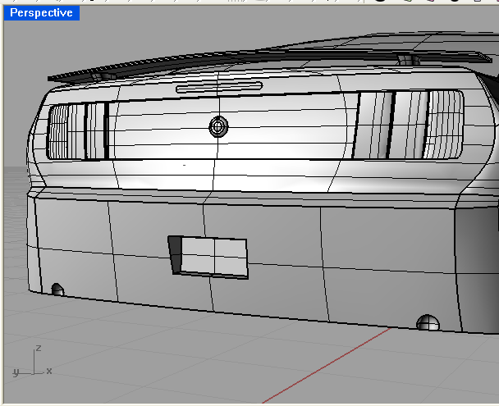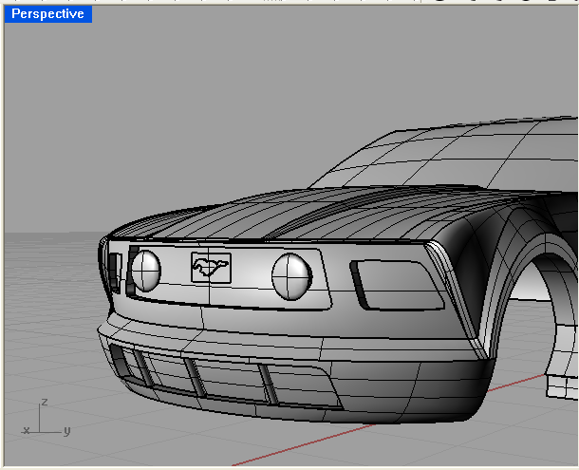

  - Creating Bulbs, Logos and Front Rods:
The Bulbs, logos, and tail lights are all created in the same general way. Just create a solid in the shape you desire (using basic shapes and control points) and Boolean Union them with the model.
    - Front Rods: Explode the model and make a copy of the lower front indent (the highlighted section in the pictures below). Next, create 3 cylinders and cap them. Rotate them to the desired angle. Make sure that they would extend through both ends of the copied section. Then split the rods with the copied surfaces. Move the rods so that they line up with the indented space in the model…

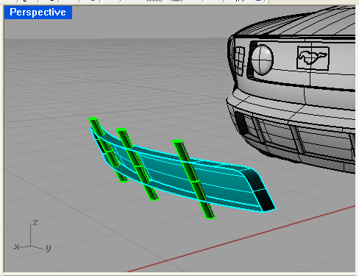

- Rendering:
To Render the model, join up all of the body pieces, (hood roof, sides, front, but not the grills, lights, windows). Once all is selected, go to Object Properties and select Plug Ins. You can select from a variety of Car Paint, colors which gives it a glossy look. Do the same for the windows but instead of selecting car paint, select Glass, and choose from a variety of colors. To get a yellow or red transparent color for the lights, select the plastic option, select, transparent, and then choose red or yellow. You can experiment with different Plug Ins and colors.

  - To create a background and road underneath the car:
- Click Raytrace and select Environment.
- Select background image
- Pick a pre-saved photo of the sky or horizon.
- Also select Ground Plane.
- You can choose one of many cement options.
- Set up your model so that it sits on the ground with the background behind it. To make the yellow lines, I used Photoshop.

- Preparing for 3D Printing

6.1 When preparing for 3D printing, the main thing to watch out for is naked edges. Naked edges are any gap between the surfaces. Throughout the modeling process, you should join all of your surfaces and check for naked edges by selecting Analyze, Edge Tools, Show edges, and select your surfaces.
6.2 To save your model so that it can be printed, save it as an STL. Select SAVE AS, and then select STL. Open Z-Edit in the Start Menu and open your model. Select CHECK MODEL and if there are no bad edges, then you are good to go.

- Conclusion
These are the basic steps to create a 2008 mustang, and virtually any car. The steps will all be the same for creating irregular shapes as well as the steps we applied. You can take these steps and techniques, along with what you have learned and discovered on your own to take your Rhino skills to the next level.

- Appendix

