The following projects are designed to help you become familiar with design software and the design process. You will need to decide which projects to complete and which software to use. Each project has associated project points. The total amount of project points is determined each semester. Students may pick projects to meet their required point total.

Mechanical Projects
Project | Description | Group | Solid Model | Points
Reverse Engineering | Reverse engineer a product. Model an existing product with at least 5 separate pieces. | No | No
Lego | Create a new Lego. It must mate with existing Lego parts. | No | Required | 20 (10 w/o print)
Flashlight | Create a new flashlight. | No | No
Eden | Create a container for anti-aging crème. | No | No
Keychain / Logo | Create an school keychain. Relevant to either a high school or college or other institute of higher learning. (As a rule, simple extrusions fit into this category.) | No | Required | Max 2 per year – one writeup
Jack o’Lantern | Create a jack o’lantern | No | Allowed
New phone | Create a new phone. | No | No
Auto Accessories | Create automotive accessories. Project may earn 10 points per part; up to 12 parts may be created. | Allowed | No | 120 max
Chess | Create new chess pieces. (At least 5 unique pieces must be made.) Project may earn 10 points per unique part. Up to 10 unique parts may be made.) | Allowed | Allowed | 100 max
Shoe | Create a new shoe. | Allowed | Allowed | 40 max
Figurines | Create unique figurines. Up to 10 points per unique figurine can be earned depending on quality. A maximum of 10 figurines can be made for the project. | Allowed | Allowed | 100 max
Class | Groups assemble parts to that get assembled into a single class project to accomplish a goal | Required | Required

Architectural Projects
Project | Description | Group | Solid Model | Points
Residential | Single-Family Dwelling under 2000 square feet | No | No | 20
Residential | Dream house. Get a customer and design a dream home (under 10000 square feet). | No | No | 20-30
Post and Beam | Design a single-family dwelling using post and beam construction. (Use SolidWorks or Revit.) | No | No | 20-40
Commercial | Design a commercial building for a specific purpose. | No | No | 20-40
Eco-Friendly | Design a “Green” home. Make sure that the technology and materials used are friendly to the environment. Use sustainable technology as much as possible. | No | No | 20-40

Miscellaneous Projects
Project | Description | Group | Solid Model | Points
3D Art | Make a piece of 3-Dimensional art that could not be made by conventional means (carving, ceramics, etc.). | No | Required | 20
Interior Design | Design furniture and other furnishings for room(s)/office(s). Total point value for project negotiated before project begins and dependent on complexity. | Allowed | Allowed | 200 max
Video Game Scenes | Design 3D scenes for video games. Total point value for project negotiated before project begins and dependent on complexity. | Allowed | No | 200 max
Video Game Character | Design 3D characters for video games. Total point value for project negotiated before project begins and dependent on complexity. | Allowed | Allowed | 200 max
Other | Other projects must be preapproved by the instructor. The points for project will be negotiated. | Allowed | Dependent on project | 200 max

Software
Beginning students must SolidWorks or Revit to create their models. Advanced students may also choose to use Blender.

Deliverables/Presentation
All projects (including architectural) must have written documentation that discusses the design process and presents the product to potential investors/buyers. Documentation must follow the given template. The documentation will also include sketches, 2D dimensioned drawings, renderings, elevations, sections, and other necessary 2D representations of the project. Projects requiring 3D models must also have a printed version of their product(s). Students must make an oral presentation of at least one of their projects each semester.

Grading
Individuals will receive their points earned for their individual projects. Groups will divide the total points among teammates based on individual performance toward the project. The rubric is based on 40 points and will be normalized to the proper amount of points for the project. Points are based on complexity of projects. Project pieces that are merely extrusions (or extrusions with cut outs) are worth less (usually around 10 points) whereas pieces that are complex solids or surfaces are worth more points. For example, key chains that are mere extrusions are only worth 10 points each unless the figure being extruded is extremely complex. Also, projects that contain pieces that must be assembled can be worth more points than projects that are single pieces. Architectural projects that include more than just walls, roofs, and foundation plans (i.e. HVAC) may receive more points. Students should always negotiate points before projects are started.
Project Examples
The Ultimate Flashlight (T.U. F.) created by Shane Winter (class of 1999, Cedarcrest High School) | 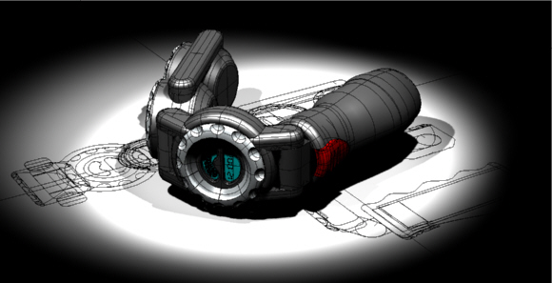
SJ Tri-Dimensional Chess Set created by Jonathan Oakes and Sam Al-Khoury (class of 2002, 2004, respectively, Cedarcrest High School) | 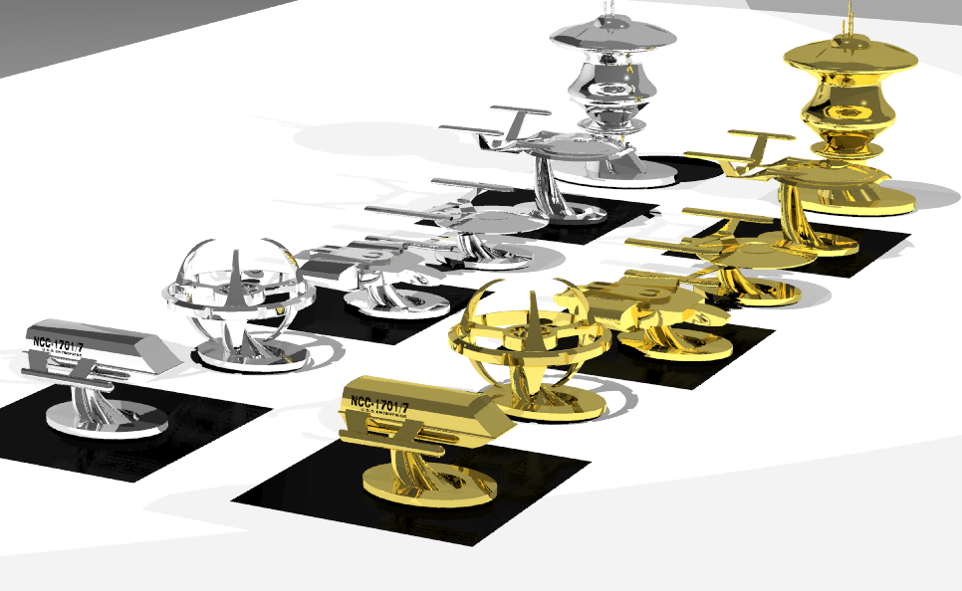
Mech created by Vong Ly (class of 2003, Cedarcrest High School) | 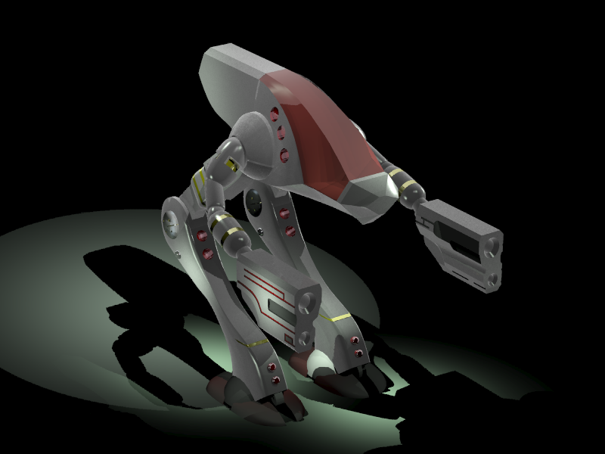
Jack o’ Lantern created by Blake Hellman (class of 2003, Cedarcrest High School) | 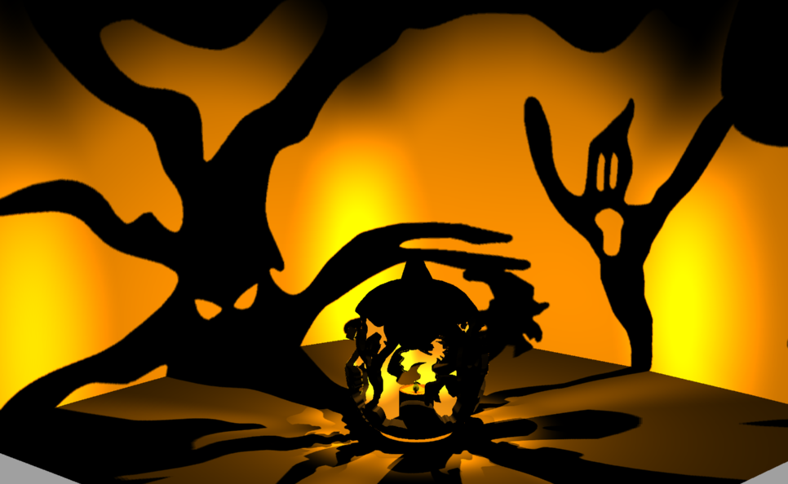
Automobile created by Kyle Head (class of 2003, Cedarcrest High School) | 