Dropping Ball Physics

Cait Hawkins

Miyoshi

1/17/24

**Product Intro:**

Rivalling industry standards, Blender is quickly proving itself as both a free and high-powered 3D software. I sought out to test its physics engine, specifically the “rigid body” property. With this project, I aimed to create a bouncing ball, in which it loops an animation between two tubes, reminiscent of the video game “Super Mario Bros.”. The resulting animation involves physics properties, with both passive and active rigid bodies.

**Product Goals:**

1. *Create a looping animation of the bouncing ball.* A staple in animation is a “bouncing ball” animation, shown to focus on the basic principles of animation and showcase the “squash and stretch”. By translating this medium to 3D, I aim to achieve similar results with the arc and loop of the bouncing ball. This can be measured by judging if the animation is seamless and looping.
2. *Add in keyframe interpolation and easing to keep the rigid body animation within the frame of the camera.* This ensures the overall fluidity of the bouncing ball animation. This can be evaluated by analyzing the movement of the ball, if it stays within frame and keeps to a consistent arc pattern.
3. I*mplement stylized effects to the environment and the ball, adding to the jolly of the animation*. By creating a cute environment, it adds to the animation, rather than keeping it gray and dull, as it appears without materials. This allows for the animation to appeal to a wider audience, the fun colors and background drawing in the eye. This can be evaluated by noting others reactions and opinions on the background and colors of the animation.
4. *Have the ball bounce exactly 3 times into the pipe.* This is to ensure the flow of the animation, not overdoing the bounciness, while keeping it on a path to the pipe. Too much bounce can make the ball overshoot the pipe completely, while too little bounce leaves it falling short of the pipe, simply rolling along the platform.

**Learning Goals:**

1. *Successfully* *configure the rigid body property to apply to the sphere.* It’s always a learning curve with learning different features on Blender, I challenged myself to approach the physics property tab in Blender, more specifically the rigid body. This feature in Blender allows the user to simulate the motion of solid objects in the engine. This is applicable to animation, saving time by having to manually keyframe and figure out the “realistic” look of motion for solid objects, as it’s automatically done with the rigid body property applied.
2. *Add passive rigid body constraints to the objects interacting with the active rigid body.* Without constraints and passive bodies, the active rigid body would literally fall endlessly. By adding these constraints to objects, it allows for there to be motion in the animation. This can be judged by how well the active object interacts and bounces off the objects around it.
3. *Configure the gravity and dynamics of the rigid body to fit the final product.* When first testing the rigid body property, the bouncing ball would go shooting off the second it touched the ground, either bouncing to high or rolling off the platform. By adjusting the rotation dynamics, bounciness, and friction between the passive and active bodies, I could learn to configure a realistic bouncing ball.
4. *Fine-tune and optimize the overall simulation by experimenting with additional parameters such as damping, collision margin, and sensitivity*. Understand the impact of these adjustments on the simulation's realism and stability, aiming to achieve a more accurate and visually appealing representation of physics in the Blender environment.

**Product Achievements:**

1. The animation creates a loop effect, it’s not a true loop because the ball doesn’t end in the same place it starts, but with the pipes it appears to continuously loop. Therefore, I’d consider this product goal successfully achieved. In doing so, I used some of the 12 basic principles of animation in my project.
2. The arcs and interpolation ease into the bouncing. We see the ball stay in frame, keeping the fluidity as the movement and bounciness of the ball appear realistic.
3. By using materials, shaders, and lighting, the scenery had a stylized, cartoonish effect to it. By converting the mesh objects into grease pencil objects, it allowed me more creativity, as I could change the outline color and fill color on objects.
4. Watching the animation and counting the bounces, the ball bounces 3 times before landing on the edge of the pipe and rolling in. Therefore, my product goal was successfully achieved while keeping the arcs and bounces realistic.

**Learning Achievements:**

1. Successfully configured the rigid body property in Blender, demonstrating a solid understanding of it. This achievement involved overcoming the learning curve, the application of the rigid body allowing for simulating object motion and movement, saving the need for manual keyframing and enhancing the realism.
2. Added passive rigid body constraints to objects interacting with the active rigid body. I applied this property to the ground, ramp, and the last pipe in the scene. I originally applied it to the first pipe in the upper left corner, however it interfered with the balls path of travel, and I couldn’t alter it without losing the pathway and number of bounces, therefore I had to sacrifice one part of this goal in order to achieve other goals.
3. Successfully configured the gravity and dynamics of the rigid body to achieve a desired final product. Initially facing issues with the bouncing ball going off uncontrollably, I had to adjust the rotation dynamics, bounciness, and friction between passive and active bodies. These factors contributed to my understanding of a realistic bouncing ball.
4. Demonstrated fine-tuning abilities to optimize the overall simulation by experimenting with different properties such as damping, collision margins, and sensitivity. I aimed to achieve a deeper than surface level understanding of the physics property in Blender.

**Process:**

Create a simple 3D model of the background to give a sense of environment and parameters. Used Cubes and cylinders to create the ground and the pipes.

Sketch out the arcs for the bouncing ball

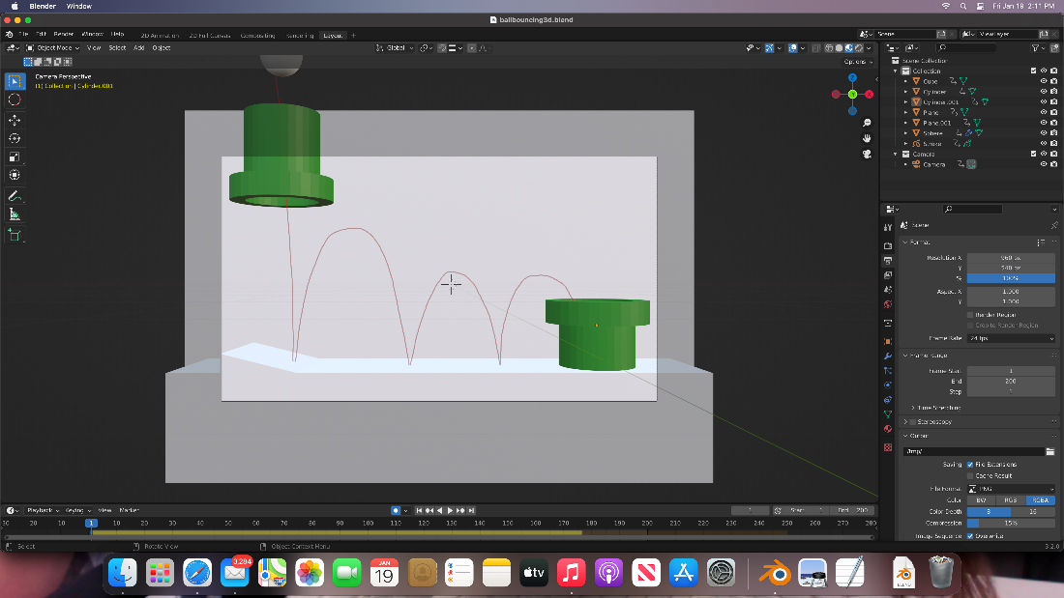

Apply the rigid body physics property to a sphere, using these parameters to affect it.

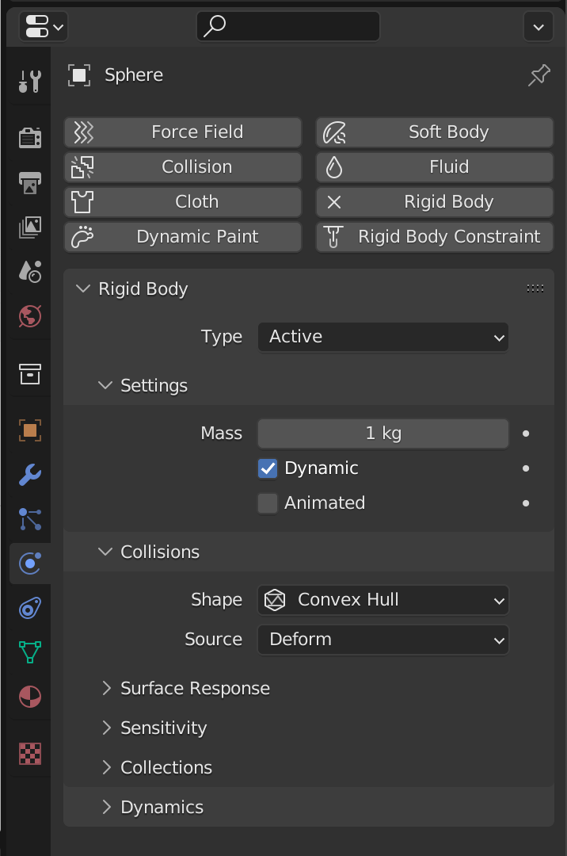

Apply to the ground where the cube will be bouncing off a passive rigid body property.

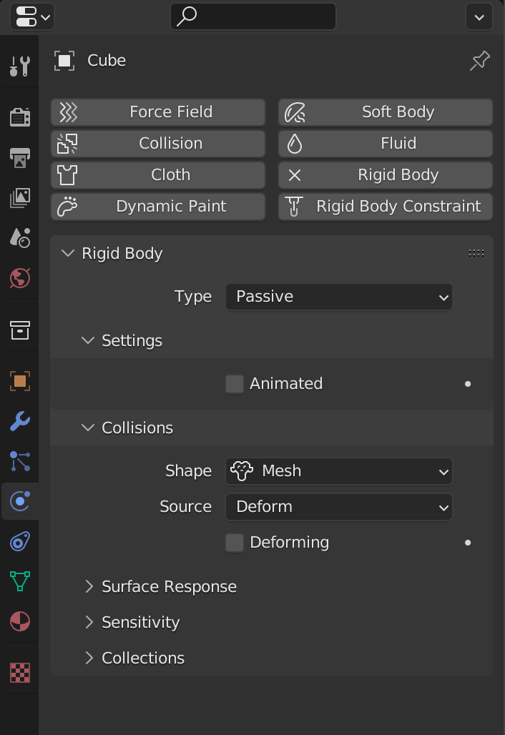

Create a ramp with the same property as the ground applied to give the ball an arc.

Apply the same passive constraint to the final pipe, allowing the ball to pass through it.

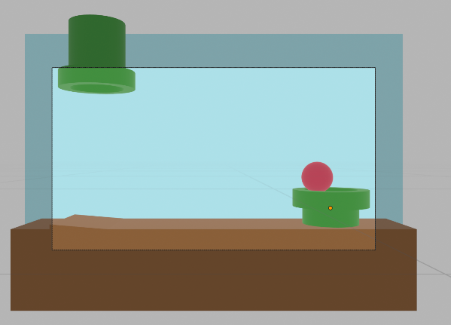

**Drawings/Models/3D Prints/ Programs**

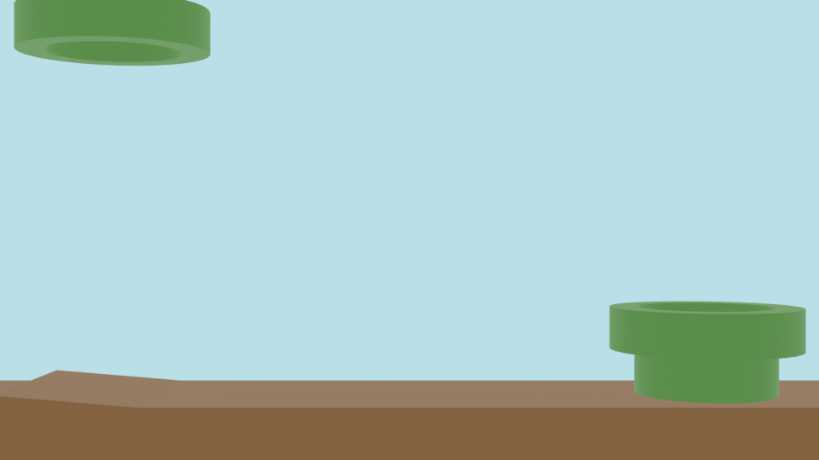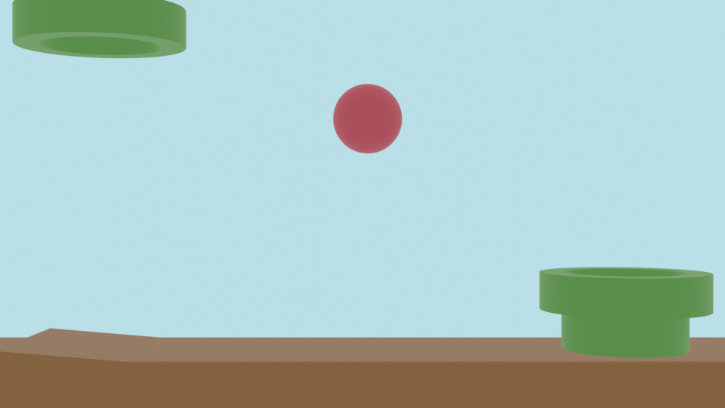

Design Document Rubric

|  |  |  |  |  |  |
| --- | --- | --- | --- | --- | --- |
|  | Level | | | | |
| Element | 0-No evidence | 1-Little evidence | 2-Some evidence | 3-Evidence | 4-Ample evidence |
| 1. Product intro  2. (2x)  3. Conventions  4. (2x) | None of the four required elements are present | Writing conventions are somewhat followed. | Writing conventions are nearly always followed. | Product is somewhat introduced. | Product is introduced with enough detail for reader to understand what is being designed. |
| Product Goals (What do you want to accomplish?) | No written documentation. | At least one product goal is identified and described. | At least two product goals are identified and described. | At least three product goals are identified and described. | At least four product goals are identified and described in detail of how the student will measure that they have been accomplished. |
| Learning goals (What do you want to learn?) | No written documentation. | At least one learning goal is identified and described. | At least two learning goals are identified and described. | At least three learning goals are identified and described. | At least four learning goals are identified and described in detail of how the student will measure that they have been accomplished. |
| Product achievements (What did you accomplish?) | No written documentation. | At least one achievement has been met and documented. | At least two achievements have been met and documented. | At least three achievements have been met and documented. | At least four achievements have been met and documented. Documentation is specific and detailed on how the goals have been met. |
| Learning achievements (What did you learn?) | No written documentation. | At least one achievement has been met and documented. | At least two achievements have been met and documented. | At least three achievements have been met and documented. | At least four achievements have been met and documented. Documentation is specific and detailed on how the goals have been met. |
| Process | No written documentation. | The design and learning process is described with little detail. | The design and learning process is described with some detail. | The design and learning process is described with ample detail. | The design and learning process is described with ample detail in such a way that readers can learn from the written document and any accompanying materials. |
| Drawings / Models / 3D Prints / Programs (4x) | No Drawings / Models / 3D Prints / Programs. | Little progress on Drawings / Models / 3D Prints / Programs. | Some progress on Drawings / Models / 3D Prints / Programs. | Drawings / Models / 3D Prints / Programs are adequate evidence to demonstrate learning and product goals have been met. | Drawings / Models / 3D Prints / Programs are ample evidence to demonstrate learning and product goals have been met and/or exceeded. |
| Final Score (out of 40) and Grade. | Does not meet standards | Can meet standards with help | Somewhat to mostly meets standards | Meets standards | Exceeds standards |

Include this rubric with your design document.

The design document may be formatted according to the student’s liking. However, please use a font no larger than 12 point. Fonts with serifs are somewhat easier to read.