Is There a Mask on Your Face?

Brian Tonnies, Baxter Brown, & Michael McGaw

COVID-19, otherwise known as SARS-CoV-2 or *the* Coronavirus, has a world-wide

death-toll of 1.04 million and over two hundred thousand lives in the United States of America have fallen victim to it [2]. Our project, *Is There a Mask on Your Face?*, looks to see if We the People are doing our part to prevent the tolls from getting any higher: checking for masks. According to a study at U.C Davis, masks cut your own risk of getting the virus by 65% as well as limit the vectors that you may spread COVID-19 if you are unfortunate enough to have it [3].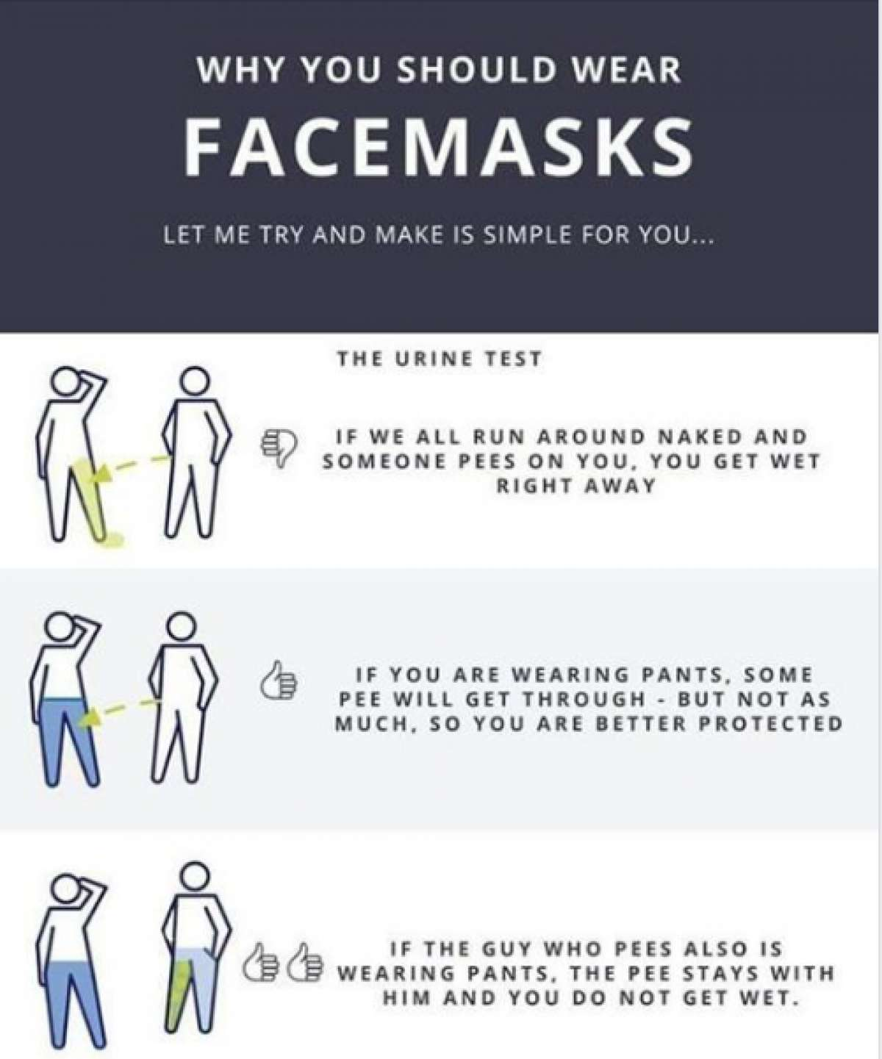

Using Neural Networks, Google and home-grown ingenuity, our neural network’s are going to predict whether your face has a mask utilizing a dataset of over one hundred thousand images of people with and without masks [4]. What we’ll attempt to do is create a supervised classification Neural Network, where our model will process an image utilizing Convolutional Nets, recognize what a face is and to finally determine if the person is wearing a mask using color-transitions and depths as heuristics. This project can be turned into something of a Litmus test to determine the decency of a person: given the efficacy of wearing a mask in the reduction of transmission/spread of COVID-19, can we identify those not wearing masks in the interest of “flattening the curve” and/or profiling problematic individuals?

### Bibliography:

[1] N. Bai. Still Confused About Masks? Here’s the Science Behind How Face Masks Prevent Coronavirus. (June 26, 2020). Retrieved October 4, 2020 from <https://bit.ly/3ir8YT3>

[2] *Coronavirus Death Toll*. <https://www.worldometers.info/coronavirus/coronavirus-death-toll/.>

[3] Fell, A., & Staff, D. (2020, July 10). *Your Mask Cuts Own Risk by 65 Percent*. UC Davis. https://www.ucdavis.edu/coronavirus/news/your-mask-cuts-own-risk-65-percent/.

[3] Cabani, A., & Hammoud, K. *cabani/MaskedFace-Net*. https://github.com/cabani/MaskedFace-Net.