IMPLANT SURGERY REPORT

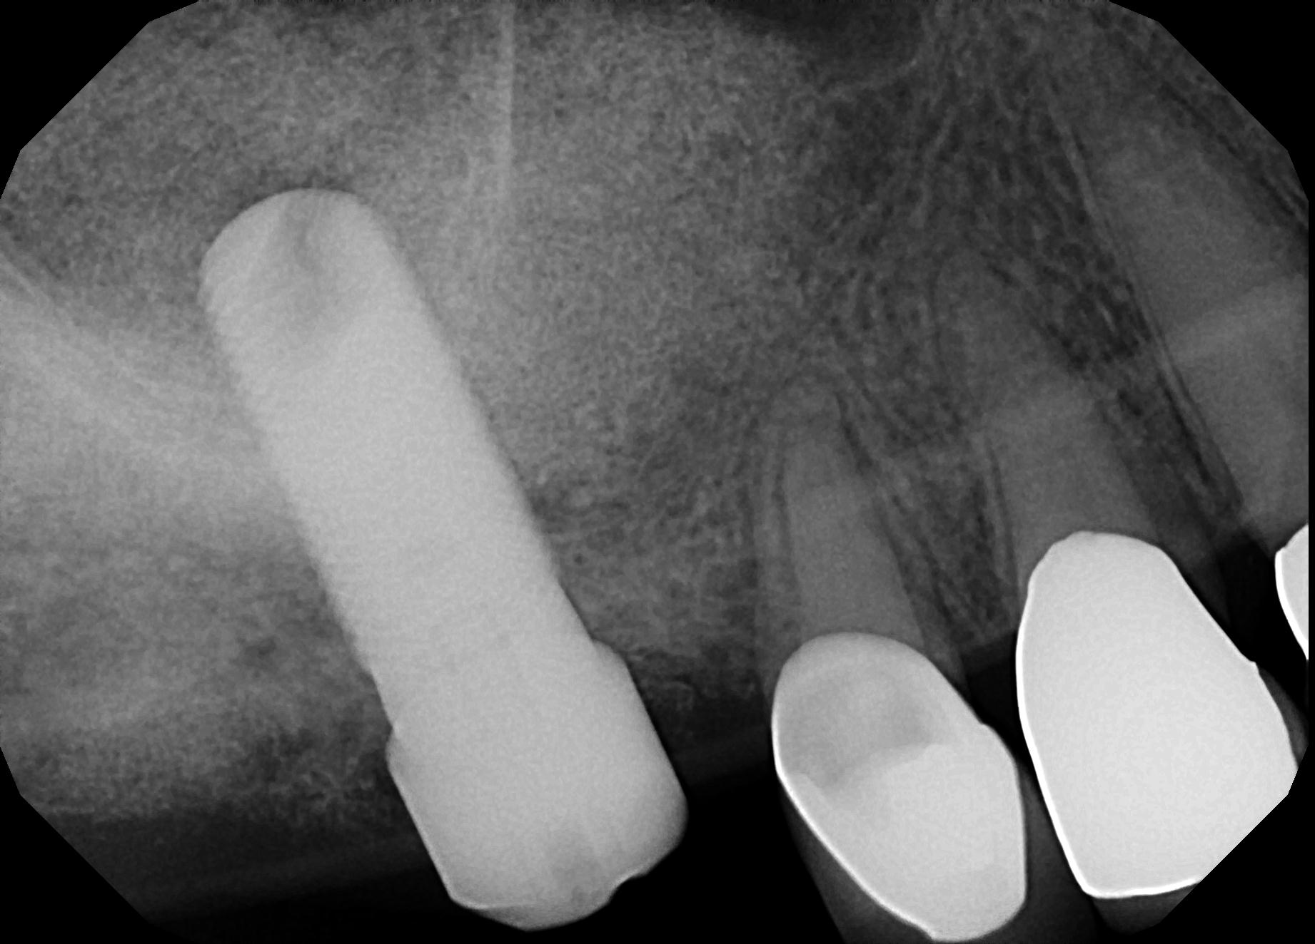

**Patient: «patient» (Chart# «chart»)**

**Surgeon: «surgeon»**

**Date: «date»**

**Uncover: «uncover_date»**

**Restore:** **«restore_date»**

**IMPLANT TYPE:**

**«implant»**

**«healing_cap»**

**RESTORATIVE PART TO ORDER:**

**«restorative_parts»**

**REPORT:**

**«report»**

**«restore»**



**Please Recycle:** Please return your healing caps to us. We only want Zimmer Encodes and NobelBiocare conical connection metal healing caps. We will reimburse $10 for each returned healing cap. Thank you

**Anesthetic: «anesthetic»**

**Patient Tolerance: «tolerance»**

**Rx: «prescriptions»**