Name: Viernes, Michael E. Grade & Section: MAWD 401 Date: 4/7/2021

**Steps**

1. Showing creation of tables and data within.

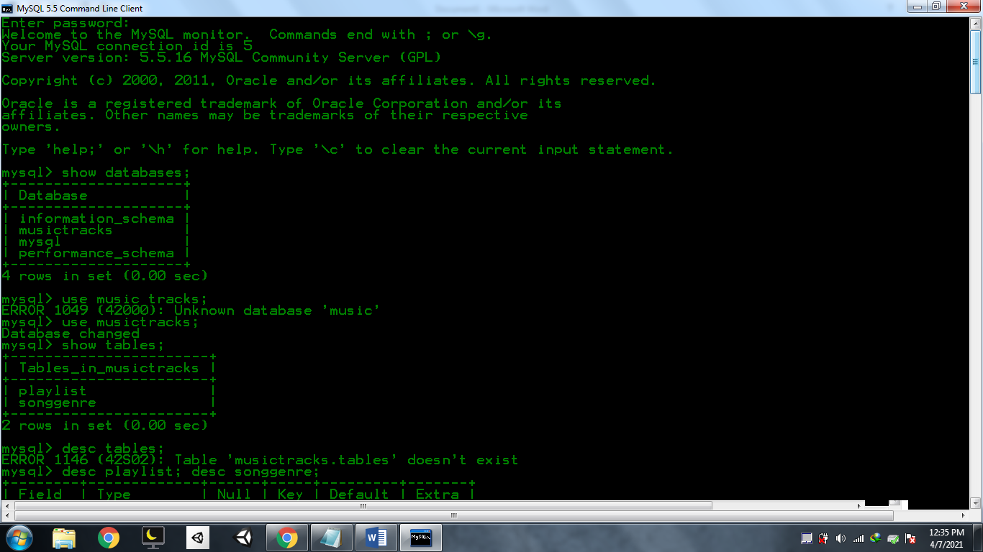

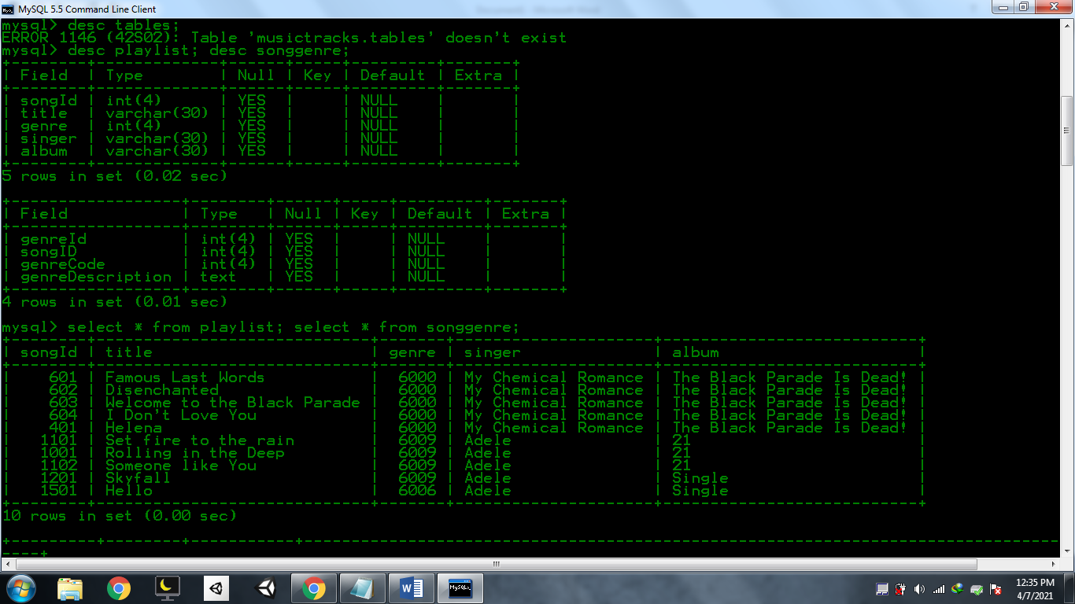

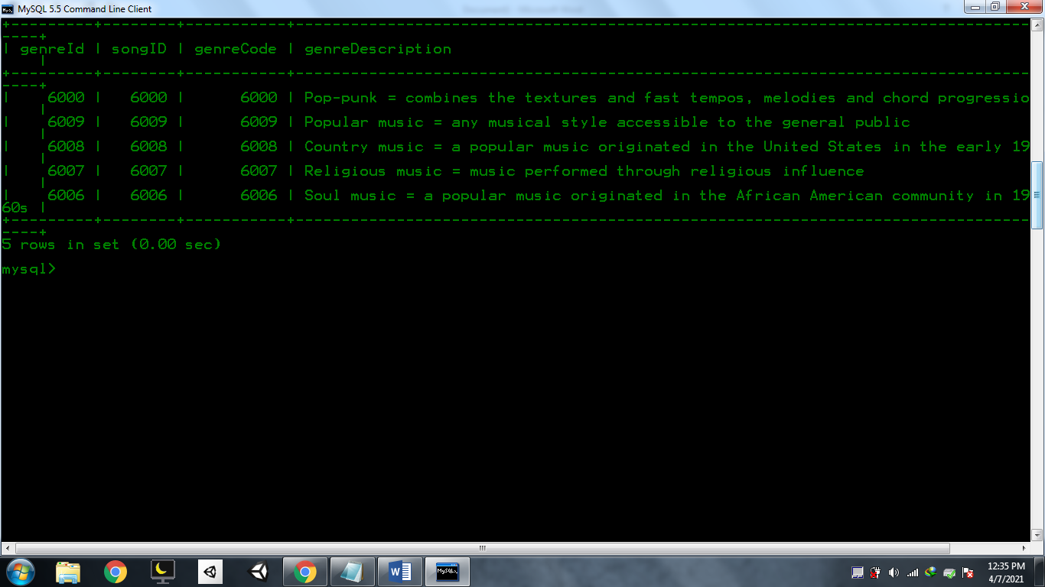

2. Joining the tables.

INNER JOIN

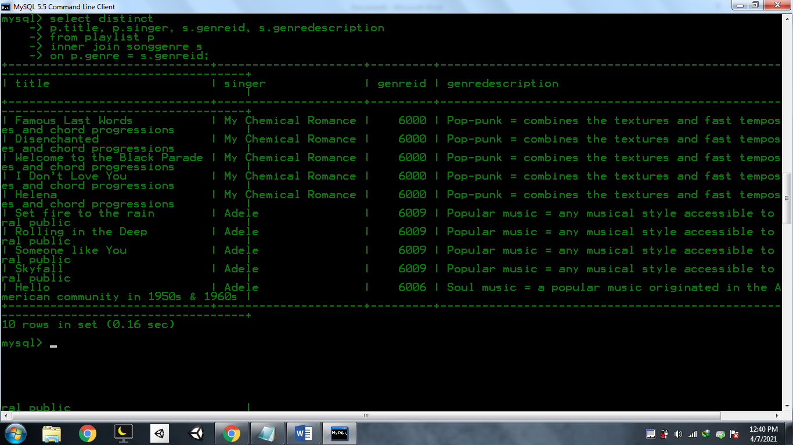

LEFT JOIN

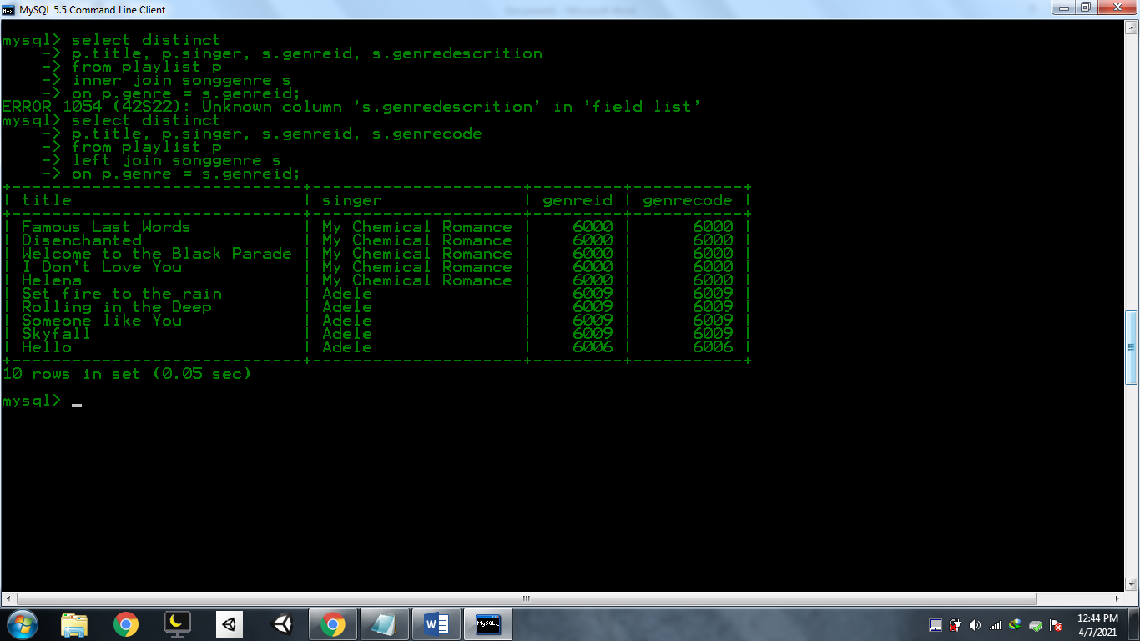

RIGHT JOIN

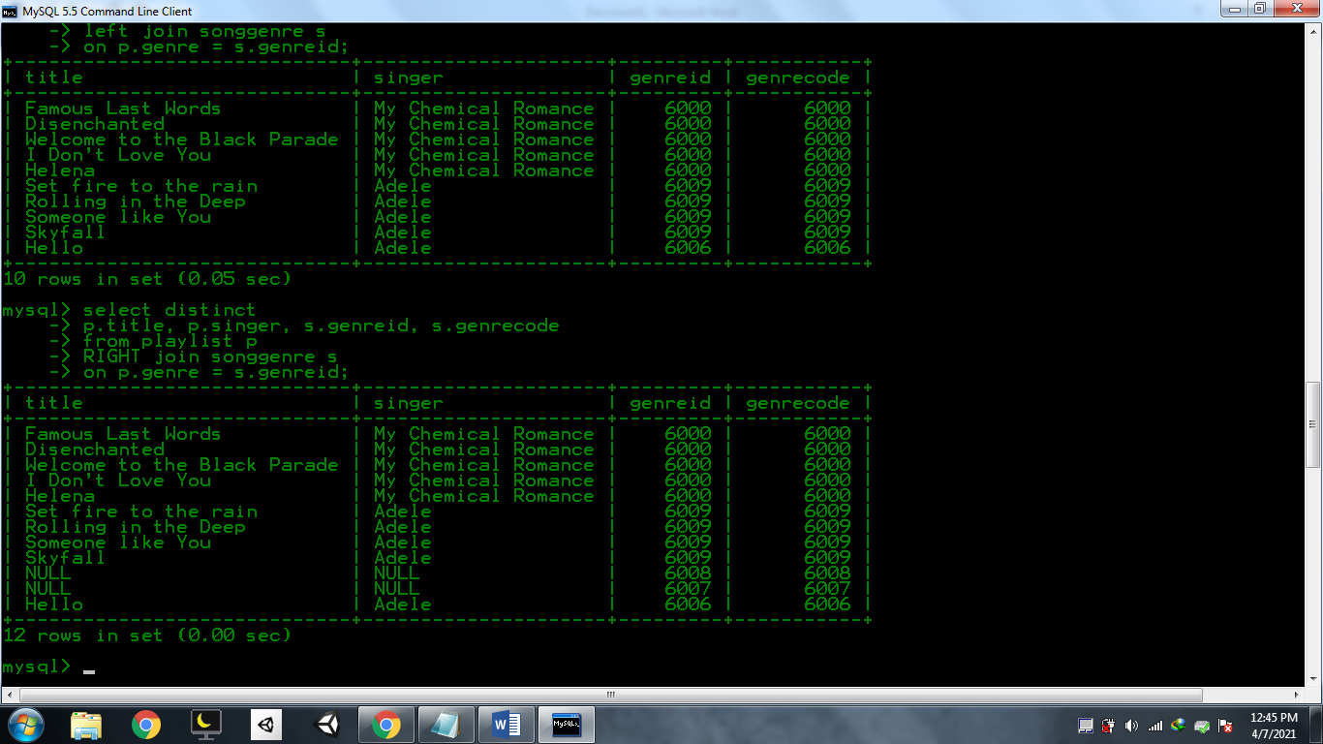

RIGHT JOIN BUT NOT NULL SINGER

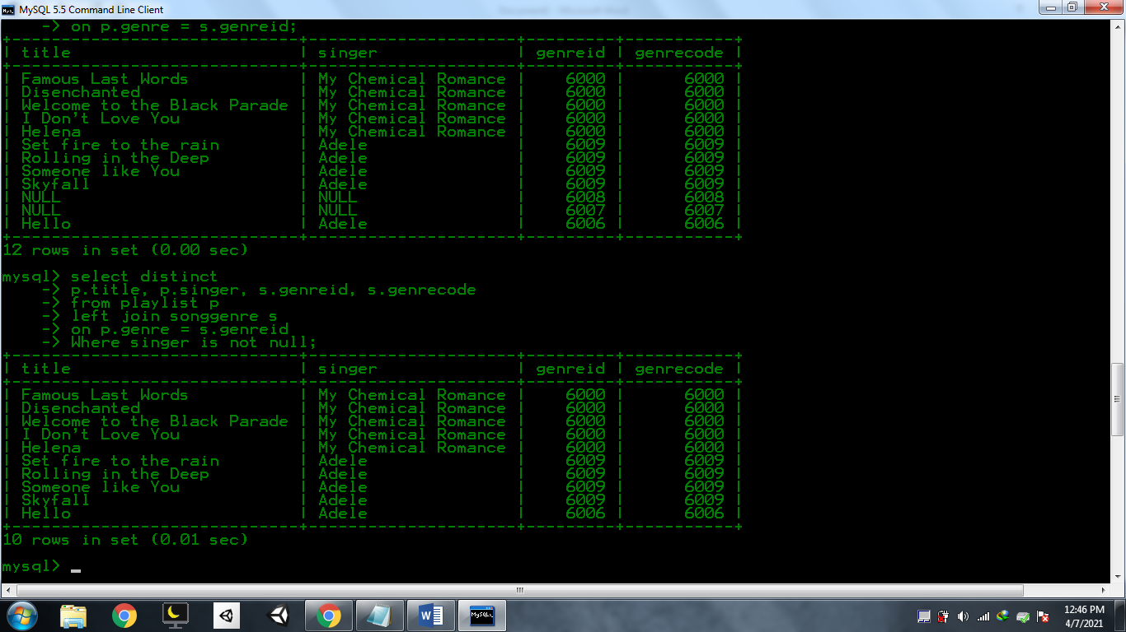

Signnificance of Joining tables:

It allows the sharing of data from one table to another. It reduces redundancies of data being inserted and created in multiple tables. Assigning them as primary keys and foreign keys are solution under the hood.

Music genres:

6000. Pop-punk (also known as punk-pop) is a rock music genre that combines the textures and fast tempos of punk rock with the melodies and chord progressions of power pop and pop music.

6009. Popular music is any musical style accessible to the general public and disseminated by the mass media.

6008. Country music, also known as country and western (or simply country) and hillbilly music, is a genre of popular music that originated in the southern United States in the early 1920s.

6007. Religious music (also sacred music) is music performed or composed for religious use or through religious influence. Gospel, spiritual, and Christian music are examples of religious music.

6006. Soul music (often referred to simply as soul) is a popular music genre that originated in the African American community throughout the United States in the 1950s and early 1960s.

Singer/Band: My Chemical Romance

Album: The Black Parade Is Dead!

Songs:

Famous Last Words 0601

Disenchanted 0602

Welcome to the Black Parade 0603

I Don't Love You 0604

Helena 0401

Singer/Bad: Adele

Album:21

Songs: Set fire to the rain 1101

Rolling in the Deep 1001

Someone like You 1102

Album: none

Skyfall 1201

Hello 1501

Inserted values in songGenre:

(6000, 6000, 6000,"Pop-punk = combines the textures and fast tempos, melodies and chord progressions"),

(6009, 6009, 6009, "Popular music = any musical style accessible to the general public"),

(6008, 6008, 6008, "Country music = a popular music originated in the United States in the early 1920s"),

(6007, 6007, 6007, "Religious music = music performed through religious influence"),

(6006, 6006, 6006, "Soul music = a popular music originated in the African American community in 1950s & 1960s");

Inserted values in playlist:

(0601, "Famous Last Words", 6000, "My Chemical Romance", "The Black Parade Is Dead!"),

(0602, "Disenchanted", 6000, "My Chemical Romance", "The Black Parade Is Dead!"),

(0603, "Welcome to the Black Parade", 6000, "My Chemical Romance", "The Black Parade Is Dead!"),

(0604, "I Don't Love You", 6000, "My Chemical Romance", "The Black Parade Is Dead!"),

(0401, "Helena", 6000, "My Chemical Romance", "The Black Parade Is Dead!"),

(1101, "Set fire to the rain", 6009, "Adele", "21"),

(1001, "Rolling in the Deep", 6009, "Adele", "21"),

(1102, "Someone like You", 6009, "Adele", "21"),

(1201, "Skyfall", 6009, "Adele", "21"),

(1501, "Hello", 6006, "Adele", "21");