Here are the pictures of my work.

1. Success for creation of tables.

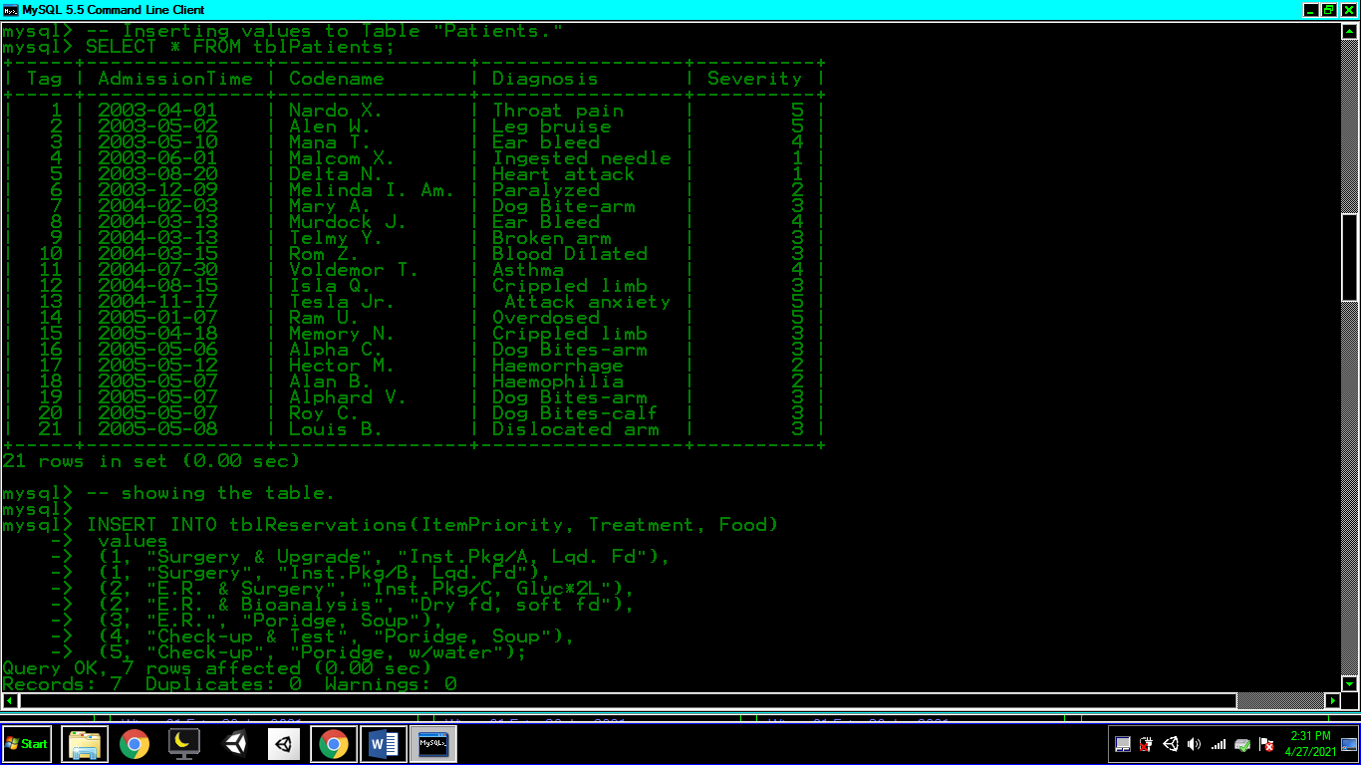

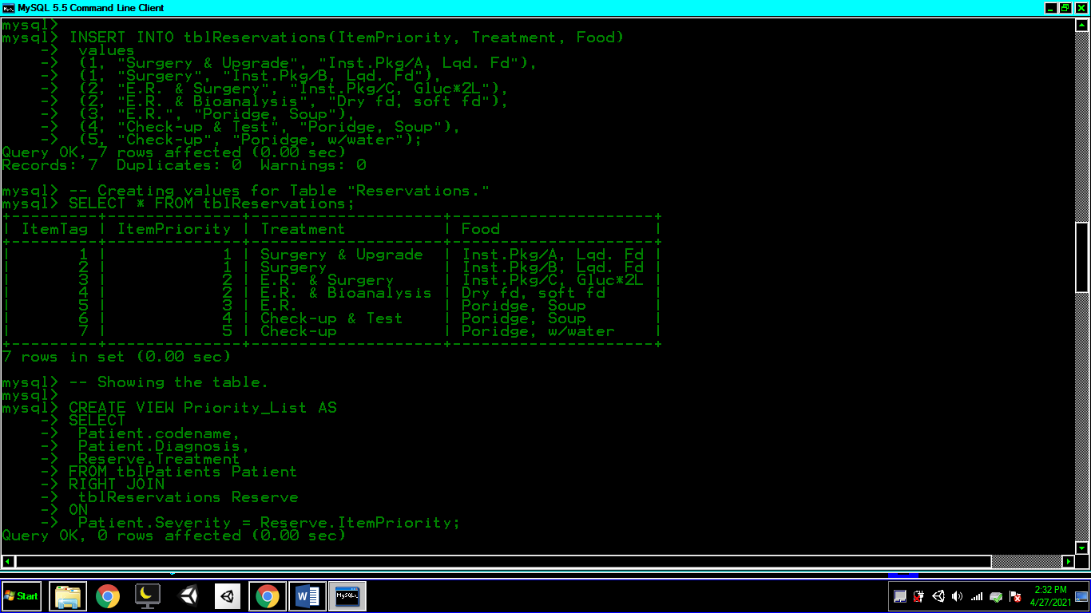

2. Success for creation of views.

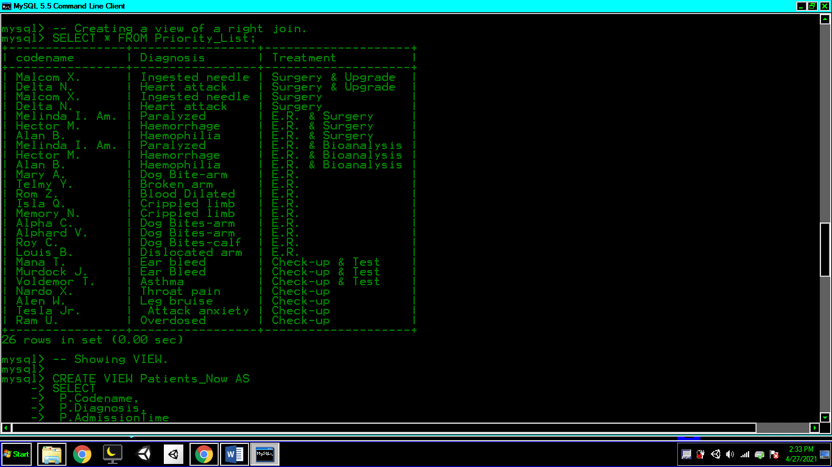

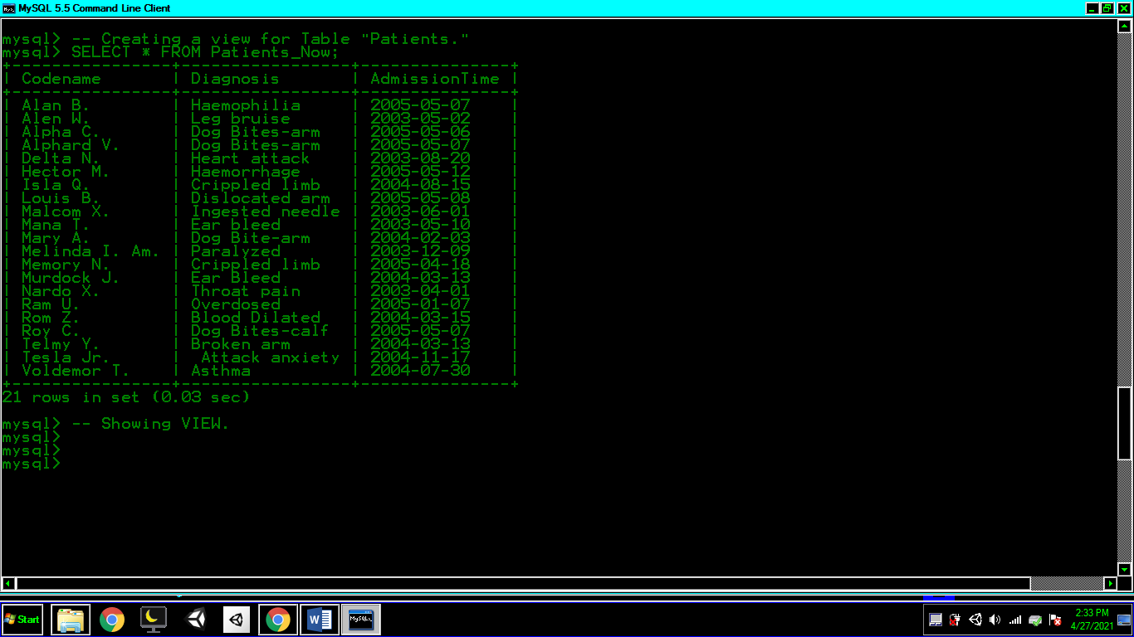

-- MY CODES FOR MYSQL.

*SHOW DATABASES;*

*CREATE DATABASE dtbPatients;*

*USE dtbPatients;*

*-- Creating and using a database;*

*SHOW TABLES;*

*CREATE TABLE tblPatients*

*(Tag INT(2) NOT NULL AUTO_INCREMENT PRIMARY KEY, AdmissionTime DATE,*

*Codename VARCHAR(15), Diagnosis VARCHAR(15), Severity INT(1) DEFAULT 1);*

*CREATE TABLE tblReservations*

*(ItemTag INT(2) AUTO_INCREMENT PRIMARY KEY, ItemPriority INT(1) DEFAULT 1, Treatment VARCHAR(20), Food VARCHAR(20) DEFAULT “Porridge”);*

*SHOW TABLES;*

*-- Creating and showing a table.*

*INSERT INTO tblPatients(AdmissionTime, Codename, Diagnosis, Severity)*

*values*

*("03-04-01", "Nardo X.", "Throat pain", 5),*

*("03-05-02", "Alen W.", "Leg bruise", 5),*

*("03-05-10", "Mana T.", "Ear bleed", 4),*

*("03-06-01", "Malcom X.", "Ingested needle", 1),*

*("03-08-20", "Delta N.", "Heart attack", 1),*

*("03-12-09", "Melinda I. Am.", "Paralyzed", 2),*

*("04-02-03", "Mary A.", "Dog Bite-arm", 3),*

*("04-03-13", "Murdock J.", "Ear Bleed", 4),*

*("04-03-13", "Telmy Y.", "Broken arm", 3),*

*("04-03-15", "Rom Z.", "Blood Dilated", 3),*

*("04-07-30", "Voldemor T.", "Asthma", 4),*

*("04-08-15", "Isla Q.", "Crippled limb", 3),*

*("04-11-17", "Tesla Jr.", " Attack anxiety", 5),*

*("05-01-07", "Ram U.", "Overdosed", 5),*

*("05-04-18", "Memory N.", "Crippled limb", 3),*

*("05-05-06", "Alpha C.", "Dog Bites-arm", 3),*

*("05-05-12", "Hector M.", "Haemorrhage", 2),*

*("05-05-07", "Alan B.", "Haemophilia", 2),*

*("05-05-07", "Alphard V.", "Dog Bites-arm", 3),*

*("05-05-07", "Roy C.", "Dog Bites-calf", 3),*

*("05-05-08", "Louis B.", "Dislocated arm", 3);*

*-- Inserting values to Table "Patients."*

*SELECT * FROM tblPatients;*

*-- showing the table.*

*INSERT INTO tblReservations(ItemPriority, Treatment, Food)*

*values*

*(1, “Surgery & Upgrade”, “Inst.Pkg/A, Lqd. Fd”),*

*(1, “Surgery”, “Inst.Pkg/B, Lqd. Fd”),*

*(2, “E.R. & Surgery”, “Inst.Pkg/C, Gluc*2L”),*

*(2, “E.R. & Bioanalysis”, “Dry fd, soft fd”),*

*(3, “E.R.”, “Poridge, Soup”),*

*(4, “Check-up & Test”, “Poridge, Soup”),*

*(5, “Check-up”, “Poridge, w/water”);*

*-- Creating values for Table “Reservations.”*

*SELECT * FROM tblReservations;*

*-- Showing the table.*

*CREATE VIEW Priority_List AS*

*SELECT*

*Patient.codename,*

*Patient.Diagnosis,*

*Reserve.Treatment*

*FROM tblPatients Patient*

*RIGHT JOIN*

*tblReservations Reserve*

*ON*

*Patient.Severity = Reserve.ItemPriority;*

*-- Creating a view of a right join.*

*SELECT * FROM Priority_List;*

*-- Showing VIEW.*

*CREATE VIEW Patients_Now AS*

*SELECT*

*P.Codename,*

*P.Diagnosis,*

*P.AdmissionTime*

*FROM tblPatients P*

*WHERE*

*P.Codename IS NOT NULL*

*GROUP BY Codename ASC;*

*-- Creating a view for Table “Patients.”*

*SELECT * FROM Patients_Now;*

*-- Showing VIEW.*