1. I added the rids attribute to the wrangler’s create child event. This argument was set to a list of all the rules I wanted to have installed on the child pico.
2. I updated their profile after receiving a child initialized event from the wrangler.
3. I used C Sharp (with the Rest Sharp library) to send http requests to the Pico engine (see github).
4. You could allow the picos to access a list of other picos on the sensor collection pick and then use the sky query function to access a shared function on a different sensor pico.

Diagram:

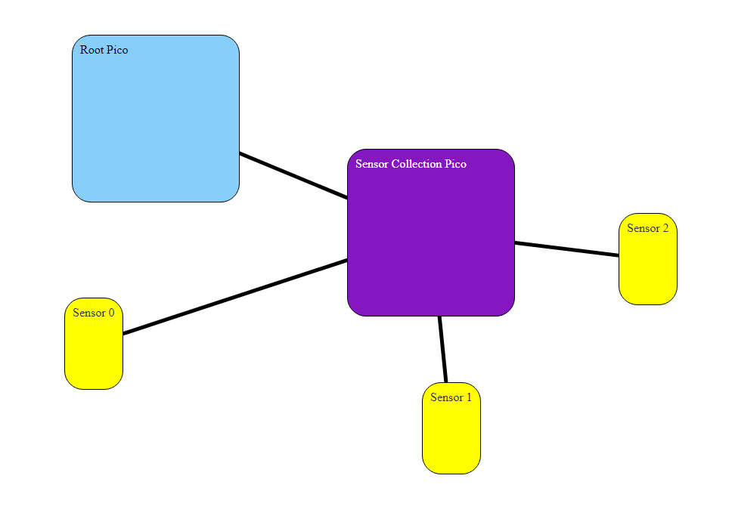

URL: https://github.com/MichaelWGibson/CS-462-Lab-6