Simple Airline Management System (SAMS)

CS 4400: Introduction to Database Systems Course Project: Fall 2023 Semester

# Examples of View Data for the Course Project: Phase 3

## -- [14] flights_in_the_air()

This view describes where flights that are currently airborne are located. We need to display what airports these flights are departing from, what airports they are arriving at, the number of flights that are flying between the departure and arrival airport, the list of those flights, the earliest and latest arrival times for the destinations and the list of planes (by the location id) flying these flights.

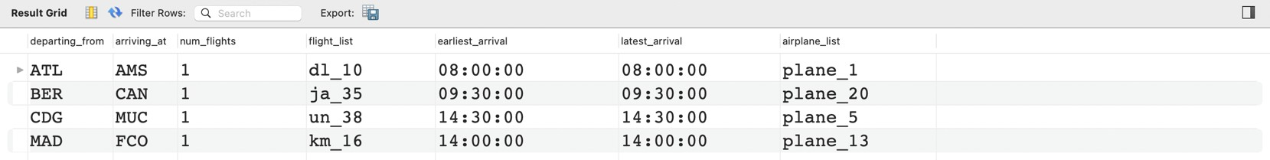

## -- [15] flights_on_the_ground()

This view describes where flights that are currently on the ground are located. We need to display what airports these flights are departing from, how many flights are departing from each airport, the list of flights departing from each airport, the earliest and latest arrival time amongst all of these flights at each airport, and the list of planes (by their location id) that are departing from each airport.

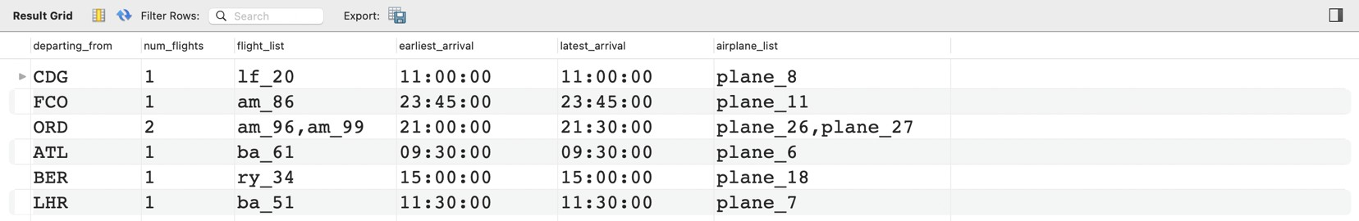

## -- [16] people_in_the_air()

This view describes where people who are currently airborne are located. We need to display what airports these people are departing from, what airports they are arriving at, the list of planes (by the location id) flying these people, the list of flights these people are on, the earliest and latest arrival times of these people, the number of these people that are pilots, the number of these people that are passengers, the number of people on the airplane, and the list of these people by their person id.

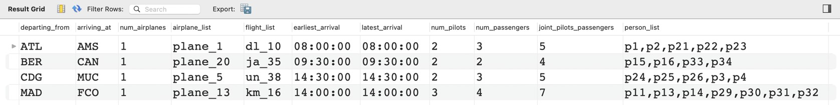

## -- [17] people_on_the_ground()

This view describes where people who are currently on the ground are located. We need to display what airports these people are departing from by airport id, location id, and airport name, the city and state of these airports, the number of these people that are pilots, the number of these people that are passengers, the number people at the airport, and the list of these people by their person id.

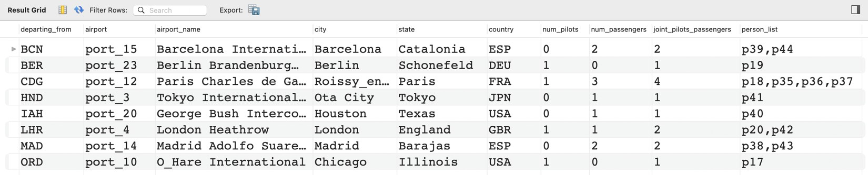

## -- [18] route_summary()

This view will give a summary of every route. This will include the routeID, the number of legs per route, the legs of the route in sequence, the total distance of the route, the number of flights on this route, the flightIDs of those flights, and the sequence of airports visited by the route.

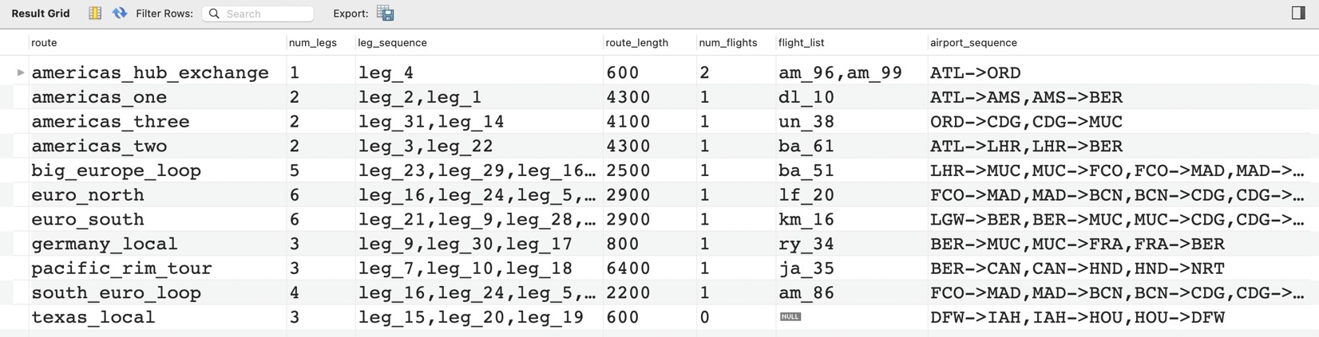

## -- [19] alternative_airports()

This view displays airports that share the same city and state. It should specify the city, state, the number of airports shared, and the lists of the airport codes and airport names that are shared.

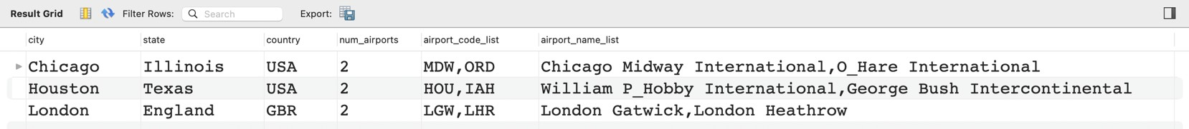

# Version History

|  |  |  |
| --- | --- | --- |
| **Version** | **Date** | **Notes** |
| 0 | September 12, 2023 | Initial Release |