CSE 6140 / CX 4140

Computational Science & Engineering Algorithms Homework 3

**Please type in all answers.**

1. (10 points) What is the running time of the breadth-first search if we represent its input graph by an adjacency matrix and modify the algorithm to handle this form of input?
2. (25 points) Consider a two-dimensional piece of land consisting of a number of towns. Consider a virus spreading across these towns.

We are given an *m × n* array that represents this land. Each element in the array has one of three values:

* 1. represents empty land
  2. represents an uninfected town
  3. represents a town infected by the virus

Every day, an uninfected town adjacent to an infected town becomes infected. Here, adjacent means left, right, up, or down (not diagonal).

Provide the pseudocode of an algorithm that finds the number of days until each town becomes infected.

The algorithm should return an array of *days* where *days*[*i*] is the number of days until town *i* becomes infected. If town *i* never gets infected, *days*[*i*] should equal -1.

1. (25 points) You are a hiker preparing for an upcoming hike. You are given heights, a 2D array of size rows x columns, where heights[row][col] represents the height of the cell (row, col). You are situated in the top-left cell (0, 0), and you want to travel to the bottom-right cell (rows-1, columns-1) (i.e., 0-indexed). You can move up, down, left, or right, and you wish to find a route requiring minimum effort.

A route’s effort is the maximum absolute difference in heights between two consecutive cells of the route. Example in the figure below.

Provide the pseudocode of an algorithm that returns the minimum effort required to travel from the top-left cell to the bottom-right cell.

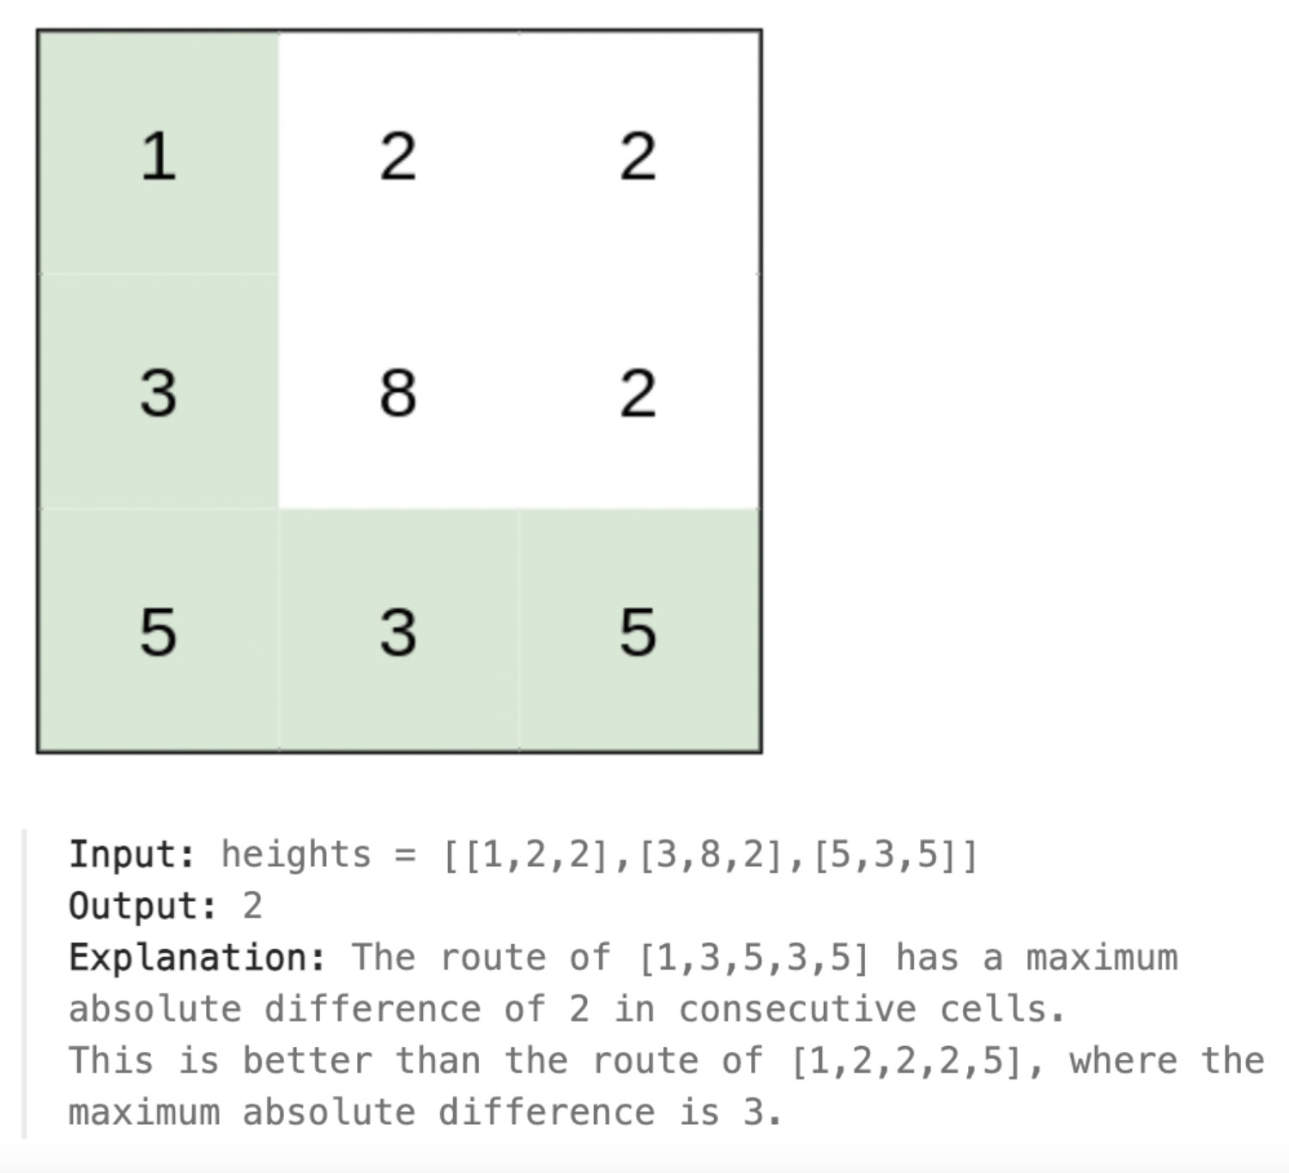

1. (20 points) There are n cities in a state. Given any two cities, x and y, we know the cost of building a road between x and y.

We want to build a network of roads such that any city can be reached from any other city (through a direct road or via intermediate cities). We want to do this at a minimum cost.

Provide the pseudocode of an algorithm to solve this problem.

1. (20 points) Prove that Prim’s algorithm (or Kruskal’s algorithm) has the greedy choice property, i.e., prove that the greedy choice is always in an optimal solution.