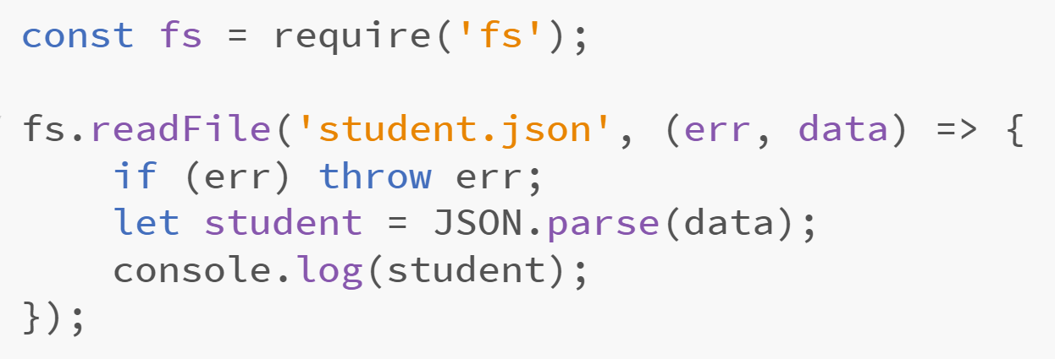

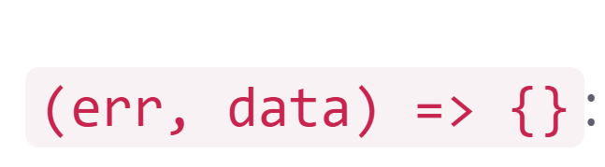

This is our callback function 。

once the file is completely read,

this function is executed

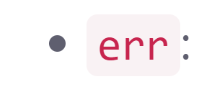

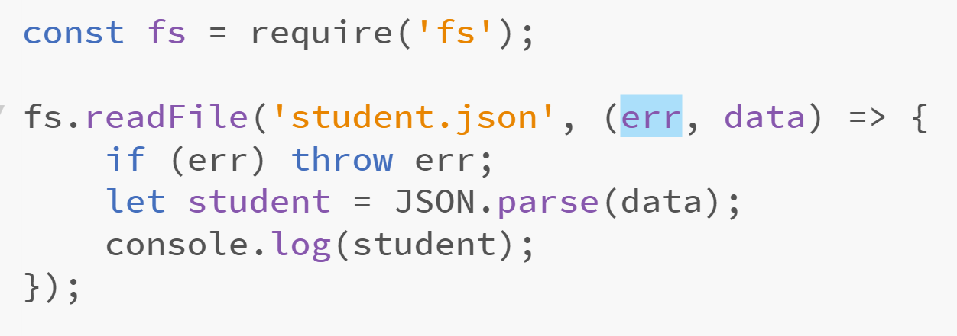

Since we can't easily use try/catch with asynchronous code,

If something goes wrong

**the function gives us** an err object

It is null if there were no errors