**Udacity Term 2 MPC project**

1. Vehicle Model

The following model from lectures is used:

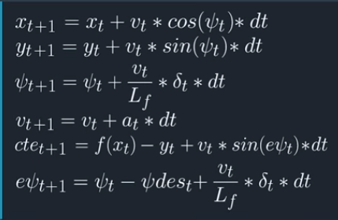

where x and y are positions of the vehicle, *Ψ* is the heading direction, v is the velocity, cte is cross-track error and e*Ψ* is the orientation error. Lf is the distance between center of mass and the front wheel of the vehicle. This model is implemented in class FG_eval.

1. Timestep Length and Elapsed Duration (N & dt)

N is equal to 25 and dt is equal to 0.05 such that the total prediction time is 1.25 seconds.

In the beginning, N= 100 and dt =0.01 but the results were not good.

The basic principle is that the total time length is decided at first and set dt smaller.

1. Polynomial Fitting and MPC Preprocessing

2nd order polynomial fitting was used; details in class FG_eval is shown in below.



1. Model Predictive Control with Latency

100 milliseconds are used for accounting latency; estimated states in 100 milliseconds are used as initial state of model predictive controller; this is equivalent that action of throttle or steering actually happens in about 100 milliseconds;