1. Radar
   1. Radar provides independent measurements for velocity;
   2. Radar reliable in different weather conditions
   3. Radar can detect small things under big objects
   4. Radar size is small

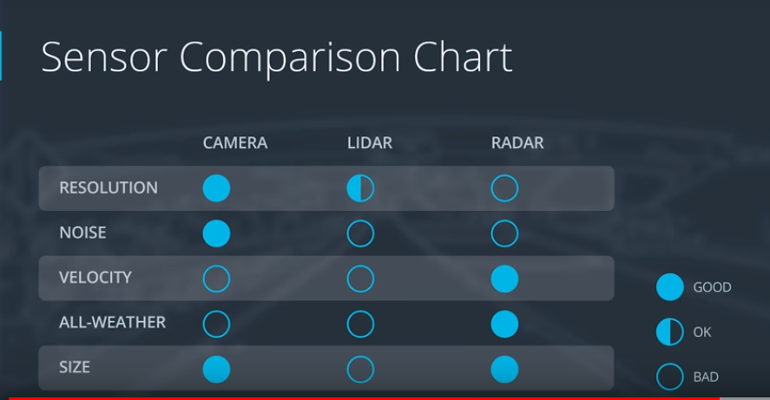

1. Kalman Filter:
   1. Physical model is good;
   2. Noise is white (uncorrelated);
   3. Covariance of the noise are exactly known

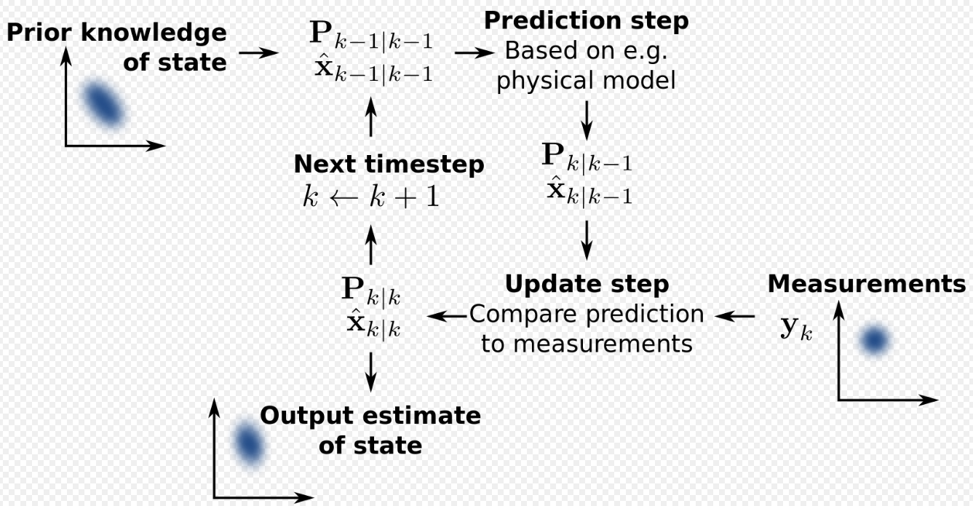



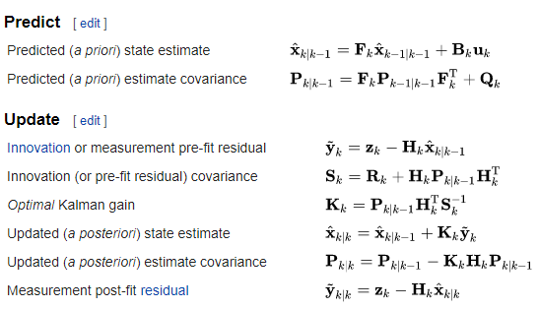

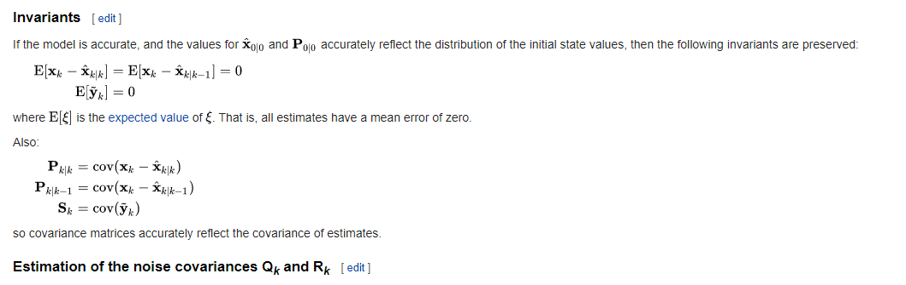

1. Covariance



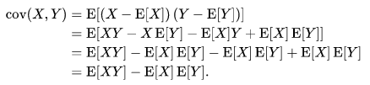

1. Extended Kalman Filter:
   1. the [nonlinear](https://en.wikipedia.org/wiki/Nonlinear) version of the [Kalman filter](https://en.wikipedia.org/wiki/Kalman_filter)
   2. Jacobian calculation

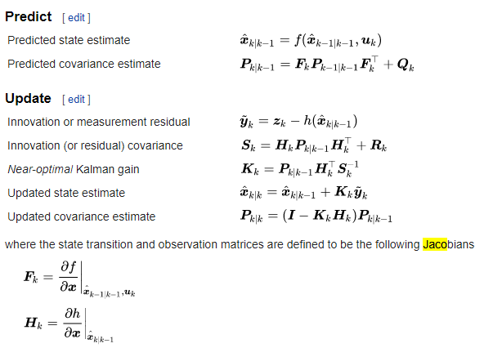

1. Unscented Kalman Filter:

The unscented Kalman filter (UKF) uses a deterministic sampling technique known as the unscented transform (UT) to pick a minimal set of sample points (called sigma points) around the mean.

The sigma points are then propagated through the non-linear functions, from which a new mean and covariance estimate are then formed.

**Steps a)** Augmented State including mean and covariance of the process noise

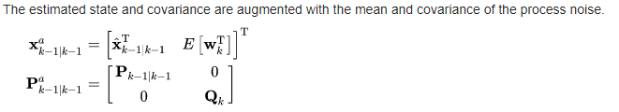

**Step b) Measurement and Measurement Covariance Prediction by use of physical model and weighting**

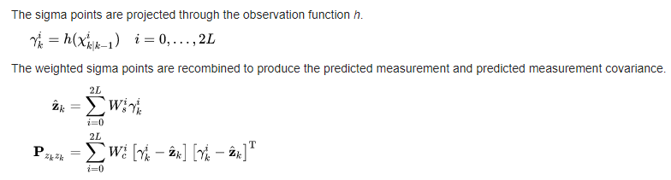

**Step C) Kalman Gain Calculation**

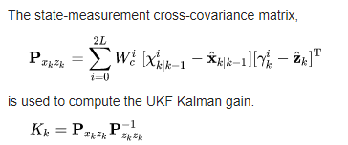

**Step d) State Updates of state and Covariance**

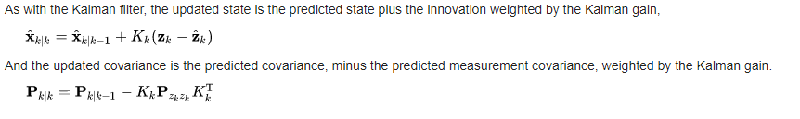

1. Particle Filter, **Sequential Monte Carlo**

GPS data for localization

Resample