
SleepSync Deployment Documentation (Partial)
1. Hosting Platform
For deploying the SleepSync backend, we selected Render.com as our hosting service. Render offers an easy-to-use platform for hosting web services with continuous deployment from Git repositories, automatic HTTPS, and a generous free tier — making it a good fit for our project.
2. Database Migration to Cloud
Before deploying the backend, we needed to ensure our database was accessible online, since our original setup used a local MySQL database via MySQL Workbench.
After evaluating several options, our group decided to migrate to Neon.tech.
Why Neon.tech?
- Fully Managed Postgres: Neon provides a serverless, highly scalable Postgres database.
- Easy Deployment: Quick setup with automatic scaling and connection pooling.
- Free Tier: Generous free tier perfect for development and early-stage deployment.
- SSL Enforced: Connections are secure by default (sslmode=require). 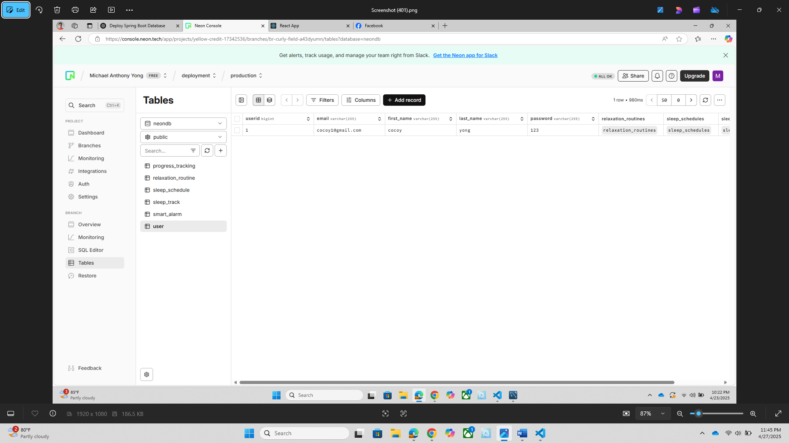

Changes to Application Configuration
To connect our Spring Boot application to the new Neon database, we updated the application.properties file:
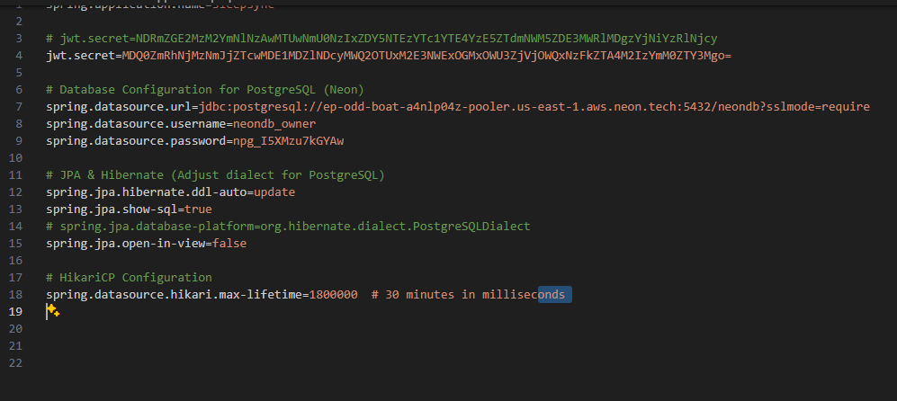

3. Building the Application (JAR file)
Before containerizing the application, we first needed to generate a runnable JAR file from our Spring Boot project.
We used the Maven Wrapper to package the application: ./mvnw package
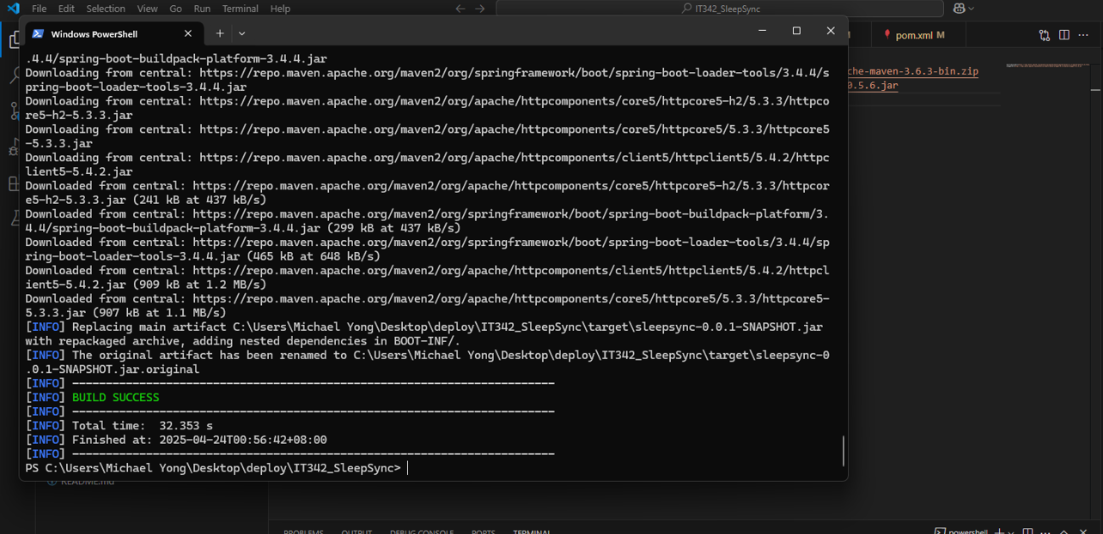
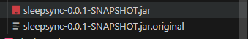
This command:
- Compiles the project.
- Runs any tests (if configured).
- Packages the application into a JAR file located in the /target directory (e.g., target/sleepsync-0.0.1-SNAPSHOT.jar).
The generated JAR file is the main artifact used in our Docker image for deployment.

4. Creating the Dockerfile
To containerize the SleepSync application, we created a Dockerfile inside the /src directory.
The Dockerfile uses a multi-stage build approach:
- First Stage: Build the JAR file using Maven inside a container.
- Second Stage: Run the JAR file using a lightweight OpenJDK image.
Here’s the Dockerfile we used:
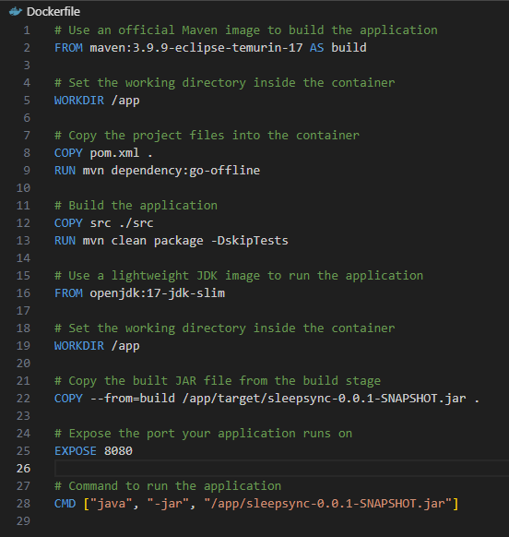

5. Building the Docker Image
After creating the Dockerfile, we proceeded to build the Docker image locally.
We used the following command: docker build -t sleepsync-app .
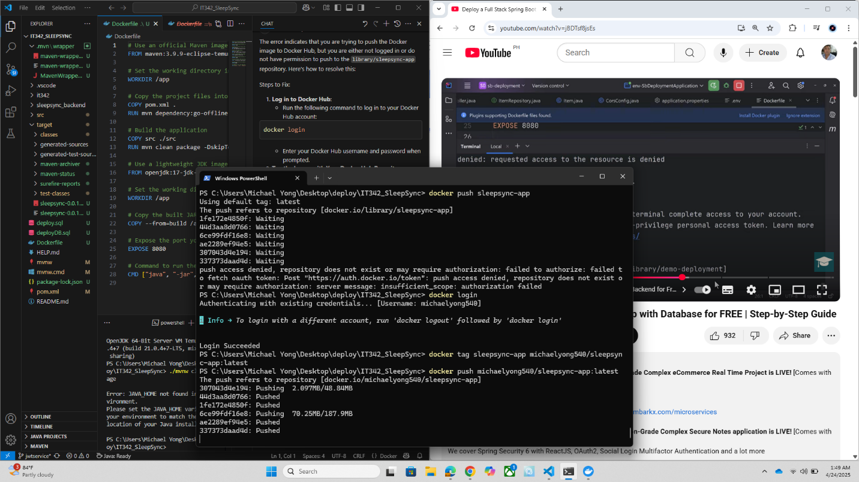
DOCKER IMAGE
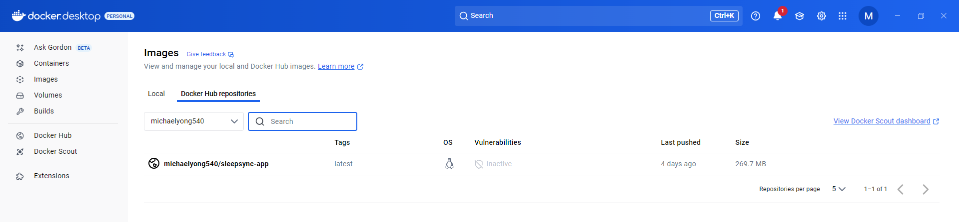
6. Deploying image in render.com
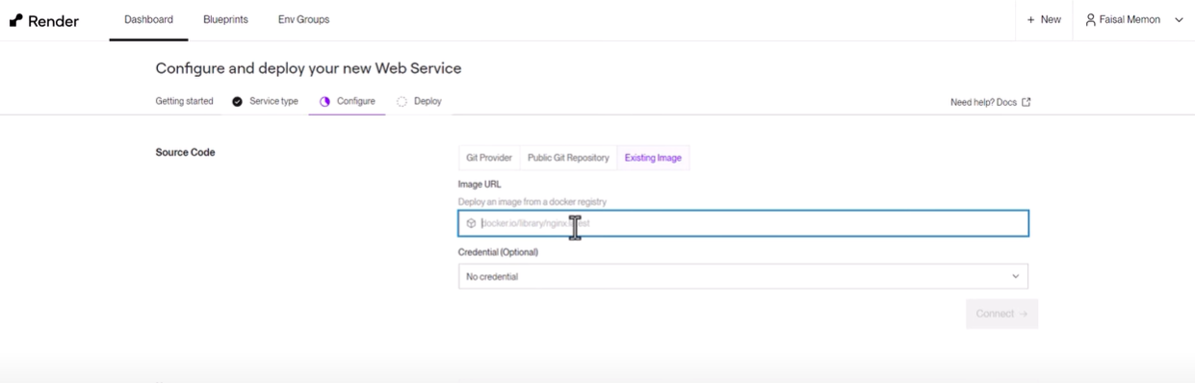
Paste the docker image url here to begin deployment. “docker.io/michaelyong540/sleepsync-app:latest”
Next: Click Connect and then Deploy Service
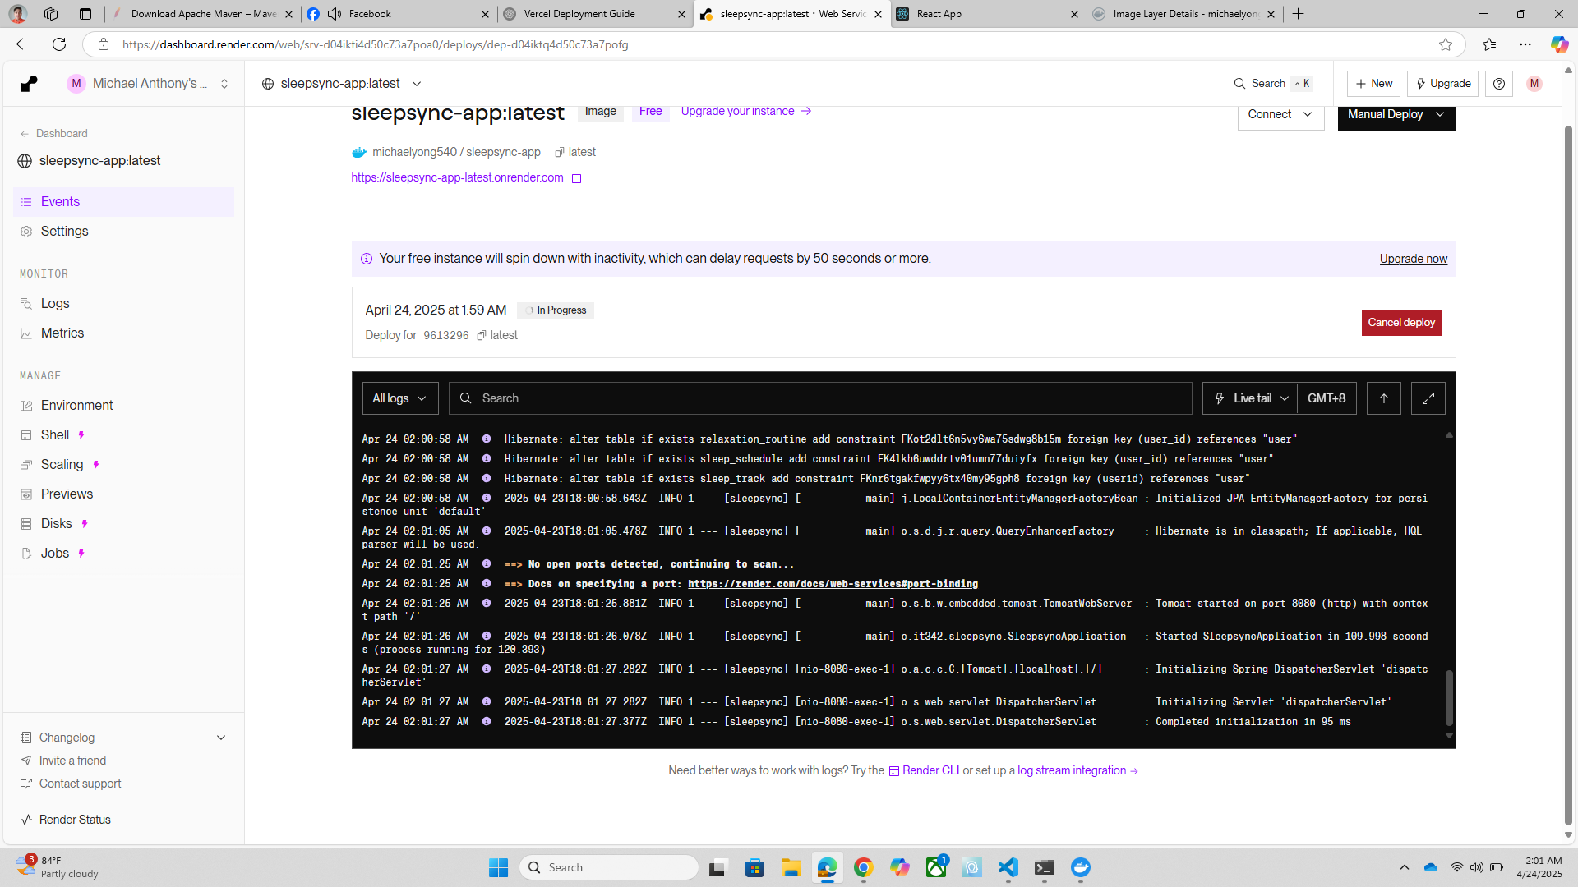

In conclusion, we achieved a deployed backend with url: “https://sleepsync-app-latest.onrender.com”

