CEBU INSTITUTE OF TECHNOLOGY UNIVERSITY

COLLEGE OF COMPUTER STUDIES

Software Design Description
for
EteeAPP

Signature
Ciddy Macapinlac


Jeskin T. Villacarlos

Change History

Preface

Table of Contents

1. I_{NTRODUCTION}............................................................................................................................................................................... 6

1.1. P_{URPOSE}...........................................................................................................................................................................................................6 1.2. S_{COPE}............................................................................................................................................................................................................... 6 1.3. DEFINITIONS AND ACRONYMS.......................................................................................................................................................................6 1.4. R_{EFERENCES}....................................................................................................................................................................................................6
- A_{RCHITECTURAL} D_{ESIGN}.............................................................................................................................................................. 7
- D_{ETAILED} D_{ESIGN}......................................................................................................................................................................... 8
Module 1........................................................................................................................................................................................................................8 Module 2........................................................................................................................................................................................................................9

1. | Introduction
1.1. | Purpose

The purpose of the EteeAPP system is to streamline and automate the Expanded Tertiary Education Equivalency and Accreditation Program (ETEEAP) application process for Cebu Institute of Technology University. This system aims to provide a comprehensive digital platform for applicants to submit their credentials, for administrators to evaluate applications, and for the institution to manage the entire accreditation workflow efficiently.
1.2. Scope
ETEEAPP encompasses:
- Applicant registration and profile management
- Document submission and verification
- Application tracking and status updates
- Administrator review interfaces
- Automated notifications and communications
- Reporting and analytics for ETEEAP management
Out of scope:
- Financial payment processing
- Integration with external academic databases
- Physical document archiving

1.3. Definitions and Acronyms

Term/Acronym | Definition
ETEEAP | Expanded Tertiary Education Equivalency and Accreditation Program
SDD | Software Design Description
API | Application Programming Interface
JWT | JSON Web Token
OAuth | Open Authorization

1.4. References

2. | Architectural Design

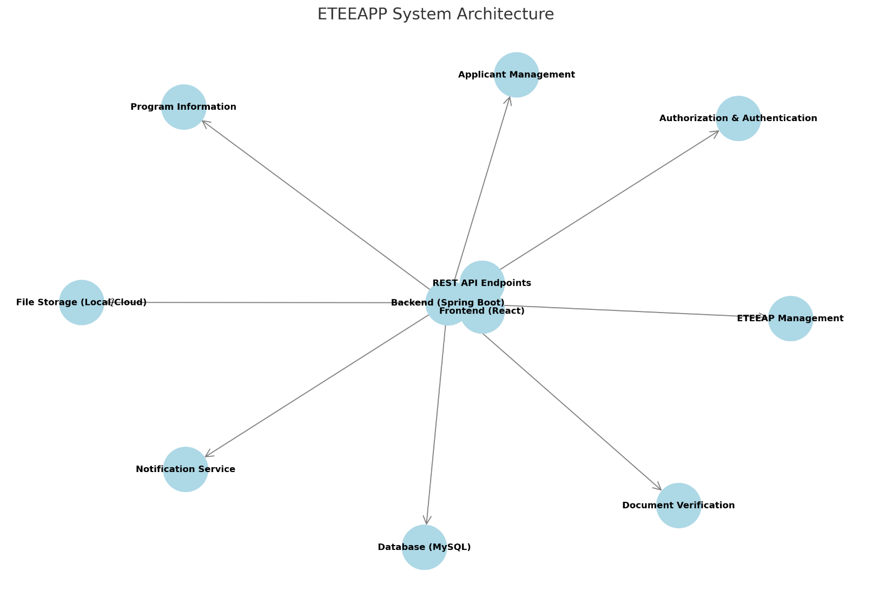
Block Diagram

Module 1

  - Welcome Page

3. | Detailed Design
Component Name | Component Name | Component Name
Applicants Page | Displays a list of applicants with their details, status, and actions. | React Component (JSX)
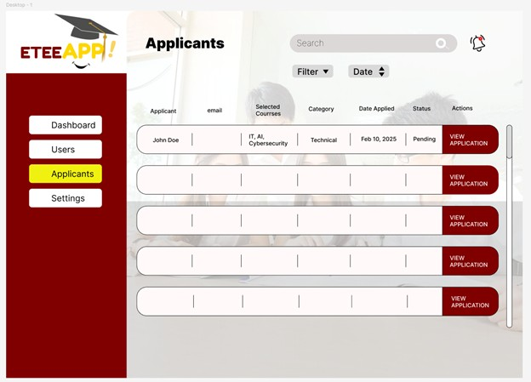
- User Interface Design

Frontend Components

Search Bar | Allows users to search applicants by name or email. | Input Field (React)
Filter Dropdown | Enables filtering applicants by category or status. | Dropdown (React Select)
Date Sort Button | Allows sorting applicants by date applied. | Button (React)
Applicants Table | Displays applicant details (name, email, courses, category, etc.). | Table (Material UI/Table)
View Application Button | Opens detailed application information for an applicant. | Button (React)
Sidebar Navigation | Provides access to Dashboard, Users, Applicants, and Settings pages. | Sidebar (React Component)
Notification Icon | Displays alerts for new applications. | Icon/Button (React)

Backend Components
Component Name | Description and Purpose | Component Type or Format
Applicant Entity | Represents an applicant in the database with fields like name, email, courses, category, date applied, and status. | Java Class (@Entity)
Applicant Service | Contains business logic for managing applicants (fetch, update, filter). | Java Class (@Service)
Applicant Controller | Provides REST API endpoints for fetching, filtering, and updating applicants. | Java Class (@RestController)

Sorting & Filtering Logic | Enables searching, sorting, and filtering applicants. | Query Methods (@Query in Repository)
Notification Service (Optional) | Sends notifications when a new application is received. | Java Class (@Service, WebSocket/Email)

Class Diagram
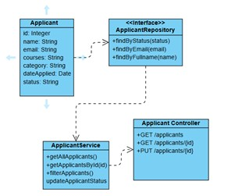

Sequence Diagram
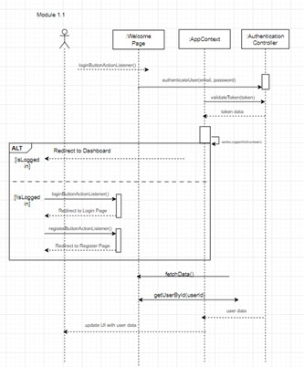

Data Design

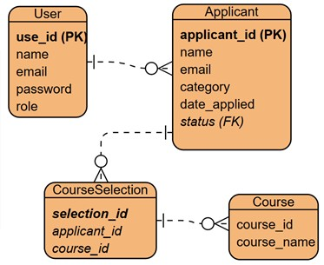
o

. . .

Module 2

2.1 Requirement Submission and Tracking (Applicant’s side)
- User Interface Design
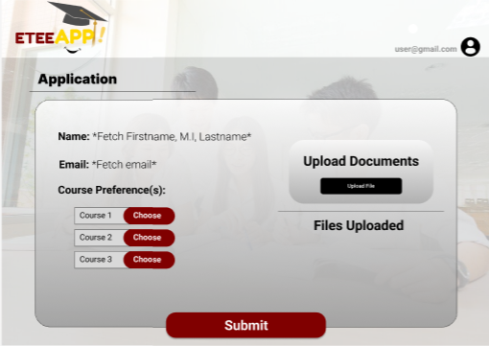
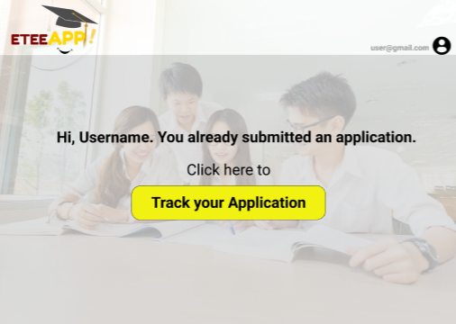
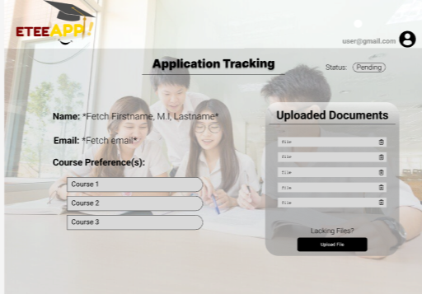
Frontend Components

Component Name | Description and  Purpose | Component Type
Document Upload Section | Allows users to upload documents via drag & drop or file selection. | React Component (JSX)
Uploaded Files List | Displays a list of uploaded documents with names, statuses, and actions. | Input Field (React)
Upload Button | Opens file picker to upload a new document. | Dropdown (React Select)
Delete Button | Removes an uploaded document from the list. | Button (React)
Submit for Review Button | Sends uploaded documents for verification. | Table (Material UI/Table)
Cancel Button | Allows users to discard changes and return to the previous page. | Button (React)
Sidebar Navigation | Provides access to other sections like Dashboard, Applicants, etc. | Sidebar (React Component)
Notification Icon | Displays alerts related to document verification status. | Icon/Button (React)

- Back-end component(s)

Component Name | Description and  Purpose | Component Type
File Upload API | Handles file uploads from the frontend and stores them in the system. | REST API (Spring Boot)
File Storage Service | Manages storing uploaded files in a local directory or cloud storage | Service Layer (Spring Boot)
Document Entity | Represents an uploaded document with attributes like name, type, status, and user reference. | JPA Entity (Spring Boot)
Document Repository | Handles database interactions for storing and retrieving | JPA Repository (Spring Boot)
 | document records.
Document Verification Service | Processes and verifies document submissions. | Service Layer (Spring Boot)
Document Controller | Exposes REST endpoints for file upload, deletion, and verification requests. | REST Controller (Spring Boot)
Notification Service | Sends alerts about document verification status updates. | Service Layer (Spring Boot)
Authentication & Authorization | Ensures only authenticated users can upload and manage documents. | Spring Security / JWT

Class Diagram
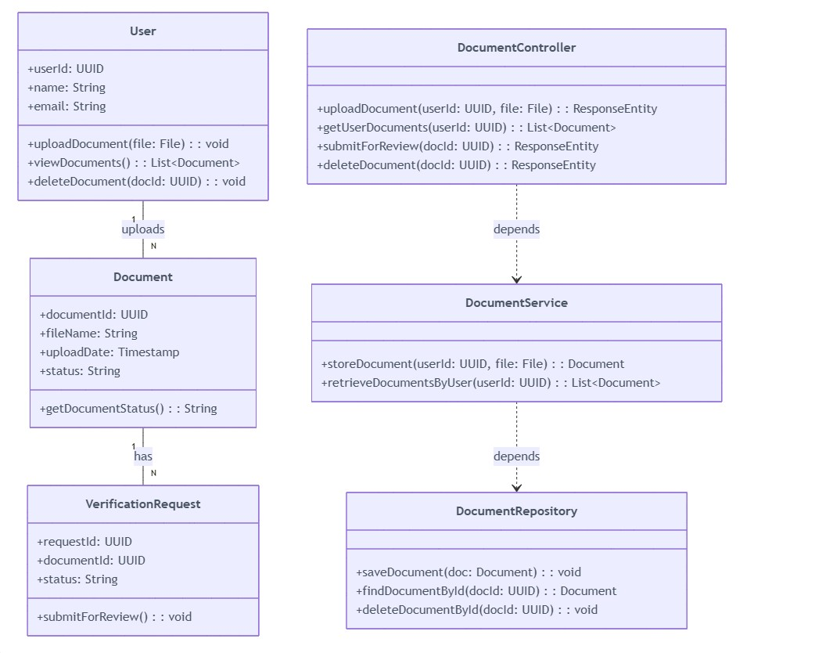

Sequence Diagram
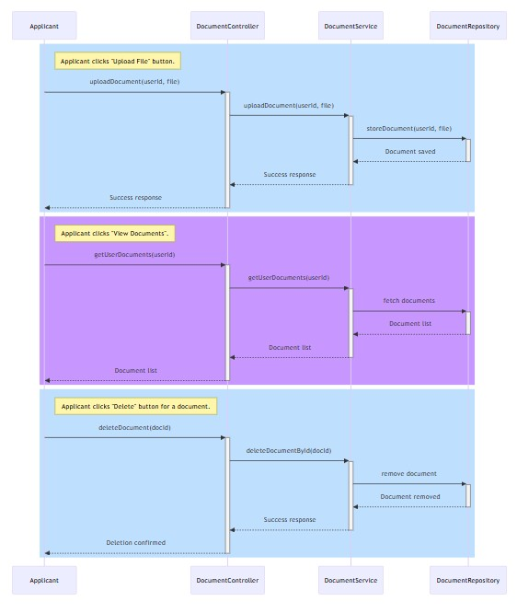

Data Design
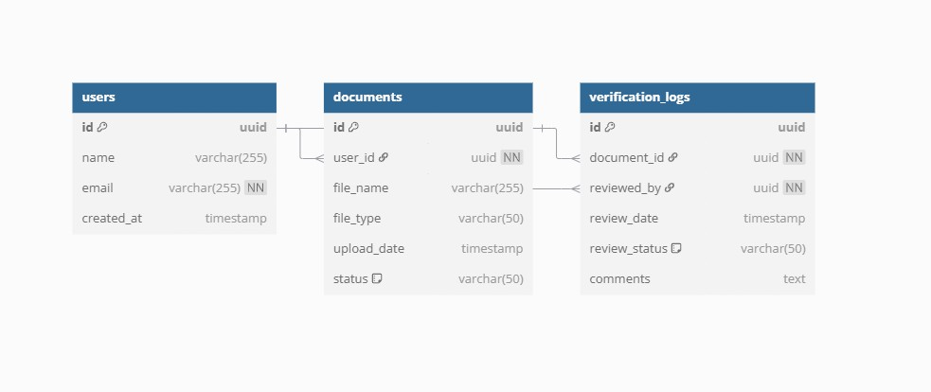

2.2 Transaction name
- User Interface Design


Module ³



- Front-end component(s)
- React.js for UI components
- Material UI for consistent design system
- Redux for state management
- Axios for API communication

Component Name | Description & Purpose | Component Type
ProgramShowcasePage | Serves as the main page displaying detailed information about ETEEAPP, including eligibility, requirements, and benefits. | Page Component
ProgramInfoCard | A reusable card component  that presents key details about ETEEAPP in a structured format. | UI Component
EligibilityCriteriaSection | Displays the specific eligibility requirements for ETEEAPP applicants. | Section Component
RequirementsList | Provides a structured list of necessary documents and qualifications for applicants. | List Component
FAQAccordion | An interactive  accordion-style component that expands to reveal frequently asked questions related to the program. | UI Component
NavigationBar | Provides navigation links to other sections of the application, ensuring a smooth user experience. | Navigation Component
FooterSection | Displays contact details, links, and additional resources related to ETEEAP. | Footer Component

- Back-end component(s)

Component Name | Description & Purpose | Component Type
ProgramController | Handles API requests related to  retrieving ETEEAP program details, eligibility, and requirements. | Controller
ProgramService | Contains business logic for fetching and processing program-related information from the database. | Service
ProgramRepository | Provides an interface to interact with the database, retrieving program information efficiently. | Repository
ProgramModel | Represents the program-related data structure in the system, mapping database records to objects. | Data Model
API Endpoints | Defines RESTful endpoints for retrieving program details, eligibility, and requirements. | API
Database (ETEEAPP_Info Table) | Stores program-related data such as descriptions, eligibility criteria, and requirements. | Database
Authentication & Authorization Middleware | Ensures access control, restricting modifications to admin users while allowing public read access. | Middleware

Use Case Diagram
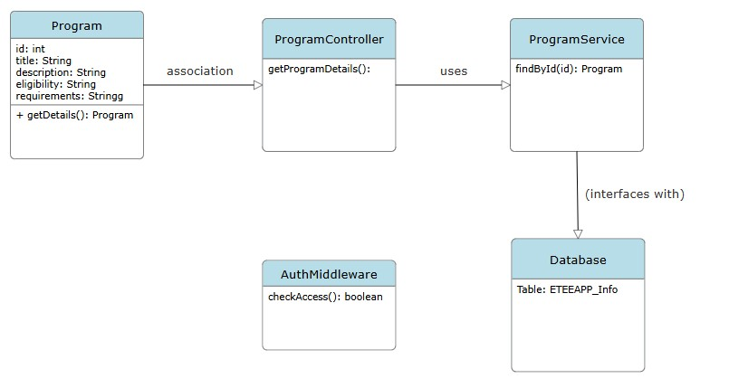
Sequence Diagram
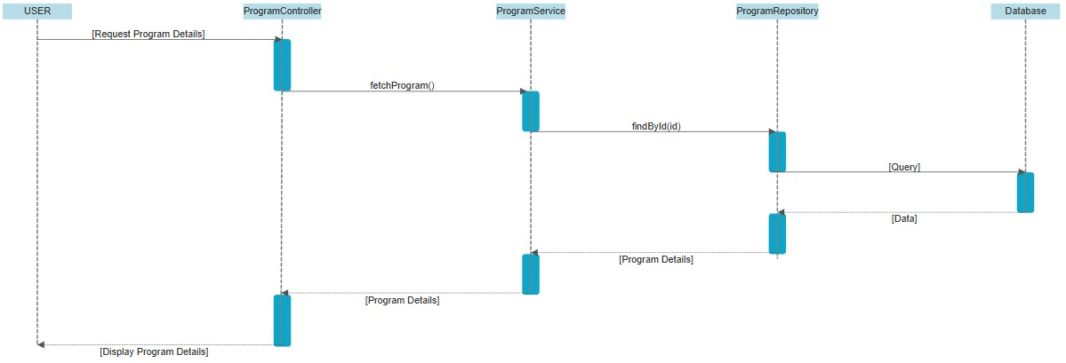

- Data Design
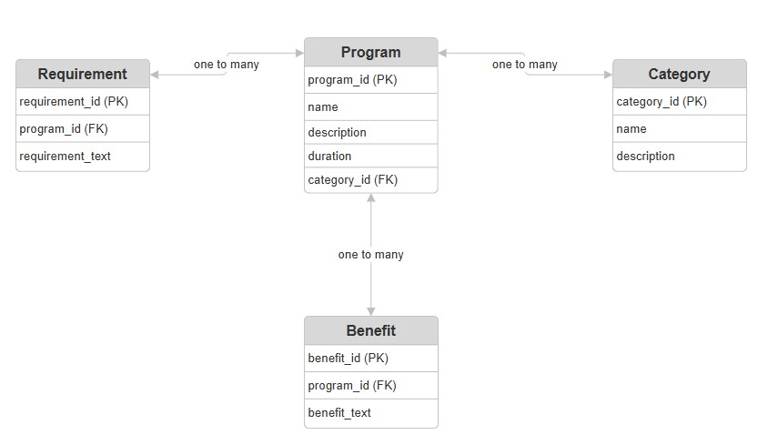

3.2 Registration
- User Interface Design
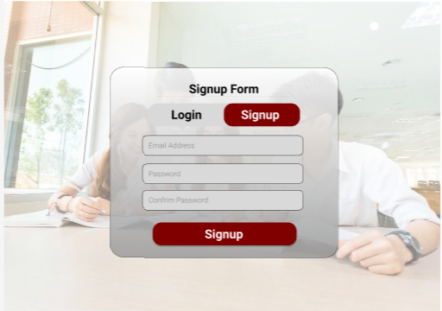

Front-end components
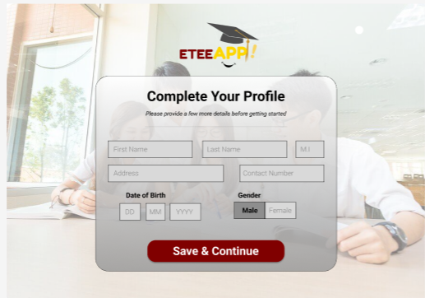

Components

Component Name | Description & Purpose | Component Type/Format
User Registration Form | Collects additional user details post-login. | UI Form (HTML, React,  etc.)
Profile Auto-Fill | Displays pre-filled name and email from Google. | UI Text Fields
Phone Number Input | Allows users to enter their contact details. | Input Field (Text)
Date of Birth Picker | Lets users select their birth date. | UI Date Picker  Component
Terms & Conditions Checkbox | Ensures users agree before submission. | Checkbox UI Component
Form Validation | Ensures correct input (e.g., required fields, file types). | Front-End Validation (JS)
Registration Submission | Sends collected data to the server for processing. | API Request (POST, JSON)
Dashboard Redirect | Guides users to their profile/dashboard after signing up. | UI Navigation Component

Back-end components

Component Name | Description & Purpose | Component Type/Format

User Data  Processing | Processes and stores user registration details. | Spring Boot Service Layer  (Java)
Database (User  Data) | Stores user registration details securely. | Spring Data JPA (MySQL /  PostgreSQL)
File Storage System | Stores uploaded documents securely. | Spring Boot File Storage  (Local/Cloud)
Admin Panel API | Provides API for admins to review and approve applications. | Spring Boot REST Controller
Email Confirmation | Sends a confirmation email post-registration. | Spring Boot Mail  (JavaMailSender)
Session  Management | Keeps users logged in after authentication. | Spring Security (JWT, OAuth)
Error Handling &  Logging | Manages errors and logs system activities. | Spring Boot Exception  Handling (ControllerAdvice,  Logger)
Security & Data  Privacy | Ensures encrypted data transmission & security compliance. | Spring Security (HTTPS,  OAuth, BCrypt)

Object-Oriented Components
Class Diagram
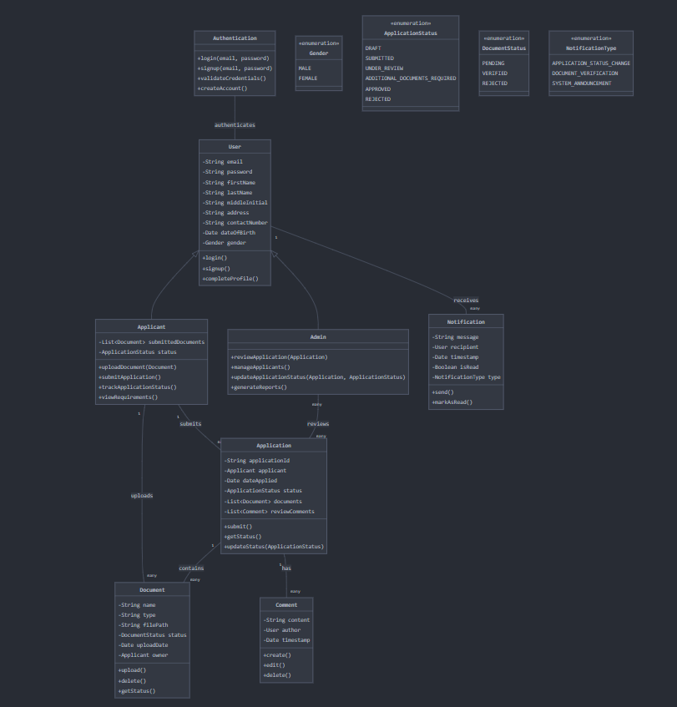

Sequence Diagram
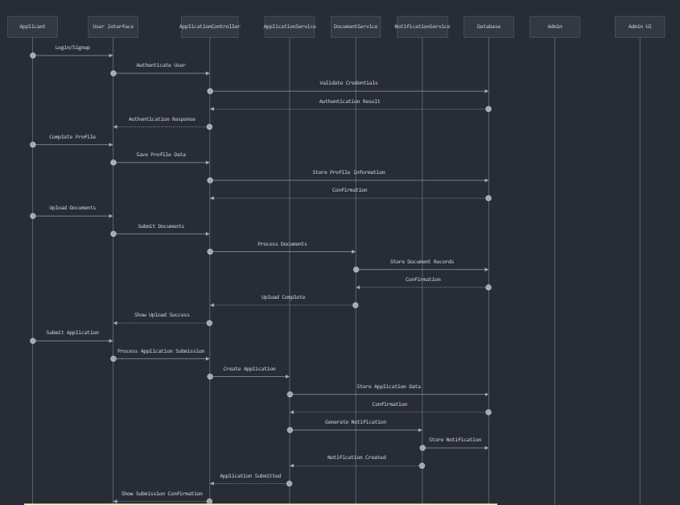
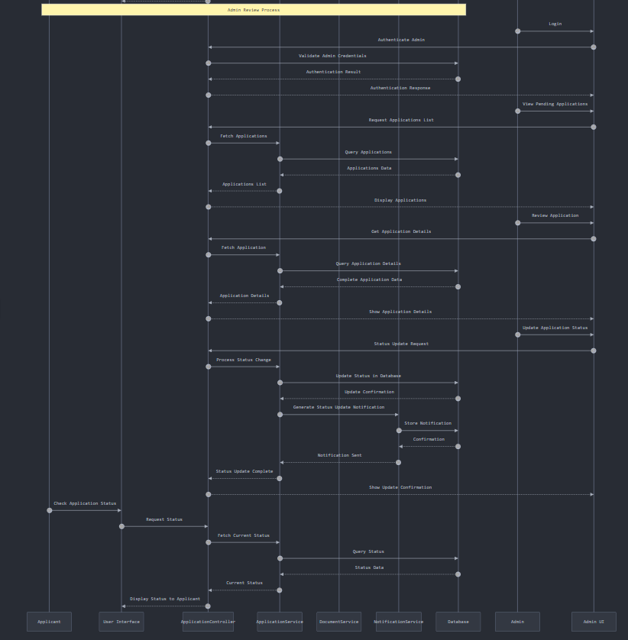

Data Design
