Equity Research Report

|  |  |  |
| --- | --- | --- |
| **Name: Apple Inc.** | **Ticker: NASDAQ:AAPL** | **Headquarters: Cupertino, CA** |
| **Target Price: $153.31814121860447** | **Price: $222.13** | **Recommendation: BUY** |

|  |  |
| --- | --- |
| **Market Profile** | |
| Closing Price | 223.12 |
| Diluted Shares Outstanding | 15343783000 |
| 52 Week High / Low | 164.08-260.1 |
| Avg. Volume (3M) | 52962733 |
| Dil. Shares Outst.(MM) | 15343783000 |
| Market Cap. | 3351730952000 |
| Dividend Yield | 0.0043585983369965175 |
| Beta | 1.178 |
| EV / Revenue | 9.134339201273542 |
| EV / EBITA | 26.524727497716487 |
| P / E | 37.287278415656736 |
| Inst. Holdings | Coming Soon |
| Insider Holdings | Coming Soon |

**Highlight**  
We issue a BUY recommendation on Apple Inc. (AAPL) with a one-year target price of $260, offering an estimated upside of 17.1% from $222.13. Key factors:  
  
Macroeconomic Outlook: Positive sentiment in the tech sector due to eased trade tensions, as seen in the recent rally of Asian tech stocks after the U.S. delayed tariffs on China and Mexico. This bodes well for Apple's global supply chain and demand.  
  
Brand Diversity: Strong product portfolio including iPhone, Mac, iPad, wearables, and services like Apple Music, Apple TV+, and Apple Pay. Diversified revenue streams across hardware, software, and subscriptions.  
  
Growth Strategy: Continued investment in R&D for new product categories (e.g., AR/VR, AI), expansion of services segment, and potential acquisitions to bolster ecosystem. Recent focus on subscription services shows promising recurring revenue growth.  
  
Valuation: Current P/E of 37.3x reflects premium for growth potential. EV/EBITDA of 26.5x and EV/Sales of 9.1x are elevated but justified by strong brand and cash flows. DCF valuation suggests $153.32, but market pricing in higher growth.  
  
Main Risk Factors: Intense competition in consumer electronics, potential supply chain disruptions from geopolitical tensions, and regulatory scrutiny over App Store practices. High valuation multiples leave little room for execution missteps.

News  
Asia Tech Stocks Rally as Trump Delays Tariffs on China and Mexico   
Asian tech stocks saw broad-based gains following the announcement of a pause in U.S. tariffs on China and Mexico. Key markets, including Japan, South Korea, and Hong Kong, advanced, with Japanese semiconductor firms Advantest and Lasertec leading the surge. The move eased investor concerns over trade tensions, boosting sentiment across the sector.   
  
Published on 2025-02-03, the news highlights how geopolitical developments continue to influence market dynamics. The tariff pause provided immediate relief, particularly for tech-heavy indices, as traders anticipated improved trade conditions and supply chain stability.

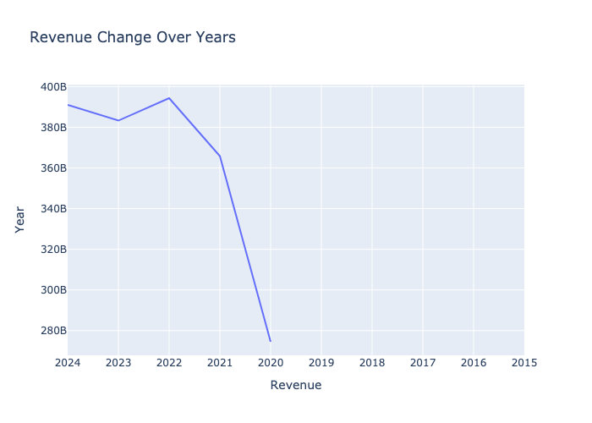

|  |  |  |  |  |  |
| --- | --- | --- | --- | --- | --- |
| Key Financials and Ratios | 2020 | 2021 | 2022 | 2023 | 2024 |
| Total Revenue ($B) | 274515000000 | 365817000000 | 394328000000 | 383285000000 | 391035000000 |
| EBITA Margin (%) | 0.2817478097736007 | 0.3286697993805646 | 0.3310467428130896 | 0.3282674772036474 | 0.3443707085043538 |
| EBIT Margin (%) | 0.24147314354406862 | 0.29782377527561593 | 0.30288744395528594 | 0.2982141226502472 | 0.31510222870075566 |
| Net Income Margin (%) | 0.20913611278072236 | 0.2588179335569424 | 0.2530964070519973 | 0.2530623426432028 | 0.23971255769943867 |
| Intrest Coverage (x) | 23.07274625826662 | 41.19054820415879 | 40.74957352439441 | 29.062039155860667 | 0 |
| Return On Equity (ROE) | 0.8786635853012749 | 1.5007132667617689 | 1.9695887275023682 | 1.5607601454639075 | 1.6459350307287095 |
| Earnings Per Share (EPS) | 3.7416457206153138 | 6.170577360224659 | 6.504458515869262 | 6.32145279948237 | 6.109054070954992 |
| PEG (%) | 3.1708888566361435 | 0.3634864369282435 | 2.8871904048664 | 170.91349250462116 | -45.93792700808932 |
| LT Dept To Assets (x) | 0.37753173936669465 | 0.3889493507159503 | 0.37555810690139046 | 0.3150690759338936 | 0.29215025480848267 |
| Total Debt / Equity (x) | 1.871439722064923 | 2.163924552226977 | 2.6144616356173036 | 1.7875325845589418 | 1.872326602282704 |