CS 500: Personal Budgeting Application
Process Summary
Michael Beal
Southern New Hampshire University

Approach and Strategy
I built a personal budgeting application that lets users track income, expenses, and savings goals. The main requirements were input validation, categorized expenses, data persistence, and at least one visualization. I used the provided coding template as my starting point and built out each section from there.

I structured the program around two classes. BudgetCategory holds the expenses for one spending category — like Housing or Food — and handles adding entries and summing totals. BudgetManager is the main controller. It stores the user's income and savings goal, keeps a dictionary of BudgetCategory objects, and handles saving and loading data. Separating these two kept the code organized and made it easy to test each piece on its own.

Two standalone validation functions, get_valid_float() and get_valid_date(), are defined outside the classes so they can be called from anywhere in the program. Both use while loops that keep asking until the user enters something valid, which prevents bad data from ever reaching the math or file operations. The main() function handles the menu loop and calls the appropriate method or helper for each choice.

Flowchart
The flowchart below shows the overall program flow. The application starts by loading any saved data, then enters the main menu loop. Each option branches to its own logic, including validation checks for options that take user input. Option 7 saves the data and exits. Any invalid menu entry loops back to the menu with an error message.

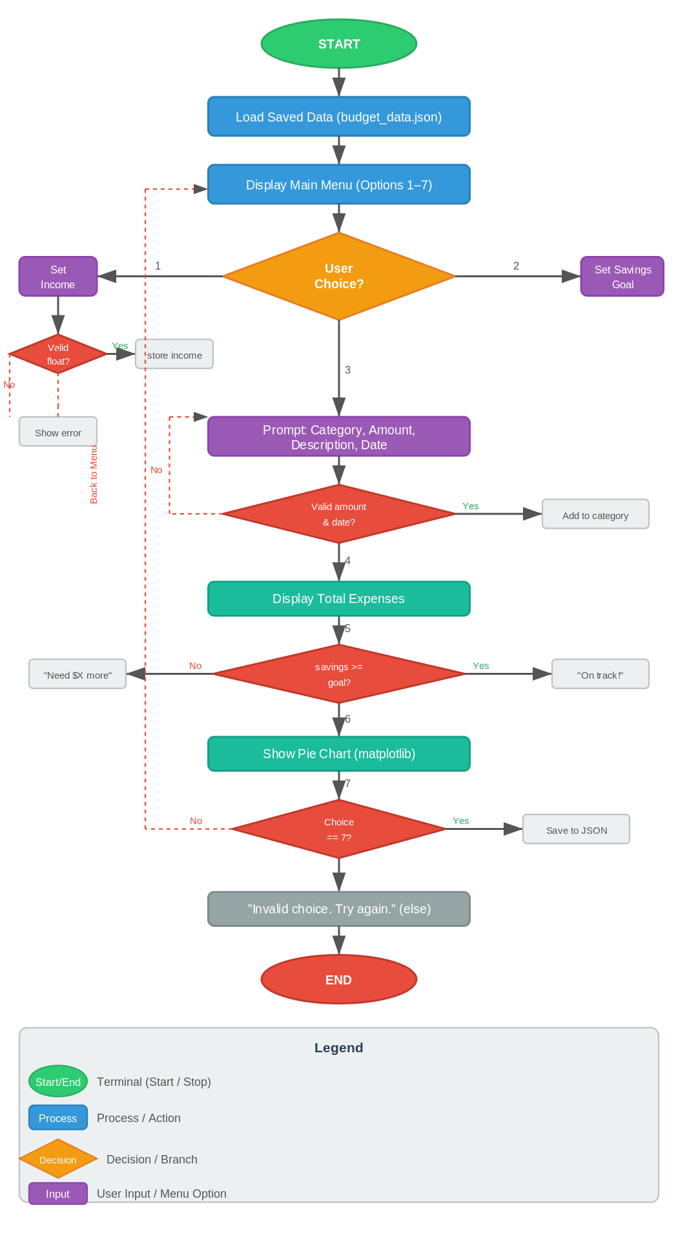

Figure 1. Personal Budgeting Application flowchart.

Pseudocode
The pseudocode below was used as the blueprint for the Python script:

START
LOAD saved data from budget_data.json (if file exists)
DISPLAY welcome message

REPEAT
DISPLAY menu options 1 through 7

GET choice from user

IF choice = 1
GET income from user (validate: must be a positive number)
STORE income
DISPLAY confirmation

ELSE IF choice = 2
GET savings goal from user (validate: must be a positive number)
STORE savings goal
DISPLAY confirmation

ELSE IF choice = 3
GET category name from user (validate: cannot be empty)
GET amount from user (validate: must be a positive number)
GET description from user
GET date from user (validate: must be YYYY-MM-DD format)
ADD expense to category
DISPLAY confirmation

ELSE IF choice = 4
CALCULATE total of all expenses
DISPLAY total

ELSE IF choice = 5
CALCULATE savings = income - total expenses
IF savings >= savings goal
DISPLAY "You are on track!"
ELSE
DISPLAY how much more is needed

ELSE IF choice = 6
DISPLAY pie chart of expenses by category (matplotlib)

ELSE IF choice = 7
SAVE all data to budget_data.json
DISPLAY "Goodbye"
EXIT loop

ELSE
DISPLAY "Invalid choice"

UNTIL choice = 7
END

Python Script
The script, personal_budget_app.py, follows the pseudocode directly. BudgetCategory and BudgetManager are defined first, followed by the two input validation helpers, and finally the main() function. I kept each method short and focused on one task so the code is easy to read and test.

Unit Tests
I wrote 15 unit tests in test_budget_app.py using Python's built-in unittest module, organized into three test classes: TestBudgetCategory, TestBudgetManager, and TestInputValidation. The tests cover adding expenses, computing totals, setting income and savings goals, progress tracking, and both the happy-path and error-path behavior of the two validation functions. unittest.mock.patch is used to simulate user input without actually running the interactive prompts.

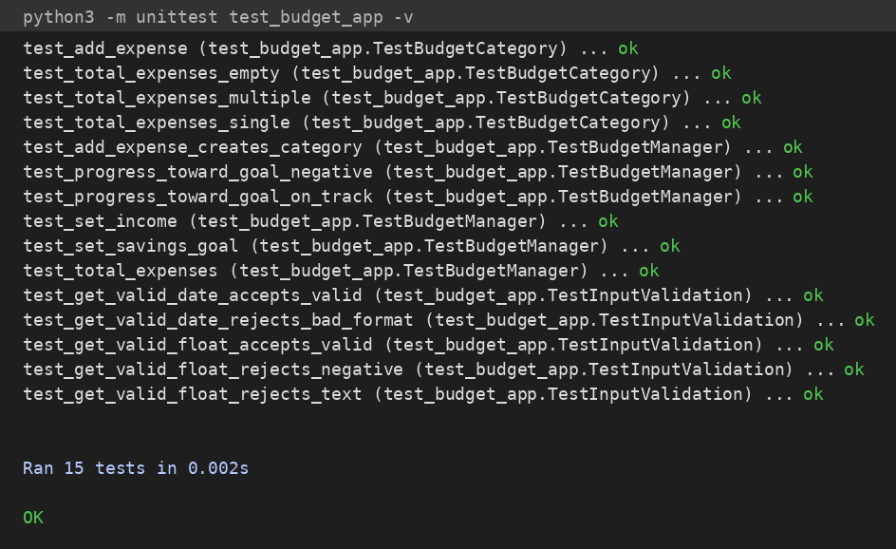

Figure 2. Unit test results — 15/15 tests pass.

Issues and How I Resolved Them
The main issue I ran into was with data loading. When the application first runs there is no budget_data.json file yet, so load_data() would throw a FileNotFoundError. I fixed that by catching the exception and doing nothing — a missing file on the first run is expected, not an error.

A smaller issue was making sure the savings progress check worked correctly when the user had not set an income or savings goal yet. Since both default to 0.0, the math still works without special casing — if no income is set, savings will be 0 minus expenses, and the "not on track" branch fires, which is the right behavior.

AI Usage Acknowledgment
Generative AI was used to revise the process summary.

References
Anthropic. (2026). Claude [Large language model]. https://claude.ai

