CS 500 Module Seven Activity: Simple Calculator
Process Summary
Michael Beal
Southern New Hampshire University
Approach and Strategy
My goal for this activity was to build a simple Python calculator that can add, subtract, multiply, and divide two numbers, and let the user keep calculating or exit. I started with the flowchart to map out the steps, then wrote pseudocode from the flowchart, and finally translated the pseudocode into Python. Working in that order kept the program small and made it easy to know what to write next.
I broke the program into two parts. Four short functions (add, subtract, multiply, and divide) do the math. A main() function shows the menu, takes the user's input, calls the right function, and prints the result. Splitting the code this way made it easy to test each math function on its own.
Flowchart
The flowchart below shows the program's flow. The user picks an option from the menu. If they pick 5, the program ends. Otherwise, the program asks for two numbers, runs the chosen operation, prints the result, and loops back to the menu.
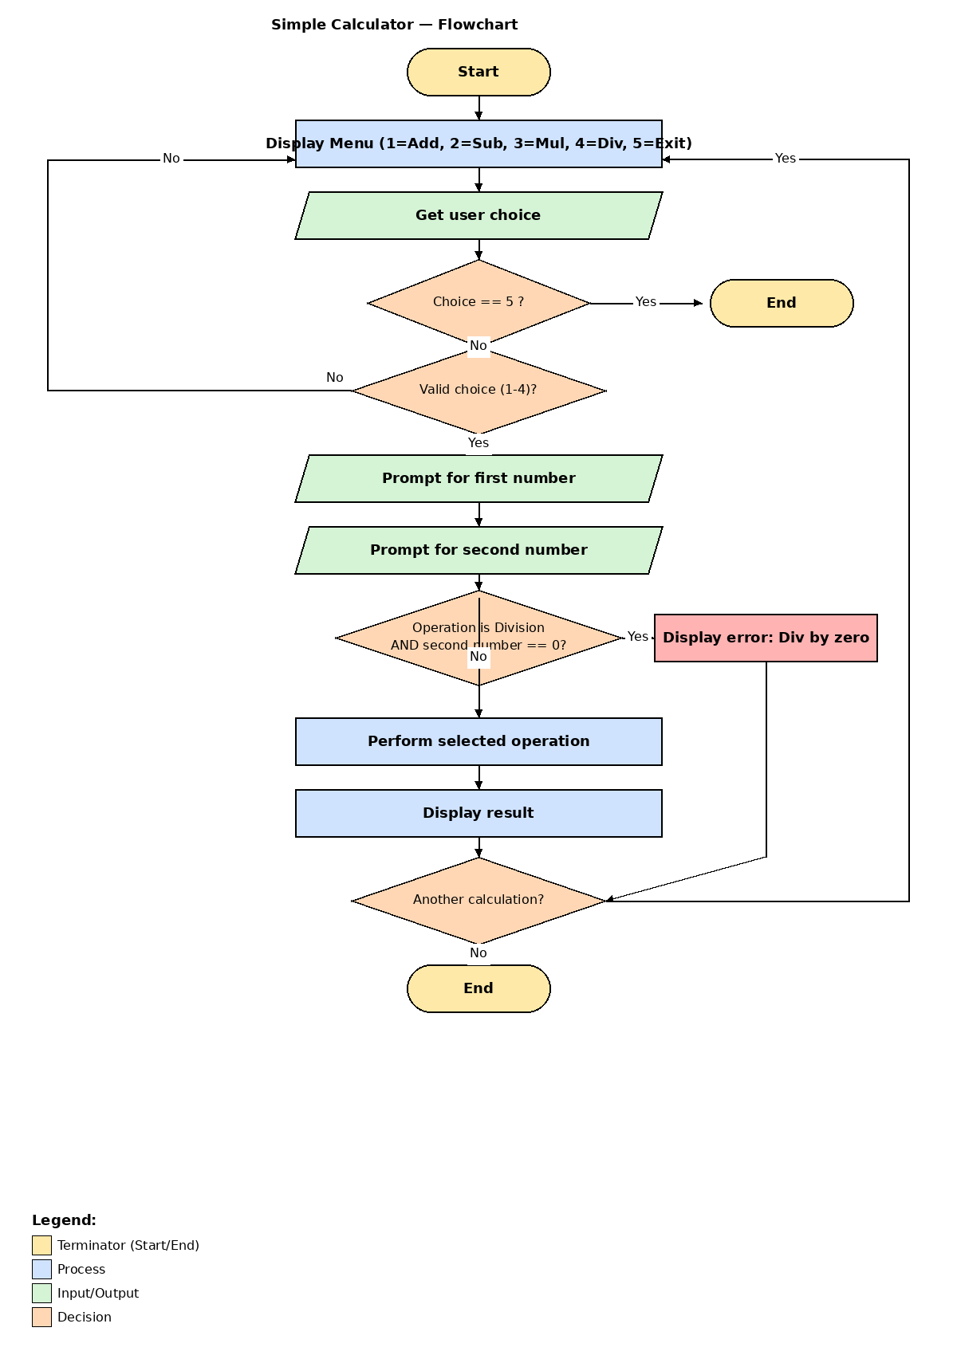
Figure 1. Calculator flowchart.
Pseudocode
The pseudocode below was used as the guide for the Python script:
START
REPEAT
DISPLAY menu (1=Add, 2=Subtract, 3=Multiply, 4=Divide, 5=Exit)
GET choice from user
IF choice = 5 THEN EXIT
IF choice not in (1,2,3,4) THEN show error and CONTINUE
GET first number
GET second number
IF choice = 1 THEN result = first + second
IF choice = 2 THEN result = first - second
IF choice = 3 THEN result = first * second
IF choice = 4 THEN
IF second = 0 THEN result = "Error: cannot divide by zero"
ELSE result = first / second
DISPLAY result
END REPEAT
STOP
Python Script
The script, calculator.py, follows the pseudocode directly. Each operation is its own function so the code is easy to read and easy to test. The divide() function checks for a zero in the bottom number and returns an error message instead of crashing. The main loop keeps showing the menu until the user picks 5 to exit.
Unit Tests
I wrote five tests using Python's built-in unittest module, one for each math function and one for the divide-by-zero edge case. All five tests passed. The screenshot below shows the console output.
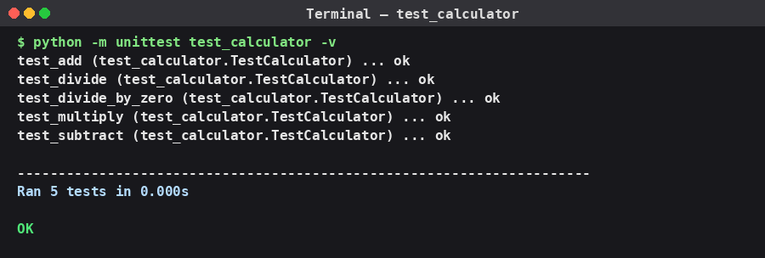
Figure 2. Unit test results — 5/5 tests pass.
Issues and How I Resolved Them
The main issue I ran into was deciding how to handle division by zero. My first version let Python raise a ZeroDivisionError, which would crash the program. I changed divide() to check whether the second number is zero first and return a clear error message instead. That way the program keeps running and the user gets a helpful message.
Optimizing the Code
Because this calculator is small and runs one calculation at a time, performance is not a real concern. The optimization I focused on was clarity. Putting each operation in its own function makes the code easier to read and easier to extend later. If I wanted to add a new operation (like exponentiation), I could write one new function and add one more if-statement to main() without changing anything else.
AI Usage Acknowledgment
Generative AI (Claude, developed by Anthropic) was used to assist in revising and expanding this activity. The flowchart design, code structure, and core ideas are my own; Claude was used to help organize and articulate the content. The AI-generated content has been reviewed and reflects my understanding of basic Python programming concepts (Anthropic, 2026).
References
Anthropic. (2026). Claude [Large language model]. https://claude.ai

