**PORTRAIT LIGHTING PATTERNS**

**Photo No. 1: Split / Side Lighting**

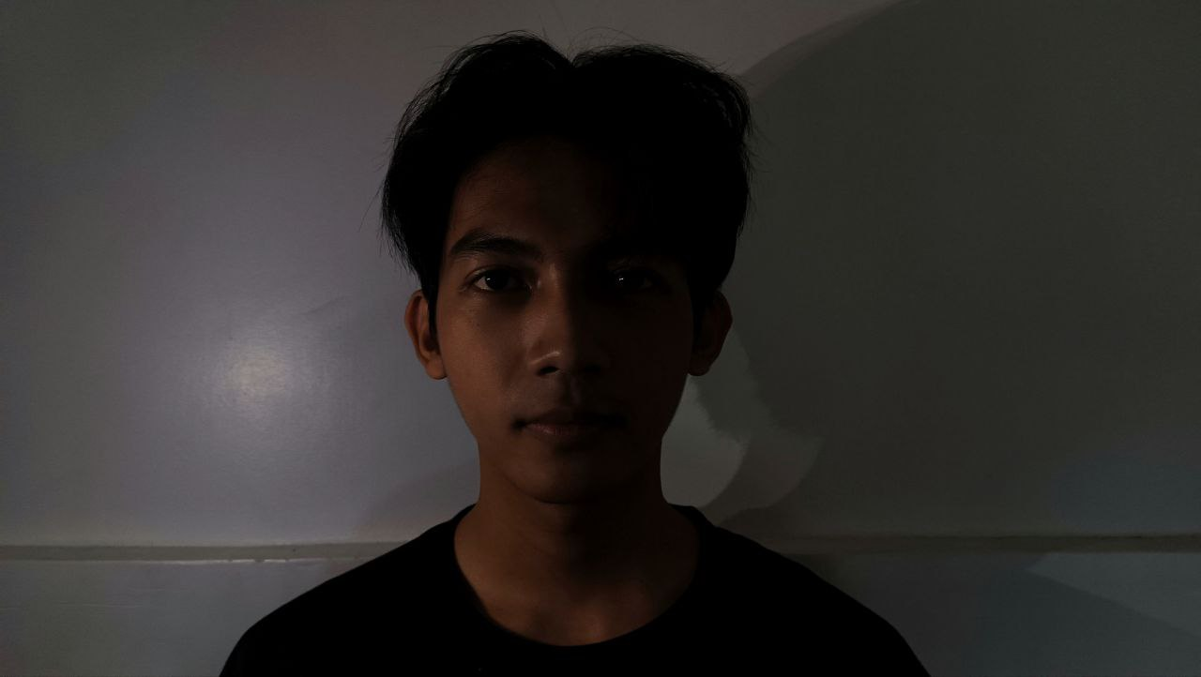

**Photo No. 2: Short Lighting**

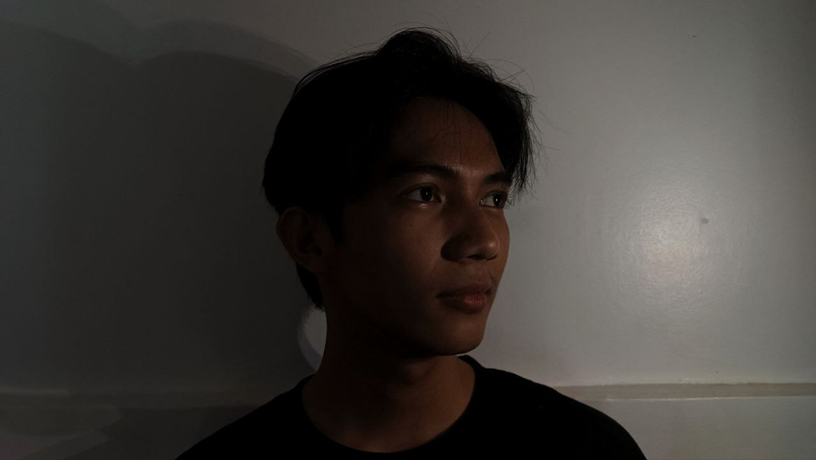

**Photo No. 3: Rembrandt**

