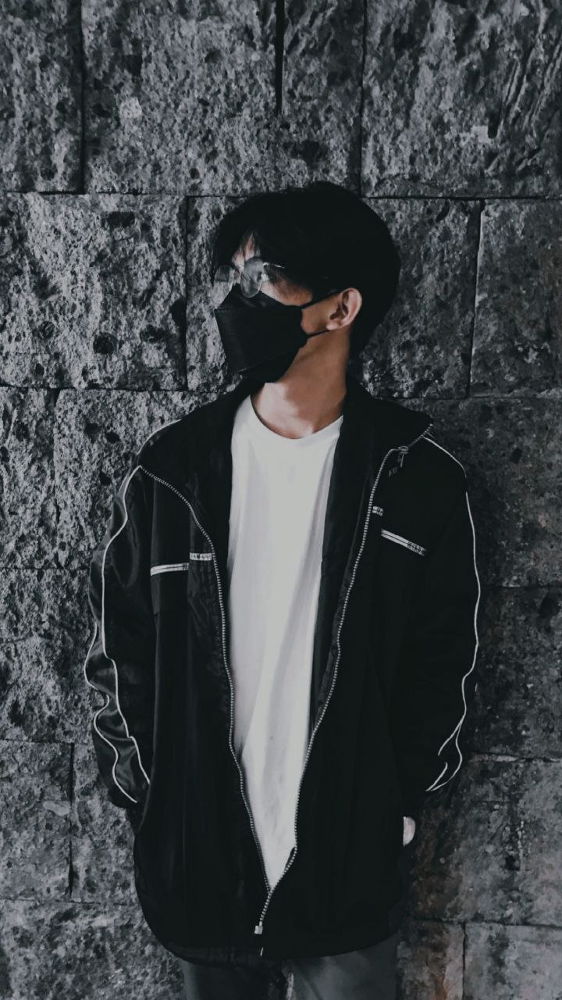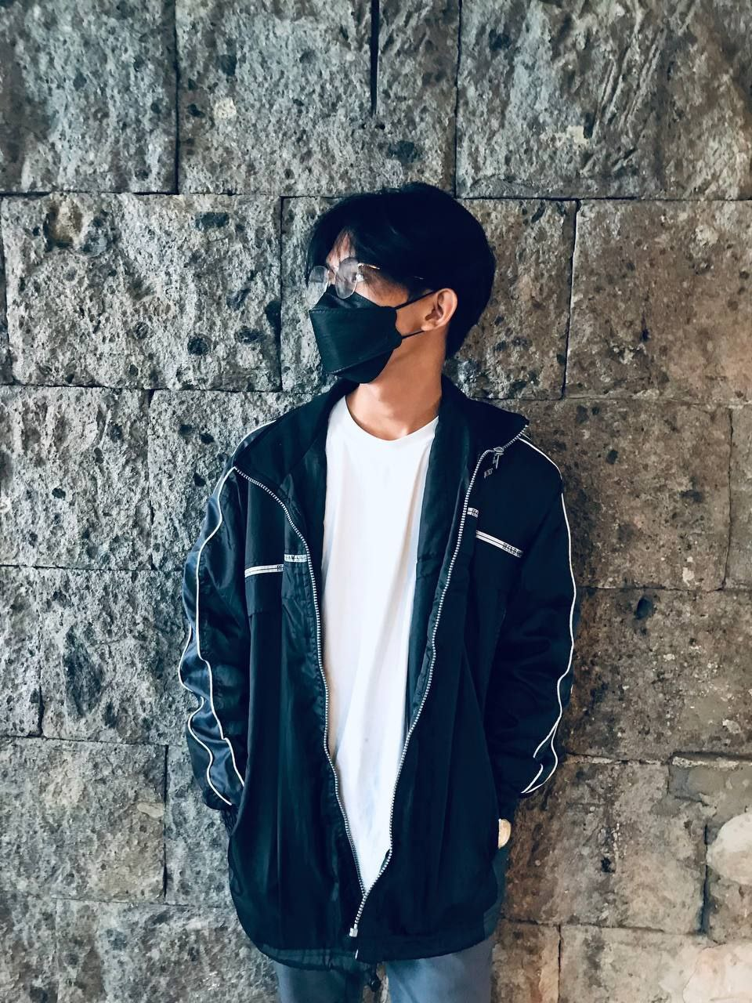

***BEFORE AFTER***

**Changes Made:** Brightness and Contrast, Temperature and Tint, Saturation and Lightness

**Application use:** Pixlr (Desktop Application)

**Photo taken through:** iPhone 7+

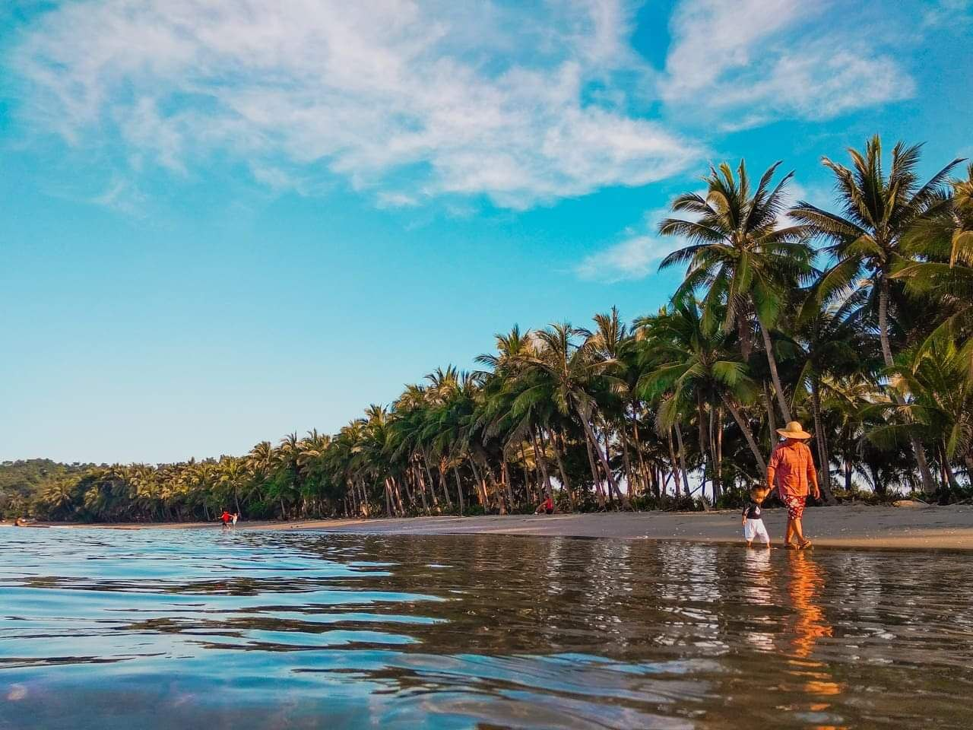

***BEFORE***

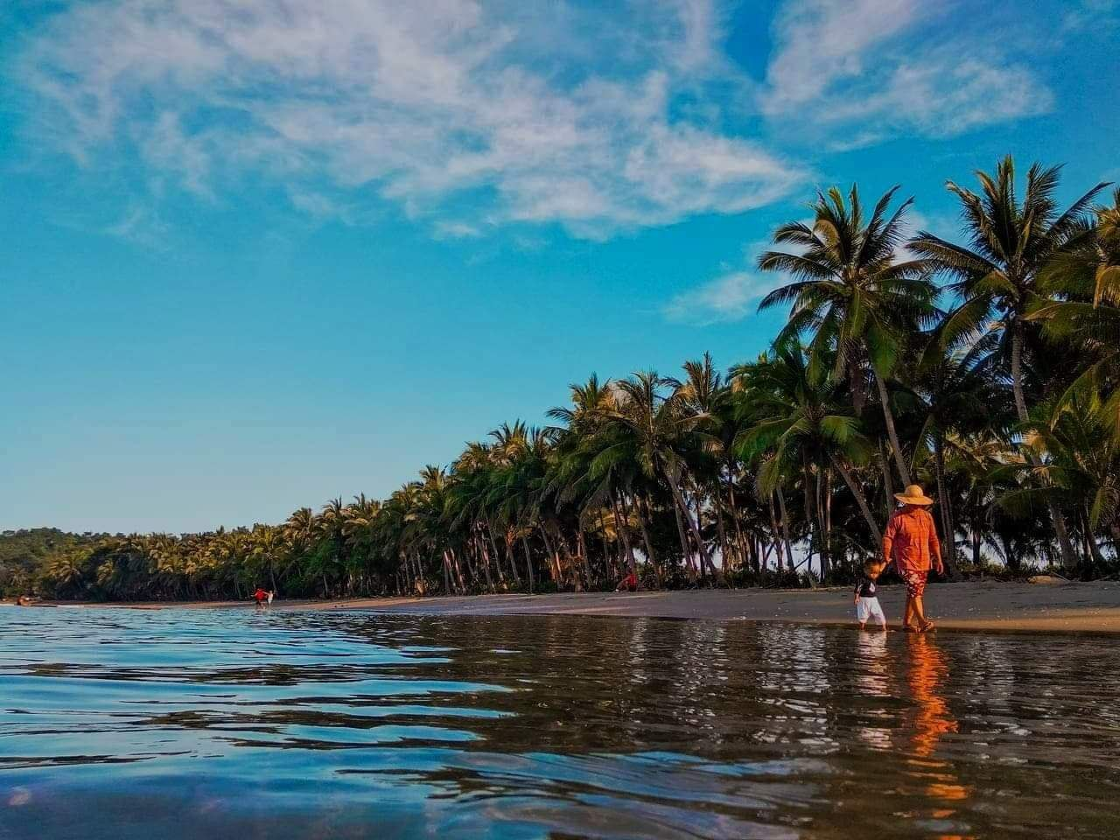

***AFTER***

**Changes Made:** Brightness and Contrast, Temperature and Tint, Saturation, Shadows, Highlights

**Application use:** Pixlr (Desktop Application)

**Photo taken through:** iPhone 7+