
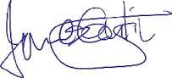

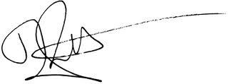
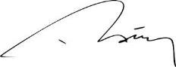

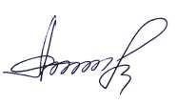
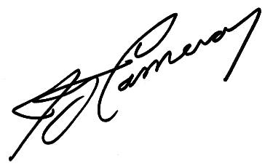
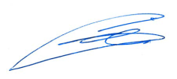
INVEST CAPITAL’S BOARD OF DIRECTORS RESOLUTION LETTER
Today 20/05/2017, Invest Capital’s board of directors deliberated and resolved on the following;
1. Review primary Projects/Business plan from local and foreign investors seeking funding from
Invest Capital PJSC.
2. Agreed to enter into bilateral business relationship with SunVesta Holding AG Project. Based on
specific terms, condition and agreements, to be agreed on based on the report of due diligence.
The following were present when this deliberation and resolution was made:
_____________________________________________________________________________________________________
1.
H.H. Sheikh Ali Saeed Ibrahim President/CEO
2.
Omar Hashem Managing Director
3.
Fazil Gamila Director of Finance
4.
Dr. Savio Hassouneh Regional Representative
______________________________________________________________________________________________________________
5.
Mrs. Susan Everest Board Member
______________________________________________________________________________________________________________
6.
Mr. Mansour Khalid Kareem Board Member
___________________________________________________________________________________________________________
7.
Dr. Sunil Bahri Arif Board Member
___________________________________________________________________________________________________________
8.
Mr.
Hisham Al Raqbani Head of General Counsel
During this meeting, it was unanimously agreed by all the members present, that Invest Capital PJSC
grants SunVesta Holding AG Project funding request which has been presented to Invest Capital
PJSC.
Having considered that this project under consideration is within our scope of funding, the final
approval for funding of this project will be the outcome of the Project legal Due diligence Report
from the Stamerge Commercial Brokers LLC.
Invest Capital PJSC can only collaborate in funding this project through a conventional loan of 3%
throughout the loan duration of the project, further to ratification and other consideration reached
by all parties involved.
The Meeting was adjourned till the next 7days, in which it is expected that the legal due diligence
report of the SunVesta Holding AG Project would be forwarded to the Board for final adoption.
Yours Faithfully,
..................................................................................
Sheikh Ahmed bin Saeed
President/CEO
Invest Capital PJSC
P.O. Box 306
15th Floor
Sheikh Zayed Road
Dubai, UAE

