**QuizApp**

*-Android project-*

*INTRODUCTION*

Everywhere around the world we observe a significant increase in technology development, as a means of making our life easier. One area in which technology plays a big part is education. In the era of information, with the help of Internet we can search & find almost any info we need. The **problem** is, there is **A LOT** of it, it is unfiltered, unstructured, or too complicated. In order to facilitate the learning process, we have many ways to engage and to test ourselves, one of which is the quiz model. Our application focuses on **facilitating** the beginning part of the learning curve by making it **entertaining & fun**, thus luring the curious in adapting to new perspectives and ways of thought. The app will be used in **digital mediums**, initially for **mobile use**.

*SOLUTION DESCRIPTION*

Imagine the following **scenario**:  Let’s say a student is looking on the Internet for information about a certain topic. He wants to stick some fast concepts in his mind, or he forgot something & wants to remember a **quick fact** that would help him in the moment. He finds our quiz app on the store. He downloads it & **quickly enters** his registering info to start a quiz. He is able to look through the categories very easily & he **finds what he needs**. He answers the quiz & at the end he finds out if he responded correctly or not! It is challenging for the moment ,but the student has now have the **concepts absorbed deeply into his mind**. He also brings his colleague to show him how simple is to learn the concepts through this app. They also make a **little contest** where they see who finishes the qiz the fastest. The essential part is that both of them **learned** what they needed, **easier & better**.

**Features**: Our project yields to create a great environment for those interested in pop quizzes while also maintaining  everything as entertaining as possible with a **scoreboard** designed to enhance the competition even among friends. Currently the final APK is in what is trivially known as a DEMO. With only **3 categories** to choose from and **3 answers per category** we simply want to prove that we are able to build the application at it’s core concept while not yet putting it out on the market (something we are considering to do in the foreseeable future). With only **6 seconds to respond to every question** we are trying to stimulate the player into paying attention and give the feeling of being on the edge, as once a wrong answer is fed into the application the questions need to be taken from the beginning. This would be normally seen as quite a frustrating thing to do, but we found this as the most efficient way of creating a stake and making the whole gameplay more challenging. Anybody can **register** with their e-mail and occuptaion , then **sign in** with their username and password with **just a press of a button**.

*IMPLEMENTATION*

In order to achieve the previously mentioned task we used, but not limit ourselves to, the following resources:

-         <https://firebase.google.com/docs/database/> here we learned how to use a real-time database and the key capabilities of Firebase. We added in the android project the Firebase Core and the Firebase Database libraries. This helped us a lot in implementing Firebase into our project. When creating the project, we used a json file to store required data like questions, categories, question scores, ranking and users. We also used support design as library. An advantage for this is the fact that the data is stored externally and more easily, using links for the category images, links which represent the sites they’re uploaded on. In annex1 you can find a printscreen showing the structure of how our Firebase looks like for questions.

        For the sign-up activity we used linear layout and edit texts to insert new usernames, passwords and e-mails into the database.

-         <https://developer.android.com/guide/components/fragments> our project implemented with the help of the mentioned link two fragments: Rankingfragment and CategoryFragment. They’re implemented through a bottom menu which has two tabs, each button for accessing the categories, respectively the rankings. In Annex2  you can see how these fragments look like at the bottom of the screen.

-<https://developer.android.com/reference/android/support/v7/widget/RecyclerView.ViewHolder> from here we figured out how to implement the RecyclerView. We also used CategoryViewHolder to process each item for the Recycler adapter and after that, added an ItemClickListener interface to implement onClick for the RecyclerItem.

    For each question from the quiz, we used ImageView and TextView, one of them being set to invisible, depending on the question.(if the question is represented by an image, the TextView will be set to invisible, and the image View will be set visible)

- <https://stackoverflow.com/questions/36903054/android-studio-layout-background-error> this stackoverflow Q&A helped us nailing down an issue we had with the background.

-         <https://developer.android.com/reference/android/support/design/widget/BottomNavigationView> here we found out how to make our own BottomNavigationView which we then used in order to give the user the option to select between the previously mentioned fragments, allowing him to switch at ease between the scoreboard and the categories of questions available.

-         <https://stackoverflow.com/questions/39394502/databasereference-and-firebasedatabase-cannot-resolve-symbol> this link helped us get rid of a *‘Cannot Resolve Symbol error’* when trying to reference DatabaseReference and FirebaseReference. Apparently we needed  the following two dependencies in our build.gradle(Module.app):

implementation 'com.google.firebase:firebase-core:16.0.4'

implementation 'com.google.firebase:firebase-database:16.0.3'

*BIBLIOGRAPHY:*

* <https://firebase.google.com/docs/database/>
* <https://developer.android.com/guide/components/fragments>
* <https://developer.android.com/reference/android/support/v7/widget/RecyclerView.ViewHolder>
* <https://stackoverflow.com/questions/36903054/android-studio-layout-background-error>
* <https://developer.android.com/reference/android/support/design/widget/BottomNavigationView>
* <https://stackoverflow.com/questions/39394502/databasereference-and-firebasedatabase-cannot-resolve-symbol>

Annex1: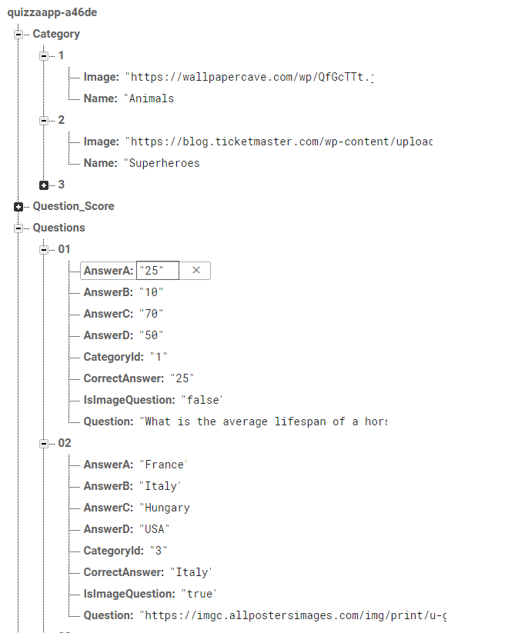

Annex2: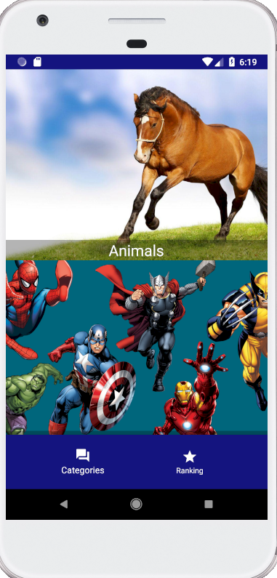

A project realized by:

-Ionașcu Alexandra

-Georgescu Mihail

-Manea Valentin

-Matei Mircea