A mathematical microscope for walking: what data-driven linear models reveal about the dynamics of human gait
Michael Hess, Michael Rosenberg, and Gordon J. Berman

Abstract
Walking is a stable rhythm produced by a high-dimensional, nonlinear body, yet a laboratory recording of it is usually reduced to a few scalars: speed, symmetry, variability, perhaps a single stability index. Here we use linear operators fitted to delay-embedded joint kinematics (dynamic mode decomposition, DMD) as a mathematical microscope: a compact generative model of each recording whose geometry can be inspected directly. We first calibrate the instrument on systems with known dynamics. In Stuart–Landau oscillators the operator's response measures recover the true decay rate; in a spring-loaded inverted pendulum the fitted spectrum is locked onto the neutral limit-cycle mode and carries no stability information, while the same fit's transient response retains part of it and the classical return map remains the accurate reference. In three humanoid robots the models forecast multi-joint gait for several strides. Applied to 299 recordings from 42 people, rescaled to a common stride duration and fitted with ridge regularization, the operators forecast held-out joint angles over a stride better than a phase-averaged template and expose the dynamical geometry of each walker's cycle. That geometry is strikingly simple: at the stride frequency the joint-to-joint response is rank one, a single profile of how strongly each joint expresses the dominant mode. Within healthy walkers, faster walking is generated by dynamics that occupy fewer effective dimensions, amplify disturbances less and are more sharply tuned to the stride, while expression shifts from the knees toward the hips. After stroke, transient growth is graded with walking ability and the paretic knee drops out of the dominant mode. The resulting profiles are individual: a held-out half of a person's recordings identifies them 65% of the time among 42 people (chance 2.4%). Because these recordings lie close to the limit cycle, they constrain the geometry of the generated cycle far better than transverse stability, which would require perturbations to resolve.

Introduction
Walking looks effortless, but every stride is the outcome of continuous coordination among the joints of both legs, adjusted for speed, terrain and the small disturbances that arise on every step. The resulting motion is strikingly regular: a stable rhythm that the body returns to after it is perturbed, that reorganizes smoothly as speed changes, and that is reorganized again, in a different way, when the body itself changes, as it does after a stroke. Each of these is a statement about dynamics, about the process that generates the motion, not only about the motion it generates.
Most descriptions of gait nonetheless summarize the output rather than the process: average joint trajectories, speed, step symmetry, stride-to-stride variability. These are useful, but they cannot distinguish two walkers whose average strides look alike while the dynamics that produce them differ, for instance in how a deviation at one joint unfolds over the following steps and spreads to others. Answering that kind of question requires a dynamical model: a rule that maps the current state of the body to the next. Unlike a description of the trajectory, such a rule can be run forward, perturbed, driven at different rhythms and compared between people, and its structure encodes how the observed motion is generated.
Decades of locomotion research have produced several complementary dynamical descriptions, each useful and each incomplete in a different way. Simple mechanical templates, the inverted pendulum and the spring-loaded inverted pendulum (SLIP), capture the energetics of the stance leg with a handful of parameters and have shaped how the field thinks about efficient gait [CITE – Full & Koditschek; Geyer, Seyfarth & Blickhan; McMahon]. They describe an idealized stride, however, not a multi-joint body, and their parameters must be assumed rather than identified from an individual's recording.
A second tradition, muscle synergies or motor modules, asks whether the nervous system simplifies its control problem by activating groups of muscles together [CITE – Ivanenko et al.; Ting & McKay; Neptune et al.]. It has shown that stroke reorganizes coordination into fewer, merged modules rather than degrading it uniformly [CITE – Clark et al. 2010]. Synergy analyses are built from electromyography rather than kinematics, and, like mechanical templates, they describe the structure of a repeating pattern more than the dynamics that carry the body from one moment of it to the next.
The tradition that treats gait most explicitly as a dynamical system asks how quickly nearby trajectories return to the cycle after a small disturbance. Floquet multipliers and local divergence (Lyapunov) exponents answer it with a single rate, and have become standard tools in research on stability and fall risk [CITE – Hurmuzlu & Basdogan 1994; Dingwell & Cusumano 2000; Bruijn et al. 2013]. A single rate is, however, a severe compression. It does not say which joints carry a deviation, how large a deviation becomes before it decays, or which rhythms excite it. For linear systems whose modes are not orthogonal (non-normal systems), a disturbance can grow substantially before it decays even when every eigenvalue implies decay, so the rate alone can misrepresent the short-term behavior that matters over a few strides [CITE – Trefethen & Embree, Spectra and Pseudospectra].
At the other end of the spectrum, data-driven models learn the dynamics directly from recordings. Learned latent representations have shown that ordinary kinematics carry individual-specific structure well beyond speed or symmetry [CITE – Winner et al. 2023], and recurrent and neural-network models can forecast gait accurately. Their flexibility comes at the cost of interpretability: a high-dimensional nonlinear network can be simulated, but it is difficult to ask what about its structure distinguishes one walker from another. Between these extremes lies a family of methods developed in fluid mechanics and applied mathematics: linear operators fitted to time-delayed measurements, known as dynamic mode decomposition (DMD) and grounded in Koopman operator theory [CITE – Schmid 2010; Tu et al. 2014; Brunton et al. 2017; Brunton & Kutz]. These models are learned from data, yet because they are linear they come with a mature toolkit for interrogating them: spectra, pseudospectra and the resolvent, which measures how strongly a system responds when driven at each frequency and has become a central tool for understanding amplification in flows [CITE – McKeon & Sharma 2010; Trefethen et al. 1993].
What is missing for gait is a dynamical model that is fitted to an individual from an ordinary, short kinematic recording, that can be interrogated directly rather than only simulated, that resolves the dynamics joint by joint, and whose resolving power has been checked against systems where the answer is known. Delay-coordinate DMD meets the first three requirements, but applying it to walking raises two difficulties. First, an operator fitted to a limit cycle inherits the cycle's neutral modes, which sit on the unit circle and dominate its spectrum, so its eigenvalues report the rhythm rather than the rate at which deviations from it decay [CITE – Revzen & Guckenheimer; Brunton & Kutz]. Second, unperturbed walking stays close to its cycle, so the data constrain the generated rhythm far better than the dynamics away from it.
We therefore treat the fitted operator not as a stability estimator but as an instrument for looking at gait dynamics: a mathematical microscope that turns a short recording into a generative model of the cycle, whose transient growth, frequency response and joint-resolved response structure can be read off directly. We calibrate what this instrument can and cannot resolve on oscillators, a mechanical walking template and walking robots, and then use it to ask how the dynamics of human walking change with speed, after stroke, and from one person to the next.

The instrument: a linear operator on delay coordinates
The state of the model is a short window of recent joint-angle history (delay coordinates): 32 consecutive samples of the six sagittal hip, knee and ankle angles, which after rescaling each recording to 100 samples per stride spans about a third of a stride. A single snapshot of posture cannot tell where the limb is heading; a window of history can. We fit the linear map that best advances this state by one step, with a ridge penalty that suppresses directions the data barely explore (regularized exact dynamic mode decomposition, DMD) [CITE – Schmid 2010; Tu et al. 2014; Brunton et al. 2017]. Delay embedding makes this a principled approximation of the underlying nonlinear dynamics on the observed attractor [CITE – Takens; Brunton et al. 2017, HAVOK].
What the instrument can resolve is set by the data. Unperturbed walking stays close to its limit cycle: more than 95% of the variance of each recording is the mean gait cycle. An operator fitted to such data is therefore primarily a generator of that cycle and of the small fluctuations around it. It determines the geometry of the generated cycle well, but it constrains the transverse dynamics, the rates at which genuinely off-cycle disturbances decay, only weakly. Resolving those would require perturbations or a denser sampling of the state space than ordinary walking provides. We keep that distinction explicit throughout.

Reading the fitted operator
The most familiar summary of a fitted linear model is its eigenvalue spectrum. For an operator fitted to a limit cycle that summary is dominated by neutral modes: the phase direction and its harmonics sit on the unit circle, so the spectral radius reports the cycle rather than how quickly deviations from it decay. We therefore read the operator through measures of its finite-time and driven response, which are defined for any linear operator and do not require separating neutral from transverse modes.
Four measures are used throughout:
- Transient growth: the largest amplification of any initial state over one stride, max over k of ‖A^k‖. A system that is stable in the long run can still amplify a disturbance before it fades if its modes are non-orthogonal; transient growth measures how much. We report it from ridge-regularized fits, on which it does not depend on the retained rank, and compare it within datasets.
- Frequency response: the resolvent gain ‖(zI − A)^{−1}‖ evaluated around the unit circle, i.e. how strongly the model responds when driven at each rhythm. Its peaks sit at the stride frequency and its harmonics; the sharpness of the stride peak (its Q-factor) measures how narrowly the dynamics are tuned to the stride.
- Joint response structure: the same resolvent, at the stride frequency, restricted to the delay coordinates of each pair of joints. This gives a 6 × 6 map of how strongly a disturbance in one joint's history appears in another's. In every human recording this map turns out to be rank one, so it reduces to two six-joint profiles: how strongly each joint is driven by the dominant mode (reception) and how strongly each joint drives it (drive). Because both are computed from the joints' recorded histories, they describe the model's internal organization, not the response to a physical push applied to one joint.
Effective dimensionality: the participation ratio of the singular values of the delay-embedded data, a continuous estimate of how many independent directions the recording occupies. Together with departure from normality (a normalized commutator norm, defined in Methods), these measures are all computed from the same fitted model.

What this paper does
We calibrate the instrument in stages, from systems with known answers to human walking. In Stuart–Landau oscillators the response measures recover a known decay rate and the one-way coupling between two oscillators. In SLIP, a mechanical walking template with an analytically known return-map multiplier, the fitted spectrum is uninformative while the response measures retain part of the stability information and the classical return map remains accurate. In three humanoid robots the models forecast multi-joint gait. We then apply the identical pipeline to 150 recordings of 17 healthy young adults across a wide range of speeds and 149 recordings from a post-stroke study (5 able-bodied controls, 11 higher-functioning and 9 lower-functioning stroke survivors). Each recording is rescaled uniformly in time so that its mean stride spans 100 samples, which makes every model's window and horizon the same fraction of a stride regardless of cadence without warping the timing within a stride. We ask how the operator's geometry changes with walking speed, how it differs after stroke, and whether it is specific to the individual.

Results

Building and reading a simple walking model
Figure 1A summarizes the pipeline. Joint-angle recordings are stacked into delay coordinates, a linear operator is fitted by least squares, and rather than reading off its eigenvalues we probe its response: how much it amplifies an initial state over successive steps (transient growth) and how strongly it responds when driven at each frequency (frequency response, tuning and joint response structure). The same pipeline is applied to every system in the paper.
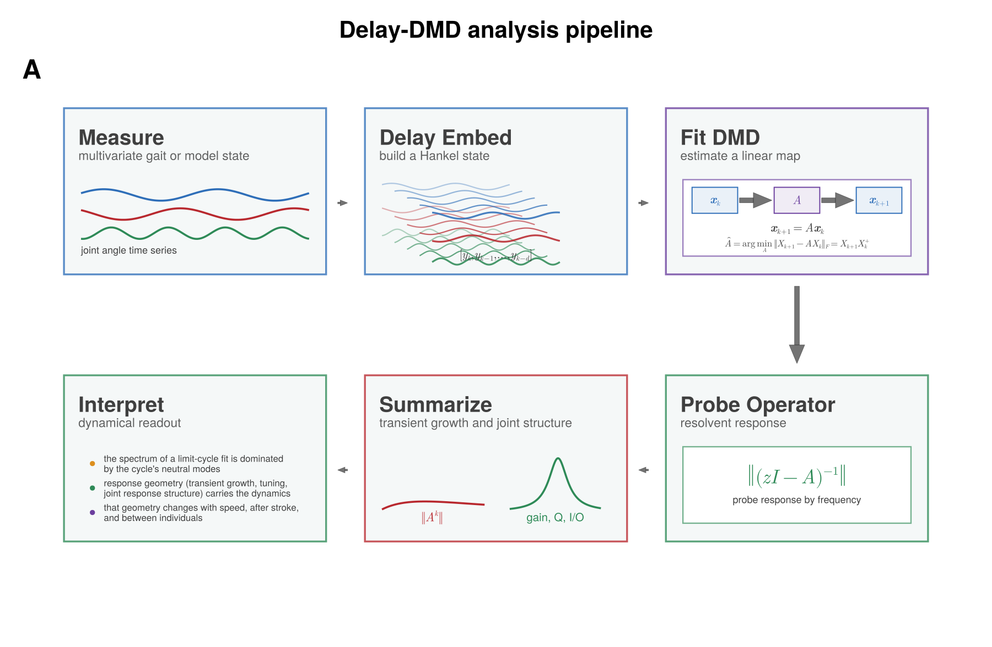
Figure 1. From joint-angle recordings to a fitted, probeable model of the gait cycle. (A) The pipeline used throughout the paper, arranged as a loop. Measure: joint-angle time series (three representative channels in blue, red and green). Delay embed: a window of the d most recent samples is stacked into one state vector [y_k, y_{k−1}, …, y_{k−d}]. Fit DMD: the linear rule x_{k+1} = A x_k that best predicts each state from the one before is estimated by least squares (Â is the fitted estimate). Probe operator: rather than reading the eigenvalues of A, we evaluate its response at every frequency through the resolvent ‖(zI − A)^{−1}‖. Summarize: the probing is condensed into transient growth ‖A^k‖ as a function of elapsed steps k (red) and the frequency response, tuning and joint response structure (green). Interpret: the three questions the paper asks of these summaries, colored to match the measures that answer them.

Calibrating the approach where the answer is already known
Before trusting these measures in gait, we tested them in Stuart–Landau oscillators, a standard two-variable system whose amplitude-growth and phase-coupling behavior can be set directly by two parameters, giving an exactly known answer against which to check our measures (Figure 2A shows the system's phase portrait for one example parameter setting, together with its governing equations). A single model, fit from several example trajectories starting at different distances from the shared limit cycle, forecasts held-out trajectories accurately whether they start from a large-amplitude state or from near the small-amplitude, unstable center of the cycle (Figure 2B).
Scanning both parameters, departure from normality tracked the amplitude-growth parameter closely (Figure 2C), while transient growth depended jointly on both parameters, peaking at intermediate amplitude combined with strong phase coupling (Figure 2D). Frequency-tuning sharpness stayed at its undisturbed ceiling for weak phase coupling and then fell sharply as coupling increased, largely independent of the amplitude parameter (Figure 2E). Together the three panels show a division of labor among the measures: departure from normality and transient growth answer mainly to the amplitude axis, whereas frequency-tuning sharpness – and, in the same way, the effective number of participating dimensions – answers mainly to the phase-coupling axis. Each measure responds to the mechanism it is meant to track rather than to noise or fitting artifacts.
Held against the system's true, analytically known decay rate, the individual measures recover it well but incompletely, and they do so in opposite directions. Departure from normality rises steadily with the true decay rate (R² = 0.90; Figure 2F, left). Transient growth tracks it about equally closely but with the opposite sign: the fitted gain falls as the true decay rate rises (R² = 0.92; Figure 2F, middle). That sign is worth pausing on. It means that in this system the extra, non-orthogonal directions the operator acquires act to damp the response rather than to amplify it – more departure from normality goes with a more strongly contracting cycle, not a more explosive one. Combining all five response measures in a single leave-one-out decoder recovers the decay rate almost exactly (R² = 0.996; Figure 2F, right), with transient growth carrying the largest weight. Point color in all three panels is the phase-coupling parameter, and it shows that the scatter left over by any single measure is organized by coupling – precisely the structure that no one measure captures alone.
As a final check, we asked whether the joint response map recovers a known directional relationship, using a pair of damped oscillators with an imposed one-way coupling. The fitted map identified the driving oscillator as the dominant input whichever oscillator was designated the driver, with the reversed direction carrying only a small residual gain (Figure 2G,H). This is the same calculation used below for joints in gait, here checked against a case where the answer is known by construction.

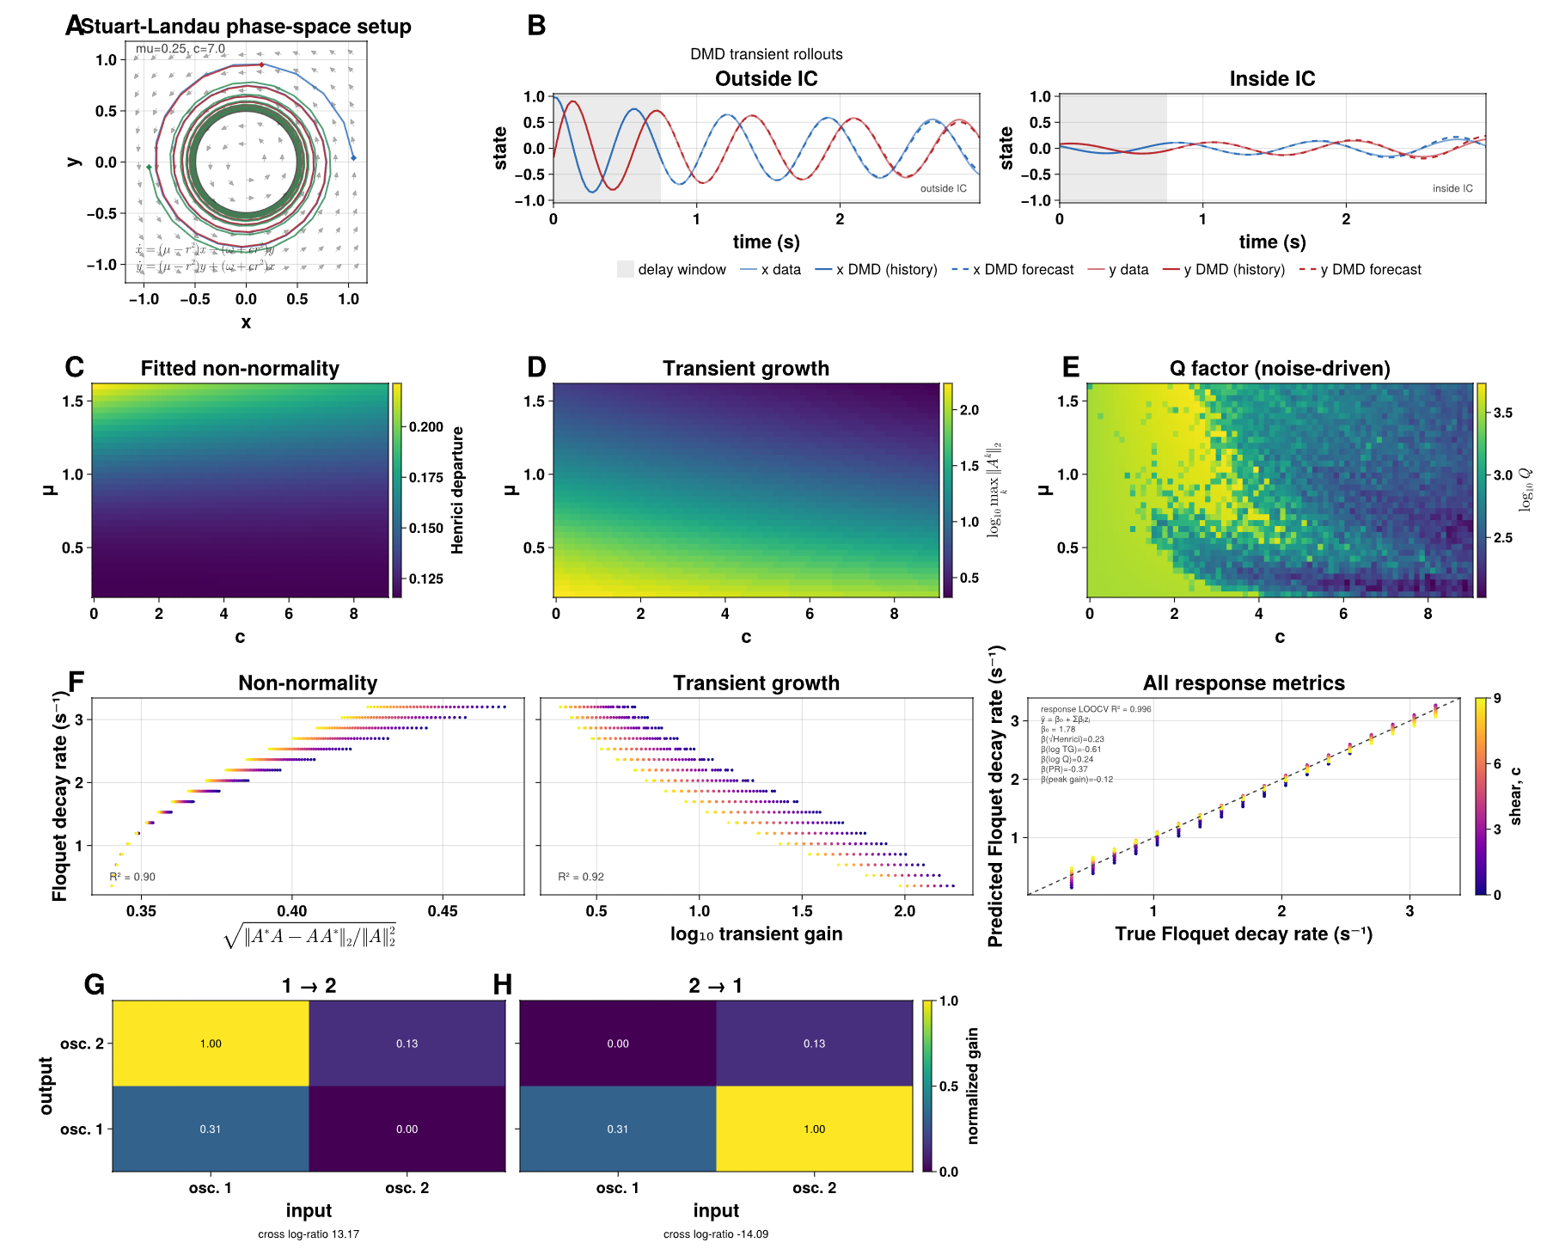
Figure 2. Stuart–Landau oscillators calibrate the response measures. (A) Phase-space portrait of the Stuart–Landau system for one example parameter setting (μ = 0.25, c = 7.0), showing three trajectories converging onto the shared limit cycle; gray arrows show the local vector field, and the governing equations are given at lower left. (B) A single model, fit from several training trajectories spanning large- and small-amplitude starting conditions, rolled forward from two held-out starting points, one far from the origin (left) and one near the unstable center (right). Thin lines are the true x (blue) and y (red) trajectories; thick lines are the model over the shaded initial history window; dashed lines are the forecast beyond it. (C) Departure from normality over the amplitude parameter μ (vertical) and the shear parameter c (horizontal). (D) log₁₀ transient growth over the same grid. (E) Frequency-tuning sharpness (Q-factor), computed from trajectories simulated with process noise (see Methods), over the same grid. (F) The true continuous-time decay rate against √(departure from normality) (left, R² = 0.90), against log₁₀ transient growth (middle, R² = 0.92), and against leave-one-out decoder predictions (right) for the full response-measure set (filled circles, R² = 0.996) and for a decoder built from the DMD eigenvalue moduli (open triangles, R² = 0.90); points are colored by c, and the text box lists the response decoder's coefficients. In this smooth, fully sampled system the eigenvalues also carry the decay rate, which is the expected control. (G, H) Joint response maps for two damped oscillators with an imposed one-way coupling, for both coupling directions; rows are the output oscillator, columns the input, and values are normalized to each map's maximum. The cross log-ratio below each panel quantifies how much more strongly the imposed direction is recovered than its reverse.

In a simple walking model, the fitted spectrum misses the truth that the same fit's response geometry recovers
The spring-loaded inverted pendulum (SLIP) is the simplest widely used mechanical model that actually has a walking-like gait cycle. At each step, the stance leg (Figure 3A, blue then red for successive steps) acts as a spring of fixed stiffness, launching the center of mass at some speed and angle; the return map connecting one step's touchdown state to the next has a stability value, ρ, that can be worked out analytically at every combination of leg stiffness and touchdown angle. We tested 153 combinations that are analytically stable and well-posed, plus three representative combinations – stable (ρ = 0.82), near the stability boundary (ρ = 1.00), and unstable (ρ = 1.12) – used as running examples throughout the figure (consistently colored blue, orange, and red).
The three representative trajectories look qualitatively different even before any model is fit: the stable case settles into a clean, repeating oscillation, the near-boundary case oscillates with only mild drift, and the unstable case grows until the simulated walker falls (Figure 3B). A single model fit to each trajectory's initial history window forecasts several strides ahead accurately in all three regimes, including the unstable one right up to the point of the fall (Figure 3C).
Here the fitted model's own spectrum and its response geometry come apart. Across the full 153-combination grid (Figure 3D), the stability value read off the fitted operator's spectrum carries essentially no information about the true ρ (cross-validated R² = 0.004). The cause is the one described above: a limit cycle has neutral directions, so the fitted spectral radius sits at |λ| = 0.9997–0.9999 per sample across the entire grid, tracking the cycle rather than the rate at which disturbances off it decay. Excluding the neutral modes and taking the largest remaining eigenvalue, converted to a per-step multiplier, does not help (r = −0.25 with the true ρ): each fit shows one dominant conjugate pair at 0.96–0.99 per step and then a gap to 0.01–0.5, with nothing near the true ρ of 0.75–0.99. The transverse multiplier is simply not resolved by these fits.
The walker's own return map, by contrast, recovers ρ accurately, as it should: this system has an exactly period-matched Poincaré section, the setting the classical estimator was designed for. Estimating the Floquet decay rate from the return map gives a median absolute error of 0.022, against 0.112 for a decoder built from the full response-measure set and 0.185 for one built from transient growth alone (Figure 3E). Where such a section exists, the classical estimator is the right tool and we use it as the reference. Its error does rise for very short records (from 0.012 to 0.134 at 15% of the simulated trial length).
What the response measures add is information that the spectrum of the same fit does not carry. Departure from normality (Figure 3F), the frequency response (Figure 3G; the unstable regime's gain stays elevated across a wider range of stride-related rhythms), transient growth (Figure 3H) and effective dimensionality (Figure 3I) each track part of the variation in the true decay rate, and combined into a single decoder they reach R² = 0.42 (Figure 3J, rightmost), against 0.004 for the spectral radius. The fitted operator does contain information about how stable this walker is; it is simply not in its eigenvalues.
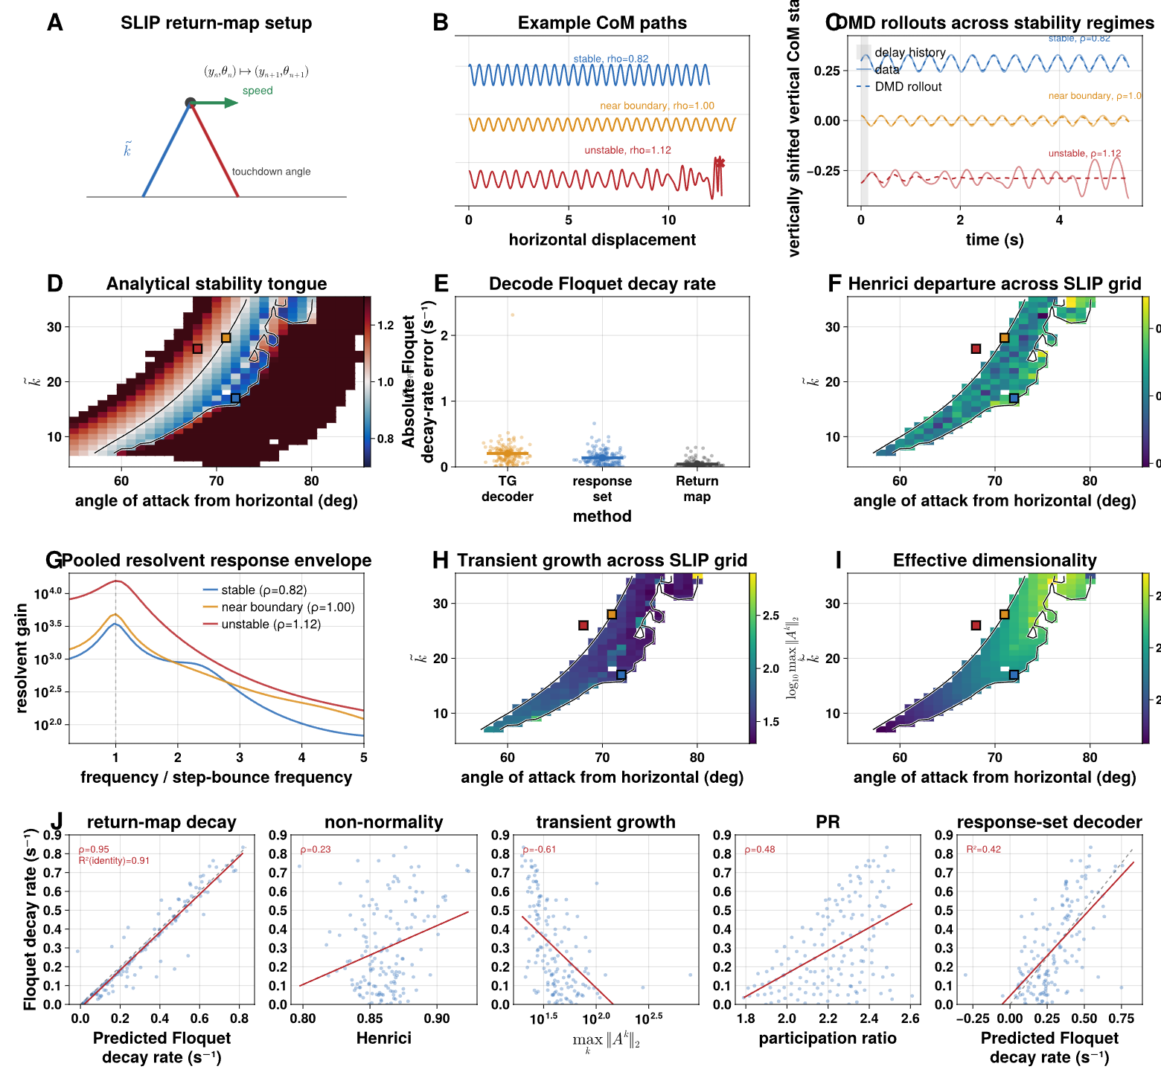
Figure 3. In a mechanical walking template (SLIP), the fitted operator's spectrum carries almost no information about stability while its response geometry does, and the walker's own return map recovers it accurately. (A) Schematic of one return-map step: the stance leg (blue) launches the center of mass, becoming the next step's stance leg (red) at its own touchdown angle; k̃ is the dimensionless leg stiffness. (B) Example center-of-mass paths for three regimes: stable (blue, ρ = 0.82), near the stability boundary (orange, ρ = 1.00) and unstable (red, ρ = 1.12, ending in a fall). (C) Vertical center-of-mass state over time for the same three regimes (offset for clarity), with the model fit over the shaded history window (solid) and forecast beyond it (dashed). (D) Analytical return-map multiplier ρ over angle of attack and k̃; the black contour marks ρ = 1, and the colored squares mark the representative points. (E) Absolute error in the continuous-time Floquet decay rate for a decoder built from transient growth alone, a decoder built from the full response-measure set, and direct estimation from the return map; bars mark medians. (F) Departure from normality over the stable region. (G) Pooled frequency-response curves for the three regimes, normalized to the fundamental. (H) log₁₀ transient growth over the grid. (I) Effective dimensionality (participation ratio) over the grid. (J) The true decay rate against the return-map estimate (leftmost; dashed identity line; Spearman r_s = 0.95, identity R² = 0.91), departure from normality (r_s = 0.23), transient growth (log axis; r_s = −0.61), effective dimensionality (r_s = 0.48), and the combined response-set decoder (rightmost; R² = 0.42); red lines are least-squares fits.

Three walking robots: multi-stride forecasts and machine-specific operator structure
Moving to real, multi-joint kinematics with known mechanics and control, we fit models to motion-capture recordings from three bipedal robots – Unitree H1, Boston Dynamics Atlas, and Unitree G1 – walking, running, and performing other locomotor behaviors on a shared set of ten joint angles (Figure 4A). An example held-out walking trial for one robot (Figure 4B) shows the fitted model's forecast tracking two of its ten joint angles closely for several strides beyond the initial history window. Across the full set of forecast horizons tested, the fitted models beat a strong phase-averaged baseline at 95% of the horizons tested for both walking and running gaits – by a factor of roughly two at half a second ahead, and still by two-thirds at four and a half seconds ahead, about four stride cycles (Figure 4C).
Comparing the three robots, transient growth during walking separates the machines (Figure 4D), in a direction consistent with their differing mechanics and control. As in the human data below, each robot's joint response map is rank one, so it reduces to a reception and a drive profile (Figure 4E). Unlike in humans, the drive profile is not flat: in all three machines hip flexion dominates both how strongly joints drive and how strongly they receive the dominant mode. For the two most comparable robots, H1 and Atlas, the profiles agree closely across their ten shared joints (reception r = 0.94, drive r = 0.89; Figure 4F). The differences that do exist are small and anatomically localized: H1 places more reception at right hip flexion and left hip rotation, Atlas more at the ankles (Figure 4G), consistent with how the two platforms actuate the hip and with Atlas's additional ankle degree of freedom.

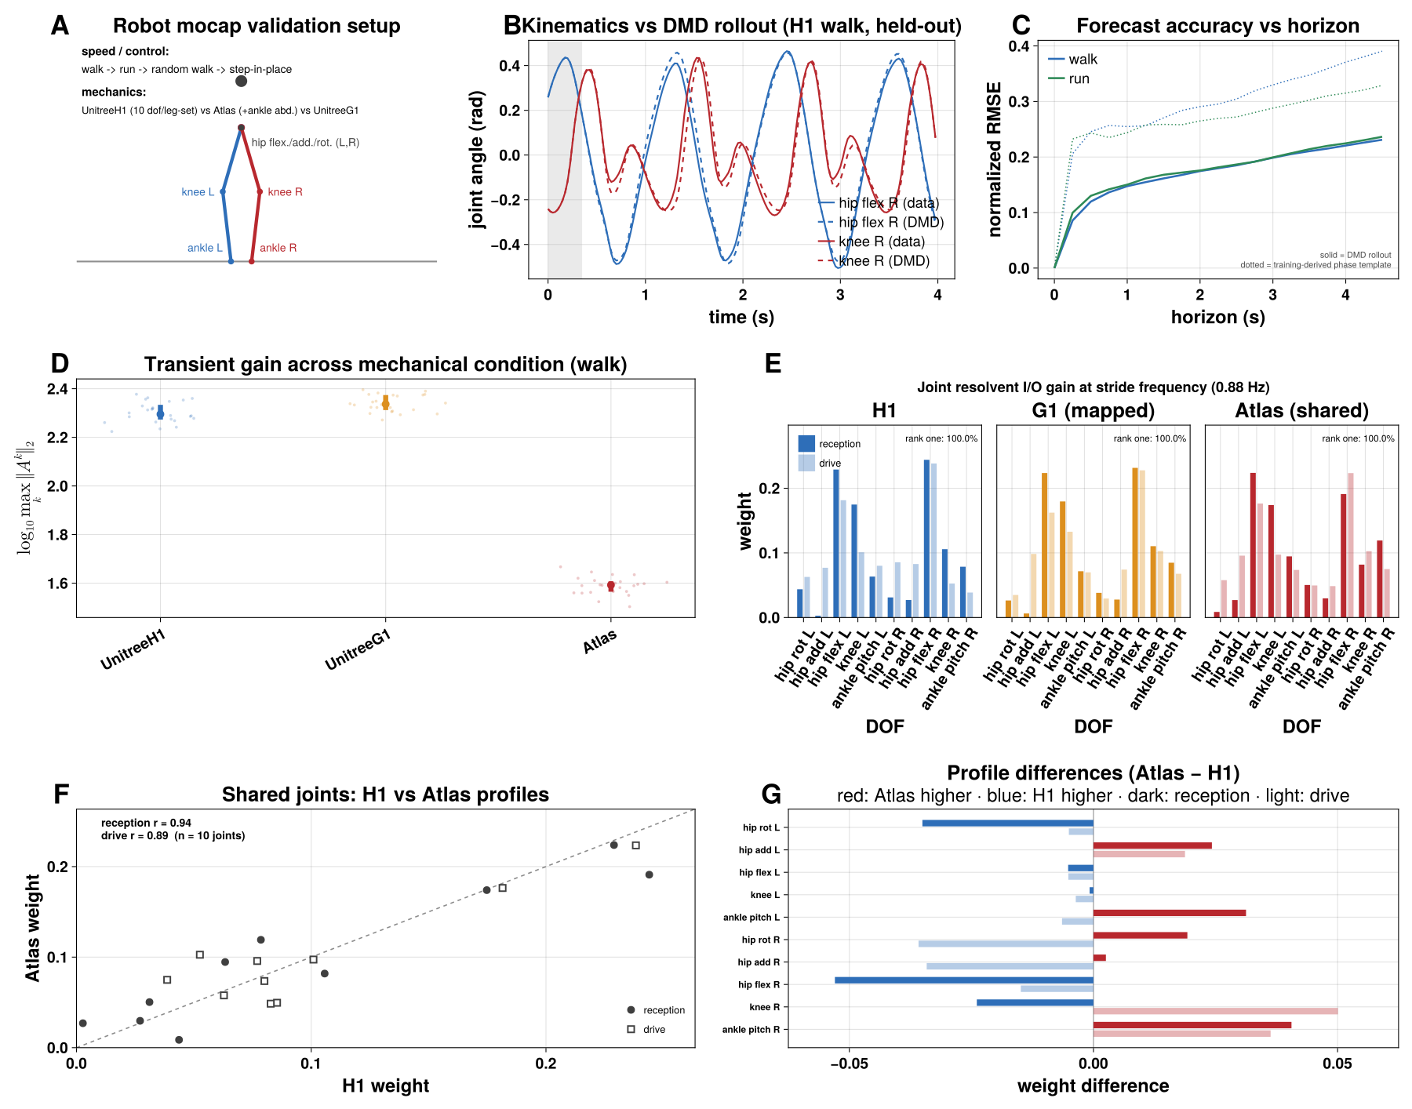
Figure 4. Three walking robots: multi-stride forecasts and machine-specific operator structure. (A) Validation setup: locomotor behaviors (walk, run, random walk, step-in-place) and the three robots (Unitree H1, Boston Dynamics Atlas, which additionally has ankle abduction, and Unitree G1). (B) An example held-out walking trial: hip flexion (blue) and knee flexion (red), true (solid) versus forecast (dashed), with the initial history window shaded. (C) Forecast error (normalized RMSE) versus horizon for walking (blue) and running (green); solid lines are the model, dotted lines a training-derived phase-average template. (D) log₁₀ transient growth during walking for each robot; trials as jittered points with mean ± SEM. (E) Reception (dark) and drive (light) profiles of each robot's rank-one joint response map at the stride frequency, in the robot's color, on a shared ten-joint set. (F) H1 against Atlas weight for each shared joint, reception (filled circles) and drive (open squares); the dashed line marks equality. (G) Atlas minus H1 difference for each joint, reception (dark) and drive (light); red bars are joints where Atlas is higher, blue where H1 is higher.

Healthy human walking: the operator's geometry changes with speed
We fit models to 150 treadmill-walking recordings from 17 healthy young adults spanning 30–220 cm/s (Figure 5A). Each recording was rescaled uniformly in time so that its mean stride spans 100 samples, and every operator was fit with the same ridge penalty (Methods), which makes the results independent of the retained rank.
The fitted operators track each walker's joint angles well beyond the history used to start them (Figure 5B). Rolled forward on held-out data, they forecast more accurately than a phase-averaged template built from the same training data: normalized error 0.135 against 0.314 at half a stride (model better in 16 of 17 subjects, sign test p < 0.001) and 0.156 against 0.312 at one stride (14 of 17, p = 0.013), with the advantage no longer consistent across subjects by two strides (Figure 5C). The template cannot follow stride-to-stride variation in period, which the dynamical model tracks; beyond that, both converge on the average cycle. The models are thus faithful generators of each walker's rhythm, which is what licenses reading their geometry.
That geometry changes consistently with speed within every person. As walking speeds up, effective dimensionality falls (participation ratio decreased with speed in all 17 subjects, mean within-subject r = −0.88), transient growth falls (17 of 17, r = −0.83; median about 1.9-fold over a stride) and the stride peak of the frequency response sharpens (Q increased in 16 of 17, r = +0.46; Figure 5D, F; sign tests p < 0.001). The pooled frequency responses show the same narrowing of the fundamental and its harmonics at faster speeds (Figure 5E). Faster walking is thus generated by dynamics that occupy fewer independent directions, amplify disturbances less over a stride and are more narrowly tuned to it. Departure from normality also falls with speed (Figure 5D, left), but because its group differences change sign across rank and regularization strength (Supplementary Information) we do not interpret it further.
The joint response map is rank one in every recording (99.9% of its energy in the first singular value, against about 81% for a shuffled null), so it reduces to a reception profile and a drive profile (Figure 5G). The structure lies mainly in reception, which is concentrated at the knees and hips with little at the ankles. With increasing speed, reception shifts from the knees and ankles toward the hips: the knees' combined share falls from 0.49 in the slowest third of trials to 0.42 in the fastest and the ankles' from 0.16 to 0.10, while the hips' rises from 0.35 to 0.48 (Figure 5H, slow to fast panels).

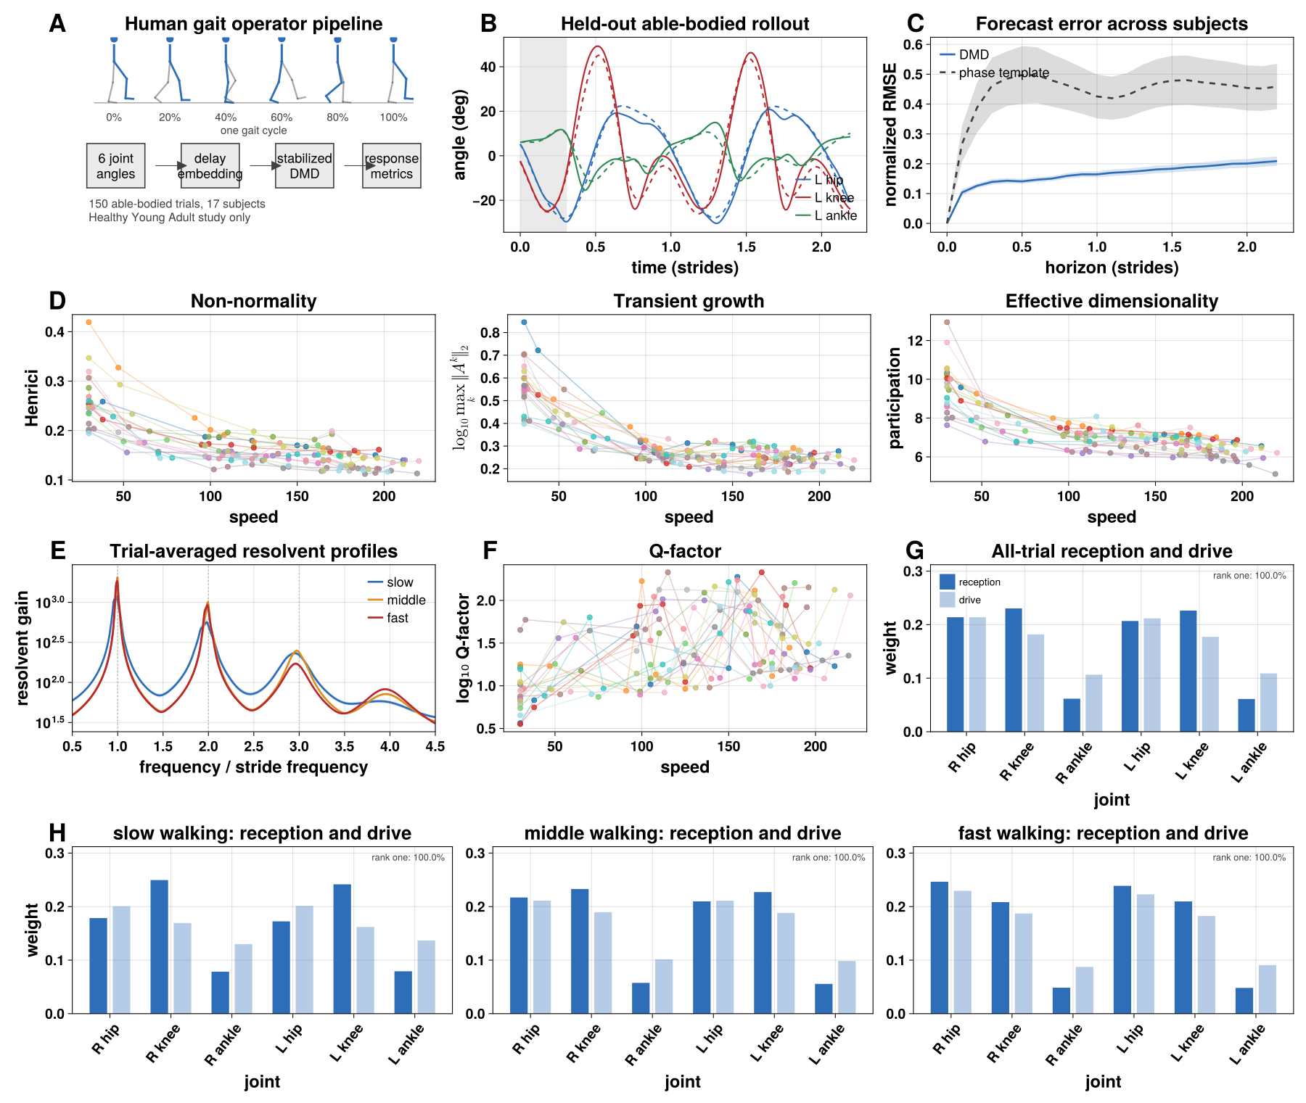
Figure 5. Healthy walking: the fitted operators forecast each walker's gait, and their geometry changes systematically with speed. (A) Pipeline applied to 150 trials from 17 subjects (Healthy Young Adult study). (B) An example held-out trial on the stride-rescaled time base: left hip (blue), knee (red) and ankle (green), true (solid) versus forecast (dashed), with the initial history window shaded; time in strides. (C) Forecast error (normalized RMSE, mean and across-subject band) versus horizon in strides for the model (blue) and a phase-averaged template from the same training data (dashed). (D) Departure from normality (Henrici), log₁₀ transient growth over one stride, and effective dimensionality (participation ratio) against walking speed (cm/s); each subject's trials are connected and colored by subject. (E) Resolvent gain against frequency in units of the stride frequency (geometric mean over trials within three speed bins; bands are SEM), evaluated on the same grid as Figure 6B; dotted lines mark harmonics. (F) log₁₀ Q-factor of the stride peak against speed. (G) Reception (dark) and drive (light) profiles of the rank-one joint response map, pooled over all trials, in the same convention as Figure 6D–F. (H) The same profiles for slow, middle and fast walking (thirds of the trials by speed), on a shared scale.

Post-stroke walking: graded transient growth and a paretic knee that drops out of the dominant mode
We applied the identical pipeline to 149 recordings from a post-stroke study: 30 trials from 5 able-bodied controls, 65 from 11 higher-functioning and 54 from 9 lower-functioning stroke survivors. The functional groups were defined by self-selected walking speed, so group and speed are partly the same variable: the able-bodied (90–160 cm/s) and lower-functioning (22–60 cm/s) groups do not overlap in speed at all, and only the higher-versus-lower-functioning comparison can be made at matched speed. All contrasts below are between subjects.
Transient growth is graded by walking ability (Figure 6A, middle): median log₁₀ growth over a stride is 0.27 in able-bodied controls, 0.39 in higher-functioning and 0.59 in lower-functioning survivors, about 1.9-, 2.5- and 3.9-fold. Every pairwise contrast is large (higher functioning vs controls d = +2.38, p = 0.001; lower vs higher functioning d = +1.94, p < 0.001). Because transient growth also falls with speed in healthy walkers (Figure 5D), part of this gradient mirrors walking speed; the contrast between the two stroke groups, whose speed ranges overlap, is the one least confounded by it. Effective dimensionality does not differ between groups (Figure 6A, right). Departure from normality is higher in the lower-functioning group (left) but, as noted above, is not interpreted.
The frequency response of stroke gait is less sharply tuned. Gain between the stride harmonics is elevated in both stroke groups, most in the lower-functioning group, and the harmonic peaks are lower and broader (Figure 6B). Q is lower than in controls in both higher-functioning (d = −1.44, p = 0.018) and lower-functioning survivors (d = −2.86, p = 0.001; Figure 6C).
The joint response structure localizes the change. As in healthy walking the map is rank one in every trial (Figure 6H), and drive is nearly uniform, so each group is summarized by its reception profile (Figure 6D–F). Controls are symmetric, with the knees receiving most strongly. In both stroke groups the paretic knee's reception falls and the non-paretic knee's rises; in the lower-functioning group the paretic knee receives no more than the paretic hip, and the non-paretic knee becomes the dominant joint of the mode.
Comparing paretic and non-paretic sides within each trial (Figure 6G), the paretic deficit is concentrated at the knee (paretic minus non-paretic reception −0.009 ± 0.002 in higher-functioning and −0.028 ± 0.002 in lower-functioning survivors, mean ± SEM over trials), smaller at the hip (−0.002 and −0.015), and absent at the ankle. Because reception is a share of each trial's total, this is a redistribution within the dominant mode: the paretic knee expresses less of it and the non-paretic side more. Since the operator is primarily a generator of the mean cycle, this redistribution largely reflects the reduced paretic-knee excursion in that cycle; what the operator adds is to express it as a change in the structure of a single dynamical mode.
We also screened whether any operator measure tracked the Berg Balance Scale or the Fugl-Meyer assessment beyond walking speed (Figure 6I). Speed alone correlates with the Berg score at r = 0.70; the best of 38 screened operator measures, median log Q, reaches only r = 0.48. For the Fugl-Meyer assessment speed is a weak predictor (r = 0.28), and the best screened measure, the change in non-paretic hip reception with speed, reaches ρ = 0.67. Each is the maximum of a screen of 38 candidates in 13 (Berg) or 20 (Fugl-Meyer) people and none survives correction for the screen; we report them as exploratory.

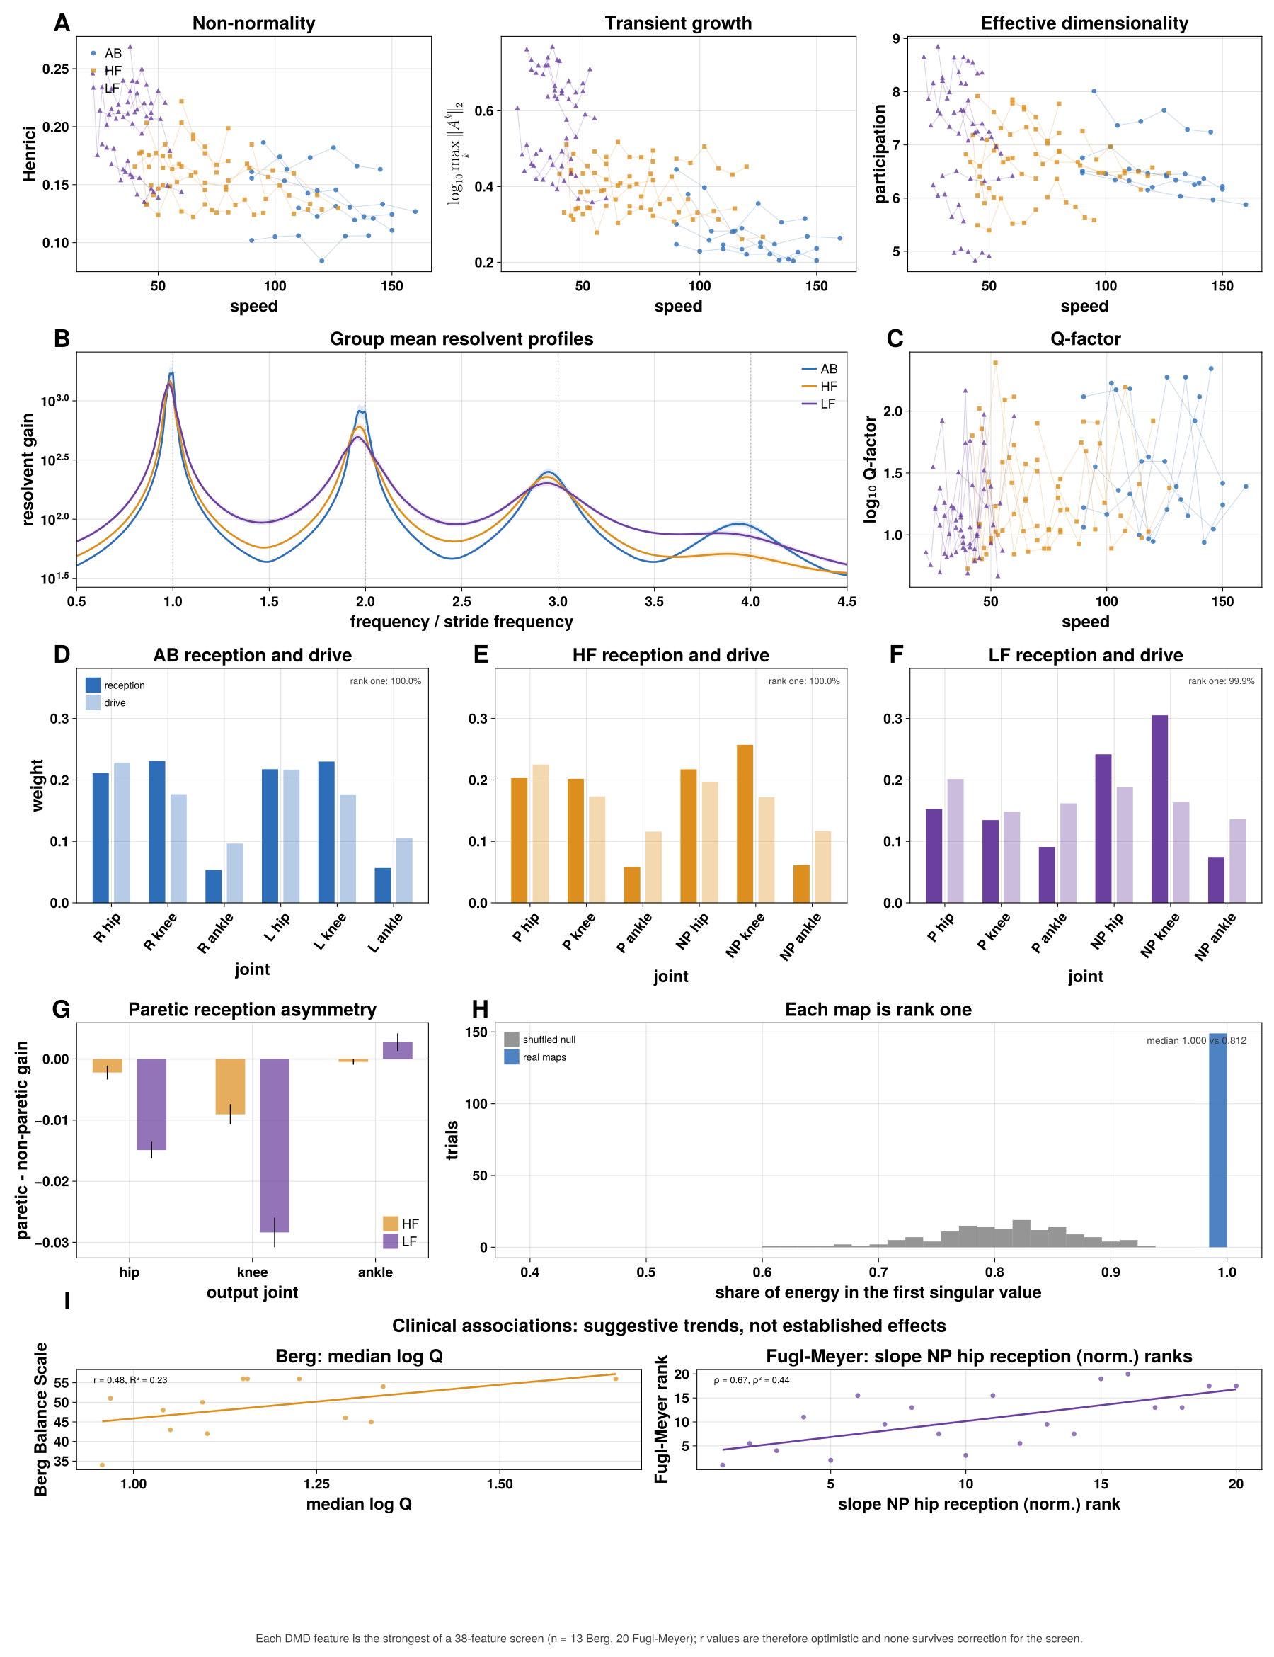
Figure 6. Post-stroke walking: graded transient growth, broader tuning, and a paretic knee that drops out of the dominant mode. (A) Departure from normality (Henrici), log₁₀ transient growth over one stride, and effective dimensionality against walking speed (cm/s), by group (able-bodied, blue circles; higher-functioning, orange squares; lower-functioning, purple triangles). (B) Resolvent gain against frequency in units of the stride frequency (geometric mean over trials within each group; bands are SEM), on the same grid as Figure 5E. (C) log₁₀ Q-factor of the stride peak against speed. (D–F) Reception (dark) and drive (light) profiles of the rank-one joint response map for able-bodied (D), higher-functioning (E) and lower-functioning (F) groups; joints are paretic (P) and non-paretic (NP); able-bodied trials use a right/left convention (Methods). (G) Paretic minus non-paretic reception by joint for the two stroke groups (mean ± SEM over trials). (H) Share of each map's energy in its first singular value, real maps against a shuffled null. (I) Exploratory clinical screen: Berg Balance Scale against median log₁₀ Q, and Fugl-Meyer rank against the speed slope of non-paretic hip reception; each is the best of a 38-feature screen and none survives correction.

Individual operator signatures
Group averages leave open whether the operator's geometry is specific to the individual. To test this we pooled every human recording, 299 trials from 42 people, and used only the normalized joint response map, which is insensitive to the overall response scale on which the two source studies differ (Methods). Each person's map is expressed as a deviation from the able-bodied reference, in units of the able-bodied spread on each joint pair.
The two able-bodied cohorts, recorded in different studies, do not separate on either the overall size of the deviation (p = 0.91) or its leading direction (p = 0.72; Figure 7A). The size of the deviation, an abnormality score, is strongly graded by walking ability: 1.0 able-bodied standard deviations in controls, 2.1 in higher-functioning and 4.1 in lower-functioning survivors (η² = 0.70, p = 0.0002; Figure 7B).
Decomposing the direction of each stroke survivor's deviation, a single shared axis accounts for 62% of the variance and is dominated by the paretic knee and paretic hip rows of the map, the same reduced paretic reception seen in Figure 6G (Figure 7C). A second axis, accounting for 13%, is not anatomically localized and is not graded by severity (Figure 7D). The remaining quarter of the variance is specific to individuals.
That individual component is reproducible. Splitting each person's recordings into two independent halves, the two halves of the same person point in similar directions (mean cosine similarity 0.68) while halves from different people do not (0.06; Figure 7E), and a held-out half identifies its owner as the nearest of 42 candidates 65% of the time, against 2.4% expected by chance. All recordings of a person come from a single session, so this is within-session reproducibility. People with similar abnormality scores can have quite different deviation patterns (Figure 7F).
Against the clinical scales, walking speed remains the stronger predictor: the abnormality score correlates with the Berg Balance Scale at r = −0.30 (speed: r = 0.70; partial correlation given speed 0.05) and with the Fugl-Meyer assessment at r = −0.27 (speed: r = 0.28; partial −0.14; Figure 7G).
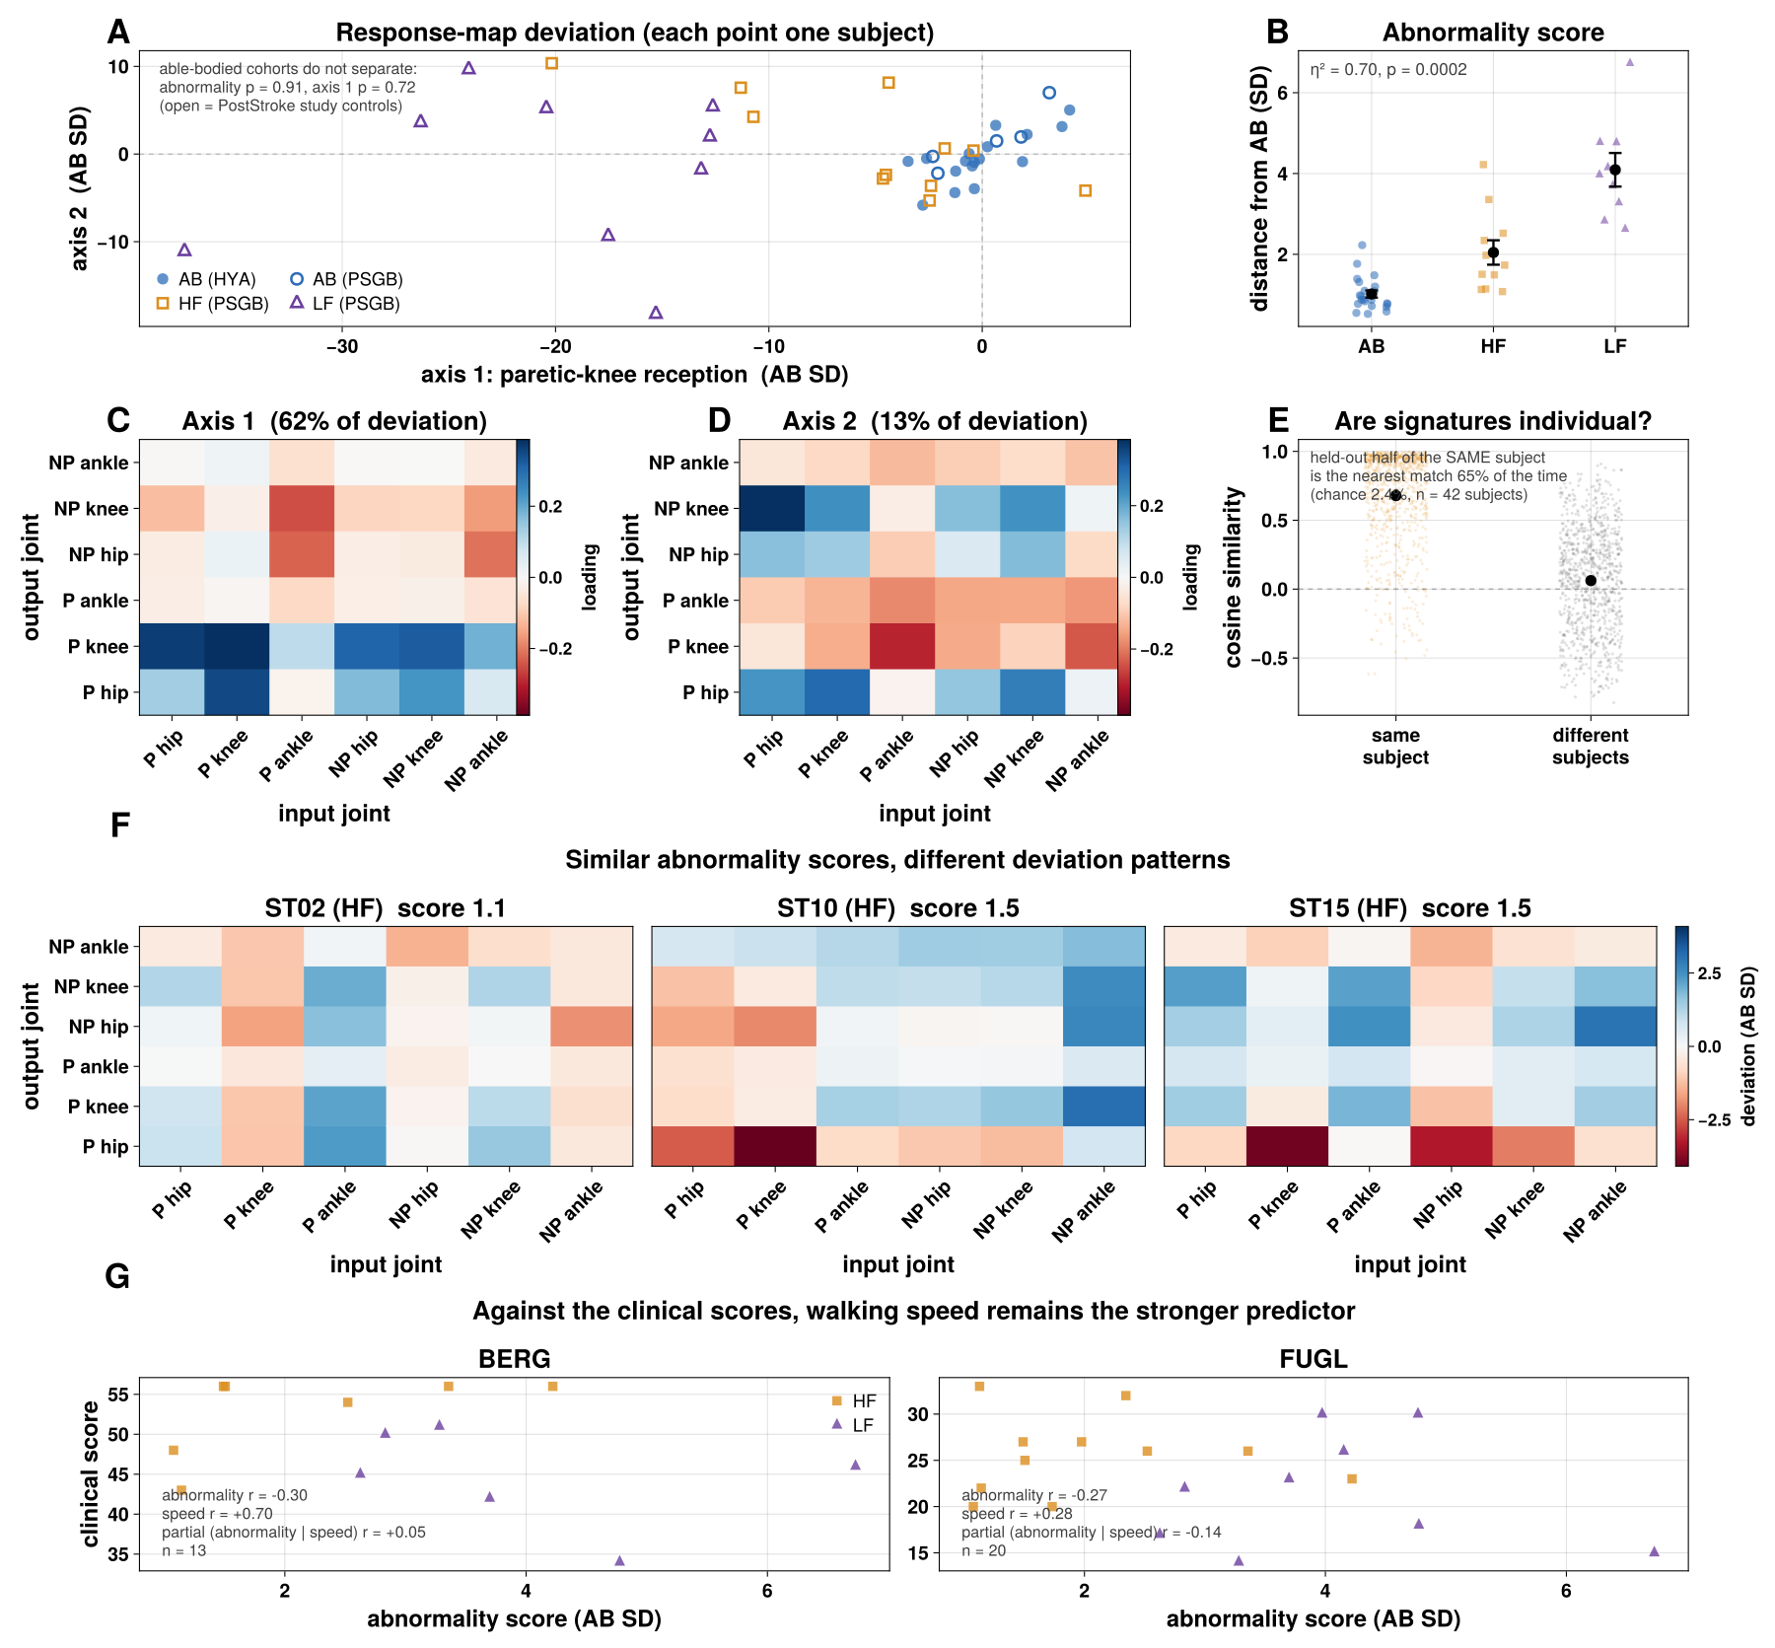
Figure 7. Individual operator signatures. (A) Every subject (n = 42, both studies) on the two shared deviation axes in C and D; filled circles are Healthy Young Adult subjects, open circles PostStroke-study controls, orange squares higher-functioning and purple triangles lower-functioning stroke survivors; the annotation tests whether the two able-bodied cohorts differ. (B) Abnormality score (root-mean-square deviation from the able-bodied reference, in able-bodied standard deviations) by group; η² and permutation p annotated. (C, D) The two shared deviation axes as 6 × 6 loading maps (output joint by row, input joint by column); axis 1 (62% of the variance among stroke survivors' deviations) is dominated by the paretic knee and hip rows; axis 2 (13%) is not anatomically localized. (E) Cosine similarity between deviation vectors from independent halves of the same subject's recordings versus different subjects'; the annotation gives the nearest-neighbor identification rate against chance. (F) Three subjects with similar abnormality scores (1.1–1.5), each shown as a 6 × 6 deviation map on a shared scale. (G) Abnormality score against the Berg Balance Scale (left) and Fugl-Meyer assessment (right), with the correlations with abnormality, with speed, and the partial correlation given speed.

Discussion
Fitted to short recordings of unperturbed walking, a linear operator on delay coordinates is a faithful generator of each walker's gait cycle, and its geometry is both simpler and more informative than its spectrum. Simpler, because the joint-resolved response at the stride frequency is rank one in every human recording: the dynamics that generate the cycle are organized around a single dominant mode, and what differs between walkers is how strongly each joint expresses it. More informative, because that expression, the mode's tuning and its transient growth change systematically with walking speed, with impairment after stroke, and between individuals, whereas the spectrum of an operator fitted to a limit cycle is dominated by the cycle's own neutral modes (Figure 3).
These results place the operator alongside, not in place of, existing descriptions of gait dynamics. Floquet multipliers and local divergence exponents quantify how quickly the cycle attracts nearby trajectories [CITE – Dingwell & Cusumano; Bruijn et al.]; our calibrations show that a fitted spectrum does not recover them from limit-cycle data, and that where a period-matched section exists the return map remains the right estimator. What the operator adds is the finite-time and driven response, quantities that are invisible to the spectrum of a non-normal operator [CITE – Trefethen & Embree], and a joint-resolved organization that is computed from kinematics alone. That organization is compatible with the muscle-synergy picture of stroke as a reorganization of coordination rather than a uniform degradation [CITE – Clark et al.; Neptune et al.]: here the paretic knee drops out of the dominant mode and the non-paretic knee takes over.
The healthy speed dependence has a natural dynamical reading. Faster walking is generated by dynamics that occupy fewer effective dimensions, amplify disturbances less over a stride and are more narrowly tuned to it, with the dominant mode shifting from the knees toward the hips. Stroke gait shows the same signature in the other direction: broader tuning, more gain between the stride harmonics and larger transient growth. Because stroke survivors also walk more slowly, these two observations are entangled, and only the contrast between the two stroke groups, whose speeds overlap, isolates an effect of impairment. Larger transient growth means that the fitted dynamics amplify some initial states more before the cycle reasserts itself; whether this reflects a genuinely less robust gait or a cycle that is less tightly constrained cannot be decided from unperturbed data.
That last point is the main limit on what this instrument can resolve. More than 95% of the variance in these recordings is the mean gait cycle, so the operators are determined chiefly by the geometry of the generated cycle and only weakly by the transverse dynamics that govern recovery from perturbations. The reduced paretic-knee reception, in particular, largely reflects the reduced paretic-knee excursion in that cycle. Without perturbations, or a denser sampling of the state space than ordinary walking provides, we therefore make no claims about transverse stability in the human data; we report the geometry and transient growth of the fitted models. A related point is that the joint response map describes the model's internal organization between joint histories, not the response to a physical push at one joint, which would require a measured input.
Several further limitations apply. The stroke groups contain 9 to 11 people each, the able-bodied comparison group in that study only 5, and functional group is defined by walking speed, so the able-bodied and lower-functioning groups cannot be compared at matched speed; the higher-versus-lower-functioning contrasts are the ones least confounded by speed. Only sagittal-plane angles were recorded, so frontal- and transverse-plane strategies are not observed. All of a person's recordings come from one session, so individual signatures are reproducible within a session; their stability over time is untested. Operator norms depend on the coordinates and rank, which is why we fix both and compare transient growth only within a dataset. The clinical associations are exploratory and do not exceed walking speed.
The natural next experiments follow from these limits: walking recordings with controlled perturbations or measured assistive inputs, which would let the same pipeline estimate transverse dynamics and input-specific responses directly, and repeated sessions, which would test whether individual signatures are stable traits. Within those limits, a linear operator fitted to a short recording already provides a compact, interpretable view of the dynamics that generate a person's walking, and of how those dynamics reorganize with speed and after stroke.

Methods

Datasets
Human kinematics comprise six sagittal joint angles (hip, knee and ankle flexion, bilaterally) sampled at 100 Hz over 15 s treadmill trials, from two studies: a healthy young adult study (150 trials, 17 subjects) and a post-stroke gait study (149 trials, 25 subjects: 30 trials from 5 able-bodied controls, 65 from 11 higher-functioning and 54 from 9 lower-functioning stroke survivors). Higher- and lower-functioning groups were defined by self-selected walking speed. Stroke channels are ordered paretic limb first in the source export; able-bodied channels are taken as right limb first. Robot recordings are motion-capture trajectories for Unitree H1, Boston Dynamics Atlas and Unitree G1 mapped to a shared ten-degree-of-freedom set, sampled at 100 Hz. [TO CHECK – acquisition citations, demographics and ethics statements for both human studies.]

Stride rescaling, delay coordinates and model fitting
Each human trial is first rescaled uniformly in time so that its mean stride spans 100 samples. The mean stride frequency is obtained from the total phase advance over the trial of the analytic signal (Hilbert transform) of the first principal component of the six angles, a quantity that is robust even where the instantaneous phase briefly runs backwards, and the trial is resampled by linear interpolation. Unlike phase normalization, this does not warp the timing within a stride or require an instantaneous phase estimate, but it makes every model's delay window and response horizon the same fraction of a stride regardless of cadence; with windows fixed in samples, cadence alone otherwise changes transient growth. All horizons are stated in strides. Let y_t denote the p-dimensional vector of joint angles at sample t (p = 6 for human trials, p = 10 for robots), after subtracting each channel's mean. We stack d consecutive samples into a single delay-coordinate state:
x_t = [ y_t ; y_{t−1} ; … ; y_{t−d+1} ] ∈ ℝ^{dp}
so that x_t carries not only the current posture but its recent history, which lets a linear model represent velocity- and acceleration-like information without explicit differentiation. We use d = 32 samples for every human model, about a third of a stride.
Given a sequence of states, we form two matrices whose columns are, respectively, all delay-coordinate states except the last and all delay-coordinate states except the first – that is, corresponding columns of X and Y are one sample apart in time – and fit the single linear operator A that best predicts each state from the one immediately before it, in the least-squares sense:
Â = argmin_A ‖Y − AX‖_F = Y X^{+}
where X^{+} denotes the Moore–Penrose pseudoinverse and ‖·‖_F the Frobenius norm. In practice we never solve this at full dimension dp. We first take the (economy) singular value decomposition X = U S V^T, retain only its leading r columns (U_r, S_r, V_r), and fit a reduced r × r operator
Ã = U_r^T Y V_r S_r^{−1}
which is the standard exact DMD algorithm [CITE – Tu et al. 2014]. For the human models we replace S_r^{−1} with the ridge (Tikhonov) filter S_r (S_r² + α s_1² I)^{−1}, where s_1 is the largest singular value, so that directions the data explore only weakly are suppressed rather than inverted. We use α = 10^{−4} and r = 70; with this penalty every response measure is identical for any r ≥ 40 (see "Choosing model complexity").
Because Ã is fit from finite, noisy data, some eigenvalues can fall slightly outside the unit circle, which would make multi-stride forecasts diverge. We pin any eigenvalue with |λ| > 1 onto the unit circle in the real Schur basis of Ã (scaling the corresponding 1 × 1 or 2 × 2 diagonal block), which, unlike rescaling eigenvalues in an eigenvector basis, is an orthogonal change of basis and cannot amplify the operator. Every response measure is computed from the stabilized operator.

Forecasting
Forecasts are evaluated on data not used for fitting: the operator is fit on an initial segment of the trial and rolled forward from history windows in the remaining segment. From an observed history window x_0 we project onto the reduced coordinates, z_0 = U_r^T x_0, iterate z_k = Ã z_{k−1}, and reconstruct the current joint angles, ŷ_k = (U_r z_k)_{1:p}. The phase-averaged template baseline is the mean cycle of the same training segment, phase-aligned to the start of each forecast. Accuracy is the normalized root-mean-square error over the forecast window,
NRMSE = RMS(ŷ − y) / RMS(y)
where RMS(·) is the root-mean-square taken over both time and joint channels in the forecast window, so an NRMSE of 1 is equivalent in scale to simply reporting zero for every channel.

Response measures
Transient growth. We compute the operator 2-norm (largest singular value) ‖Ã^k‖_2 for every whole number of steps k from 0 up to K, and report the maximum:
TG = max_{k=0,…,K} ‖Ã^k‖_2
We take K = 100 steps (one stride on the rescaled time base) for human models and K = 4d for robot models.
Departure from normality. A matrix is normal if it commutes with its transpose (A^TA = AA^T), in which case its eigenvectors can be chosen orthogonal and its eigenvalues fully determine its transient behavior. We measure departure from this condition with a normalized commutator norm (labeled Henrici in the figures):
dep(Ã) = ‖Ã^TÃ − ÃÃ^T‖_2 / ‖Ã‖_2^2
which is 0 exactly when Ã is normal and increases toward 1 as its eigenvectors become more skewed relative to one another.
Frequency response. For a frequency f in cycles per sample, we evaluate the resolvent of Ã on the unit circle:
z = exp(i·2π·f / f_s), gain(f) = ‖(zI − Ã)^{−1}‖_2 = 1 / σ_{min}(zI − Ã)
where σ_min is the smallest singular value. Scanning f from 0 to the Nyquist frequency gives the full frequency-response curve. On the rescaled time base the mean stride frequency is f_0 = 1/100 cycles per sample, and harmonic gains are evaluated at f_0, 2f_0, 3f_0, …. Tuning sharpness (the Q-factor) is the ratio of the peak frequency to the half-power bandwidth around it, and is reported on a log scale:
Q = f_{peak} / (f_{right} − f_{left}), gain(f_{left}) = gain(f_{right}) = gain(f_{peak})/√2
For the calibration analysis in Figure 2E, this quantity is only meaningful if the underlying trajectory actually contains a disturbance for shear-induced phase drift to act on; a trajectory integrated with zero noise carries no such information regardless of the true underlying physics (see Discussion). We therefore compute Figure 2E from trajectories simulated with additive process noise (not measurement noise added after the fact), averaged over 8 noise realizations per grid cell; every other figure's Q-factor is computed directly from the recorded or simulated trial as described above.
Effective dimensionality. From the singular values σ_1, σ_2, … of the delay-coordinate data matrix X used to fit the model, we compute the participation ratio
PR = (Σᵢ σᵢ)² / Σᵢ σᵢ²
which equals the true rank if all retained singular values are equal, and falls toward 1 as the variance concentrates onto a single dominant direction; it is a continuous, data-driven stand-in for "how many effective coordination patterns" the recording actually uses.
Joint response map, reception and drive. For an input joint and an output joint we evaluate how strongly the resolvent at the stride frequency maps the input joint's delay-coordinate block onto the output joint's, through the reduced subspace U_r:
G_{out,in} = ‖ C_{out} (zI − Ã)^{−1} B_{in} ‖_2
where B_in and C_out select the rows of U_r for the input and output joints' d delayed copies. Collecting G_out,in over all pairs gives a p × p map, normalized to sum to one. This is a gain between joint histories, not the response to a physical perturbation applied at one joint. Because every human map is rank one (median share of energy in the first singular value 0.999, against 0.81 for maps with shuffled entries), we summarize each map by its leading left and right singular vectors, normalized to sum to one: the reception profile (how strongly each joint receives) and the drive profile (how strongly each joint drives).

Choosing model complexity
Without regularization, transient growth of a delay-coordinate DMD operator rises steadily with the retained rank r, because the trailing singular directions, which the data explore only at tiny amplitude, are inverted and then mapped back onto the dominant ones. We therefore regularize rather than truncate. In a sweep over r ∈ {10, 20, 40, 70, 100, 150} and α ∈ {0, 10^{−6}, 10^{−5}, 10^{−4}, 10^{−3}} across all 299 trials, α = 10^{−4} made transient growth and every other response measure identical for all r ≥ 40, while held-out forecast error at half a stride (0.17) matched the best unregularized fits; α = 10^{−3} over-smoothed the dynamics (error 0.23). The group differences in transient growth reported here were present at every α and rank tested. Departure from normality is not: its group differences change sign with r and α, so it is reported but not interpreted. The delay count d = 32 is fixed for every human model. Variation of transient growth with α is shown in the Supplementary Information.

Why normalized response maps, not magnitudes, are compared across studies
The two human source studies were preprocessed differently before we received them. Standard, non-dynamical gait metrics overlap completely between the studies, so this is a difference in processing rather than in the walking, but it changes how cleanly the delay-coordinate models fit and therefore shifts every measure that depends on absolute response scale (transient growth, frequency-response gain, departure from normality). The joint response map, normalized to sum to one within each trial, is far less sensitive to this difference (Figure 7A tests it directly). Scale-sensitive measures (Figures 5 and 6) are therefore compared only within a single study; the individual-signature analysis (Figure 7), which uses only normalized maps, pools both studies.

Statistics
The independent unit is the subject. Group contrasts compare subject means with Cohen's d and two-sided permutation tests of subject labels. Within-subject speed associations are computed as the correlation between each subject's trials and speed, summarized by the mean correlation and a sign test on the per-subject slopes. Where a measure is selected from a screen (Figure 6I), the screen size is reported and the result is treated as exploratory.

Individual operator signatures
Each trial's normalized joint response map is log-transformed and averaged within subject to give one 6 × 6 summary per subject, S. Writing S̄_AB and s_AB for the per-pair mean and standard deviation across able-bodied subjects (leave-one-out when scoring an able-bodied subject), each subject's deviation is
D = (S − S̄_{AB}) / s_{AB} (element-wise, one value per pathway)
and the abnormality score in Figure 7B is its root-mean-square over the 36 pairs. Shared deviation axes (Figure 7C, D) are the leading right singular vectors of the matrix of stroke survivors' deviations, with variance explained computed from the squared singular values. Reproducibility (Figure 7E) uses 200 random splits of each subject's recordings into halves; for each split, deviation vectors are built from each half against a reference from half of the able-bodied subjects, and we report cosine similarity within versus between subjects and the rate at which a half identifies its own subject as nearest neighbour among all 42.

