Data-driven linear models reveal transient structure in the dynamics of biological locomotion: application to human gait
Michael Hess, Michael Rosenberg, and Gordon J. Berman

Abstract
Movement emerges from a nervous system and a body that are coupled through continuous sensory feedback, so the contributions of neural control and of mechanics to a movement cannot be cleanly separated. A dynamical model of the movement itself sidesteps this problem by capturing the combined neuromechanical system as a single rule that can be run forward and probed. In human walking, such models could reveal how individual-specific yet stable gait patterns are generated, but existing approaches either compress the dynamics to a single stability rate or are too flexible to interpret. Here we fit linear dynamical models to short recordings of joint kinematics and characterize them by how they amplify and respond to disturbances, rather than by their eigenvalues. In systems with known dynamics (oscillators, a mechanical walking model and three walking robots), these responses carry information that the models' eigenvalues miss. In 299 recordings from 42 people, the models reveal a simple organization: at the stride frequency, the response among joints is dominated by a single mode. Faster walking reorganizes this mode in every person, shifting it from the knees toward the hips and reducing how strongly disturbances are amplified. After stroke, amplification is higher at a given walking speed in lower-functioning survivors, and the paretic knee contributes less to the dominant mode. These dynamical signatures are specific enough to identify most stroke survivors from independent halves of their recordings.

Significance
Walking is controlled by a brain and a body that continuously shape one another, which makes it hard to say what differs between one person's walking and another's. We fit simple dynamical models directly to how people's joints move and ask how those models respond to disturbances. Validated on systems where the answer is known, the models show that human walking is organized around a single dominant pattern of joint coordination that changes systematically with walking speed and after stroke, and that differs measurably between individuals. Because the approach needs only ordinary motion recordings, it offers a route to characterizing each person's walking dynamics.

Introduction
Every movement emerges from a loop. The nervous system issues commands, muscles and limbs respond according to their mechanics, and sensory signals about the resulting motion feed back to shape the next command [CITE – Dickinson et al. 2000; Rossignol, Dubuc & Gossard 2006; Nishikawa et al. 2007]. In locomotion this loop runs continuously, through spinal and supraspinal feedback, reflexes and the passive dynamics of the limbs. Because each component responds to the others, the contributions of neural control and of mechanics to a given stride cannot be cleanly separated: changing one changes the inputs to the other. Walking is nonetheless strikingly regular. It is a stable rhythm that the body returns to after a disturbance, that reorganizes smoothly as speed changes, and that is reorganized again, differently, when the body itself changes, as after a stroke. It is also individual: each person's gait pattern is distinct, yet stable from stride to stride [CITE – Horst et al. 2019]. Characterizing what differs between individuals is difficult precisely because the pattern we observe is the output of the whole loop.
One way forward is to model the loop as a whole. A dynamical model of the kinematics, a rule that maps the current state of the body to its next state, incorporates the neural and mechanical contributions into a single model that can be run forward, perturbed, driven at different rhythms and compared between people. Average joint trajectories, speed or step symmetry describe what the loop produces; a dynamical model describes how it produces it.
Physics-based and physiological models are the most established route to locomotor dynamics. Mechanical templates such as the inverted pendulum and the spring-loaded inverted pendulum (SLIP) capture the energetics of the stance leg with a handful of parameters, and allow hypotheses about the control of locomotion to be tested without the burden of physiological detail [CITE – McMahon & Cheng 1990; Full & Koditschek 1999; Geyer, Seyfarth & Blickhan 2006]. Musculoskeletal models add that detail, and analyses such as induced acceleration analysis map how a muscle's force at one joint accelerates the others [CITE – Zajac & Gordon 1989; Anderson & Pandy 2003; Neptune, Kautz & Zajac 2001]. Muscle synergy analyses, in turn, describe how muscle activity is grouped and how stroke reorganizes it [CITE – Ting & McKay 2007; Clark et al. 2010], although they describe the structure of activation patterns rather than dynamics. Templates describe an idealized stride rather than a multi-joint body, and musculoskeletal models depend on parameters that must be assumed rather than identified from an individual's recording.
Data-driven approaches instead estimate dynamics directly from recordings. Decades of this work have produced measures of how quickly walking recovers from small disturbances, Floquet multipliers and local divergence (Lyapunov) exponents, which are now standard in research on stability and fall risk [CITE – Hurmuzlu & Basdogan 1994; Dingwell & Cusumano 2000; Bruijn et al. 2013]. These compress the dynamics to a single rate, which does not say which joints carry a deviation, how large it becomes before it decays, or which rhythms excite it. At the other extreme, learned representations and neural-network models show that ordinary kinematics carry individual-specific structure well beyond speed or symmetry [CITE – Winner et al. 2023], but a high-dimensional nonlinear network is hard to interrogate: it can be simulated, but it is difficult to ask what about its structure distinguishes one walker from another. What is needed is a model that can be fitted to an individual from an ordinary, short kinematic recording, that can be interrogated directly rather than only simulated, that resolves the dynamics joint by joint, and whose resolving power has been checked against systems where the answer is known.
Dynamic mode decomposition (DMD) is a candidate. Developed in fluid mechanics and grounded in Koopman operator theory, it fits a linear operator to time-delayed measurements, giving a model that is learned from data yet comes with a mature toolkit for interrogating it [CITE – Schmid 2010; Tu et al. 2014; Brunton et al. 2017; Brunton & Kutz 2019]. Delay coordinates let a linear model approximate nonlinear dynamics on the observed attractor [CITE – Takens 1981; Brunton et al. 2017]. Applied to walking, however, DMD has two known limitations. First, an operator fitted to a limit cycle inherits the cycle's neutral modes, which sit on the unit circle and dominate its spectrum, so its eigenvalues report the rhythm rather than the rate at which deviations from it decay [CITE – Revzen & Guckenheimer 2008; Brunton & Kutz 2019]. Second, unperturbed walking stays close to its cycle, so the data constrain the generated rhythm far better than the dynamics away from it.
Both limitations concern the eigenvalues, and both can be partly sidestepped by reading the operator through its responses instead. Linear systems whose modes are not orthogonal (non-normal systems) can amplify a disturbance substantially before it decays, even when every eigenvalue implies decay; this transient growth is invisible in the spectrum but governs how such systems behave over short times [CITE – Trefethen et al. 1993; Trefethen & Embree 2005]. The resolvent, the operator's response when driven at each frequency, describes which rhythms the system amplifies and has become a central tool for understanding amplification in flows [CITE – McKeon & Sharma 2010]. Restricted to pairs of joints, the same resolvent gives a joint-resolved map of how strongly activity in one joint's recent history appears in another's, similar in spirit to induced acceleration analysis but estimated from kinematics alone. These finite-time and driven responses are defined for any linear operator and do not require separating the neutral modes of the cycle from the dynamics transverse to it.
Here, we fit such operators to short recordings of joint kinematics and characterize gait dynamics by their transient growth, frequency response and joint-resolved response. We first calibrate what these measures can and cannot resolve in an oscillator and a mechanical walking model whose dynamics are known exactly, and in three walking robots. We then apply the identical pipeline to 299 recordings from 42 people and ask how the dynamics of human walking change with speed, how they differ after stroke, and whether they are specific to the individual. Because walking speed and functional ability are entangled after stroke, we treat speed as a dynamical factor in its own right and use mixed-effects models to separate its contribution from those of group and individual.

Results

A probeable model of the gait cycle
Our approach is summarized in Figure 1. Joint-angle recordings are stacked into delay coordinates, a window of each joint's recent history, and we fit the linear operator A that best advances this state by one time step (Methods). Rather than reading off the operator's eigenvalues, we probe its responses. Transient growth is the largest factor by which any initial state is amplified over one stride; a value above one is possible only when the operator is non-normal, so it measures how much non-normality shapes the model's short-term behavior. The frequency response is the model's gain when driven at each rhythm, and its Q-factor measures how sharply the stride peak is tuned. The joint response map is the frequency response at the stride frequency, resolved by input and output joint. Effective dimensionality is the number of independent directions the recording occupies. Each measure has a simple physical reading: a system with high transient growth lets a small push grow before it fades, a sharply tuned system responds strongly only near its own rhythm, and a joint with a high weight in the response map strongly expresses the dominant mode.
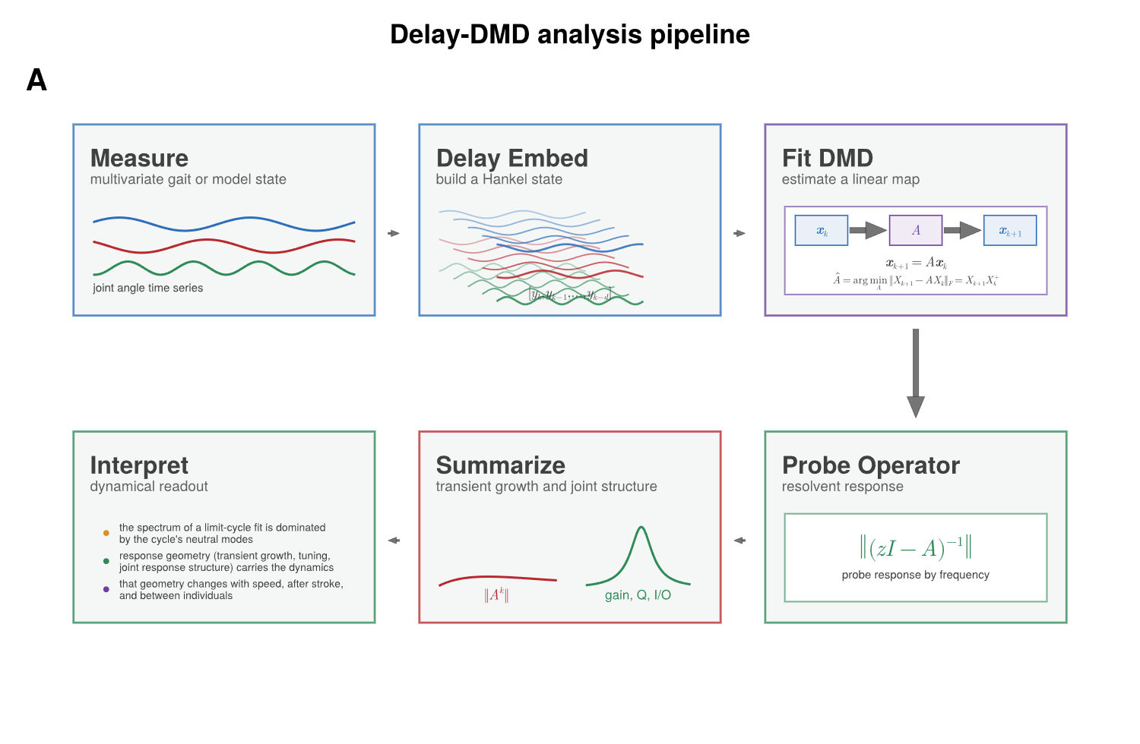
Figure 1. From joint-angle recordings to a fitted, probeable model of the gait cycle. (A) The pipeline used throughout the paper, arranged as a loop. Measure: joint-angle time series (three representative channels in blue, red and green). Delay embed: a window of the d most recent samples is stacked into one state vector [y_k, y_{k−1}, …, y_{k−d}]. Fit DMD: the linear rule x_{k+1} = A x_k that best predicts each state from the one before is estimated by least squares (Â is the fitted estimate). Probe operator: rather than reading the eigenvalues of A, we evaluate its response at every frequency through the resolvent ‖(zI − A)^{−1}‖. Summarize: the probing is condensed into transient growth ‖A^k‖ as a function of elapsed steps k (red) and the frequency response, tuning and joint response structure (green). Interpret: the three questions the paper asks of these summaries, colored to match the measures that answer them.

Calibrating the measures where the answer is known
We first demonstrate these properties in the Stuart–Landau oscillator, the normal form of an oscillator near the onset of oscillation, whose dynamics can be set exactly. With r² = x² + y²,
dx/dt = (μ − r²) x − (ω + c r²) y, dy/dt = (μ − r²) y + (ω + c r²) x
The parameter μ sets the amplitude of the limit cycle (r = √μ) and how quickly deviations in amplitude decay (at rate 2μ); the shear c makes the rotation frequency depend on amplitude, so a disturbance to amplitude is converted into a shift in phase. A single model, fitted to several trajectories starting at different distances from the limit cycle, forecasts held-out trajectories accurately whether they start far from the cycle or near its unstable center (Figure 2A,B).
Scanning both parameters, the measures answered to different mechanisms. Departure from normality tracked the amplitude parameter μ (Figure 2C). Transient growth was largest for small μ, when the cycle attracts nearby trajectories only weakly, fell as μ increased, and depended only weakly on c (Figure 2D). The Q-factor stayed at its ceiling for weak shear and fell sharply as shear increased, largely independent of μ (Figure 2E). Departure from normality and transient growth therefore report the amplitude dynamics, and the Q-factor reports the coupling of amplitude to phase.
Against the true decay rate (2μ), departure from normality rose (R² = 0.90; Figure 2F, left) and transient growth fell (R² = 0.92; Figure 2F, middle). A leave-one-out decoder combining all five response measures recovered the decay rate almost exactly (R² = 0.996; Figure 2F, right). The scatter left by each single measure was organized by shear (point color), structure that no single measure captures.
Finally, we asked whether the joint response map recovers a known directional relationship, using two damped oscillators with an imposed one-way coupling. The map identified the driving oscillator as the dominant input whichever oscillator was the driver, with the reverse direction carrying only a small residual gain (Figure 2G,H). This is the same calculation used below for joints in gait.
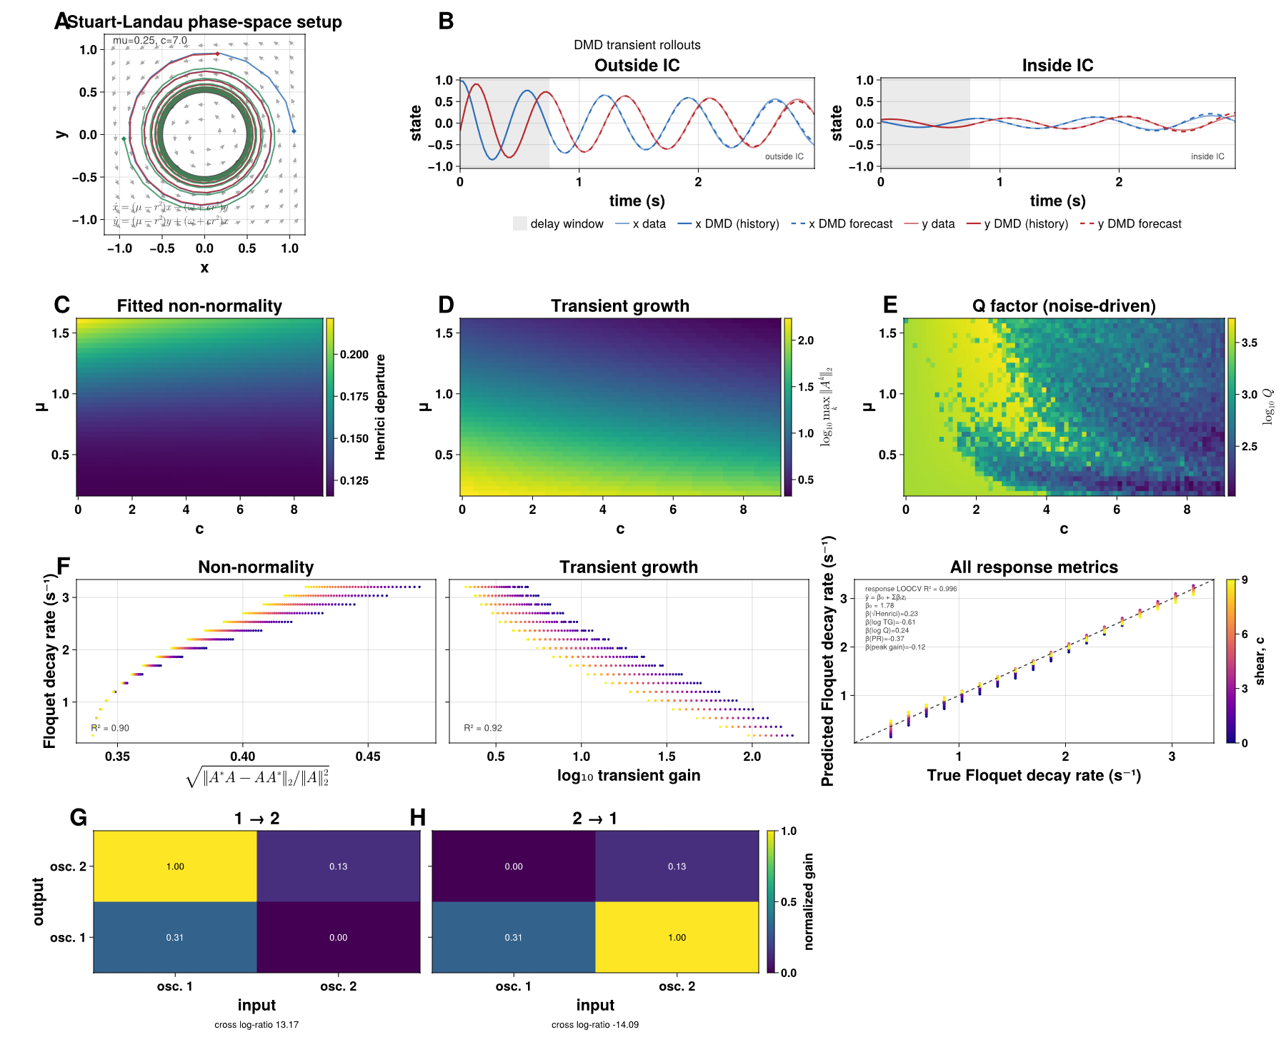
Figure 2. Stuart–Landau oscillators calibrate the response measures. (A) Phase-space portrait of the Stuart–Landau system for one example parameter setting (μ = 0.25, c = 7.0), showing three trajectories converging onto the shared limit cycle; gray arrows show the local vector field, and the governing equations are given at lower left. (B) A single model, fit from several training trajectories spanning large- and small-amplitude starting conditions, rolled forward from two held-out starting points, one far from the origin (left) and one near the unstable center (right). Thin lines are the true x (blue) and y (red) trajectories; thick lines are the model over the shaded initial history window; dashed lines are the forecast beyond it. (C) Departure from normality over the amplitude parameter μ (vertical) and the shear parameter c (horizontal). (D) log₁₀ transient growth over the same grid. (E) Frequency-tuning sharpness (Q-factor), computed from trajectories simulated with process noise (see Methods), over the same grid. (F) The true continuous-time decay rate against √(departure from normality) (left, R² = 0.90), against log₁₀ transient growth (middle, R² = 0.92), and against leave-one-out decoder predictions (right) for the full response-measure set (filled circles, R² = 0.996) and for a decoder built from the DMD eigenvalue moduli (open triangles, R² = 0.90); points are colored by c, and the text box lists the response decoder's coefficients. In this smooth, fully sampled system the eigenvalues also carry the decay rate, which is the expected control. (G, H) Joint response maps for two damped oscillators with an imposed one-way coupling, for both coupling directions; rows are the output oscillator, columns the input, and values are normalized to each map's maximum. The cross log-ratio below each panel quantifies how much more strongly the imposed direction is recovered than its reverse.

In a walking model, the fitted spectrum misses stability that the response measures partly recover
The spring-loaded inverted pendulum (SLIP) is the simplest widely used mechanical model that actually has a walking-like gait cycle. At each step, the stance leg (Figure 3A, blue then red for successive steps) acts as a spring of fixed stiffness, launching the center of mass at some speed and angle; the return map connecting one step's touchdown state to the next has a stability value, ρ, that can be worked out analytically at every combination of leg stiffness and touchdown angle. We tested 153 combinations that are analytically stable and well-posed, plus three combinations representing stable (ρ = 0.82), near the stability boundary (ρ = 1.00), and unstable (ρ = 1.12) gaits. These combinations are used as representative examples throughout the figure (consistently colored blue, orange, and red).
The three representative gaits look qualitatively different: the stable case settles into a clean, repeating oscillation, the near-boundary case oscillates with mild drift, and the unstable case grows until the walker falls (Figure 3B). A model fitted to each trajectory's initial history window forecasts the stable and near-boundary gaits accurately for several strides (Figure 3C). It fails on the unstable gait within the first stride: the fitted operator is stabilized so that forecasts cannot diverge (Methods), and it therefore cannot represent the growing oscillation (Figure 3C, red).
Across the full grid, the stability read off the fitted operator's spectrum carries essentially no information about the true multiplier ρ (cross-validated R² = 0.004) [TO ADD – SI figure: fitted spectral radius and largest non-neutral eigenvalue against ρ]. The fitted spectral radius sits at |λ| = 0.9997–0.9999 per sample across the entire grid, tracking the neutral direction of the cycle. Excluding the neutral modes does not help (r = −0.25 with the true ρ): each fit shows one dominant conjugate pair at 0.96–0.99 per step and then a gap to 0.01–0.5, with nothing near the true ρ of 0.75–0.99.
The walker's own return map, by contrast, recovers ρ accurately, as expected for a system with an exactly period-matched Poincaré section. Estimating the Floquet decay rate from the return map gives a median absolute error of 0.022, against 0.112 for a decoder built from the full response-measure set and 0.185 for one built from transient growth alone (Figure 3E). Its error rises for very short records (from 0.012 to 0.134 at 15% of the simulated trial length).
The response measures of the same fits each track part of the variation in the true decay rate (Figure 3J): weakly for departure from normality (Spearman r_s = 0.23; Figure 3F), more strongly for effective dimensionality (r_s = 0.48; Figure 3I) and transient growth (r_s = −0.61; Figure 3H). The frequency response of the unstable regime stays elevated across a wider range of rhythms (Figure 3G). Combined in a single decoder, the response measures reach R² = 0.42 (Figure 3J, right), against 0.004 for the spectral radius.
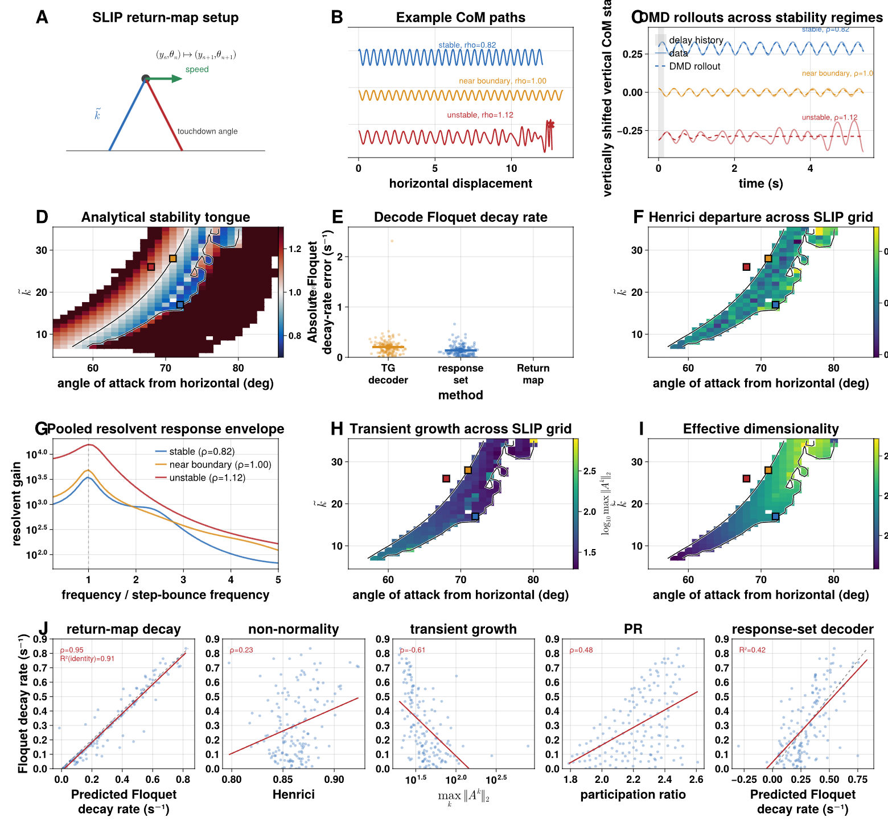
Figure 3. In a mechanical walking template (SLIP), the fitted operator's spectrum carries almost no information about stability while its response geometry does, and the walker's own return map recovers it accurately. (A) Schematic of one return-map step: the stance leg (blue) launches the center of mass, becoming the next step's stance leg (red) at its own touchdown angle; k̃ is the dimensionless leg stiffness. (B) Example center-of-mass paths for three regimes: stable (blue, ρ = 0.82), near the stability boundary (orange, ρ = 1.00) and unstable (red, ρ = 1.12, ending in a fall). (C) Vertical center-of-mass state over time for the same three regimes (offset for clarity), with the model fit over the shaded history window (solid) and forecast beyond it (dashed); the stabilized model cannot represent the growth of the unstable gait, so its forecast stays flat. (D) Analytical return-map multiplier ρ over angle of attack and k̃; the black contour marks ρ = 1, and the colored squares mark the representative points. (E) Absolute error in the continuous-time Floquet decay rate for a decoder built from transient growth alone, a decoder built from the full response-measure set, and direct estimation from the return map; bars mark medians. (F) Departure from normality over the stable region. (G) Pooled frequency-response curves for the three regimes, normalized to the fundamental. (H) log₁₀ transient growth over the grid. (I) Effective dimensionality (participation ratio) over the grid. (J) The true decay rate against the return-map estimate (leftmost; dashed identity line; Spearman r_s = 0.95, identity R² = 0.91), departure from normality (r_s = 0.23), transient growth (log axis; r_s = −0.61), effective dimensionality (r_s = 0.48), and the combined response-set decoder (rightmost; R² = 0.42); red lines are least-squares fits.

Walking robots: multi-stride forecasts and machine-specific structure
Moving to real, multi-joint kinematics with known mechanics and control, we fit models to motion-capture recordings from three bipedal robots – Unitree H1, Boston Dynamics Atlas, and Unitree G1 – walking, running, and performing other locomotor behaviors on a shared set of ten joint angles (Figure 4A). An example held-out walking trial for one robot (Figure 4B) shows the fitted model's forecast tracking two of its ten joint angles closely for several strides beyond the initial history window. Across the full set of forecast horizons tested, the fitted models beat a strong phase-averaged baseline at 95% of the horizons tested for both walking and running gaits – by a factor of roughly two at half a second ahead, and still by two-thirds at four and a half seconds ahead, about four stride cycles (Figure 4C).
Transient growth during walking separates the machines (Figure 4D): the two Unitree robots, H1 and G1, are similar, and Atlas is markedly lower. Each robot's 10 × 10 joint response map is rank one: more than 99.9% of its energy lies in the first singular value, so every entry is the product of a weight for the receiving joint and a weight for the driving joint. The map therefore reduces to two ten-joint profiles, its leading left and right singular vectors, which we call reception and drive (Figure 4E). Unlike in humans, the drive profile is not flat: in all three machines hip flexion dominates both profiles. The profiles of the three robots agree closely (Figure 4F; reception r = 0.94 between H1 and Atlas and 0.995 between H1 and G1; drive r = 0.89 and 0.86). On the scale of the weights themselves, the differences are small (Figure 4G). G1's reception differs from H1's by at most 0.017 at any joint, whereas Atlas's differs by up to 0.05, mainly at right hip flexion and the ankles; for drive, both robots differ from H1 by similar amounts.
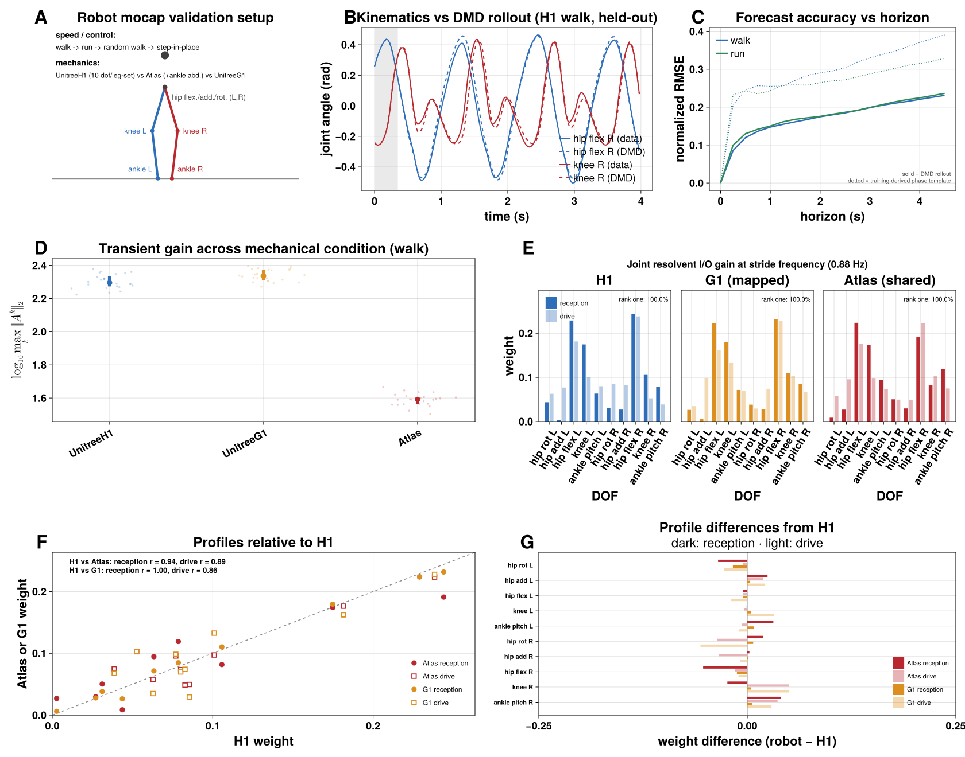
Figure 4. Three walking robots: multi-stride forecasts and machine-specific operator structure. (A) Validation setup: locomotor behaviors (walk, run, random walk, step-in-place) and the three robots (Unitree H1, Boston Dynamics Atlas, which additionally has ankle abduction, and Unitree G1). (B) An example held-out walking trial: hip flexion (blue) and knee flexion (red), true (solid) versus forecast (dashed), with the initial history window shaded. (C) Forecast error (normalized RMSE) versus horizon for walking (blue) and running (green); solid lines are the model, dotted lines a training-derived phase-average template. (D) log₁₀ transient growth during walking for each robot; trials as jittered points with mean ± SEM. (E) Reception (dark) and drive (light) profiles of each robot's rank-one joint response map at the stride frequency, in the robot's color, on a shared ten-joint set. (F) Atlas (red) and G1 (gold) weight against H1 weight for each joint, reception (filled circles) and drive (open squares); the dashed line marks equality and the correlations with H1 are annotated. (G) Difference from H1 for each joint, for Atlas (red) and G1 (gold), reception (dark) and drive (light), on the same scale as the weights in E.

Able-bodied walking: speed reorganizes the dynamics
We fitted models to 150 treadmill-walking recordings from 17 able-bodied young adults spanning 30–220 cm/s (Figure 5A). Each recording was rescaled uniformly in time so that its mean stride spans 100 samples, so that every model's history window and response horizon cover the same fraction of a stride whatever the cadence (Methods). Unperturbed walking stays close to its cycle: the mean stride alone accounts for a median 98.5% of each recording's variance, and for more than 95% in 89% of all 299 human recordings (Methods).
The fitted models track each walker's joint angles well beyond the history used to start them (Figure 5B). On held-out data they forecast more accurately than a phase-averaged template built from the same training data: median normalized error 0.135 against 0.314 at half a stride (98% against 90% of variance explained; model better in 16 of 17 subjects, sign test p < 0.001) and 0.156 against 0.312 at one stride (14 of 17, p = 0.013), with the advantage no longer consistent across subjects by two strides (11 of 17; Figure 5C). The template is the training data's mean cycle, aligned to the start of each forecast and then advanced at the mean training period. It therefore cannot follow the stride-to-stride variation in period and waveform that the dynamical model carries forward from its history window.
The dynamics change consistently with speed within every person (Figure 5D,F). As walking speeds up, effective dimensionality falls (in all 17 subjects), transient growth falls (17 of 17) and the stride peak of the frequency response sharpens (Q rose in 16 of 17). The changes are steepest at slow speeds and level off above about 100 cm/s, so we modeled each measure against the logarithm of speed, with an intercept and a speed slope for each person (mixed-effects models; Methods). Speed accounted for 74% of the variance in log transient growth, 69% in effective dimensionality and 23% in log Q (likelihood-ratio tests, all p < 10⁻⁷). Each doubling of speed lowered transient growth by 25% (−0.12 log₁₀ units) and effective dimensionality by 1.1, and raised Q by 72% (+0.24 log₁₀ units). The pooled frequency responses show the same narrowing of the fundamental and its harmonics at faster speeds (Figure 5E). Departure from normality also falls with speed (Figure 5D, left), but because its group differences change sign with the rank and regularization of the fit (Methods), we do not interpret it further.
The joint response map is rank one in every recording (99.9% of its energy in the first singular value, against about 81% for a shuffled null), so it reduces to a reception and a drive profile (Figure 5G). Drive is nearly uniform across joints; the structure lies in reception, which is concentrated at the knees and hips. With increasing speed, reception shifts from the knees and ankles toward the hips (Figure 5H): the knees' combined share falls from 0.49 in the slowest third of trials to 0.42 in the fastest and the ankles' from 0.16 to 0.10, while the hips' rises from 0.35 to 0.48.
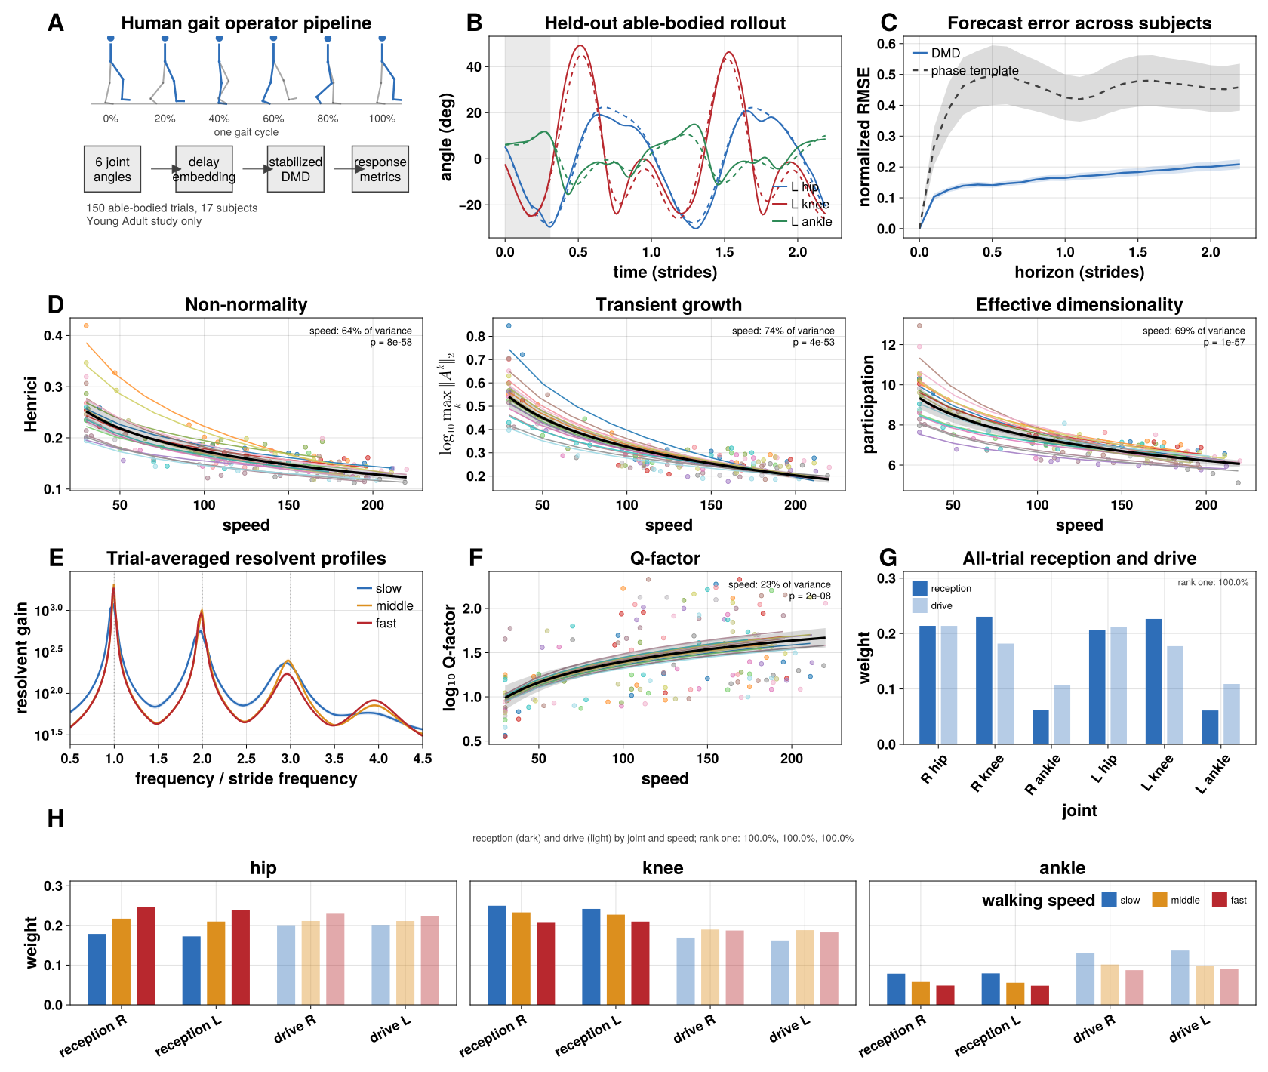
Figure 5. Able-bodied young adults: the fitted operators forecast each walker's gait, and their geometry changes systematically with speed. (A) Pipeline applied to 150 trials from 17 subjects (Young Adult study). (B) An example held-out trial on the stride-rescaled time base: left hip (blue), knee (red) and ankle (green), true (solid) versus forecast (dashed), with the initial history window shaded; time in strides. (C) Forecast error (normalized RMSE, mean and across-subject band; the text reports subject medians, which are less affected by a few poorly matched templates) versus horizon in strides for the model (blue) and a phase-averaged template from the same training data (dashed). (D) Departure from normality (Henrici), log₁₀ transient growth over one stride, and effective dimensionality (participation ratio) against walking speed (cm/s); trials are colored by subject. Thin lines are each subject's fit from a mixed-effects model against log speed, and the black line is the population fit with its 95% band; annotations give the share of variance explained by speed and the likelihood-ratio p value (Methods). (E) Resolvent gain against frequency in units of the stride frequency (geometric mean over trials within three speed bins; bands are SEM), evaluated on the same grid as Figure 6B; dotted lines mark harmonics. (F) log₁₀ Q-factor of the stride peak against speed, in the same format as D. (G) Reception (dark) and drive (light) profiles of the rank-one joint response map, pooled over all trials, in the same convention as Figure 6D–F. (H) Reception (dark) and drive (light) weight of each joint for slow (blue), middle (gold) and fast (red) walking (thirds of the trials by speed), one panel per joint, on a shared scale.

Post-stroke walking: higher transient growth and a paretic knee that drops out of the dominant mode
We applied the identical pipeline to 149 recordings from a post-stroke study: 30 trials from 5 able-bodied controls, 65 from 11 higher-functioning and 54 from 9 lower-functioning stroke survivors. The functional groups were defined by self-selected walking speed, so group and speed are partly the same variable: the able-bodied (90–160 cm/s) and lower-functioning (22–60 cm/s) groups do not overlap in speed at all, while the higher-functioning group (40–127 cm/s) overlaps both. We therefore analyzed each measure with the same mixed-effects model as above, adding group and its interaction with speed, and partitioned its variance into parts attributable to group, to speed, to their shared component, to individuals and to trial-to-trial variation (Methods; SI Appendix, Fig. S2 [TO ADD – mixed-model figure]).
Transient growth, our measure of non-normal amplification, is graded by walking ability (Figure 6A, middle): median log₁₀ growth over a stride is 0.27 in able-bodied controls, 0.39 in higher-functioning and 0.59 in lower-functioning survivors, about 1.9-, 2.5- and 3.9-fold. Both group (likelihood-ratio p = 0.0005) and speed (p = 0.0003) contribute. Within each person, transient growth fell with speed (Figure 6A, middle). In the controls it fell by −0.12 log₁₀ units per doubling of speed, the same rate as in able-bodied young adults. In the stroke groups it fell less steeply, but the difference in slope was not significant (group × speed interaction p = 0.22). At a given speed, lower-functioning survivors had higher transient growth than higher-functioning survivors (+0.13 log₁₀ units, about 1.34-fold, p = 0.0007), and higher-functioning survivors higher than controls (+0.08, about 1.2-fold, p = 0.01). Group and speed together accounted for 65% of the variance: 44% attributable to group alone, 3% to speed alone, and 18% shared between them because the groups walk at different speeds. Individuals accounted for a further 28% and trial-to-trial variation for 7%. Comparisons between controls and lower-functioning survivors at a given speed rest on extrapolation, because their speeds do not overlap.
Effective dimensionality fell with speed (p < 10⁻¹⁰) but did not differ between groups (p = 0.54); most of its variance (79%) lay between individuals (Figure 6A, right). Departure from normality likewise fell with speed (p < 10⁻⁸) without a group difference (p = 0.63; Figure 6A, left), and, as above, is not interpreted further.
The frequency response of stroke gait is less sharply tuned on average: gain between the stride harmonics is elevated in both stroke groups, most in the lower-functioning group, and the harmonic peaks are lower and broader (Figure 6B). Subject-mean Q is lower than in controls in both higher-functioning (d = −1.44) and lower-functioning survivors (d = −2.86; Figure 6C). Q varies widely from trial to trial within a person, however (89% of its variance), and in the mixed-effects model neither group (p = 0.69) nor speed (p = 0.93) explains it (Figure 6C). We therefore do not treat the difference in tuning as established in this sample.
The joint response structure localizes the change. As in able-bodied walking the map is rank one in every trial (Figure 6H), and drive is nearly uniform, so each group is summarized by its reception profile (Figure 6D–F). Controls are symmetric, with the knees receiving most strongly. In both stroke groups the paretic knee's reception falls and the non-paretic knee's rises; in the lower-functioning group the paretic knee receives no more than the paretic hip, and the non-paretic knee becomes the dominant joint of the mode.
Comparing paretic and non-paretic sides within each trial (Figure 6G), the paretic deficit is concentrated at the knee (paretic minus non-paretic reception −0.009 ± 0.002 in higher-functioning and −0.028 ± 0.002 in lower-functioning survivors, mean ± SEM over trials), smaller at the hip (−0.002 and −0.015), and absent at the ankle. Because reception is a share of each trial's total, this is a redistribution within the dominant mode: the paretic knee expresses less of it and the non-paretic side more. Since the operator is primarily a generator of the mean cycle, this redistribution largely reflects the reduced paretic-knee excursion in that cycle; what the operator adds is to express it as a change in the structure of a single dynamical mode.
We also screened whether any operator measure tracked the Berg Balance Scale or the Fugl-Meyer assessment beyond walking speed (Figure 6I). Speed alone correlates with the Berg score at r = 0.70; the best of 38 screened operator measures, median log Q, reaches only r = 0.48. For the Fugl-Meyer assessment speed is a weak predictor (r = 0.28), and the best screened measure, the change in non-paretic hip reception with speed, reaches ρ = 0.67. Each is the maximum of a screen of 38 candidates in 13 (Berg) or 20 (Fugl-Meyer) people and none survives correction for the screen; we report them as exploratory.
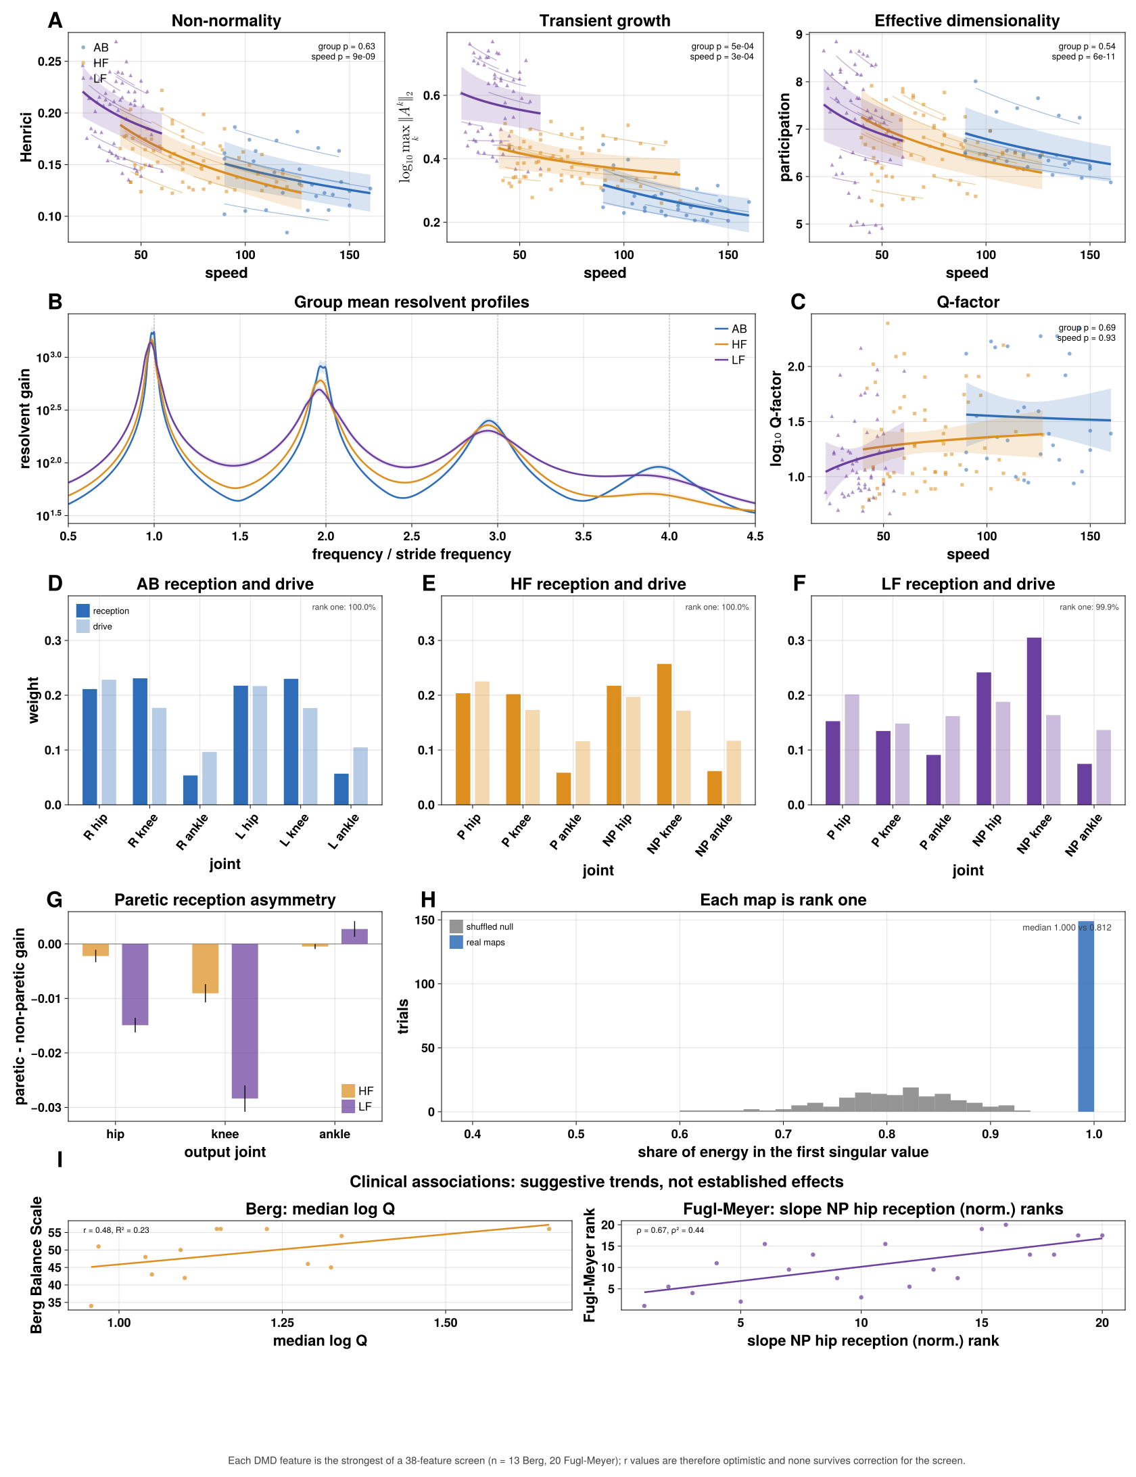
Figure 6. Post-stroke walking: higher transient growth at a given speed, and a paretic knee that drops out of the dominant mode. (A) Departure from normality (Henrici), log₁₀ transient growth over one stride, and effective dimensionality against walking speed (cm/s), by group (able-bodied, blue circles; higher-functioning, orange squares; lower-functioning, purple triangles). Thin lines are each subject's fit from a mixed-effects model against log speed, and thick lines each group's fit with its 95% band, drawn only over the speeds that group walked at; annotations give likelihood-ratio p values for group and speed (Methods). (B) Resolvent gain against frequency in units of the stride frequency (geometric mean over trials within each group; bands are SEM), on the same grid as Figure 5E. (C) log₁₀ Q-factor of the stride peak against speed, in the same format as A. (D–F) Reception (dark) and drive (light) profiles of the rank-one joint response map for able-bodied (D), higher-functioning (E) and lower-functioning (F) groups; joints are paretic (P) and non-paretic (NP); able-bodied trials use a right/left convention (Methods). (G) Paretic minus non-paretic reception by joint for the two stroke groups (mean ± SEM over trials). (H) Share of each map's energy in its first singular value, real maps against a shuffled null. (I) Exploratory clinical screen: Berg Balance Scale against median log₁₀ Q, and Fugl-Meyer rank against the speed slope of non-paretic hip reception; each is the best of a 38-feature screen and none survives correction.

Individual operator signatures
Group averages leave open whether these dynamics are specific to the individual. To test this we pooled every human recording, 299 trials from 42 people. A model was fitted to each trial at its own walking speed, and the trials' normalized joint response maps were averaged within each person, across speeds. We used only the normalized map because it is insensitive to the overall response scale, on which the two source studies differ (Methods). Each person's map is expressed as a deviation from the able-bodied reference, in units of the able-bodied spread on each joint pair.
The two able-bodied cohorts, recorded in different studies, do not separate on either the overall size of the deviation (p = 0.91) or its leading direction (p = 0.72; Figure 7A). The size of the deviation, an abnormality score, is strongly graded by walking ability: 1.0 able-bodied standard deviations in controls, 2.1 in higher-functioning and 4.1 in lower-functioning survivors (η² = 0.70, p = 0.0002; Figure 7B).
Decomposing the direction of each stroke survivor's deviation, a single shared axis accounts for 62% of the variance and is dominated by the paretic knee and paretic hip rows of the map, the same reduced paretic reception seen in Figure 6G (Figure 7C). A second axis, accounting for 13%, is not anatomically localized and is not graded by severity (Figure 7D). The remaining quarter of the variance is specific to individuals.
That individual component is reproducible. We split each person's recordings into two halves, averaged the per-trial maps within each half, and compared the halves' deviations (200 random splits). Halves of the same person point in similar directions (median cosine similarity 0.82, mean 0.68), while halves from different people do not (median 0.08; Figure 7E). A held-out half identifies its owner as the nearest of 42 candidates 65% of the time, against 2.4% expected by chance. Identification depends strongly on group: 99% for lower-functioning survivors, 89% for higher-functioning survivors and 38% for able-bodied participants, whose maps all lie close to the shared reference. The sign of the deviation carries information: ignoring it lowers identification to 59%. For comparison, the same procedure applied to each trial's mean stride waveform identifies 54% of people (75–76% of stroke survivors and 35% of able-bodied participants), so the response map identifies stroke survivors better than their average kinematics do. All recordings of a person come from a single session, so this is within-session reproducibility. People with similar abnormality scores can have quite different deviation patterns (Figure 7F).
Against the clinical scales, walking speed remains the stronger predictor: the abnormality score correlates with the Berg Balance Scale at r = −0.30 (speed: r = 0.70; partial correlation given speed 0.05) and with the Fugl-Meyer assessment at r = −0.27 (speed: r = 0.28; partial −0.14; Figure 7G).
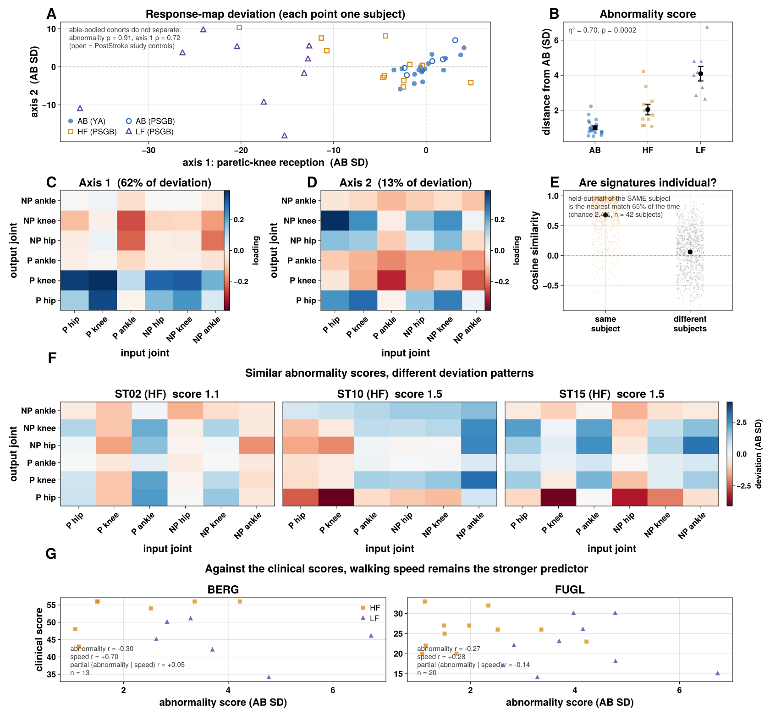
Figure 7. Individual operator signatures. (A) Every subject (n = 42, both studies) on the two shared deviation axes in C and D; filled circles are Young Adult study subjects, open circles PostStroke-study controls, orange squares higher-functioning and purple triangles lower-functioning stroke survivors; the annotation tests whether the two able-bodied cohorts differ. (B) Abnormality score (root-mean-square deviation from the able-bodied reference, in able-bodied standard deviations) by group; η² and permutation p annotated. (C, D) The two shared deviation axes as 6 × 6 loading maps (output joint by row, input joint by column); axis 1 (62% of the variance among stroke survivors' deviations) is dominated by the paretic knee and hip rows; axis 2 (13%) is not anatomically localized. (E) Cosine similarity between deviation vectors from independent halves of the same subject's recordings versus different subjects'; the annotation gives the nearest-neighbor identification rate against chance (rates by group in the text). (F) Three subjects with similar abnormality scores (1.1–1.5), each shown as a 6 × 6 deviation map on a shared scale. (G) Abnormality score against the Berg Balance Scale (left) and Fugl-Meyer assessment (right), with the correlations with abnormality, with speed, and the partial correlation given speed.

Discussion
Fitted to short recordings of unperturbed walking, a linear operator on delay coordinates is a faithful generator of each walker's gait cycle, and its responses are both simpler and more informative than its spectrum. Simpler, because the joint-resolved response at the stride frequency is rank one in every human recording: the dynamics that generate the cycle are organized around a single dominant mode, and what differs between walkers is how strongly each joint expresses it. More informative, because that expression, the mode's tuning and its transient growth change systematically with walking speed, after stroke and between individuals, whereas the spectrum of an operator fitted to a limit cycle is dominated by the cycle's neutral modes. Our calibrations show this directly: in a mechanical walking model the fitted spectrum carried no information about stability, while the response measures of the same fits carried part of it (Figure 3).
Because the model is fitted to kinematics, it describes the closed neuromechanical loop as a whole, not the nervous system or the body alone. This is both a limitation and a strength. The model cannot say whether a change in its responses arises from altered neural commands, altered reflexes or altered limb mechanics, but it captures their combined effect, which is what shapes a person's walking, in a single model that can be probed.
These results place the operator alongside existing descriptions of gait dynamics rather than in place of them. Floquet multipliers and local divergence exponents quantify how quickly the cycle attracts nearby trajectories [CITE – Dingwell & Cusumano 2000; Bruijn et al. 2013]; our calibrations show that a fitted spectrum does not recover them from limit-cycle data, and that where a period-matched section exists the return map remains the right estimator. What the operator adds is the finite-time and driven response, which is invisible to the spectrum of a non-normal operator [CITE – Trefethen & Embree 2005], and a joint-resolved organization computed from kinematics alone. The joint response map resembles induced acceleration analysis in asking how activity at one joint appears at another [CITE – Zajac & Gordon 1989], but it relates joint histories within a fitted model rather than muscle forces within a model of the body.
The paretic-knee result may connect to work on muscle coordination after stroke. Clark and colleagues found that stroke survivors' paretic legs use fewer, merged muscle synergies [CITE – Clark et al. 2010]. The most impaired, slowest walkers co-activated most leg muscles during stance and coupled the quadriceps and hamstrings in swing, and less impaired walkers coupled the quadriceps with either the hamstrings or the calf muscles. In each case the paretic knee extensors become tied to muscles that serve other functions, which could reduce the knee's independent contribution to the gait cycle and so its weight in the dominant mode. We did not record muscle activity, so this link remains a hypothesis. Muscle coordination complexity after stroke also changes with walking speed, at similar rates in the paretic and non-paretic legs [CITE – Sánchez et al. 2026]; in our data, effective dimensionality likewise depended on speed and on the individual but not on group, so speed should be considered alongside impairment in both kinds of analysis.
Speed and impairment act on overlapping aspects of the dynamics. In able-bodied walkers, faster walking lowers transient growth and effective dimensionality, sharpens tuning, and shifts the dominant mode from the knees toward the hips. Stroke survivors, who walk more slowly, show higher transient growth and, on average, broader tuning. Mixed-effects models separate the two in part: transient growth falls with speed within every group, and lower-functioning survivors sit above higher-functioning survivors at a given speed, whereas the difference in tuning does not exceed its trial-to-trial variability. Speed is therefore not a nuisance to be removed but one of the main axes along which gait dynamics are organized, and almost a fifth of the variance in transient growth after stroke cannot be assigned to group or to speed alone because the two are entangled. Higher transient growth means that the fitted dynamics amplify some initial states more before the cycle reasserts itself; whether this reflects a less robust gait or a cycle that is less tightly constrained cannot be decided from unperturbed data.
That last point is the main limit on what this approach can resolve. The mean gait cycle accounts for 98.5% of the variance in a typical recording, so the operators are determined chiefly by the geometry of the generated cycle and only weakly by the transverse dynamics that govern recovery from perturbations. The reduced paretic-knee reception, in particular, largely reflects the reduced paretic-knee excursion in that cycle. Without perturbations, or a denser sampling of the state space than ordinary walking provides, we therefore make no claims about transverse stability in the human data; we report the geometry and transient growth of the fitted models. Likewise, the joint response map describes the model's internal organization between joint histories, not the response to a physical push at one joint, which would require a measured input.
Several further limitations apply. The stroke groups contain 9 to 11 people each and the able-bodied comparison group in that study only 5. Functional group is defined by walking speed, so the able-bodied and lower-functioning groups cannot be compared at matched speed, and mixed-model estimates for that contrast rely on extrapolation. Only sagittal-plane angles were recorded, so frontal- and transverse-plane strategies are not observed. All of a person's recordings come from one session, so individual signatures are reproducible within a session; their stability over time is untested. Operator norms depend on the coordinates and rank, which is why we fix both and compare transient growth only within a dataset. The clinical associations are exploratory and do not exceed walking speed.
The natural next experiments follow from these limits: walking recordings with controlled perturbations or measured assistive inputs, which would let the same pipeline estimate transverse dynamics and input-specific responses directly, and repeated sessions, which would test whether individual signatures are stable traits. Within those limits, a linear operator fitted to a short recording already provides a compact, interpretable view of the dynamics that generate a person's walking, and of how those dynamics reorganize with speed and after stroke.

Methods

Datasets
Human kinematics comprise six sagittal joint angles (hip, knee and ankle flexion, bilaterally) sampled at 100 Hz over 15 s treadmill trials, from two studies: an able-bodied young adult study (150 trials, 17 subjects) and a post-stroke gait study (149 trials, 25 subjects: 30 trials from 5 able-bodied controls, 65 from 11 higher-functioning and 54 from 9 lower-functioning stroke survivors). Higher- and lower-functioning groups were defined by self-selected walking speed. Stroke channels are ordered paretic limb first in the source export; able-bodied channels are taken as right limb first. Robot recordings are motion-capture trajectories for Unitree H1, Boston Dynamics Atlas and Unitree G1 mapped to a shared ten-degree-of-freedom set, sampled at 100 Hz. [TO CHECK – acquisition citations, demographics and ethics statements for both human studies.]

Stride rescaling, delay coordinates and model fitting
Each human trial is first rescaled uniformly in time so that its mean stride spans 100 samples. The mean stride frequency is obtained from the total phase advance over the trial of the analytic signal (Hilbert transform) of the first principal component of the six angles, a quantity that is robust even where the instantaneous phase briefly runs backwards, and the trial is resampled by linear interpolation. Unlike phase normalization, this does not warp the timing within a stride or require an instantaneous phase estimate, but it makes every model's delay window and response horizon the same fraction of a stride regardless of cadence; with windows fixed in samples, cadence alone otherwise changes transient growth. All horizons are stated in strides. Let y_t denote the p-dimensional vector of joint angles at sample t (p = 6 for human trials, p = 10 for robots), after subtracting each channel's mean. We stack d consecutive samples into a single delay-coordinate state:
x_t = [ y_t ; y_{t−1} ; … ; y_{t−d+1} ] ∈ ℝ^{dp}
so that x_t carries not only the current posture but its recent history, which lets a linear model represent velocity- and acceleration-like information without explicit differentiation. We use d = 32 samples for every human model, about a third of a stride.
Given a sequence of states, we form two matrices whose columns are, respectively, all delay-coordinate states except the last and all delay-coordinate states except the first – that is, corresponding columns of X and Y are one sample apart in time – and fit the single linear operator A that best predicts each state from the one immediately before it, in the least-squares sense:
Â = argmin_A ‖Y − AX‖_F = Y X^{+}
where X^{+} denotes the Moore–Penrose pseudoinverse and ‖·‖_F the Frobenius norm. In practice we never solve this at full dimension dp. We first take the (economy) singular value decomposition X = U S V^T, retain only its leading r columns (U_r, S_r, V_r), and fit a reduced r × r operator
Ã = U_r^T Y V_r S_r^{−1}
which is the standard exact DMD algorithm [CITE – Tu et al. 2014]. For the human models we replace S_r^{−1} with the ridge (Tikhonov) filter S_r (S_r² + α s_1² I)^{−1}, where s_1 is the largest singular value, so that directions the data explore only weakly are suppressed rather than inverted. We use α = 10^{−4} and r = 70; with this penalty every response measure is identical for any r ≥ 40 (see "Choosing model complexity").
Because Ã is fit from finite, noisy data, some eigenvalues can fall slightly outside the unit circle, which would make multi-stride forecasts diverge. We pin any eigenvalue with |λ| > 1 onto the unit circle in the real Schur basis of Ã (scaling the corresponding 1 × 1 or 2 × 2 diagonal block), which, unlike rescaling eigenvalues in an eigenvector basis, is an orthogonal change of basis and cannot amplify the operator. Every response measure is computed from the stabilized operator.

Stuart–Landau oscillator
Calibration trajectories were simulated from the Stuart–Landau equations given in Results, with base angular frequency ω = 2π, over a grid of amplitude parameters μ and shear values c. The true continuous-time decay rate of amplitude deviations is 2μ, and the limit-cycle frequency is (ω + cμ)/2π.

Variance explained by the mean stride
To quantify how closely each recording stays to its cycle, each trial was phase-normalized to 100 samples per stride (Hilbert phase of the first principal component of the six angles), and its mean stride was computed. Variance explained is VE = 1 − Σ‖y − ȳ_cycle‖² / Σ‖y − ȳ‖², where ȳ_cycle repeats the mean stride at each phase and ȳ is each channel's mean. Across all 299 human trials the median VE was 98.5% (able-bodied 98.8%, higher-functioning 98.5%, lower-functioning 97.5%), and 89% of trials exceeded 95%. A normalized forecast error e corresponds to a variance explained of 1 − e².

Forecasting
The fitted operator is evaluated on data not used for fitting: it is fit on an initial segment of the trial and rolled forward from history windows in the remaining segment. From an observed history window x_0 we project onto the reduced coordinates, z_0 = U_r^T x_0, iterate z_k = Ã z_{k−1}, and reconstruct the current joint angles, ŷ_k = (U_r z_k)_{1:p}. The phase-averaged template baseline is the mean cycle of the same training segment, obtained by folding the training data at its mean stride period. At the start of each forecast the template is aligned to the history window by the phase offset, and an affine amplitude correction, that best match it, and it is then advanced at the mean training period. Accuracy is the normalized root-mean-square error over the forecast window,
NRMSE = RMS(ŷ − y) / RMS(y)
where RMS(·) is the root-mean-square taken over both time and joint channels in the forecast window, so an NRMSE of 1 is equivalent in scale to simply reporting zero for every channel.

Response measures
Transient growth. We compute the operator 2-norm (largest singular value) ‖Ã^k‖_2 for every whole number of steps k from 0 up to K, and report the maximum:
TG = max_{k=0,…,K} ‖Ã^k‖_2
We take K = 100 steps (one stride on the rescaled time base) for human models and K = 4d for robot models.
Departure from normality. A matrix is normal if it commutes with its transpose (A^TA = AA^T), in which case its eigenvectors can be chosen orthogonal and its eigenvalues fully determine its transient behavior. We measure departure from this condition with a normalized commutator norm (labeled Henrici in the figures):
dep(Ã) = ‖Ã^TÃ − ÃÃ^T‖_2 / ‖Ã‖_2^2
which is 0 exactly when Ã is normal and increases toward 1 as its eigenvectors become more skewed relative to one another.
Frequency response. For a frequency f in cycles per sample, we evaluate the resolvent of Ã on the unit circle:
z = exp(i·2π·f / f_s), gain(f) = ‖(zI − Ã)^{−1}‖_2 = 1 / σ_{min}(zI − Ã)
where σ_min is the smallest singular value. Scanning f from 0 to the Nyquist frequency gives the full frequency-response curve. On the rescaled time base the mean stride frequency is f_0 = 1/100 cycles per sample, and harmonic gains are evaluated at f_0, 2f_0, 3f_0, …. Tuning sharpness (the Q-factor) is the ratio of the peak frequency to the half-power bandwidth around it, and is reported on a log scale:
Q = f_{peak} / (f_{right} − f_{left}), gain(f_{left}) = gain(f_{right}) = gain(f_{peak})/√2
For the calibration analysis in Figure 2E, this quantity is only meaningful if the underlying trajectory actually contains a disturbance for shear-induced phase drift to act on; a trajectory integrated with zero noise carries no such information regardless of the true underlying physics (see Discussion). We therefore compute Figure 2E from trajectories simulated with additive process noise (not measurement noise added after the fact), averaged over 8 noise realizations per grid cell; every other figure's Q-factor is computed directly from the recorded or simulated trial as described above.
Effective dimensionality. From the singular values σ_1, σ_2, … of the delay-coordinate data matrix X used to fit the model, we compute the participation ratio
PR = (Σᵢ σᵢ)² / Σᵢ σᵢ²
which equals the true rank if all retained singular values are equal, and falls toward 1 as the variance concentrates onto a single dominant direction; it is a continuous, data-driven stand-in for "how many effective coordination patterns" the recording actually uses.
Joint response map, reception and drive. For an input joint and an output joint we evaluate how strongly the resolvent at the stride frequency maps the input joint's delay-coordinate block onto the output joint's, through the reduced subspace U_r:
G_{out,in} = ‖ C_{out} (zI − Ã)^{−1} B_{in} ‖_2
where B_in and C_out select the rows of U_r for the input and output joints' d delayed copies. Collecting G_out,in over all pairs gives a p × p map, normalized to sum to one. This is a gain between joint histories, not the response to a physical perturbation applied at one joint. Because every human map is rank one (median share of energy in the first singular value 0.999, against 0.81 for maps with shuffled entries), we summarize each map by its leading left and right singular vectors, normalized to sum to one: the reception profile (how strongly each joint receives) and the drive profile (how strongly each joint drives).
For robots, the same construction gives a 10 × 10 map; each robot's map is likewise rank one, and its reception and drive profiles are compared between robots by Pearson correlation and by joint-wise differences.

Choosing model complexity
Without regularization, transient growth of a delay-coordinate DMD operator rises steadily with the retained rank r, because the trailing singular directions, which the data explore only at tiny amplitude, are inverted and then mapped back onto the dominant ones. We therefore regularize rather than truncate. In a sweep over r ∈ {10, 20, 40, 70, 100, 150} and α ∈ {0, 10^{−6}, 10^{−5}, 10^{−4}, 10^{−3}} across all 299 trials, α = 10^{−4} made transient growth and every other response measure identical for all r ≥ 40, while held-out forecast error at half a stride (0.17) matched the best unregularized fits; α = 10^{−3} over-smoothed the dynamics (error 0.23). The group differences in transient growth reported here were present at every α and rank tested. Departure from normality is not: its group differences change sign with r and α, so it is reported but not interpreted. The delay count d = 32 is fixed for every human model. Variation of transient growth with α is shown in the Supplementary Information.

Why normalized response maps, not magnitudes, are compared across studies
The two human source studies were preprocessed differently before we received them. Standard, non-dynamical gait metrics overlap completely between the studies, so this is a difference in processing rather than in the walking, but it changes how cleanly the delay-coordinate models fit and therefore shifts every measure that depends on absolute response scale (transient growth, frequency-response gain, departure from normality). The joint response map, normalized to sum to one within each trial, is far less sensitive to this difference (Figure 7A tests it directly). Scale-sensitive measures (Figures 5 and 6) are therefore compared only within a single study; the individual-signature analysis (Figure 7), which uses only normalized maps, pools both studies.

Statistics
The independent unit for group contrasts is the subject. Group contrasts of subject means use Cohen's d and two-sided permutation tests of subject labels. Within-subject speed associations are summarized by a sign test on the per-subject slopes. Where a measure is selected from a screen (Figure 6I), the screen size is reported and the result is treated as exploratory.
Speed, group and individual contributions were estimated with linear mixed-effects models fitted by maximum likelihood (MixedModels.jl), following approaches used to separate speed from other factors in locomotion [CITE – Machado et al. 2015]. Speed entered as log₂(speed), centered, so that slopes are changes per doubling of speed; the measures change most at slow speeds, and log speed fit the young-adult data much better than linear speed (AIC lower by 8–101 across measures) and the post-stroke data equally well (within 3). For the post-stroke study each measure y was modeled as y ~ group × speed + (1 + speed | subject), with able-bodied controls as the reference group; for the able-bodied young adults, y ~ speed + (1 + speed | subject). Fixed effects were tested by likelihood-ratio tests against models without the term (for group, including its interaction with speed). Pairwise group contrasts at a given speed are taken from the model without the interaction, which was not significant for any measure (p ≥ 0.22). Figures 5D,F and 6A,C show each subject's fitted line (fixed effects plus that subject's random intercept and slope) and the population or group line with a 95% Wald band from the fixed-effect covariance, drawn only over the speeds each group walked at. Variance was partitioned following Nakagawa and Schielzeth [CITE – Nakagawa & Schielzeth 2013; Johnson 2014]: the fixed-effect component is the variance of the fixed-effect predictions, the individual component is the mean over trials of zᵀΣz for the random intercept and slope (z = [1, speed], Σ their covariance), and the residual component is the residual variance. The shares unique to group and to speed are the decrease in marginal R² when that term is removed; the shared share is the remainder of the fixed-effect component.

Individual operator signatures
Each trial's normalized joint response map is log-transformed and averaged within subject to give one 6 × 6 summary per subject, S. Writing S̄_AB and s_AB for the per-pair mean and standard deviation across able-bodied subjects (leave-one-out when scoring an able-bodied subject), each subject's deviation is
D = (S − S̄_{AB}) / s_{AB} (element-wise, one value per pathway)
Each trial's model is fitted at that trial's walking speed, so a subject's summary averages over the speeds they walked at. The abnormality score in Figure 7B is the root-mean-square of D over the 36 pairs. Shared deviation axes (Figure 7C, D) are the leading right singular vectors of the matrix of stroke survivors' deviations, with variance explained computed from the squared singular values. Reproducibility (Figure 7E) uses 200 random splits of each subject's recordings into halves; for each split, the per-trial maps are averaged within each half, deviation vectors are built from each half against a reference from the able-bodied subjects' first halves, and we report cosine similarity within versus between subjects (median and mean) and the rate at which a half identifies its own subject as nearest neighbour among all 42, overall and averaged within each group. As a kinematic baseline, the same procedure was applied to each trial's mean phase-normalized stride (6 joints × 100 samples).

