

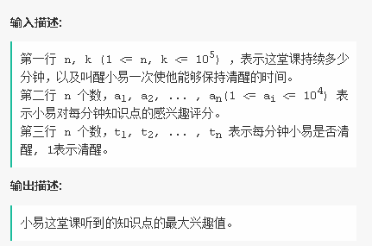





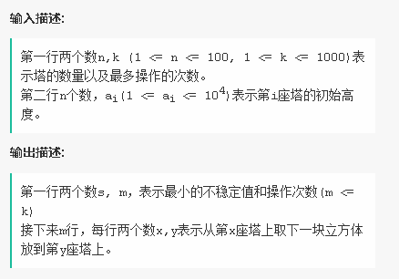



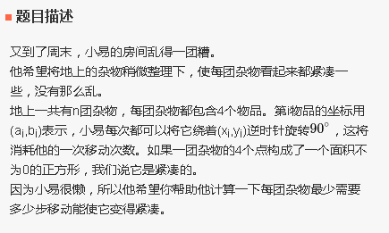

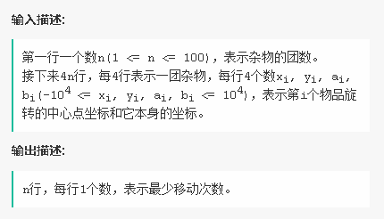

4

1 1 0 0

-1 1 0 0

-1 1 0 0

1 -1 0 0

1 1 0 0

-2 1 0 0

-1 1 0 0

1 -1 0 0

1 1 0 0

-1 1 0 0

-1 1 0 0

-1 1 0 0

2 2 0 1

-1 0 0 -2

3 0 0 -2

-1 1 -2 0

1

-1

3

3