**Question 1:** Sunshine Bank is trying to decrease the losses of its personal loan department. Over the past 5 years the bank has collected several types of data on its customers. This includes their age, their level of education, years of employment with current employer, years at current residence, household income, debt to income ratio, credit card debt and other types of debt of the customer. The bank has given these customers personal loans in the past and has a record of whether they have defaulted on this loan or not. Use the data in Bankloan_Model_Test_Data.sav to build a model to predict if a customer is likely to default or not. Once you have built the model, use it to predict which of the customers listed in Bankloan_Prediction_Data.sav are likely to default. Use probability of 0.5 as a cutoff. Please list the account numbers for the customers who are likely to default.

**Answer:**

**Question 2:** Data on the corn consumption in Wisconsin from year 2000 to 2013 is given in the file Corn.sav. Fit a linear, exponential and quadratic trend model and select the best model. Based on the selected model, forecast the 2014 corn consumption levels.

**Answer:**

**Linear Trend Model**

The model being fit is given by:

Corn_Consumptiont = a + b*t

The Model Summary below:

|  |  |  |  |  |
| --- | --- | --- | --- | --- |
| **Model Summary** | | | | |
| Model | R | R Square | Adjusted R Square | Std. Error of the Estimate |
| 1 | .979a | .959 | .955 | 1.63592 |
| a. Predictors: (Constant), Time | | | | |

The estimated coefficients are given:

|  |  |  |  |  |  |  |
| --- | --- | --- | --- | --- | --- | --- |
| **Coefficientsa** | | | | | | |
| Model | | Unstandardized Coefficients | | Standardized Coefficients | t | Sig. |
| B | Std. Error | Beta |
| 1 | (Constant) | 187.212 | .924 |  | 202.719 | .000 |
| Time | -1.808 | .108 | -.979 | -16.666 | .000 |
| a. Dependent Variable: Corn consumption in thousands of bushels | | | | | | |

The linear trend model is given by:

Corn_Consumptiont = 187.212 – 1.808*t

Model simplified:

Corn_Consumption2014 = 187.212 – 1.808*15 = 160.092

The actual predicted enrollments are illustrated below:

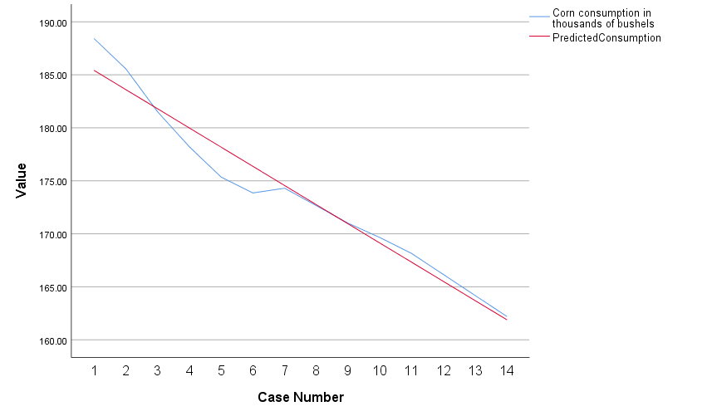

**Exponential Trend Model**

The model being fit is given by:

Corn_Consumptiont = aebt

Taking the log of both sides:

Log (Corn_Consumptiont) = log (a) + b*t

The Model Summary is given below:

|  |  |  |  |  |
| --- | --- | --- | --- | --- |
| **Model Summary** | | | | |
| Model | R | R Square | Adjusted R Square | Std. Error of the Estimate |
| 1 | .982a | .965 | .962 | .00863 |
| a. Predictors: (Constant), Time | | | | |

The estimated coefficients are given below:

|  |  |  |  |  |  |  |
| --- | --- | --- | --- | --- | --- | --- |
| **Coefficientsa** | | | | | | |
| Model | | Unstandardized Coefficients | | Standardized Coefficients | t | Sig. |
| B | Std. Error | Beta |
| 1 | (Constant) | 5.234 | .005 |  | 1074.776 | .000 |
| Time | -.010 | .001 | -.982 | -18.123 | .000 |
| a. Dependent Variable: Log_CornConsumption | | | | | | |

The exponential trend model is:

Log (Corn_Consumptiont) = 5.234 - .010*t

Taking the exponent on both sides:

Corn_Consumptiont = e5.234 - .010*t

Simplified:

Corn_Consumptiont = e5.234 - .010*15 = 161.42

The actual predicted enrollments are shown below:

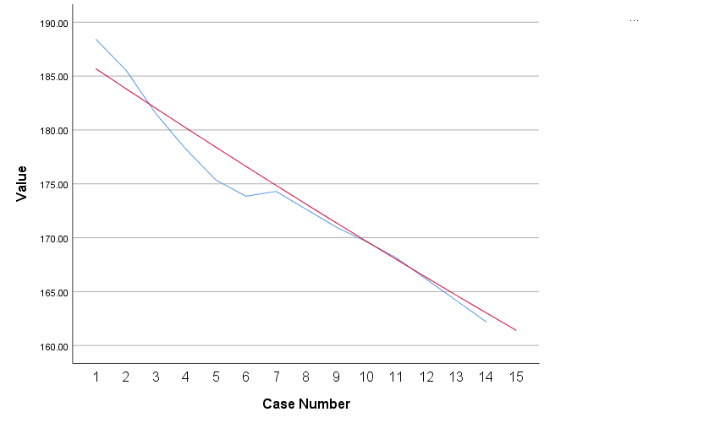

**Quadratic Trend Model**

The model being fit is given by:

Corn_Consumptiont = a + b*t + c*t2

The Model Summary is given below:

|  |  |  |  |  |
| --- | --- | --- | --- | --- |
| **Model Summary** | | | | |
| Model | R | R Square | Adjusted R Square | Std. Error of the Estimate |
| 1 | .987a | .974 | .970 | 1.34589 |
| a. Predictors: (Constant), TimeSq, Time | | | | |

The estimated coefficients are:

|  |  |  |  |  |  |  |
| --- | --- | --- | --- | --- | --- | --- |
| **Coefficientsa** | | | | | | |
| Model | | Unstandardized Coefficients | | Standardized Coefficients | t | Sig. |
| B | Std. Error | Beta |
| 1 | (Constant) | 189.800 | 1.254 |  | 151.354 | .000 |
| Time | -2.778 | .385 | -1.505 | -7.223 | .000 |
| TimeSq | .065 | .025 | .540 | 2.594 | .025 |
| a. Dependent Variable: Corn consumption in thousands of bushels | | | | | | |

The quadratic trend model is:

Corn_Consumption = 189.8 – 2.778*t + .065*t2

Simplifying both sides:

Corn_Consumption = 189.8 – 2.778*15 + .065*152 = 162.76

The actual predicted enrollments are shown below:

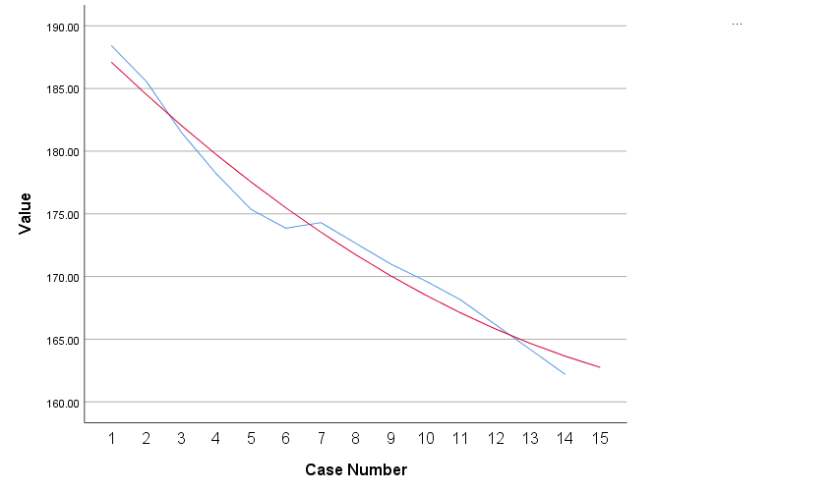

**Final Answer**

Quadratic Trend – with the highest R Square value – is the best model.

The 2014 projection is given by:

Corn_Consumption = 189.8 – 2.778*15 + .065*152 = 162.76

**Question 3:** Data on the daily exchange rate between the Japanese Yen and the US Dollar is given in the file JapaneseYen.sav. Compute the three-period trailing moving average and the three-period centered moving average. Also plot the Japanese Yen, TMA and CMA. Note that you must also submit the SPSS file with your computations.

**Answer:**

**TMA and CMA Computations**

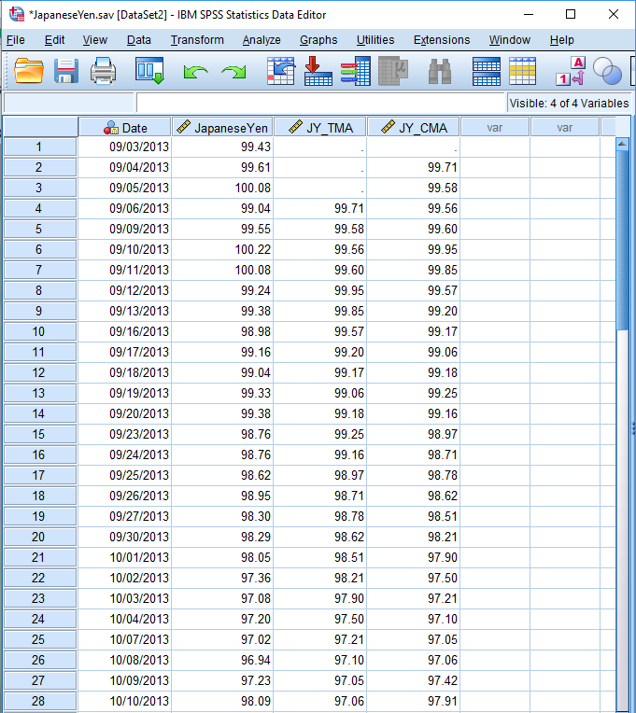

**Plot of MPG, TMA, and CMA**

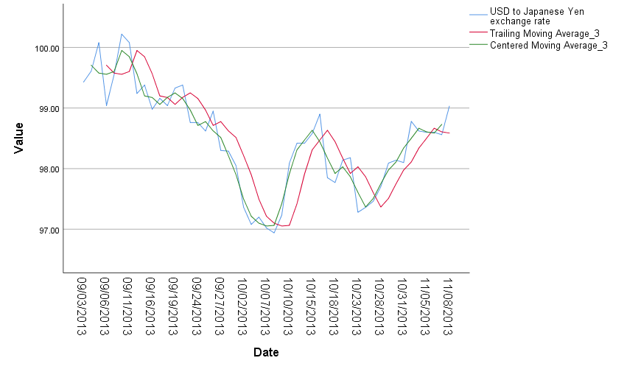

**Question 4:** The yearly car sales (in thousands) in the state of Illinois are provided in Car Sales.xlsx. Using Exponential Smoothing Method A and Method B provide a forecast for the year 1998. Please provide a clear screenshot of the excel computation. Also note that you must submit the excel file with your computations.

**Answer:**

**Computed Exponential Smoothing Method A and B**

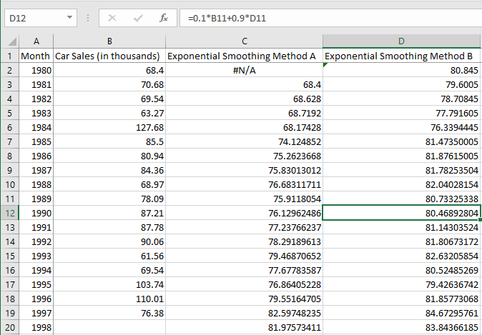

Forecast for Week 19 (Method A): 81.98

Forecast for Week 19 (Method B): 83.84