# Identifying Audio Language

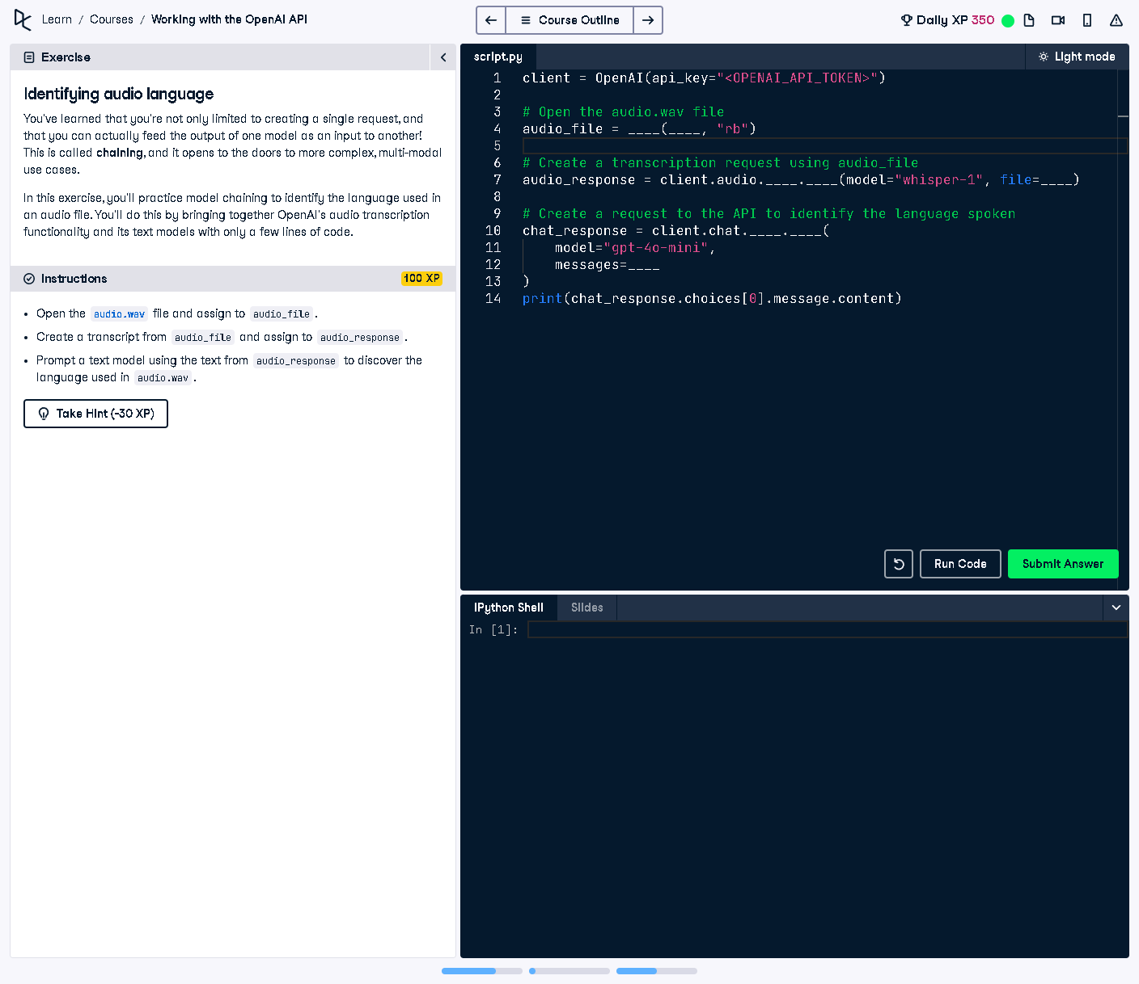

## Question:

In this exercise, we will identify the language spoken in an audio file by first transcribing it using OpenAI's Whisper model and then using a text-based AI model to analyze the transcribed text to determine the language.

## Explanation:

The task requires using OpenAI's Whisper model to transcribe an audio file ('audio.wav') and then feeding the resulting text into a chat model to analyze and identify the language spoken. This showcases how different AI models can be chained together for multi-modal applications.

## Answer:

client = OpenAI(api_key="<OPENAI_API_TOKEN>")  
  
# Open the audio.wav file  
audio_file = open("audio.wav", "rb")  
  
# Create a transcription request using audio_file  
audio_response = client.audio.transcriptions.create(model="whisper-1", file=audio_file)  
  
# Create a request to the API to identify the language spoken  
chat_response = client.chat.completions.create(  
 model="gpt-4o-mini",  
 messages=[  
 {"role": "system", "content": "You are a languages specialist."},  
 {"role": "user", "content": "Identify the language used in the following text: " + audio_response.text}  
 ]  
)  
print(chat_response.choices[0].message.content)

## Explanation of the Code:

1. The OpenAI client is initialized with an API key.  
2. The audio file ('audio.wav') is opened in binary mode for reading.  
3. A transcription request is made using the Whisper model, extracting the text from the audio.  
4. The transcribed text is then sent to a chat model (GPT-4o-mini) with a system message setting its role as a language specialist.  
5. The model receives a request to identify the language of the transcribed text.  
6. The detected language is returned and printed as output.