**How to Install ELK Stack (Elasticsearch, Logstash, and Kibana) on Ubuntu4 20.04**

**Introduction**

The ELK stack is a set of applications for retrieving and managing log files.

It is a collection of three open-source tools, **Elasticsearch**, **Kibana**, and **Logstash**. The stack can be further upgraded with **Beats**, a lightweight plugin for aggregating data from different data streams.

**In this tutorial, learn how to install the ELK software stack on Ubuntu 18.04 / 20.04.**



**Prerequisites**

* A Linux system running Ubuntu 20.04 or 18.04
* Access to a terminal window/command line (**Search** > **Terminal**)
* A user account with **sudo** or **root** privileges
* Java version 8 or 11 (required for Logstash)

## **Step 1: Install Dependencies**

### **Install Java**

The ELK stack requires Java 8 to be installed. Some components are compatible with Java 9, but not Logstash.

**Note:** To [check your Java version](https://phoenixnap.com/kb/check-java-version-linux), enter the following:

java -version

The output you are looking for is **1.8.x_xxx.** That would indicate that Java 8 is installed.

**If you already have Java 8 installed, skip to Install Nginx.**

1. If you don’t have Java 8 installed, install it by opening a terminal window and entering the following:

sudo apt-get install openjdk-8-jdk

2. If prompted, type **y** and hit **Enter** for the process to finish.

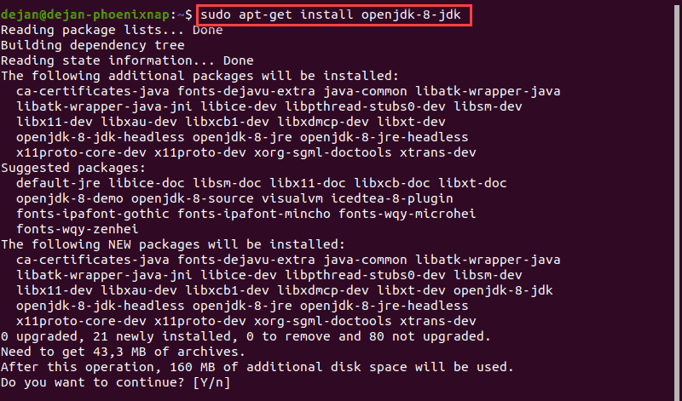

### **Install Nginx**

Nginx works as a web server and [proxy server](https://phoenixnap.com/glossary/proxy-server). It’s used to configure password-controlled access to the Kibana dashboard.

1. Install Nginx by entering the following:

sudo apt-get install nginx

2. If prompted, type **y** and hit **Enter** for the process to finish.

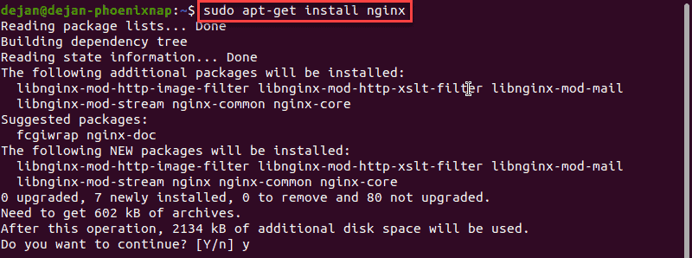

**Note:** For additional tutorials, follow our guides on [installing Nginx on Ubuntu](https://phoenixnap.com/kb/install-nginx-on-ubuntu) and [setting up Nginx reverse proxy For Kibana](https://phoenixnap.com/kb/kibana-nginx-proxy)

## **Step 2: Add Elastic Repository**

Elastic repositories enable access to all the open-source software in the ELK stack. To add them, start by importing the GPG key.

1. Enter the following into a terminal window to import the PGP key for Elastic:

wget -qO - <https://artifacts.elastic.co/GPG-KEY-elasticsearch> | sudo apt-key add -

2. The system should respond with **OK**, as seen in the image below.

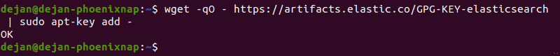

3. Next, install the **apt-transport-https** package:

sudo apt-get install apt-transport-https

4. Add the Elastic repository to your system’s repository list:

echo "deb <https://artifacts.elastic.co/packages/7.x/apt> stable main" | sudo tee –a /etc/apt/sources.list.d/elastic-7.x.list

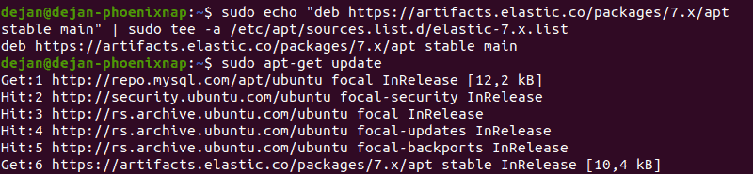

## **Step 3: Install Elasticsearch**

1. Prior to installing Elasticsearch, update the repositories by entering:

sudo apt-get update

2. Install Elasticsearch with the following command:

sudo apt-get install elasticsearch

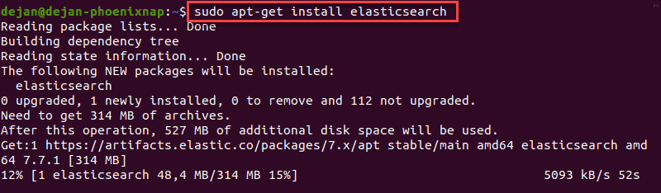

### **Configure Elasticsearch**

1. Elasticsearch uses a configuration file to control how it behaves. Open the configuration file for [editing in a text editor](https://phoenixnap.com/kb/best-linux-text-editors-for-coding) of your choice. We will be using nano:

sudo nano /etc/elasticsearch/elasticsearch.yml

2. You should see a configuration file with several different entries and descriptions. Scroll down to find the following entries:

#network.host: 192.168.0.1#http.port: 9200

3. Uncomment the lines by deleting the **hash** (**#**) **sign** at the beginning of both lines and replace **192.168.0.1** with **localhost**.

It should read:

network.host: localhosthttp.port: 9200

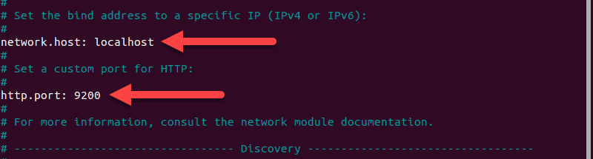

4. Just below, find the *Discovery* section. We are adding one more line, as we are configuring a single node cluster:

discovery.type: single-node

For further details, see the image below.

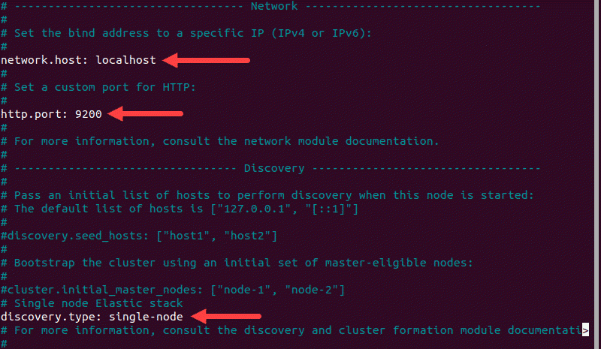

5. By default, **JVM heap size** is set at 1GB. We recommend setting it to no more than half the size of your total memory. Open the following file for editing:

sudo nano /etc/elasticsearch/jvm.options

6. Find the lines starting with **-Xms** and **-Xmx**. In the example below, the maximum (**-Xmx**) and minimum (**-Xms**) size is set to 512MB.

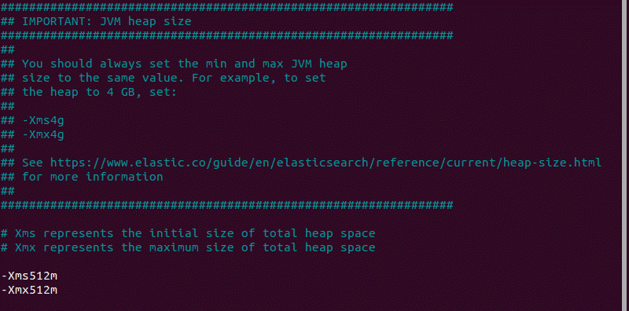

### **Start Elasticsearch**

1. Start the Elasticsearch service by running a **systemctl** command:

sudo systemctl start elasticsearch.service

It may take some time for the system to start the service. There will be no output if successful.

2. Enable Elasticsearch to start on boot:

sudo systemctl enable elasticsearch.service

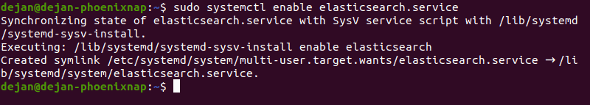

### **Test Elasticsearch**

Use the **curl** command to test your configuration. Enter the following:

curl -X GET "localhost:9200"

The name of your system should display, and **elasticsearch** for the cluster name. This indicates that Elasticsearch is functional and is listening on **port 9200**.

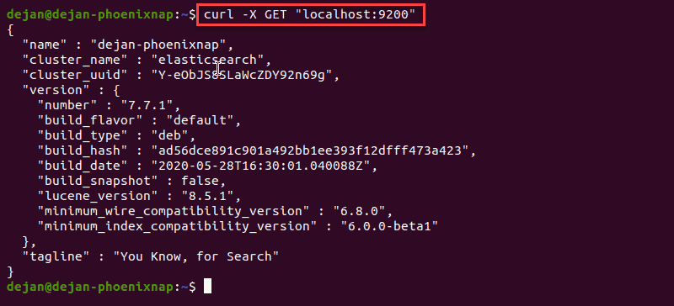

## **Step 4: Install Kibana**

It is recommended to install Kibana next. Kibana is a graphical user interface for parsing and interpreting collected log files.

1. Run the following command to install Kibana:

sudo apt-get install kibana

2. Allow the process to finish. Once finished, it’s time to configure Kibana.

### **Configure Kibana**

1. Next, open the **kibana.yml** configuration file for editing:

sudo nano /etc/kibana/kibana.yml

2. Delete the **#** sign at the beginning of the following lines to activate them:

#server.port: 5601#server.host: "your-hostname"#elasticsearch.hosts: ["<http://localhost:9200>"]

The above-mentioned lines should look as follows:

server.port: 5601server.host: "localhost"elasticsearch.hosts: ["<http://localhost:9200>"]

3. Save the file (Ctrl+**o**) and exit (Ctrl+ **x**).

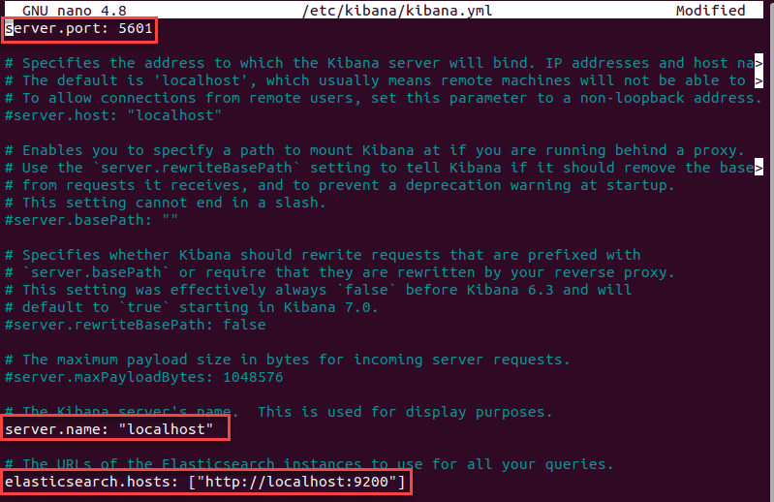

**Note:** This configuration allows traffic from the same system Elasticstack is configured on. You can set the **server.host** value to the address of a remote server.

**Start and Enable Kibana**

1. Start the Kibana service:

sudo systemctl start kibana

There is no output if the service starts successfully.

2. Next, configure Kibana to launch at boot:

sudo systemctl enable kibana

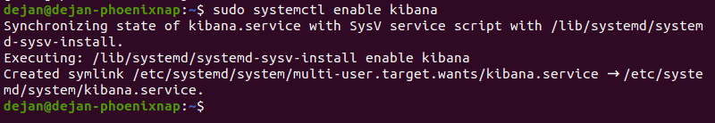

### **Allow Traffic on Port 5601**

If the [UFW firewall](https://phoenixnap.com/kb/configure-firewall-with-ufw-on-ubuntu) is enabled on your Ubuntu system, you need to **allow traffic on port 5601** to access the Kibana dashboard.

In a terminal window, run the following command:

sudo ufw allow 5601/tcp

The following output should display:



### **Test Kibana**

To access Kibana, open a web browser and browse to the following address:

<http://localhost:5601>

The Kibana dashboard loads.



If you receive a *“Kibana server not ready yet”* error, check if the Elasticsearch and Kibana services are active.

**Note:** Check out our in-depth [Kibana tutorial](https://phoenixnap.com/kb/kibana-tutorial) to learn everything you need to know visualization and data query.

## **Step 5: Install Logstash**

Logstash is a tool that collects data from different sources. The data it collects is parsed by Kibana and stored in Elasticsearch.

Install Logstash by running the following command:

sudo apt-get install logstash

### **Start and Enable Logstash**

1. Start the Logstash service:

sudo systemctl start logstash

2. Enable the Logstash service:

sudo systemctl enable logstash

3. To check the status of the service, run the following command:

sudo systemctl status logstash

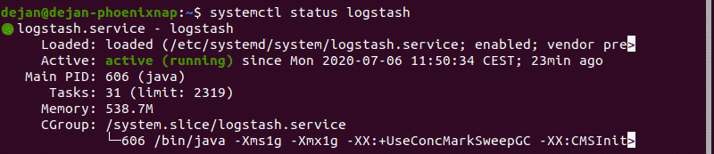

### **Configure Logstash**

Logstash is a highly customizable part of the ELK stack. Once installed, configure its **INPUT**, **FILTERS**, and **OUTPUT** pipelines according to your own individual use case.

All custom Logstash configuration files are stored in **/etc/logstash/conf.d/.**

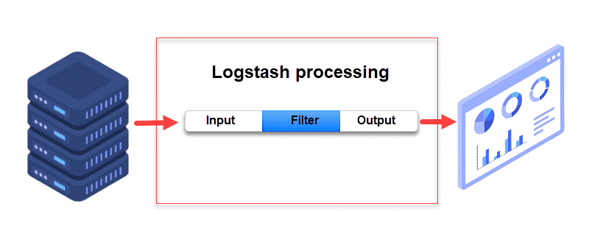

**Note:** Consider the following [Logstash configuration examples](https://www.elastic.co/guide/en/logstash/7.0/config-examples.html) and adjust the configuration for your needs.

## **Step 6: Install Filebeat**

**Filebeat** is a lightweight plugin used to collect and ship log files. It is the most commonly used Beats module. One of Filebeat’s major advantages is that it slows down its pace if the Logstash service is overwhelmed with data.

Install Filebeat by running the following command:

sudo apt-get install filebeat

Let the installation complete.

**Note:** Make sure that the Kibana service is up and running during the installation and configuration procedure.

### **Configure Filebeat**

Filebeat, by default, sends data to Elasticsearch. Filebeat can also be configured to send event data to Logstash.

1. To configure this, edit the **filebeat.yml** configuration file:

sudo nano /etc/filebeat/filebeat.yml

2. Under the *Elasticsearch* o*utput* section, comment out the following lines:

# output.elasticsearch:  
 # Array of hosts to connect to.  
 # hosts: ["localhost:9200"]

3. Under the *Logstash output* section, **remove the hash sign** (**#**) in the following two lines:

# output.logstash  
 # hosts: ["localhost:5044"]

It should look like this:

output.logstash  
 hosts: ["localhost:5044"]

For further details, see the image below.

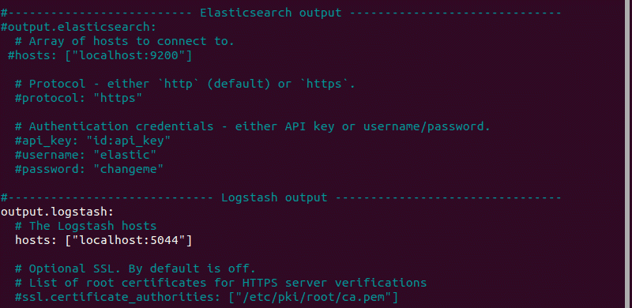

4. Next, enable the **Filebeat system** module, which will examine local system logs:

sudo filebeat modules enable system

The output should read **Enabled system**.

5. Next, load the index template:

sudo filebeat setup --index-management -E output.logstash.enabled=false -E 'output.elasticsearch.hosts=["localhost:9200"]'

The system will do some work, scanning your system and connecting to your Kibana dashboard.

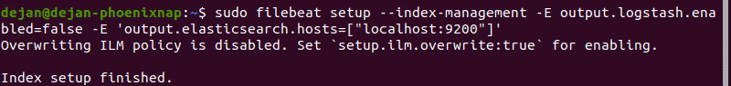

### **Start and Enable Filebeat**

Start and enable the Filebeat service:

sudo systemctl start filebeatsudo systemctl enable filebeat

### **Verify Elasticsearch Reception of Data**

Finally, verify if Filebeat is shipping log files to Logstash for processing. Once processed, data is sent to Elasticsearch.

curl -XGET <http://localhost:9200/_cat/indices?v>

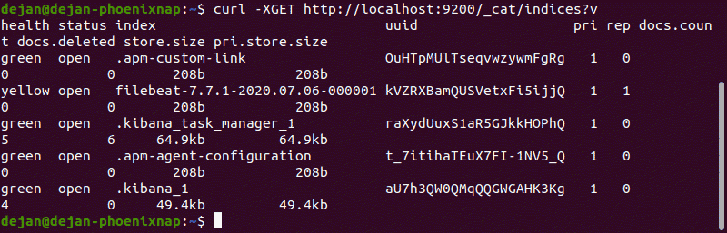

**Note:** For further details on health status indicators, please see [Elastic’s Cluster Health](https://www.elastic.co/guide/en/elasticsearch/reference/current/cluster-health.html) documentation.

**Conclusion**

Now you have a functional ELK stack installed on your Ubuntu system. We recommend defining your requirements and start adjusting ELK for your needs. This [powerful monitoring tool](https://phoenixnap.com/blog/best-server-monitoring-tools-software) can be customized for individual use cases.

Customize data streams with Logstash, use different Beats modules to gather various types of data, and utilize Kibana for easy browsing through log files.