 Grabify IP grabber

step 1: Google search “Grabify Ip Logger”

Step 2: Click on the First Link You see.

and add the URL of Youtube

Step 3: Now tap on create URL then You will see dialogue box like below jsut agree and create URL.

I agree

Step 4: Link information On NEW URL tap on ChangeDomain/Make a custom Link

Do as I said Follow the Above step (I am not Your GIRLFRIEND But Follow😂😂😂)

Step 5: Change according to You want.

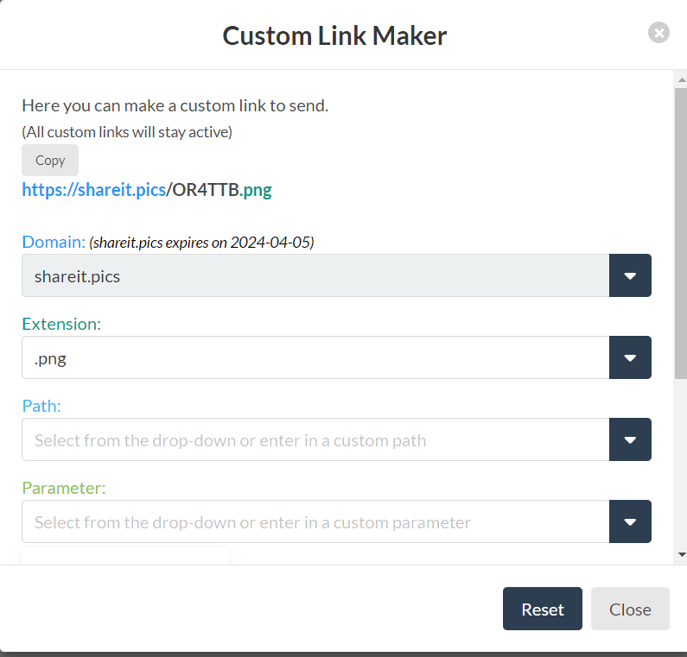

Don’t Tap On RESET Just COPY and send To your VICTIM

Step 6: Use any Chat app to send the Link. I already shared too my victim You will see results Like Below.