# How many sales will be won?

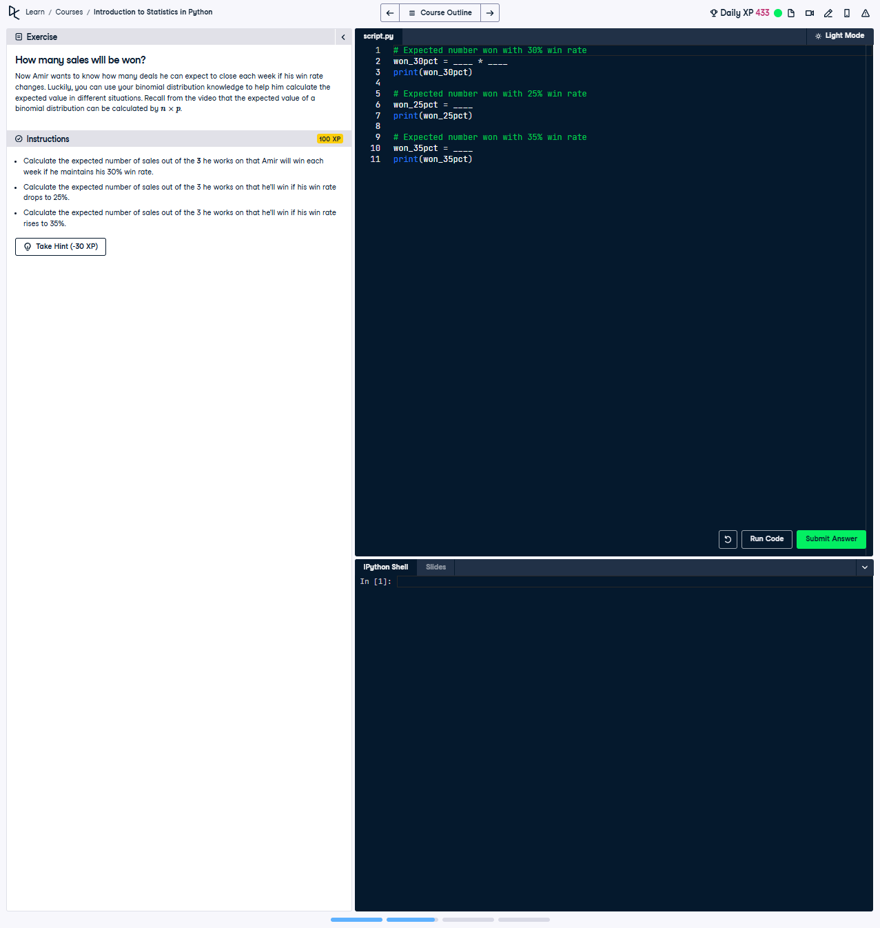

## Question:

Calculate the expected number of sales out of the 3 he works on that Amir will win with each win rate: 30%, 25%, and 35%. Use the provided binomial distribution formula.

## Explanation of the Question:

This question requires calculating the expected number of successes in a binomial distribution, which is done using the formula E(X) = n * p. Here, n is the number of trials (3), and p is the success probability (30%, 25%, or 35%).

## Answer:

from scipy.stats import binom  
  
# Calculate expected number of wins for 30% win rate  
won_30pct = 3 * 0.3  
print(won_30pct)  
  
# Calculate expected number of wins for 25% win rate  
won_25pct = 3 * 0.25  
print(won_25pct)  
  
# Calculate expected number of wins for 35% win rate  
won_35pct = 3 * 0.35  
print(won_35pct)

## Explanation of the Answer:

The formula E(X) = n * p is applied for each win rate. For 30%, the expected value is 3 * 0.3, yielding 0.9. Similarly, for 25%, the expected value is 3 * 0.25, yielding 0.75. For 35%, the expected value is 3 * 0.35, yielding 1.05. These calculations represent the average number of successes.