# AI Python for Beginners: Lesson 5 - Running Your First Program (Answers)

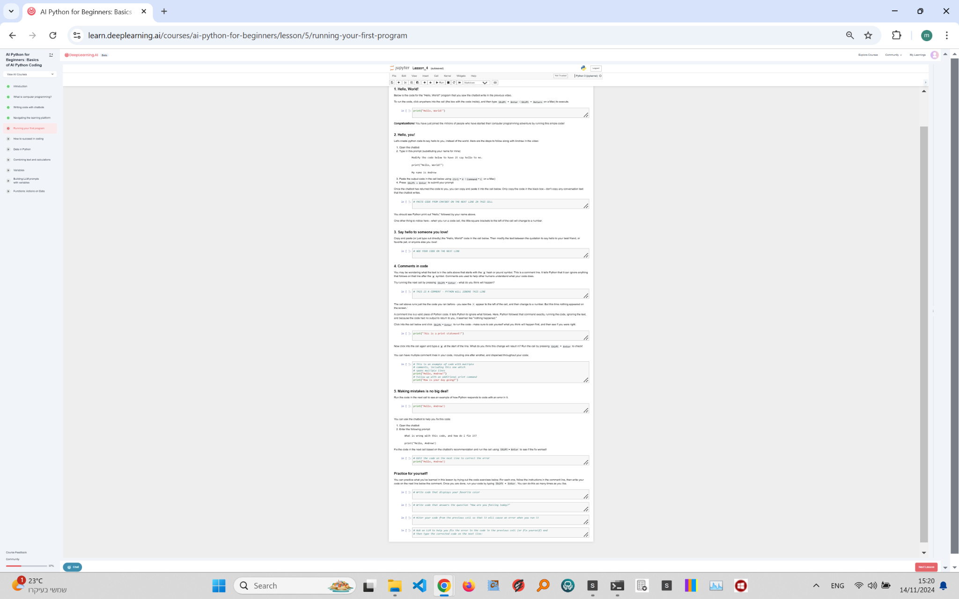

## Exercise Explanation:

In this lesson, you will practice running Python code that will allow you to display your favorite color, answer the question of how you're feeling, intentionally cause an error, and then fix that error using an LLM or by yourself.

## Practice Exercises:

1. Write code that displays your favorite color:  
# Answer:  
favorite_color = 'Blue'  
print(favorite_color)

2. Write code that answers the question 'How are you feeling today?':  
# Answer:  
feeling = 'Excited to learn!'  
print(feeling)

3. Alter your code from the previous cell so that it will cause an error when you run it:  
# Answer (causing an error by calling an undefined variable):  
print(favorite_colorr) # typo in the variable name

4. Ask an LLM to help you fix the error in the code in the previous cell (or fix yourself) and then type the corrected code on the next line:  
# Answer (fixing the typo by using the correct variable name):  
print(favorite_color)