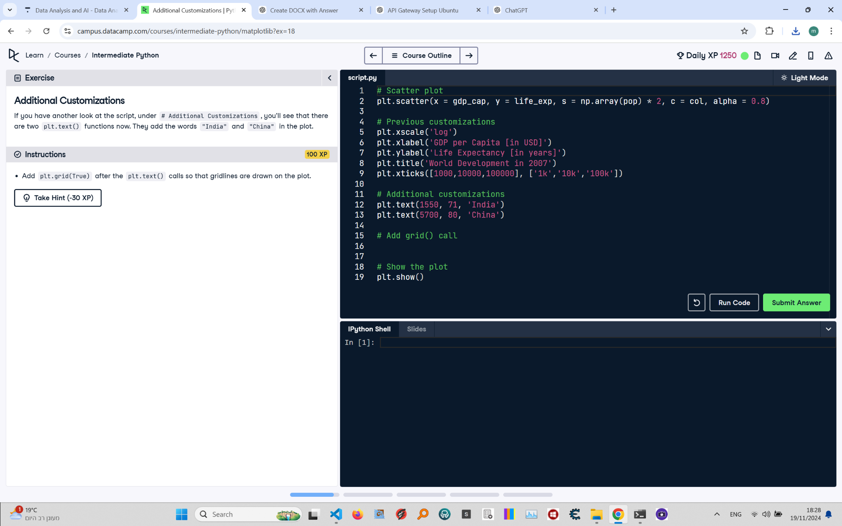

# Additional Customizations: Instructions and Explanation

In this task, you will add gridlines to your scatter plot to enhance readability. Use the plt.grid(True) function after adding the text labels for 'India' and 'China'.

# Concise Correct Answer

# Scatter plot with customizations  
plt.scatter(x=gdp_cap, y=life_exp, s=np.array(pop) * 2, c=col, alpha=0.8)  
# Scatter plot with color and adjusted size  
  
# Previous customizations: log scale, labels, and title  
plt.xscale('log')  
plt.xlabel('GDP per Capita [in USD]')  
plt.ylabel('Life Expectancy [in years]')  
plt.title('World Development in 2007')  
plt.xticks([1000, 10000, 100000], ['1k', '10k', '100k'])  
  
# Additional customizations: add text labels for 'India' and 'China'  
plt.text(1550, 71, 'India')  
plt.text(5700, 80, 'China')  
  
# Add gridlines to the plot  
plt.grid(True)  
  
# Show the plot  
plt.show()