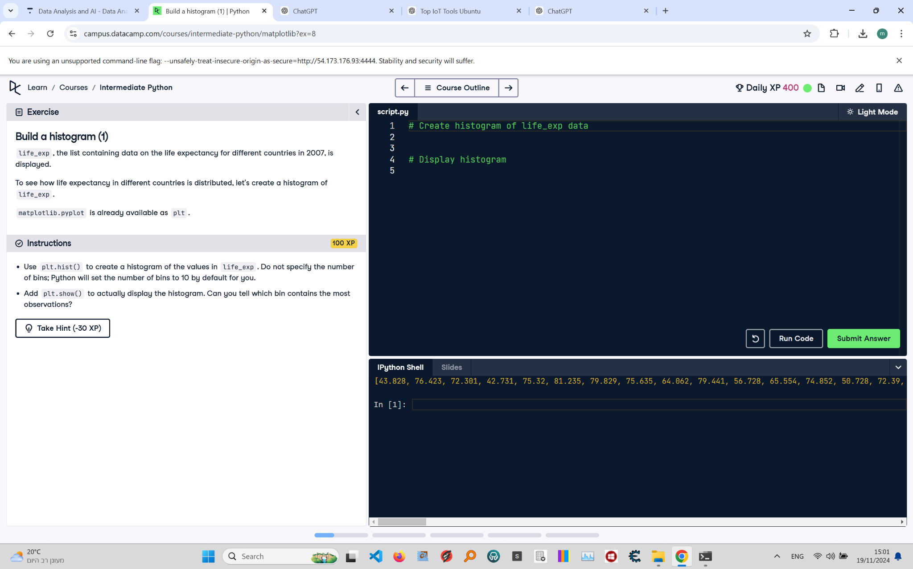

# Build a Histogram (1): Instructions and Explanation

In this task, you are asked to create a histogram to observe the distribution of life expectancy values across different countries using the 'life_exp' data loaded from a CSV file.  
  
Instructions:  
- Use the provided code to load the data, create a histogram with 'plt.hist()', and display it with 'plt.show()'.  
- Make sure not to redefine 'life_exp' after loading it from the CSV file.

# Full Corrected Answer

import matplotlib.pyplot as plt; import importlib; importlib.reload(plt)  
import pandas as pd  
# Import necessary libraries and reload plt to clear previous plots  
  
plt.clf()  
# Clear the current figure to ensure no overlap  
  
df = pd.read_csv('https://assets.datacamp.com/course/intermediate_python/gapminder.csv', index_col=0)  
# Load the Gapminder dataset, using the first column as the index  
  
life_exp = list(df.life_exp)  
# Convert the life expectancy data to a list  
print(life_exp)  
# Print the life expectancy values to verify the data  
  
# Make sure not to redefine life_exp here  
plt.hist(life_exp)  
# Create a histogram of the life expectancy data  
  
plt.show()  
# Display the histogram to observe the distribution of life expectancy values