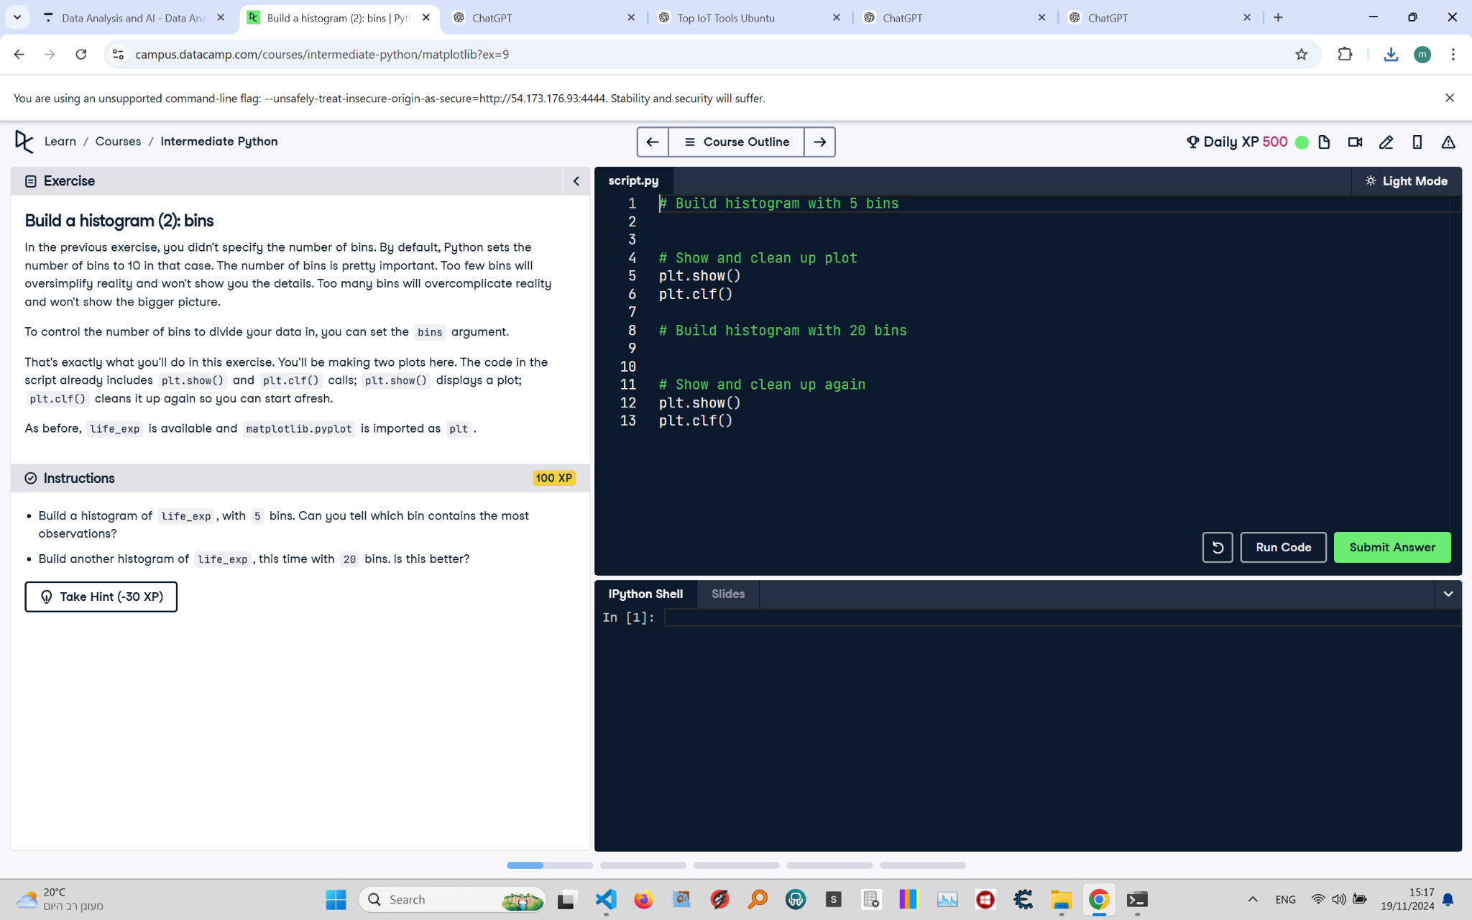

# Build a Histogram (2): Instructions and Explanation

In this task, you are asked to build histograms using life expectancy data from a DataFrame. You will create two histograms of the 'life_exp' data: one with 5 bins and another with 20 bins, to observe how the distribution varies.  
  
Instructions:  
- Load the data from the CSV file into a DataFrame.  
- Build a histogram of 'life_exp' with 5 bins and display it.  
- Clear the figure with 'plt.clf()'.  
- Build another histogram of 'life_exp' with 20 bins and display it.

# Full Corrected Answer with Explanations

# Make sure to use the life_exp data from the DataFrame  
df = pd.read_csv('https://assets.datacamp.com/course/intermediate_python/gapminder.csv', index_col=0)  
# Load the Gapminder dataset from the given URL, using the first column as the index  
life_exp = list(df.life_exp)  
# Convert the life expectancy data from the DataFrame into a list  
  
# Now build the histogram with 5 bins  
plt.hist(life_exp, bins=5)  
# Create a histogram with 5 bins to group the data broadly  
plt.show()  
# Display the histogram with 5 bins  
plt.clf()  
# Clear the current figure to prepare for the next histogram  
  
# And then with 20 bins  
plt.hist(life_exp, bins=20)  
# Create a histogram with 20 bins for a more detailed view of the distribution  
plt.show()  
# Display the histogram with 20 bins  
plt.clf()  
# Clear the current figure to ensure a clean state for future plots