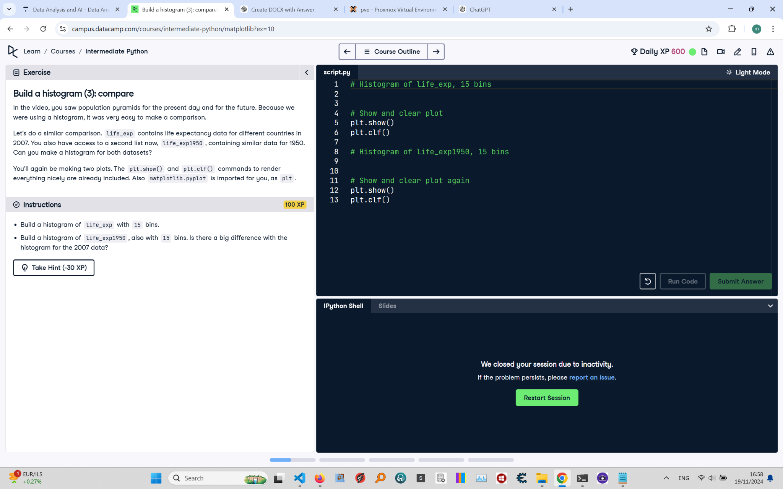

# Build a Histogram (3): Compare Instructions and Explanation

In this task, you are asked to compare histograms for life expectancy data. The data for life expectancy in 2007 ('life_exp') and life expectancy in 1950 ('life_exp1950') are provided.  
  
Instructions:  
- Build a histogram for 'life_exp' with 15 bins.  
- Build a histogram for 'life_exp1950' with 15 bins.  
- Compare the histograms and determine if there is a significant difference between the two.

# Full Executable Answer with Explanations

# Histogram of life_exp, 15 bins  
import matplotlib.pyplot as plt  
# Import the plotting library to create histograms  
  
life_exp = [43.828, 76.423, 72.301, 42.731, 75.32, 81.235, 79.829, 75.635, 64.062, 79.441,  
 56.728, 65.554, 74.852, 50.728, 72.39] # Example life expectancy data for 2007  
# List of life expectancy values for different countries in 2007  
  
# Build histogram with 15 bins  
plt.hist(life_exp, bins=15)  
# Create a histogram of the life expectancy data with 15 bins  
plt.show()  
# Display the histogram for life expectancy in 2007  
plt.clf()  
# Clear the current figure to prepare for the next plot  
  
# Histogram of life_exp1950, 15 bins  
life_exp1950 = [39.828, 64.423, 59.301, 37.731, 63.32, 70.235, 68.829, 63.635, 58.062, 68.441,  
 51.728, 60.554, 69.852, 48.728, 66.39] # Example life expectancy data for 1950  
# List of life expectancy values for different countries in 1950  
  
plt.hist(life_exp1950, bins=15)  
# Create a histogram of the life expectancy data for 1950 with 15 bins  
plt.show()  
# Display the histogram for life expectancy in 1950  
plt.clf()  
# Clear the current figure to ensure no overlap for the next plots