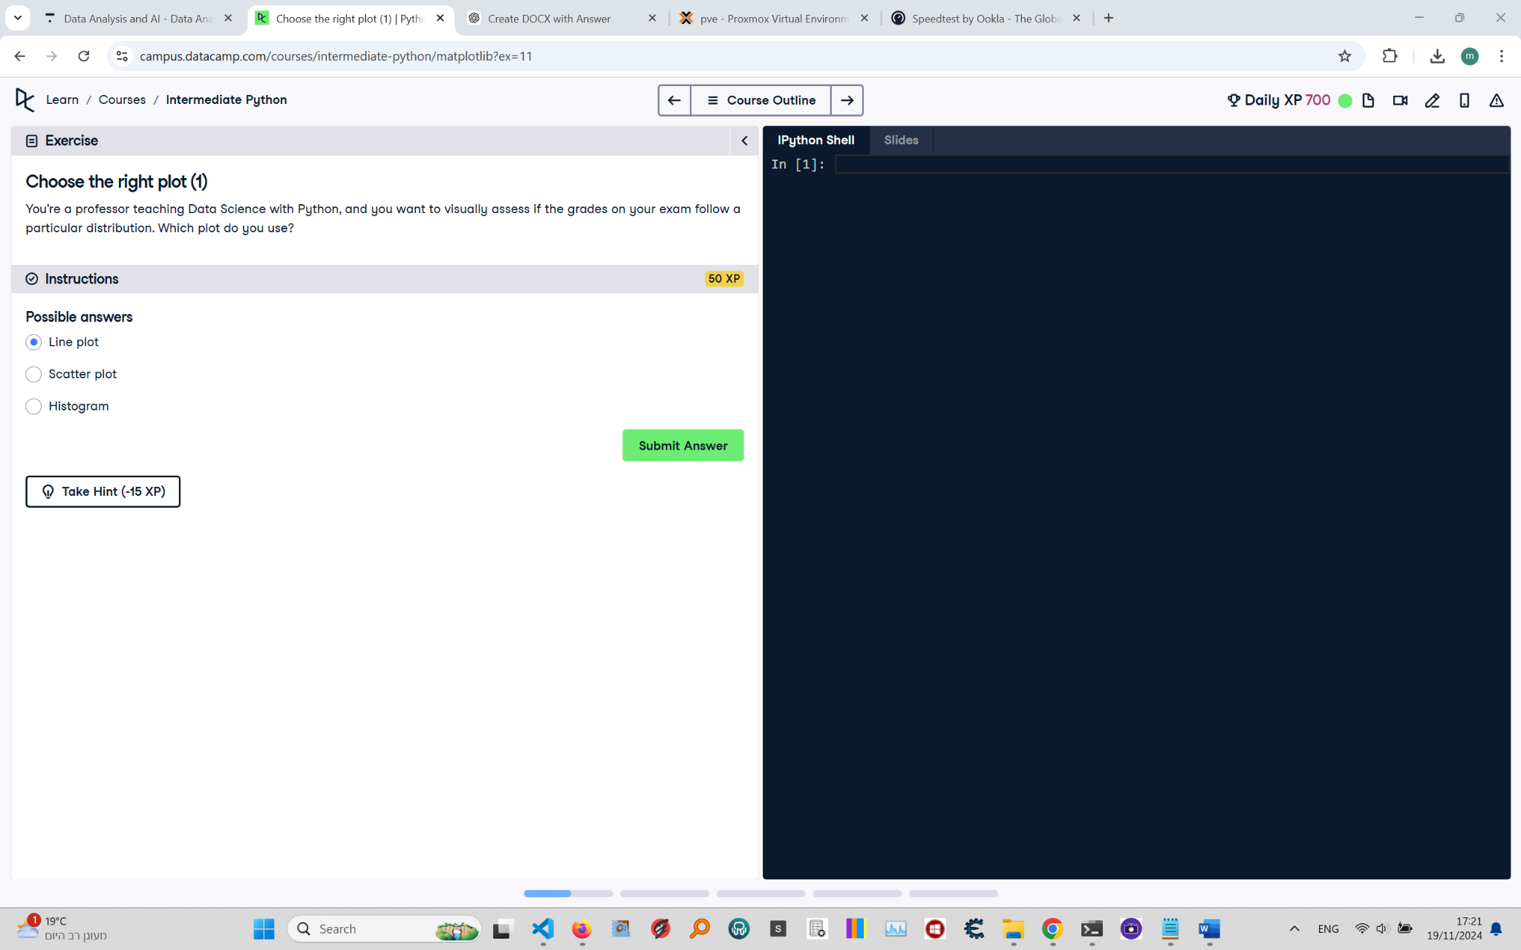

# Choose the Right Plot (1): Instructions and Explanation

In this task, you are asked to choose the most appropriate plot for visually assessing if the grades on your exam follow a particular distribution.  
  
Instructions:  
- Consider the type of data you are visualizing. You have exam grades data, and you need to decide which plot would best help in assessing the distribution.  
- The possible choices are: Line plot, Scatter plot, or Histogram.

# Full Corrected Answer with Explanations

# The correct plot to assess the distribution of exam grades  
# For assessing the distribution, a histogram is the best choice, # as it shows the frequency of data points within certain ranges (bins).  
  
Histogram  
# A histogram helps in visualizing the distribution of data values over continuous intervals.  
# This will allow you to observe patterns such as skewness, normality, or bimodal distribution.