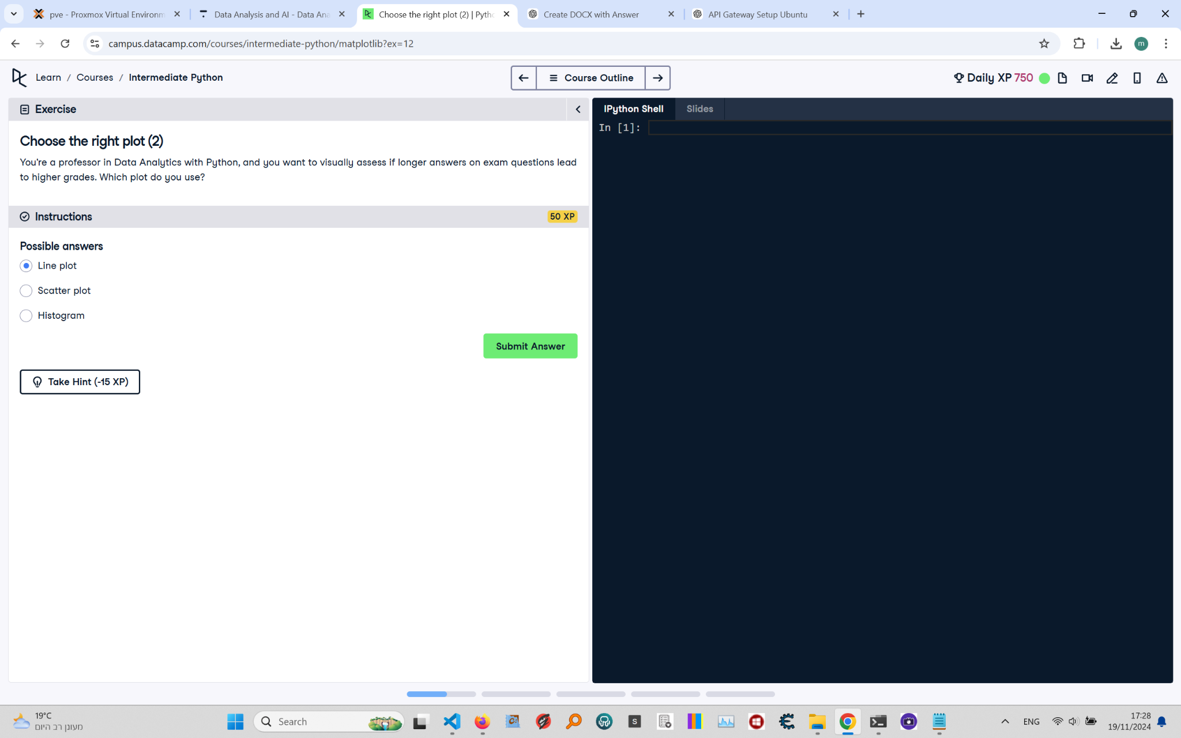

# Choose the Right Plot (2): Instructions and Explanation

In this task, you are asked to choose the most appropriate plot for visually assessing if longer answers on exam questions lead to higher grades.  
  
Instructions:  
- Consider the type of data you are trying to analyze. You have data that can represent a possible relationship or correlation between two continuous variables: answer length and grades.  
- The possible choices are: Line plot, Scatter plot, or Histogram.

# Full Corrected Answer with Explanations

# The correct plot to assess the relationship between answer length and grades  
# To analyze if there is a correlation between two continuous variables, a scatter plot is the best choice.  
  
Scatter plot  
# A scatter plot helps visualize the relationship between two numerical variables,  
# allowing you to observe patterns or correlations.