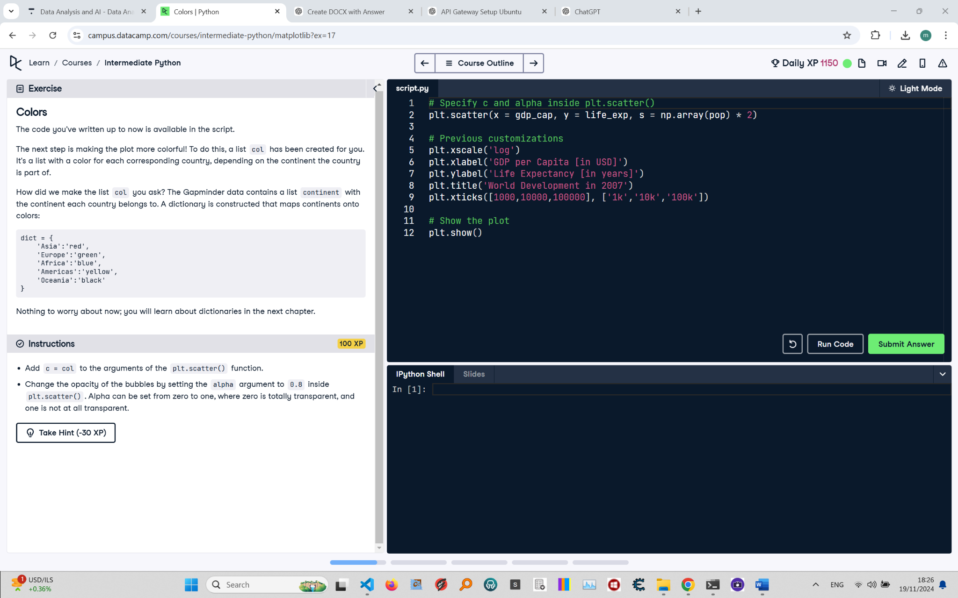

# Colors: Instructions and Explanation

In this task, you will add color and adjust the opacity of the bubbles in your scatter plot. Use the provided list 'col' for colors and set 'alpha' for transparency.

# Concise Correct Answer

# Specify color and alpha inside plt.scatter()  
plt.scatter(x=gdp_cap, y=life_exp, s=np.array(pop) * 2, c=col, alpha=0.8)  
# Add colors using 'col' and set transparency to 0.8  
  
plt.xscale('log')  
plt.xlabel('GDP per Capita [in USD]')  
plt.ylabel('Life Expectancy [in years]')  
plt.title('World Development in 2007')  
plt.xticks([1000, 10000, 100000], ['1k', '10k', '100k'])  
plt.show() # Display the plot