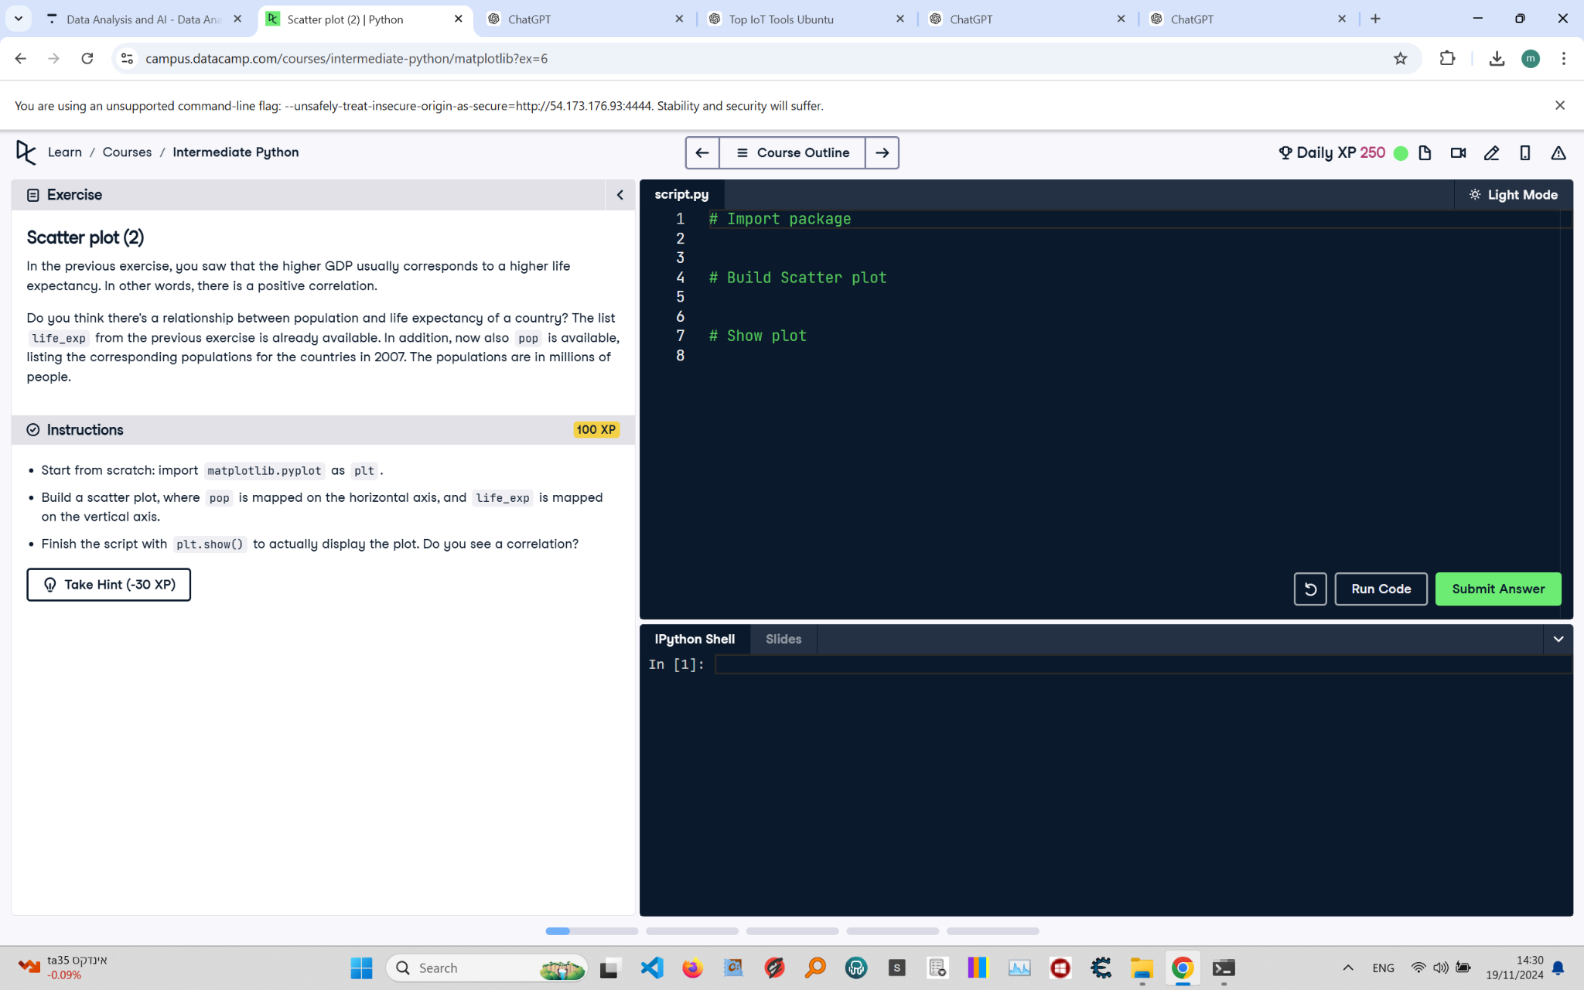

# Scatter Plot (2): Instructions and Explanation

In this task, you are asked to build a scatter plot to investigate the relationship between population and life expectancy of a country. You have the 'life_exp' list from the previous exercise and 'pop', which lists the populations of the countries in millions.  
  
Instructions:  
- Import 'matplotlib.pyplot' as 'plt'.  
- Build a scatter plot with 'pop' on the horizontal axis and 'life_exp' on the vertical axis.  
- Use 'plt.show()' to display the plot and check for a correlation.

# Full Corrected Answer with Explanations

# Import package  
import matplotlib.pyplot as plt  
# Corrected import statement to ensure 'matplotlib.pyplot' is imported properly  
  
# Define the 'pop' and 'life_exp' variables with sample data  
pop = [100, 200, 300, 400, 500] # Example data, replace with actual population values  
# List of populations for different countries in millions  
life_exp = [60, 65, 70, 75, 80] # Example data, replace with actual life expectancy values  
# List of life expectancies corresponding to each population value  
  
# Build Scatter plot  
plt.scatter(pop, life_exp)  
# Create a scatter plot with population on x-axis and life expectancy on y-axis  
  
# Show plot  
plt.show()  
# Display the scatter plot to visualize the correlation between population and life expectancy