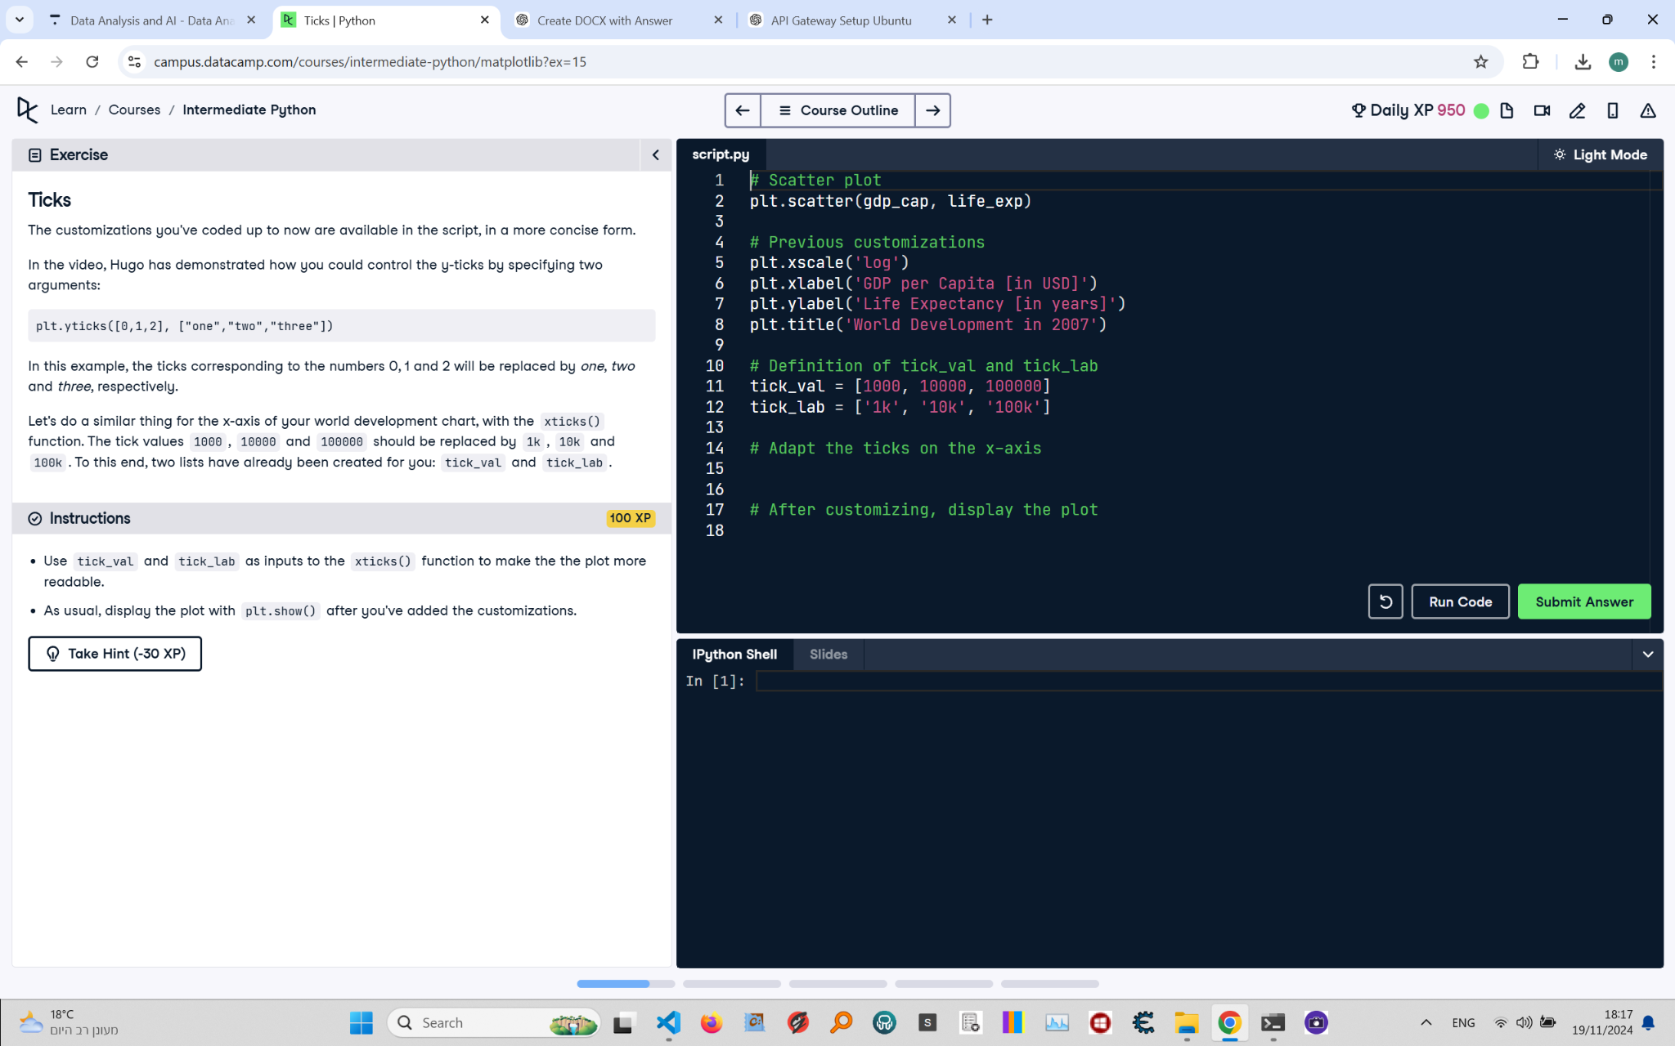

# Ticks: Instructions and Explanation

In this task, you need to customize the x-ticks on your scatter plot to make it more readable. You will use 'tick_val' and 'tick_lab' with the 'xticks()' function to replace numerical tick values with more readable labels.

# Full Corrected Answer

# Scatter plot with GDP per capita and life expectancy  
plt.scatter(gdp_cap, life_exp)  
# Create a scatter plot of GDP per capita vs. life expectancy  
  
# Previous customizations: log scale and axis labels  
plt.xscale('log')  
# Set the x-axis to a logarithmic scale  
plt.xlabel('GDP per Capita [in USD]')  
# Label the x-axis  
plt.ylabel('Life Expectancy [in years]')  
# Label the y-axis  
plt.title('World Development in 2007')  
# Add a title to the plot  
  
# Definition of tick values and their corresponding labels  
tick_val = [1000, 10000, 100000]  
# Define the tick values for the x-axis  
tick_lab = ['1k', '10k', '100k']  
# Define the labels for the tick values  
  
# Adapt the ticks on the x-axis using tick_val and tick_lab  
plt.xticks(tick_val, tick_lab)  
# Replace the tick values with the defined labels  
  
# Display the plot  
plt.show()  
# Show the customized scatter plot