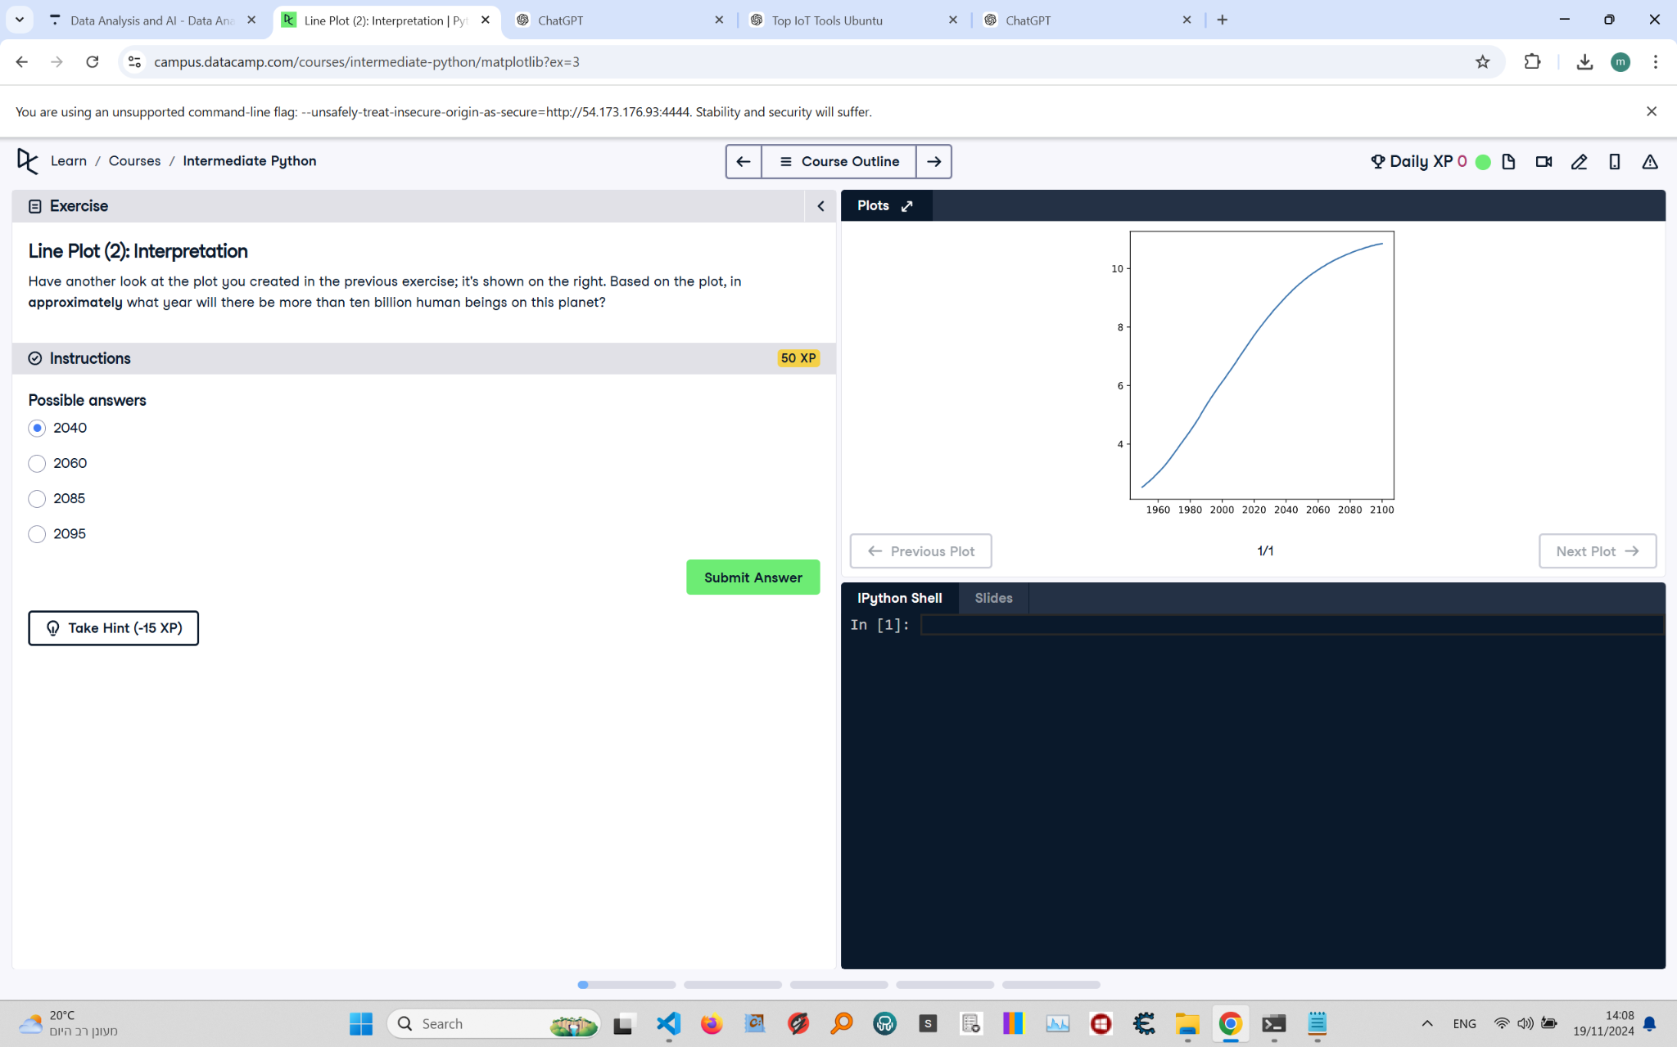

# Line Plot (2): Interpretation

**In this task, you are asked to interpret the line plot shown. Based on the plot, you need to determine the approximate year when the world population will exceed ten billion. Carefully analyze the trend and choose the best answer from the provided options.**

# Correct Answer

**The correct answer is: 2060.**  
**Explanation:** The plot indicates that the world population will surpass ten billion around the year 2060. The curve shows a steady increase, crossing the ten-billion mark at this approximate year.