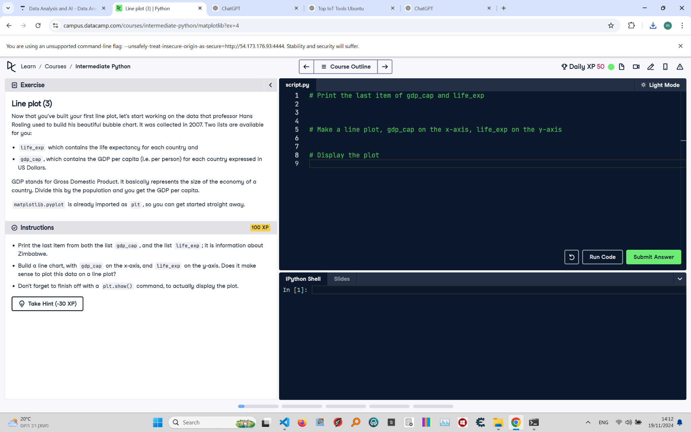

# Line Plot (3): Instructions and Explanation

In this task, you are asked to create a line plot using data collected in 2007. You have two lists: 'life_exp', which contains life expectancy for each country, and 'gdp_cap', which contains GDP per capita (in US Dollars) for each country.  
  
Instructions:  
- Print the last item from both 'gdp_cap' and 'life_exp'; it represents data about Zimbabwe.  
- Create a line plot with 'gdp_cap' on the x-axis and 'life_exp' on the y-axis.  
- Use 'plt.show()' to display the plot.

# Full Answer with Explanations

# Print the last item from gdp_cap and life_exp  
print(gdp_cap[-1])  
# Access the last item of gdp_cap, representing Zimbabwe's GDP per capita  
print(life_exp[-1])  
# Access the last item of life_exp, representing Zimbabwe's life expectancy  
  
# Make a line plot, gdp_cap on the x-axis, life_exp on the y-axis  
import matplotlib.pyplot as plt  
# Import the plotting library to create visualizations  
plt.plot(gdp_cap, life_exp)  
# Create a line plot with GDP per capita on x-axis and life expectancy on y-axis  
  
# Display the plot  
plt.show()  
# Show the plot to visualize the data