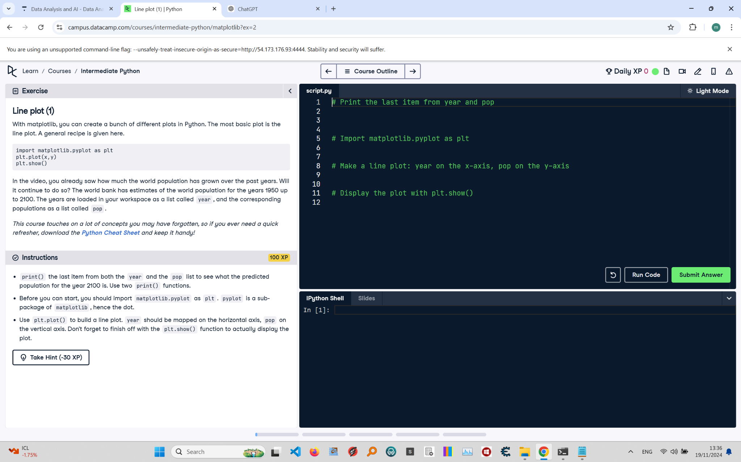

# Recreated Question and Terminal Output Explanation

**In this exercise, you are asked to use matplotlib to create a line plot that displays the growth of the world population from 1950 to 2100. The years are stored in a list called 'year', and the corresponding populations are stored in a list called 'pop'. You should import 'matplotlib.pyplot as plt', use 'plt.plot()' to plot the data, and display the plot using 'plt.show()'. Before plotting, print the last item from both 'year' and 'pop'.**

# Correct Answer

**# Print the last item from year and pop**  
**print(year[-1])**  
**print(pop[-1])**  
  
**# Import matplotlib.pyplot as plt**  
**import matplotlib.pyplot as plt**  
  
**# Make a line plot: year on the x-axis, pop on the y-axis**  
**plt.plot(year, pop)**  
  
**# Display the plot with plt.show()**  
**plt.show()**