# Add Conditionals in While Loop

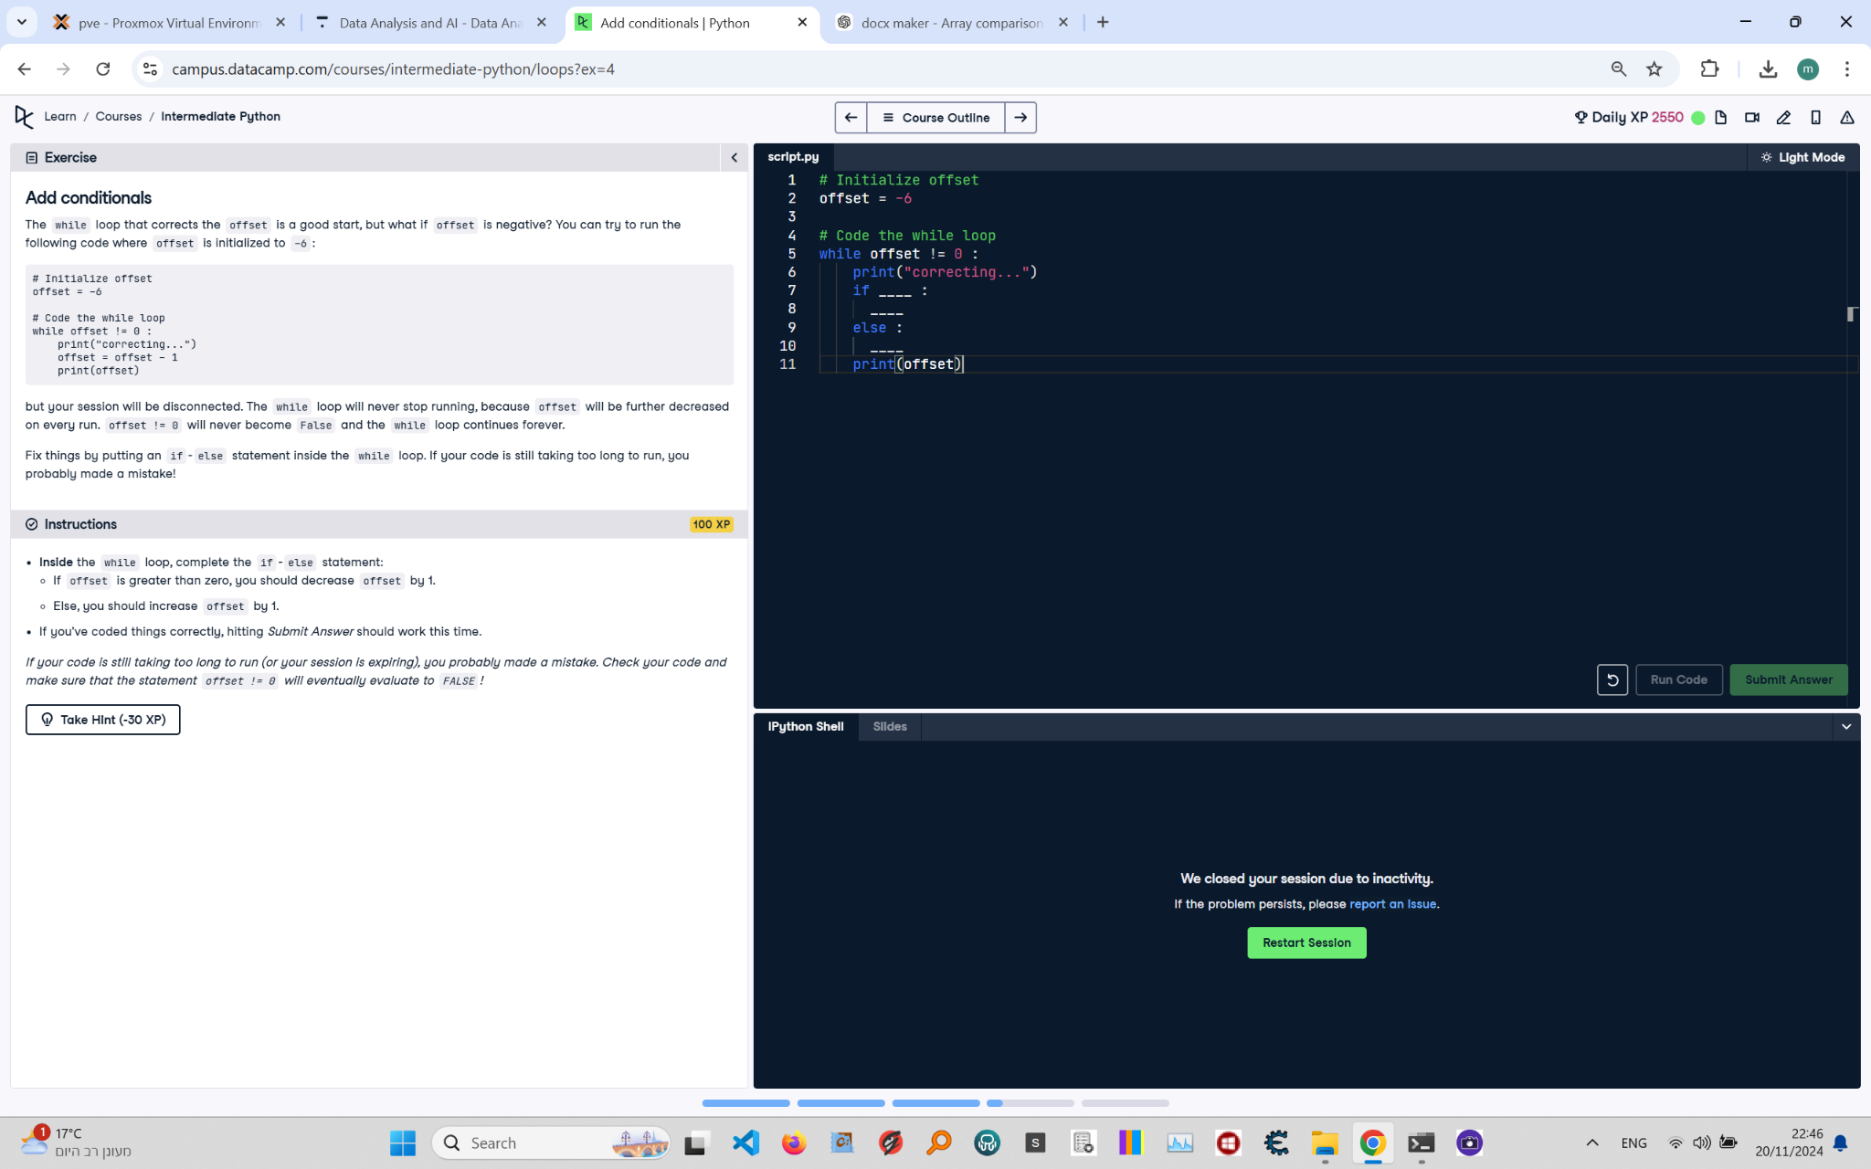

**Question:**

The `while` loop that corrects the `offset` is a good start, but what if `offset` is negative? You can try to run the following code where `offset` is initialized to `-6`:  
  
```python  
offset = -6  
while offset != 0:  
 print("correcting...")  
 offset = offset - 1  
 print(offset)  
```  
  
But your session will be disconnected. The `while` loop will never stop running, because `offset` will be further decreased on every run. `offset != 0` will never become `False`, and the `while` loop continues forever.  
  
**Instructions:**  
Fix things by putting an `if-else` statement inside the `while` loop. Complete the `if-else` statement:  
- If `offset` is greater than zero, you should decrease `offset` by 1.  
- Else, you should increase `offset` by 1.  
  
If you've coded things correctly, hitting `Submit Answer` should work this time. Make sure that the statement `offset != 0` will eventually evaluate to `False`.

**Answer:**

Here is the Python code that solves the problem:

# Initialize offset  
offset = -6  
  
# Code the while loop  
while offset != 0:  
 print("correcting...")  
 if offset > 0:  
 offset = offset - 1  
 else:  
 offset = offset + 1  
 print(offset)

**Explanation:**

1. **Initialization**: The variable `offset` is initialized to `-6`.  
2. **While loop condition**: The `while` loop runs as long as `offset` is not equal to `0`.  
3. **If-else inside the loop**:  
 - If `offset > 0`, the value of `offset` is decreased by `1`.  
 - If `offset <= 0`, the value of `offset` is increased by `1`.  
4. **Print statements**: The message `correcting...` is printed during each iteration, followed by the updated value of `offset`.  
5. **Loop termination**: The `offset` value is incremented or decremented during each iteration, eventually reaching `0`. When `offset == 0`, the loop condition `offset != 0` evaluates to `False`, and the loop terminates.